1 | Introduction and Executive Summary | Page 2
2 | The Community Estate in Barnet | Page 6
3 | Consultation | Page 12
4 | Opportunities for Hubs and Co-location | Page 15
5 | Support for Community Groups and Routes for Engagement | Page 17
6 | Governance Arrangements | Page 19
7 | Approach to Ownership and Occupancy | Page 22
8 | Next Steps | Page 24
 | Appendix 1  Buildings and sites included in the list of Community Assets | Page 26
 | Appendix 2  FutureGov Consultation Report | Page 30
 | Appendix 3  A sample Lease Agreement | Page 46
Community Asset Strategy

1. Introduction and Executive Summary
This document sets out the Council’s strategy for making best use of its land and property portfolio to support community and voluntary sector organisations whilst ensuring that financial and community benefits are maximised for the benefit of residents and to help deliver objectives in our Corporate Plan.
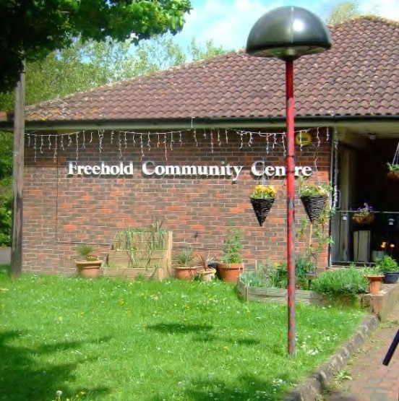
The Council has already put in place a Strategic Asset Management Plan (SAMP) which sets out our vision for Council land and property over the next five years and provides a framework for management of our community assets (known collectively as the community estate) in the context of our wider portfolio of assets.
Whilst all Council assets and some private assets such as pubs and sports facilities have the potential to delivery community benefits, this strategy focuses primarily on 141 properties from our overall portfolio that are used primarily for community purposes. This strategy defines these as Council owned land and buildings which are used for social, recreational or leisure purposes, and are occupied by a variety of organisations ranging from charitable and voluntary groups to commercial leisure organisations.
We have consulted extensively with community and voluntary groups in developing this strategy and will continue to work closely with them to implement this strategy.

Executive Summary
The Council owns 141 sites across the Borough which can be classed as community assets because they are used primarily by third parties for community activities rather than for providing operational Council services. These assets include sports facilities, playing fields, bowling greens, gyms and sports centres, and a variety of buildings including community halls, offices, nurseries and a community library. Some of these sites are operated on a commercial basis by the private sector whilst others are managed and used by voluntary and community organisations.
There are a variety of lease arrangements in operation reflecting the wide range of uses. A number of assets have been transferred on long leases passing the responsibilities and financial benefits to the lessee, while others have been let on short leases or licences, resulting in an element of control, responsibility and rental income falling to the Council. Whilst it is important to maintain some flexibility in agreement of leases, moving forward the Council would like to take a more standardised approach which provides clarity about the responsibilities of occupiers and the authority in relation to the management and maintenance of community assets.
The Council recognises the important social and economic contribution that the voluntary and community sector (VCS) makes to the borough and appreciates the role it has in helping to deliver the objectives in the Council’s Corporate Plan to ensure that Barnet is a place:
- Of opportunity, where people can further their quality of life.
- Where responsibility is shared, fairly.
- Where people are helped to help themselves, recognising that prevention is better than cure.
- Where services are delivered efficiently to get value for money for the taxpayer.

The Council has also agreed a Community Participation Strategy. This sets out how it will work with local residents and community groups in order to increase self-sufficiency, reduce reliance on statutory services, and make the best possible use of community strengths to tailor services to local need. Voluntary and community groups have a key role to play in achieving this vision and the Strategy commits to making sure the resources and assets which are available to support their work are used as effectively as possible.

Barnet is also facing severe financial pressures and has a duty to ensure that it is realising Best Value from all its assets, including those that are used for community purposes. A key challenge for this strategy is to ensure that the social and wider economic value provided by community assets is properly taken into account whilst maximising their contribution to helping the Council balance its books.

- The Council will generate a commercial yield on community assets, but this could be subsided where an organisation is clearly supporting the Council’s objectives or assisting with service delivery.
- The Community Asset Strategy will prioritise utilisation of buildings and identifying opportunities for organisations to share and colocate.
- The Community Asset Strategy will also set out the approach to community “right to bid”, and explore how community assets can be used as a tool for encouraging community engagement.

Fig. 1 – Principles for Community Estate, Strategic
Asset Management Plan 2014
The Council has adopted a Strategic Asset Management Plan (SAMP) which sets out the principles for how it will manage the community estate within the context of its overall portfolio of land and properties. The SAMP commits to making efficient and effective use of Council assets to support community groups.

The Council recognises the importance of ensuring that the community estate is fit for purpose, maintained to a good standard and flexible enough to meet the needs of local communities, whilst also helping the Council to meet its objectives.

Building upon the framework provided by the SAMP, the following objectives and principles for the Community Asset Strategy have been identified and consulted upon:

- To provide communities with the best possible assets to meet their local needs, investing in modern, flexible, functional space for residents and VCS groups
- To enable communities to become active and independent, and able to take on more responsibility for their local areas and reduce the need for Council services
- To rationalise the Council’s estate, without compromising these aims, to ensure it is being used efficiently to support the Council’s priorities and create the best possible value for residents. This should include exploring partnership working with other public bodies, and finding opportunities to create ‘community hub’ facilities in which groups might be colocated.

To achieve these objectives the Council will adopt the following approach to management of community assets:
- We will seek to generate a commercial yield on all community assets.
- Use some of the additional income raised by charging commercial rents to consider providing a subsidy where an organisation is clearly supporting the Council’s objectives or assisting with service delivery and would not be able to do so without financial assistance.
- Seek to maximise the use of buildings and identify opportunities for organisations to share and co-locate.
- Develop community hubs in the borough which will provide a facility that can be used by a variety of community groups.
- Take a positive approach to the transfer of assets to the VCS where this can be demonstrated to be of benefit to the wider community and help the Council deliver its objectives.
- Ensuring that the use of community buildings and land fits with the Council’s objectives and identified needs of the local community

2. The Community Estate in Barnet

2.1 What do we mean by Community Asset?

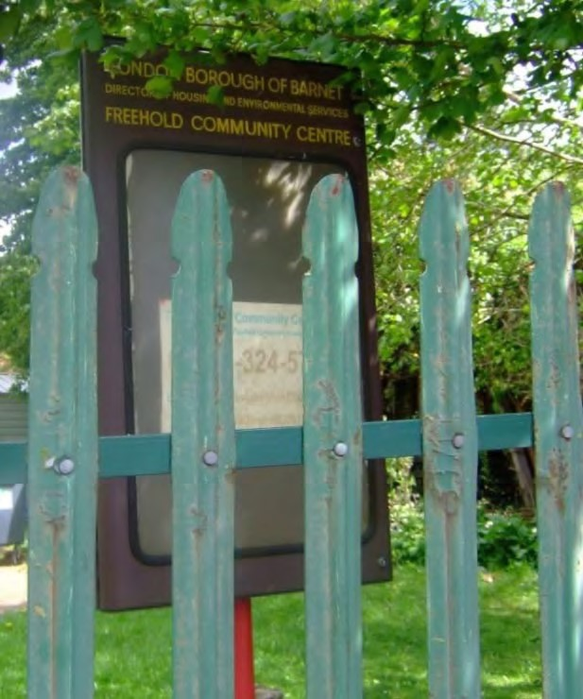
‘Community asset’ is a term used in a variety of ways, from the very narrow – in which only land and buildings owned or managed by community organisations and where profit is invested back into the community are considered community assets –to the very broad – in which all public and some private sector assets are considered a community asset because its use is for the benefit of the community.

The feedback from consultation carried out in early 2015 was that all Council owned buildings should be considered as community buildings and the use of the building should dictate whether it is considered to provide community benefit. The Council has listened to this feedback and proposes that it does consider the majority of its assets as being used for community benefit and that where possible it will seek to promote local priorities through their use.

However, the measures set out in this Strategy relate most closely to those buildings and land which are occupied by third parties and can both give and achieve the greatest benefit by using them to support VCS organisations – such as community centres and community halls, sport and leisure facilities, and various other types of buildings let to community groups. Therefore assets such as schools, for example, whose facilities are clearly provided for community use, have been excluded from the scope of this Strategy at this time as they are subject to a different set of governance arrangements. It is recognised that the list of buildings that fulfil these criteria is not fixed and that it will change as some buildings are taken out of use and others become available for community participation. In addition, when specific proposals for change in an area arise, the Council will be pragmatic about which buildings could be included for consideration (for example, the use of libraries).

Opportunities may also be identified where there is scope to share operational buildings with third party organisations based on local need and the commissioning priorities of the respective services. This means there could be circumstances in which particular assets or buildings currently used for delivery of Council services could become part of the community estate. It is possible, therefore, that a Council service might be co-located in a building with voluntary or community groups or other parties, either by making use of some of the space in a new building or by reducing use of an existing building, allowing other tenants to move in. Certain services are more likely to be well-suited to this approach than others as follows:

- services where community participation, volunteering, and co-production with community members are seen as significant opportunities, such as children’s centres or libraries
- Projects which benefit from opportunities to integrate different services around a particular place or community. An example of such a project might be a training scheme giving young people catering skills, in which part of their training involves running a lunch club for older residents.
- Services which are developing a commissioning model which focuses on community activity.

In other cases, a Council asset may become surplus to the requirements of the service and the Council may look to dispose of it or put it to another use. In such circumstances the asset could potentially be made available for community use.

Some buildings currently leased by the Council solely for commercial purposes also have the potential to move in and out of the community estate – for example, shops which fall into disuse could be taken over by a community occupier.

There is also the potential for mixed-use developments which co-locate commercial and community occupiers through, for example, commitments by developers to provide community facilities as part of new developments through Section 106 or Community Infrastructure Levy arrangements.

It is not the aim of this strategy to seek to make assumptions about which buildings may fall into this category, but to ensure that there is an appropriate policy framework in place, so that when opportunities or needs arise, there are no significant barriers in place that prevent the right changes taking place.

The Council therefore recognises that there are potential benefits which can be derived from the relationship between the community estate and other assets used by the Council, other public sector bodies and commercial occupiers (including privately owned assets), and that as specific propositions in particular areas are considered a wider view may need to be taken.

2.2 What do we know about Barnet’s Community Estate?

Location of Community Assets

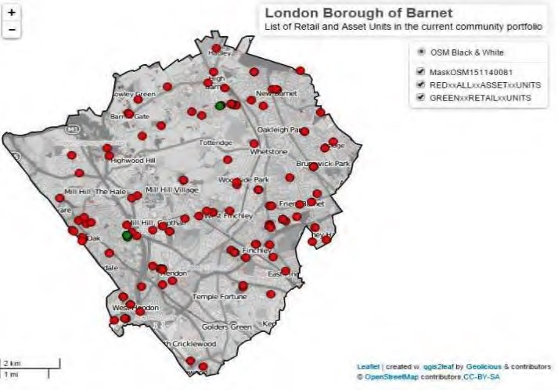
As the map opposite shows, the community estate is widely dispersed around the borough providing the potential for rationalisation. The table attached at Appendix 1 provides a complete list of these assets.

Fig.2 Map of Community Assets in Barnet

Types of Asset
Table 1 below provides an overview of Council owned buildings and land that provide community benefit and are let to third parties and have been consulted on as community assets:

Description | Count | Description | Count
Community Centre | 24 | Bowling Club | 4
Youth Club | 13 | Rugby Club | 3
Sports Club | 10 | Gym | 2
Office | 10 | Leisure Centre | 2
Retail | 10 | Sports Pitches | 2
Hall | 8 | Nursery | 2
Football Club | 7 | Animal Clinic | 1
Golf Club | 7 | Garage | 1
Cricket Club | 7 | Library | 1
Miscellaneous | 7 | Museum | 1
Vacant | 7 | Stadium | 1
Tennis Club | 5 | Community Transport | 1
Day Centre | 5
 |  | Grand Total | 141

Table 1. Community assets in Barnet

This range of assets provides opportunities for working with existing users and the community to ensure that potential community benefits are fully realised as well as providing value for money. This will be achieved by a process of review which is described in more detail below.

Current Lease Arrangements

Lease Status |  | % | Notes
Expired | 30 | 20% | The majority of agreements currently in place are leases which grant an interest in the land and generally transfer exclusive occupation and liabilities for the building to the lessee. Other arrangements include Licences, which provide permission to use the property and generally responsibility for the building is retained by the landlord.
Expires before 2021 | 21 | 15%
Expires between 2021 and 2025 | 5 | 4%
Expires after 2025 | 51 | 39%
Other Agreements (e.g. licences) | 34 | 22%
Total | 141

Table 2. Lease status for community assets in Barnet

As shown in the Table 2 above, a significant proportion of leases have expired or will expire in the next 5 years, providing opportunities for reviewing existing arrangements against the criteria set out in this strategy. The Council will may also seek changes to leases that are not due to expire through negotiation with occupiers where this would assist in delivery of our aims and objectives as set out in this document.

The variety of lease arrangements currently in place means that lessees are often unclear about their obligations, for example on repairs and maintenance, and the Council will seek to put in place more standardised terms across its portfolio as leases are renewed or agreed.

Condition and Costs

Estimated costs for repairs and maintenance are available for just over half of the community assets. The estimated cost is in the region of £2.7m with a breakdown provided below.

44

21

10

4
62

0

10

20

30

40

50

60

70
Less than 25K

K and <
>=25
50
k
K and <
>=50
100
k
>=100
k

Not known

Count

Cost
Estimated Costs
Total Est. Costs -
£2.7M

Fig.3 Estimated repair costs for community assets in Barnet

A key part of our strategy is to develop a better understanding of the condition of the community estate, and there is still significant work to do to understand the outstanding potential repair bill – not just for the 62 classified as “not-known” but also to get a more detailed understanding of the others. In most cases, the lease arrangements mean that the repairs are the responsibility of the lessee. However, given that several of the occupants of current buildings may not have the financial resources to fully fund all the work that needs to take place, understanding the potential liability is a key element in developing any option appraisals for change.

Work is currently being undertaken to agree the arrangements for a programme of conditions surveys during 2015/16 which will help fill the data gap in this area. This will also provide data to better understand the extent to which these buildings are currently compliant with the full range of lease conditions. However, this is a programme for all the properties within the Council’s property portfolio and therefore other assets may be considered priorities over those included within this strategy (e.g. Children Centres, Libraries etc.).

2.3 Review Process

An initial review of the 141 properties on the list has been undertaken to start the discussion with the community about where most effort needs to be directed in the next stage of this process. We have classified the portfolio into different categories to give us a better overall understanding of the constraints on the estate and how much room we have to influence it, to help us develop the implementation plan for this Strategy. However, this is simply an initial rating and the plan itself will not be developed without in-depth engagement with occupiers of the community buildings.

The portfolio was therefore reviewed and classified as follows:

Key | Definition | No of buildings in
 |  | this group
Green | Limited or no opportunity for change in next 5-10 years – long lease or commercial use, but opportunities for community use will be considered as review of community assets progresses | 65
Blue | Requires some review due to lease arrangements, building conditions or other reasons – but not priority for change in next 1-2 years | 11
Orange | Requires some action due to a range of factors (lease expires, development opportunities, vacant sites etc.) | 43
Yellow | Collection of sites that have some issues to be addressed where there would appear to be potential for location of a community hub type arrangement as set out in section 4 below. | 18 sites with 21 separate lease arrangements

Table 3- Initial assessment of community assets

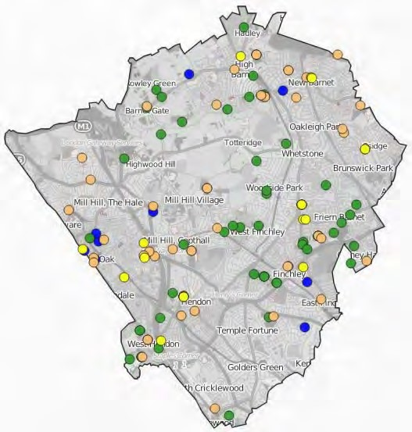
Fig.4 shows the geographical location of these buildings. It should be noted that this initial classification is designed to provide a focus for discussion and no formal proposals are being made at this time.
However, the implementation plan is likely to include these areas to enable the Council to discuss these in more detail with the local community, and the process for this will be included in an implementation plan that will be developed over the summer (2015).

When exploring proposals for a potential
‘community hub’ at the Old Barn in East Fig. 4 Map of community assets following initial Finchley, the Council worked with local assessment
community groups and representatives to explore what opportunities there were in the local area for groups to co-locate within the new hub, and for rationalisation of the Council’s existing estate. A mapping exercise was carried out showing Council assets, which is shown fig. 5 below.
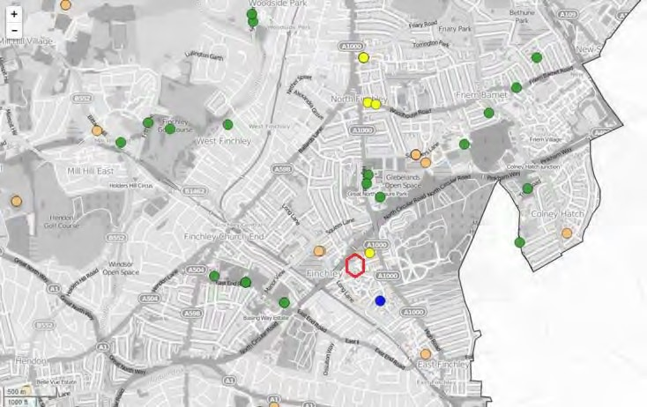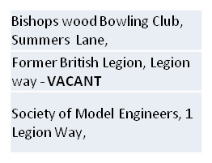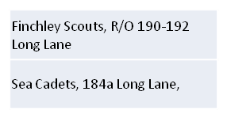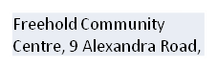

The Old Barn, Tarling Road

Fig.5 Map showing community assets close to Old Barn N2.
This was used as the starting point for a discussion about what would be provided from the Old Barn, forming part of a longer programme of engagement with the community to make use of local knowledge and ensure the proposals for the hub met local needs.
Demonstrating the benefit of local knowledge, community members also identified a number of non-Council buildings which they considered community assets and potential opportunities for colocation as part of this exercise.
The Council will continue to work in dialogue with community groups as it implements this Strategy, to ensure it comes up with the right solution for each local area as well as helping to deliver its commissioning priorities.
More information about community hubs is available in section 4 below.

3. Consultation
Prior to development of this strategy the Council engaged with the community formally and informally in a number of ways, including:
- A general survey about civil society and community activism carried out by CommUNITY Barnet in 2009
- A qualitative needs assessment in 2010
- A review of compliance issues across the estate in 2012
- A stakeholder engagement meeting in 2013
- Consultations exercises on the Council’s priorities and spending review in 2013 and 2014
- A series of formal interviews with a range of voluntary and community groups in 2014

The following issues emerged from these exercises and these have informed the development of proposals for the Community Asset Strategy which were then subject to a public consultation which started in December 2014:

Issues | How addressed in CAS
The quality and use of the community estate:  Existing assets are not always best suited to the needs of the groups using them, with inadequate parking, poor access, lack of storage, inflexible space and poor energy efficiency. | Proposals to rationalise and make more efficient use of existing assets to provide modern builds in the form of community hubs and generate additional income for reinvestment in community portfolio
Rights and responsibilities:  Confusion around what rights and responsibilities community groups have and how best to engage with the Council. Lack of appreciation of the varied capacity of occupiers to meet repairing obligations. | Clarification of rights and responsibilities and intention to take a more standardised approach to agreements.  Helping community groups to work together and co-locate and identify groups that will take responsibility for management and maintenance of community assets.
Being fair in relation to funding:  A need for grant funding or subsidy for groups that do not have access to alternative fundraising routes. | Policy of charging commercial rate in all cases supported by a clear and fair subsidy system for community groups who are helping the Council to deliver its objectives. This will be funded by the additional income raised.
Relationship between growth and development: Opportunities for promote growth and regeneration, through disposal of some sites and opportunities for new community facilities. | Review and rationalisation of existing community estate.
Working with other public sector bodies:  The Council should consider the potential for working with other public sector organisations and neighbouring authorities | As the CAS is implemented, opportunities for working with other public sector bodies will be considered, particularly where there are potential opportunities for co-location of services and VCS groups.

Table 4 – consultation issues

The public consultation exercise held from December 2014 through to March 2015 gave community groups the opportunity to express their views and opinions in relation to the emerging Community Asset Strategy.

The consultation exercise was designed to seek stakeholder and the general public’s response to the following specific key areas:

- The definition of community buildings.
- The objectives and aims of the Strategy.
- The principles for the governance of community assets.
- The proposed respective rights and responsibilities for the Council and users of the community estate.
- The proposed policy for community asset transfer.
- The proposed criteria by which the Council will offer support to voluntary and community groups.
An online survey was launched in December 2014 on the Engage Barnet website which resulted in 19 responses to the questionnaire by the closing date of Friday the 13th February 2015. The responses to these showed that approximately 60% of respondents agreed with the Council’s proposals whilst about 30% did not agree, as summarised in the Table 5 below:
Question | Strongly agree/Tend to agree | Strongly disagree/ Tend to disagree | Neither agree nor  disagree/ Don’t know
Are these the right objectives? | 11 | 5 | 3
Will the aims ensure we meet our objectives? | 10 | 5 | 2
Have we considered right areas for our governance principles? | 7 | 4 | 2
Will support criteria help achieve the aims of the strategy? | 8 | 4 | 1
Table 5 – summary of responses to on line consultation

In addition, a series of workshops was arranged in relation to the Community Asset Strategy. A copy of the consultation report undertaken jointly by LBB, Capita and Futuregov is attached at Appendix
2.
The issues that emerged from the workshops were as follows:
Issue | How addressed in CAS
Community Assets should be given a broad definition. | The Council accepts that as a public body, its entire asset portfolio essentially belongs to the community and that it manages it on behalf of the residents of Barnet, and this has been taken into account in the definition in 3.1 above, which recognises they need to consider opportunities that may be offered for other Council and nonCouncil facilities to support the activities of community and voluntary groups.
That the Council should ensure it “gets the basics right” with a focused customer service. | Section 6 of the CAS sets out clear governance arrangements for management of the community estate going forwards and the implementation plan will also consider the case for a specific liaison post to support community groups who wish to engage with the Council about use of its assets.
The Community Asset Strategy should focus on community need. | The aim of the CAS is to ensure that communities have the best possible facilities available to them to meet local need and the criteria for considering how we will support community groups through use of our portfolio reflects the group’s ability to meet the needs of the wider community.
That the Council should increase the capacity of its community assets over a longer term, taking an enabling role. | The Council will seek to increase capacity through a rationalisation of the existing community estate, which will focus on delivering modern fit for purpose facilities which are fully utilised and which give community groups the resources they need to carry out their work.
That the Council should continue to work with the broader community to better match needs with services including the potential for community hubs. | The Council will work with the wider community as well as its community occupiers as it carries out a review of the community estate and explores opportunities for the development of community hubs.

The consultation indicates a degree of broad support for the principles that were consulted upon, albeit with limited feedback. However, the Council recognises as organisations will be more concerned about the specific impact of changes on their current arrangements, it will need to consult on specific proposals, on an area by area basis, as options for change emerge.

In addition, the Council has recently agreed a new Corporate Plan and set of Commissioning Plans through to 2020. Opportunities for delivering these thorough new arrangements will be part of the detailed implementation phase of this strategy. This is an important first step in ensuring that any discussion between the Council and community groups can take place with a good understanding of what the Council is likely to be able to support going forward given the difficult financial settlements likely over the next 4-5 years up to 2020.

4. Opportunities for Hubs and Co-location
The Council, through this Strategy, is keen to explore opportunities to make more efficient use of its estate by maximising the times during which its assets are being used by community groups. One way to do this is to encourage different groups to co-locate within an asset. This could involve a community group using the same facility as a Council or public sector service or could involve a range of groups working together in a ‘community hub’ arrangement.
This approach has a number of benefits:
- Residents are more easily able to access a number of different services if these are provided in a single location – which can facilitate a more holistic approach to residents’ needs
- Community groups gain opportunities to work together, by networking, cooperating with and supporting one another
- Services can be grouped together to meet the needs of a local area and share infrastructure, which enables community groups to operate in a more sustainable way
- It also enables the Council to rationalise its estate – using assets more efficiently could allow the disposal of those which are surplus to requirements and reinvestment in the remaining estate to improve the condition of community facilities.
The Council will therefore encourage community groups to co-locate more often than is the case at present, and will review the spread and current usage of its assets and the distribution of community groups and services across the Borough to identify opportunities to do this. This could potentially also involve co-locating a community group with a Council or other public sector service – especially where these services complement one another. When a number of services are co-located in a single building or a local area, they can be thought of as a community ‘hub’.
The Council will also consider investing in a number of purpose-built community hubs. These would be multi-use facilities built specifically with a view to maximising the benefits of co-location and enabling as wide a range of groups as possible to benefit from the use of Council assets. Community hubs can be underpinned by flexible lease and management arrangements which can facilitate more use by smaller groups who may not wish to take on overall responsibility for an asset, and this is discussed in more detail in section 6 below.
The Council will look to ensure that hubs are distributed across the Borough in a way which reflects the needs of local communities and the Council’s commissioning priorities for that local area. Initial mapping of the community estate has suggested that from a pure property perspective there may be opportunities associated with those assets marked as yellow in the table shown in section 2.3 above.
The Council will use clear criteria to prioritise opportunities which come forward to invest in hubs, focusing on the proposed location, the opportunities it would provide, its financial sustainability, and whether capacity exists in the local community to manage a hub. These criteria are fully set out in Fig. 6 below:
Proposed location of the hub
- Would it support a logical distribution of hubs across the Borough?
- Is it accessible? Does it have good public transport links? Could it have access to parking for older people, disabled people, or people with young children?
- Is the proposed location in an area with demonstrable demand for premises or for services of the types proposed?
New opportunities provided by the hub
- Would this hub have the potential to attract investment from other sources?
- Will it provide an opportunity to rationalise other public sector buildings in that area?
- What investment would be required to set this up?
Sustainability of the business model
- Would a hub make local groups more sustainable by giving them the chance to join up and share back office costs?
- Would the projected rental income and/or business activity cover the core running costs of the facility?
- Would space be available for rent by either public bodies or private sector organisations?
Existing community capacity to support the hub
- Is there interest among local community groups in being part of a hub?
- Do local groups have any existing knowledge or capacity of the requirements for managing community buildings?
- Does the local community have fundraising skills or capacity?

Fig. 6- Criteria for prioritising investment in community hubs

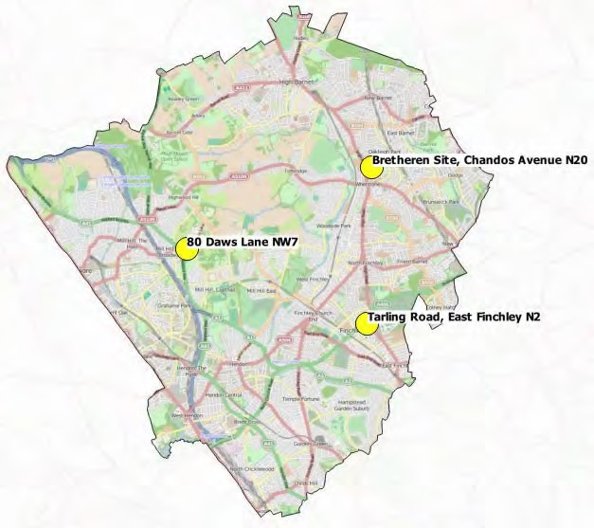
The Council has so far identified three potential opportunities for community hubs, at 80 Daws Lane (NW7), the ‘Brethren’ site at Chandos Avenue (N20), and the Old Barn at Tarling Road (N2). These are shown on map in fig 7 opposite.

The Council will also explore options to incorporate a hub into the development of its new headquarters in Colindale, looking in particular at services which could complement the Council’s activities. We will use these opportunities as pilots which identify best practice for the future development of hubs in Barnet, with a focus on understanding the practical issues involved, developing a robust
framework for joint working with Fig. 7 Map of potential hub sites communities, and developing sustainable business models and approaches to managing hubs.

5. Support for Community Groups and Routes for Engagement

5.1 Support

The Council recognises the need to be consistent and transparent about the circumstances under which it will commit to supporting VCS groups through use of its assets, the level of support it is able to give and what it expects in return. This is particularly important in the challenging economic climate, as part of the Council’s focus on fairness, responsibility and opportunity.

To achieve this, the following criteria will be taken in account when consideration is given to supporting community groups both to ensure that VCS organisations are able to operate in a way that is sustainable, and that the Council maximises the use of its assets to support the work of groups which contribute to its goals:

Criteria 1- The type of service the group or organisation provides, taking into account:
- The work of the organisation contributes to one or more of the Council’s strategic priorities and supports its commissioning plans.
- The work of the organisation is carried out in response to, and meets, a defined local need.
- The work of the organisation delivers a service of a kind from which the Council is considering withdrawing or where community provision could produce better outcomes.
- The work of the organisation is delivered in a way which provides additional value, such as the use of apprenticeships or volunteering opportunities.
- The organisation caters for many different sections of the community.

Criteria 2 – The extent to which the organisation and its use of the asset supports community participation and involvement, taking into account:
- The organisation is committed to the on-going consultation and involvement of the community, particularly around managing the asset.
- The local community is involved in designing and/or delivering the organisation’s activities.
- The organisation enables the local community to take action to address issues which matter to them.
- The organisation encourages entrepreneurialism and social enterprise.

Criteria 3 – The robustness and sustainability of the organisation, taking into account:
- If the group is already receiving support from the Council, it is performing well against agreed measures.
- The organisation is viable and sustainable, and passes an accredited vetting process for community organisations (such as the VISIBLE standard)
- The organisation is purely not-for-profit and has limited income from commercial support (for example, a paying bar).
- The organisation has capacity to raise additional funds or bring in external investment.

Criteria 4 – Effective utilisation and management of the asset
- The building is fully utilised by one or more community groups to ensure maximum benefit is being derived from the asset.
- The building is managed effectively and fully compliant

These criteria will form the basis of a toolkit that will be used to determine support when we are working with the VCS to determine lease arrangements as they are reviewed as part of this strategy or come up for renewal.

5.2 Engaging with the Council

As the Council implements this strategy, it will develop a first point of contact for community groups who are already, or who wish to enquire about, occupying or owning a Council asset and/or other matters relating to community assets. The Council will make this available through its website at www.barnet.gov.uk as part of its broader offer of support to community groups.

6. Governance Arrangements

It is essential that the Community Estate is governed according to a set of clear and consistent principles, to ensure that there is fair and common treatment for different groups who wish to use community assets. To achieve this, the Council will adopt the following principles to state:

- How the Council will consider the relationship between financial value obtained from the community estate and the social or community benefit delivered by its occupiers
- The Council’s approach to the rent charged on community properties and arrangements for determining subsidy
- The Council’s approach to lease and licence arrangements
- The Council’s approach to ownership and occupancy

6.1 Community benefit and financial value

The Council will seek to agree a level of social or community benefit to be delivered by organisations making use of its assets, including:
- the provision of additional activities or opportunities such as volunteering or apprenticeships in delivering services
- coordination with other Council strategies or with plans for particular localities or communities
- full utilisation of the building as far as is practicable
- value for money for Barnet’s residents
- financially sustainable arrangements for groups using our community assets
- Ensuring that a compliant building is maintained.

6.2 Rental value and subsidy

The Council will operate a standard policy in which the rental value of each of its community buildings is assessed on the basis of full market rental value for community use. Where the occupier is deemed to be contributing to local priorities and fulfilling other criteria for support, the Council may choose to grant financial assistance in the form of a rebate to provide support (through an agreement with the occupier), at a level which reflects the community benefit the organisation is providing.

The benefits of this approach are that it
- Allows a clear assessment of the value of the support the Council is offering the occupier, without this affecting the investment value of the asset
- Allows the level of support to be set in relation to the benefit provided by the organisation
- Enables asset-related support to be weighed up against other kinds of support being offered to community groups
- Allows the Council to support community groups to become more independent and resilient by encouraging them to move towards meeting the rental obligations themselves through a phased withdrawal of the subsidy.
- Encourages full utilisation of the asset

The overall costs of subsidies provided by the Council to support the use of community assets will be met from the additional income raised through the application of commercial rents across the portfolio, and will not exceed the existing costs incurred by the Council associated with management of the community estate.

The allocation of subsidy will reflect the criteria set out in 6.1 above, and a clear process for dealing with applications for subsidy will be in place and published by September 2015 to support the implementation plan.

6.3 Leases and occupation of community buildings

The length of lease for community buildings can have a significant impact on occupiers, affecting their ability to raise funds and ensure sustainability. A lease which runs for less than 25 years can make it more difficult for community organisations to raise funds. However, long leases also have a significant effect on the Council’s ability to use its assets flexibly and to respond to changes in circumstances.

The Council needs to be able to nuance its approach to lease arrangements so that it can respond to this. For example, a community group might lose the skills of a key staff member who had been enabling it to fulfil its maintenance liabilities. Alternatively, a group may be granted a lease on a Council property on the basis of the work it is doing at present but its role may shift to the point that its work no longer directly supports Council priorities.

Each lease agreement will be preceded by a clear statement setting out the heads of terms (contractual principles) applying to the agreement, including the relative rights and responsibilities of each party. A sample heads of terms statement is included at Appendix 3 of this Strategy.

In general terms, where an occupier is offered a leasehold interest, it is proposed that this will be for a term of 25 years, on full repairing and insuring terms (which means that the tenant is responsible for all repair and insurance obligations). It will be contracted outside the Landlord and Tenant Act 1954, subject to 5 yearly upward only rent reviews and a 6-month rolling break clause which can be brought into effect by the Council only. Asking for leases to be contracted outside of the Landlord and Tenant Act 1954 means that there is no automatic right to renewal or right to compensation on the lease expiring. In addition, the lease will contain a provision where if the primary use of the asset no longer supports Council priorities, the lease may be determined on 3 months written notice by the Council.

If community occupiers need leases guaranteed for up to 25 years in order to secure funding, the terms may include a provision where a suitable lease may be granted if the occupier’s funding bid depends on it and a sustainable business plan is presented.

The Council will assess the skills and capacity of any community group interested in the use of a building to manage the maintenance and compliance issues which may arise, and will offer the group an arrangement, based on this assessment, as to whether the Council or the group should be liable for maintenance. Depending on the level of liability assumed by the Council, alternative terms may be offered to the group with regard to the level of subsidy and length of lease, potentially also on different repairing and insuring terms. This will be decided on a case by case basis.

6.4 Landlord/tenant relationship

This is a direct contractual relationship between the Council and the occupier of a community property. Each occupier has their own agreement with the Council and agrees clear contractual responsibilities in relationship to the maintenance of the building and compliance with the terms of the lease. The Council is responsible for monitoring compliance with the lease. This model may be suitable for discrete community facilities, or for standalone buildings and sites with a single occupant.

Single head lessee
This is a direct contractual relationship between the Council and one occupier of a community property, who then takes on responsibility for managing the other organisations who are using the building.

This model would work particularly well for community hubs, in which the head lessee might also take on responsibility for the day to day management and maintenance of the building. Community groups who only want to use a building for part of the week have the opportunity to request a licence to do so without having to take on responsibility for running and operating a building.

Licences

A licence has different legal status to a lease. It is a permission to occupy land or property rather than a legal interest. It has the advantage of being a flexible arrangement which either the licensor or the occupier can terminate at any time, with a short notice period. However, licences also have some limitations. They cannot be used by community groups to attract external funding or grants as they do not grant the licensee an interest in the property. A licence is generally only used for shortterm or shared occupation.

Licences therefore will be offered to community organisations that need part-time or temporary use of a community property (for example, less than three days a week). They should also be offered to any party who does not wish to be considered for either a head lessee or a landlord and tenant style arrangement.

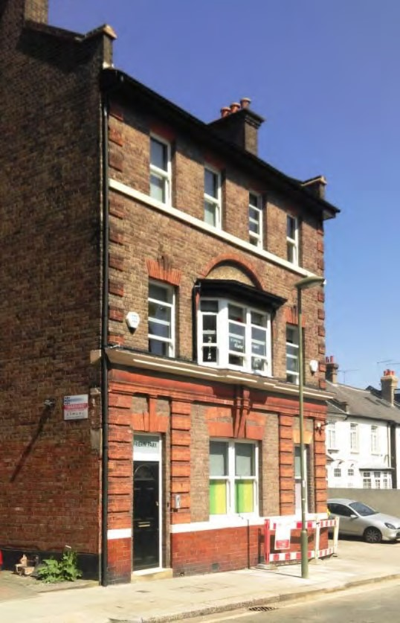
7. Approach to Ownership and Occupancy

Under the Localism Act there are a number of routes whereby communities have been empowered to seek control of local assets that are important to them and these are summarised in the table below.
The Council will work positively with community groups who seek ownership of a community asset where this is of benefit to the Authority and local residents, and in future, in the first instance, contact should be made through the route which will be developed as set out in 5.2 above.
The Council will advise communities of the most appropriate route to achieve their objectives relating to ownership of an asset.
The various legislative options for communities to take control of public assets set out in the Table 6 below.
As part of the implementation of this Strategy, the Council will explore opportunities to work strategically with community groups, where appropriate, on transfer of the ownership or management of assets, focusing in particular on areas where this may enable a community group to contribute to public sector outcomes and the Council’s commissioning priorities.
Options for Community Ownership
Community Asset Transfer | Process by which a public body and proactively and voluntarily choose to transfer ownership or management of assets to a community organisation, often at less than market value. The Council will consider this where:  - Social or community benefits outweigh benefit from rental income or a capital receipt  - Transfer would result in a reduction in costs or demand for Council services  - The proposal would support the Council’s strategic priorities  - The proposal is considered financially viable and sustainable  This is the best route for engagement for groups wishing to take control of a community asset.
Community  Right to Bid | Gives community organisations opportunity to nominate a building or piece of land, including a Council asset, to be listed as an “asset of community value” (ACV).  If listed as an ACV, if the owner wishes to sell the asset, it must allow community organisations 6 months to put together a proposal and raise funds to buy the asset on the open market. The Community Right to bid does not oblige the asset owner to sell to the community group and the Community Asset Transfer is a more effective route for this.
Decisions on AVC status are made by the Council’s Community Leadership Committee.

The register of assets of community value already registered in Barnet can be found on the Council’s website www.barnet.gov.uk

Community  Right to  Contest | This can be used to trigger the sale of land or property owned by the Council or the Government where it can be demonstrated that the asset is empty or underused, and there are no plans to bring it back into use. The Council will encourage community groups considering this approach to explore options with the authority first.
Table 6 – options for community ownership

8. Next Steps
The following actions will be required in order to implement this Strategy.

Over the period between June and September 2015, the Council will develop a detailed evidencebased implementation plan highlighting the resources and time likely to be required to implement the Strategy.

The Council will engage with current users of its community buildings, by

- Writing to the occupiers with a copy of the Strategy, requesting feedback and questions and asking for comments on how they would see this impacting their own circumstances;
- Prioritising the review of those properties highlighted in the CAS as requiring action or having potential for community hubs;
- Holding preliminary discussions on individual arrangements where they are occupied and the lease has expired;
- Building a profile of our users, working together to make sure that use of our buildings meets local needs realises benefits for the wider community.

This initial engagement will be completed by September 2015 and reported back to the Assets, Regeneration and Growth Committee.

The Council will further improve the information it holds about the condition of its buildings, by

- reviewing the data that is available on the current community asset base, including information on the condition and compliance of the buildings
- assessing the likely level of need for community facilities in Barnet
- establishing a plan and timeline for gathering data for assets where condition and compliance surveys are not currently available, in order to further inform our analysis of the financial implications of delivering the Strategy.

A project will be set up to establish the condition of the community buildings. This will consist of an initial desktop study and, where it is deemed necessary, full condition and compliance surveys. It is the Council’s intention to work closely with the individual user of each building and, if necessary due to the condition of the building or for other reasons, to re-provide an appropriate facility. The Council will also engage with local residents when decisions on community facilities are being considered. This project will include a prioritised detailed programme of inspections, analysis and consultation with lessees to determine options for individual buildings and will be completed by December 2015 and reported back to the Assets, Regeneration and Growth Committee.

The Council will develop a detailed implementation plan for taking forward the three pilot community hubs identified, including early engagement with appropriate stakeholders. This will be completed by September 2015 and reported back to the Assets, Regeneration and Growth Committee.

The Council will review the outcomes of these three pilots and develop appropriate toolkits, policies and procedures relating to such matters as the measurement of social value, appropriate level of engagement, processes for grant applications. This will be completed by March 2016 and reported back to the Assets, Regeneration and Growth Committee.

In particular, the Council will establish how it will measure social benefit through a fair, open, and transparent process which is in line with the criteria set out in section 5 of this Strategy. The process will need to establish who will make the assessments and how users of community buildings will be engaged in the assessment process.

The Council will establish what resources are needed to support work between commissioners, the Estates team and the building occupiers and to establish who will take the role of facilitator in the development of individual business cases. These business cases will need to demonstrate financial sustainability, full utilisation of the building and support for local priorities.

The plan will be underpinned by the development of a detailed Equalities Impact Assessment.

The full implementation plan setting out the above steps will be presented to the Assets, Regeneration and Growth committee in September 2015.

Appendix 1 – Buildings and sites included in the list of Community Assets
Property Name | Postcode
St John's Ambulance, Church Farm Garage, Church Farm, | EN4
3rd East Barnet Scout Group, Vernon Crescent, | EN4 8QG
Oakhill Park Bowls Club, Oakhill Park, Parkside Gardens | EN4 8JS
The Whale Centre, Church Farm, Church Hill Road | EN4 8XE
Tower Gym, Church Farm, Church Hill Road | EN4 8XE
New Barnet Community Centre 48-50 Victoria Road, | EN4 9PF
Nightingale Nursery, 23 Victoria Road, | EN4 9PH
East Barnet Rifle Club Albert Road, | EN4 9SH
Quinta Club, Mays Lane, | EN5
Barnet 1st Scout Group, Priory Grove, | EN5
St John's Ambulance, Priory Grove, | EN5 2BE
Arkley Village Hall, Brickfield Lane, | EN5 3LD
Barnet Lawn Tennis Club, Gloucester Road, | EN5 1RS
Old Elizabethans Cricket Club, Gypsy Corner, Mays Lane, | EN5 2AG
Barnet Table Tennis Club, Barnet Lane Playing Fields, | EN5 2DN
The Stables Horse Activity Centre, Barnet Lane, | EN5 2DN
Former Old Stationers Barnet Lane Playing Fields, | EN5 2DN
The Barnet Club, Barnet Lane, | EN5 2DN
Ludgrove Club, Dollis Brook Walk, | EN5 2PU
Rainbow Community Centre, Dollis Valley Drive | EN5 2UN
Arkley Golf Club, Rowley Green Road, | EN5 3HL
Hadley F.C, Brickfield Lane, Arkley, | EN5 3LD
Barnet Museum, 31 Wood Street, Barnet | EN5 4BE
1374 East Barnet Squadron, Gloucester Road, | EN5 4BP
Old Fold Manor Golf Club, Old Fold Lane, | EN5 4QN
East Barnet Golf Club Tudor Sports Ground Pavilion, Clifford Road, | EN5 5NY
Golfwise Ltd, Tudor Sports Ground Pavilion, Clifford Road, | EN5 5NY
Queen Elizabeth’s Leisure Centre, Meadway, | EN5 5RR
The Old Bull, Suzie Earnshaw Theatre School, 68 High Street , | EN5 5SJ
Oakhill Park Golf Course, Oakhill Park, Parkside Gardens | EN5 8JP
Montrose Tram Shed, Montrose Park, | HA8
Market Lane Community Hall, Burnt Oak, | HA8
TAVRA, Watling Park Former Bowling green, Colchester Road, | HA8
Pavilion Way sports ground, Pavilion Way, Burnt Oak, | HA8
Sangam Centre, 210 Burnt Oak Broadway, | HA8 0AP
North Road Community Centre, 230 North Road, | HA8 0AP
Stag House, 94 Burnt Oak Broadway, | HA8 0BE
Minotaur Thai Boxing Gym, Back Lane, | HA8 0LQ
Burnt Oak Spiritualist Church, Watling Community Centre, Orange Hill Road, | HA8 0TR
Watling Community Centre, 143 Orange Hill Road, | HA8 0TR

Property Name | Postcode
Nomads Community Gym, 3a Hamonde Close, | HA8 8TG
Thorne Hall, Hurstmead Court | HA8 8TU
Rendezvous Centre Coppetts Rd, | N10 1JS
Powerleague, Bobby Moore Way, Trott Road, | N10 1ST
Freehold Community Centre, 9 Alexandra Road, | N10 2EY
Barnet Talking Newspaper, Wetherill Road, | N10 2LS
Friern Barnet Library, Friern Barnet Road, | N11 3DS
Incognito Theatre, Holly Park Road, | N11 3HB
Arts Depot, 5 Nether Street, Tally Ho Corner | N12 0GA
Great North Leisure Park, Chaplin Square, | N12 0GL
Hindu Cultural Centre, 3 Lyndhurst Avenue, | N12 0LX
Bishopswood Bowling Club, Summers Lane, | N12 0PD
Glebelands Indoor Bowls Club, Summers Lane, | N12 0PD
Finchley Rugby Football Club, Summers Lane, | N12 0PD
The Albanian Association, Summers Lane, | N12 0PD
Wingate and Finchley FC, Summers Lane, | N12 0PD
Society of Model Engineers, 1 Legion Way, | N12 0QF
Former British Legion, Legion way, | N12 0QF
Comfort Hotel, 3 Leisure Way, | N12 0QZ
David Lloyd Leisure Club, Leisure Way, | N12 0QZ
Compton Academy Sports Centre, Compton School, Summers Lane, | N12 0RF
Barnet Housing Aid Centre, part 36b Woodhouse Road, | N12 0RG
Homeless Action in Barnet, part 36 b Woodhouse Road, | N12 0RG
Old Finchleians Club, 12 Southover, | N12 7JE
Woodside Park Club, Southover , | N12 7JG
East Barnet Scout Hut, Osidge Lane, | N14 5DU
Former Association Of Veterans Of Foreign Wars, Osidge Lane, | N14 5DU
Bishopswood Bowling Club, Lyttelton Playing Fields,Norrice Lea | N2 0DD
RSPCA, 28 Market Place, | N2 8BB
Grange Community Centre, Red Lion Hill, | N2 8ED
The Old Barn, Tarling Road, | N2 8LB
North Middlesex Golf Club, Manor House, Friern Barnet Lane | N20 0NL
Friary House - Rooms Pf10/Pg11 , Friary Park, | N20 0NR
Friary House, 1st Fl, Pt 2nd Fl & Store In Stable, Friary Park, | N20 0NR
Friary House, Room Pf11, Friary Park | N20 0NR
Friary House, Room Ps2 (Shared )M R 2 , Friary Park, | N20 0NR
Totteridge Millhillians Cricket Club Totteridge Green, | N20 8PB
Totteridge Tennis Club, Great Bushey Drive, | N20 8QL
Finchley Lawn Tennis Club, Brent Way, | N3 1AR
Finchley Scouts, R/O 190-192 Long Lane, | N3 2HY
Sea Cadets, 184a Long Lane, | N3 2RA
Wilf Slack Memorial Ground, 19 East End Road, former Smiths Field, | N3 2SU

Property Name | Postcode
Middlesex County Cricket Club, East End Road, | N3 2TA
Avenue House, 17 East End Road, | N3 3QE
Wilf Slack Memorial Ground, 19 East End Road, former car park, | N3 2SU
Finchley Cricket Club, Arden Playing Fields, 33-45 East End Road, | N3 2TA
Little Wood Garden Suburb Theatre, Little Wood, Oakwood Road, | NW11
Northway Tennis Centre, Northway Gardens, | NW11 6RJ
Claremont Community Centre, Claremont Road, | NW2 1BP
Brondesbury Cricket, Tennis and Squash Club 5A Harman Drive | NW2 2EB
Greyhound Hill All Weather Pitch, Greyhound Hill, | NW4
Metro Golf, Copthall Sports Centre, Champions Way, | NW4 1PX
Hendon Rugby FC, Copthall Sports Centre, Greenlands Lane, | NW4 1RL
Allianz Stadium, Copthall Sports Centre, Greenlands Lane, | NW4 1RL
Cheshir House, 1-28 Foster Street, | NW4 2AA
Brampton Lawn Tennis club, Prothero Gardens, | NW4 3SJ
Algernon Road Multi Cultural Centre, Algernon Road, | NW4 3TA
Hendon Mosque and Islamic Centre, 4a Park Road, | NW4 3QB
Kennedy Leigh Family Centre, Edgeworth Close, | NW4 4HJ
Barnet CAB, 40/42 Church End, | NW4 4JT
Barnet CAB 44 Church End, NW4 4JT | NW4 4JT
Meritage Club, Church End, NW4 4JT | NW4 4JT
Sherrick House (Pt) 30 Church End, | NW4 4JX
Sherrick House( Pt) 28 Church End, NW4 4JX | NW4 4JX
Former Cricket Pavilion, Mill Hill Park, | NW7
Frith Grange Camping Ground, Frith Lane, | NW7
Mill Hill Village Sports Club, Burtonhole Lane, | NW7 1AS
Old Camdenians Sports and Social Club, Burtonhole Lane, | NW7 1AS
Hendon 16th Scout Group, Brownsea Walk, Sanders Lane, | NW7 1BF
Community Transport Mill Hill Depot, Bittacy Hill, | NW7 1BL
Frith Grange Camping Ground, Frith Lane | NW7 1PT
Finchley Golf Club, Nether Court, Frith Lane, | NW7 1PU
Mill Hill Rugby FC, Copthall Sports centre, Champions Way, | NW7 2EL
Mill Hill Golf Club, 100 Barnet Way, | NW7 3AL
Old Cholmeleians Sports Ground, Hendon Wood Lane, | NW7 4HR
Sea Cadets, Former Civil Defence building, 80 Daws Lane, | NW7 4SL
Grahame Park All Weather Pitch, Grahame Park Way, | NW9
Noel Lounge, Grahame Park, | NW9
Tedder Lounge, Wiggins Mead, | NW9
Hendon Sea Training Corps, Woodfield Park, Cool Oak Lane | NW9
Former Scout Hut, Avion Crescent, off Grahame Park Way, | NW9 5QY
Independent Living Centre (Former Flightways) The Concourse, | NW9 5UX
Grahame Park Community Centre, The Concourse, | NW9 5XB
Chin Woo Ltd, Lower Ground Floor West Hendon Playing Fields Pavilion, Goldsmith Avenue | NW9 7EU
Property Name | Postcode
Parkside View Nursery, West Hendon Playing Fields Pavilion, Goldsmith Avenue | NW9 7EU
Hendon Rifle Club, Woodfield Park, Cool Oak Lane, | NW9 7NB
Phoenix Canoe Club(Former North Circular Sailing Club), Woodfield Park, Cool Oak Lane, | NW9 7ND
Princes Park Youth FC, Woodfield Park, Cool Oak Lane, | NW9 7ND
Hanuman Community Centre, Marquin Centre, Marsh Drive, | NW9 7QE
West Hendon Community Centre, Marsh Drive, | NW9 7QE
List of retail units leased for community purposes
37 Homefield, Dollis Valley | EN5 2UJ
38 Homefield, Dollis Valley | EN5 2UJ
20 The Concourse, Grahame Park | NW9 5TX
11 The Concourse, Grahame Park | NW9 5XB
12 The Concourse, Grahame Park | NW9 5XB
14 The Concourse, Grahame Park | NW9 5XB
15 The Concourse, Grahame Park | NW9 5XB
4 and 5 The Concourse, Grahame Park | NW9 5XB
7 The Concourse, Grahame Park | NW9 5XB
8 The Concourse, Grahame Park | NW9 5XB
9 The Concourse, Grahame Park | NW9 5XB

Community Asset
Strategy -
Community group consultation
“The connection we have with the local people is the most powerful community asset”

COMMUNITY MEMBER

Page 30
The community and the council: how can Barnet get the most from it’s assets?
45
Representatives of different VCS organisations contributed their opinions about how to better manage the community assets through...
3
Discovery workshops

%DUQHWIDFHVDVLJQLÀFDQWFKDOOHQJHLQ 7KHWKUHHZRUNVKRSVEURXJKWWRJHWKHU NHHSLQJVHUYLFHVJRLQJwhilst having D WRWDORIUHSUHVHQWDWLYHVRIGLIIHUHQW
VLJQLÀFDQWEXGJHWFXWVRIRYHU P Voluntary Community Sector (VCS) WR,W·VWKHUHIRUHLPSRUWDQWWKDWWKH organisations in Barnet.

PRVWYDOXHLVJDLQHGIURPFRPPXQLW\DVVHWV 7KURXJKWKH&RPPXQLW\$VVHW6WUDWHJ\ :RUNVKRSVRSHQHGXSWKLVEURDGDUHDDQG &$6%DUQHWLVDGGUHVVLQJWKLVFKDOOHQJH JDYHFRPPXQLW\JURXSVWKHVSDFHWRH[SUHVV WKHLUGLIIHUHQWSRLQWVRIYLHZV7KLVLQFOXGHG 7KLVSDSHUUHÁHFWVWKHÀQGLQJVRIWKUHH SUREOHPVROYLQJH[HUFLVHVLQVXEMHFWVVXFK FRQVXOWDWLRQZRUNVKRSVZKLFKWRRNSODFHLQ DVFRORFDWLRQDVVHWPDSSLQJOHDVHVDQG )HEUXDU\ZKLFKZLOOIHHGLQWRWKH&$6 WKHUHODWLRQVKLSZLWKWKHFRXQFLO DORQJVLGHVLPXOWDQHRXVFRQVXOWDWLRQV

Contents
The findings align with the structure of the Community Asset Strategy:
- Defining the community estate
- Objectives and aims
- Governance principles
- Supporting community groups
Page 32

Defining Community Estate
&$66(&7,21

“The connection we have with the local people is the most powerful community asset”

:+$7:(+($5'

7KH&RPPXQLW\$VVHW6WUDWHJ\DVNVZKHWKHU  WKHGHÀQLWLRQRI¶FRPPXQLW\DVVHW·QHHGVWR  EHZLGHQHG%XLOGLQJVIURPZKLFKFRXQFLO  VHUYLFHVDUHSURYLGHGVXFKDVOLEUDULHV  OHLVXUHFHQWUHVRIÀFHRUSDUNVDUHQRW  FXUUHQWO\FRQVLGHUHG¶FRPPXQLW\DVVHWV·  &RPPXQLW\JURXSVDWWHQGLQJIHOWWKDWWKHVH  ¶RWKHU·EXLOGLQJVZHUHYLHZHGDQGDUHXVHG  DV¶FRPPXQLW\DVVHWV·<RXWKFHQWUHVDQG  OLEUDULHVKDYHDOUHDG\EHHQKDQGHGRYHUWR  WKHFRPPXQLW\DQGOHLVXUHFHQWUHVDUHUXQE\  VRFLDOHQWHUSULVHV  $NH\FRQFHUQIURPDWWHQGHHVZDVWKDWWKH  FRXQFLOZDVERWKKDQGLQJRYHUWKHVHUYLFH  GHOLYHU\IXQFWLRQVDVZHOODVWKHXOWLPDWH  UHVSRQVLELOLW\IRUWKRVHVHUYLFHVWRH[LVWLQ  DQ\JLYHQDUHD  :+$77+,60($16  7KHUHLVDQRSSRUWXQLW\IRU%DUQHWWRPDNH  DFOHDUHUGLVWLQFWLRQEHWZHHQ%DUQHW·V  GHOLYHU\DQG¶HQDEOLQJ·UROH%URDGO\WKLVLV  WKHGLIIHUHQFHLQSURYLGLQJIURQWOLQHVWDIIDQG  VXSSRUWLQJRWKHUVWRSURYLGHWKHP7KLVJRHV  EH\RQGWKHSURYLVLRQRIDVVHWVDQGZRXOG LQFOXGHKRZWKHFRXQFLOZLOOEHVXSSRUWLQJ  QHWZRUNVWUDLQLQJDQGSURYLGLQJDUHVSRQVLYH  DVVHWPDQDJHPHQWVHUYLFH | 7KHUHDVRQVWKLVLVLPSRUWDQWLVEHFDXVH  OLNHDOOORFDODXWKRULWLHV%DUQHWFDQPDNH  SODQQLQJGHFLVLRQVDVERWKDODQGORUGDQG  UHJXODWRUDFURVVHYHU\W\SHRIDVVHWPDQ\  RIZKLFKDUHUHÁHFWHGLQWKH&RPPXQLW\5LJKW  WR%LG7KHFRXQFLODOVRKDVLQÁXHQFHRYHU  QHZGHYHORSPHQWVDQGFDQJHWYDOXHIURP  WKHFRPPXQLW\IURP¶3ODQQLQJ*DLQ·VHFWLRQ  DJUHHPHQWV&RPPXQLW\,QIUDVWUXFWXUH  /HYLHVDQGVRPHLQÁXHQFHRYHUVFKRROV  KRXVLQJDQGFRPPHUFLDOEXLOGLQJV%DUQHW  DUHRQHRIWKHÀUVWORFDODXWKRULWLHVWRZULWH  D&RPPXQLW\$VVHW6WUDWHJ\DQGWKHUHLV DQRSSRUWXQLW\WRWDNHDURXQGHGYLHZWKHVH assets.  7KLVZDVUHÁHFWHGE\FRPPXQLW\JURXSVZKR  IHOWWKDW%DUQHWLVQDWXUDOO\YLHZHGDVKDYLQJ  ¶VNLQLQWKHJDPH·DQGXOWLPDWHUHVSRQVLELOLW\  IRUVXSSRUWLQJVHOIVXVWDLQLQJFRPPXQLWLHV  HYHQZKHQWKHÀQDQFLDOVLWXDWLRQLV  UHVWULFWLYHRUSROLWLFDOSULRULWLHVPD\EH IRFXVHGHOVHZKHUH  7KHFRXQFLOWKHUHIRUHKDVDQRSSRUWXQLW\WR  WDNHDEURDGYLHZRIFRPPXQLW\DVVHWVWR  HQVXUHWKHGRWVOLQHXSPRUHFOHDUO\WKDQ  WKH\FXUUHQWO\GR
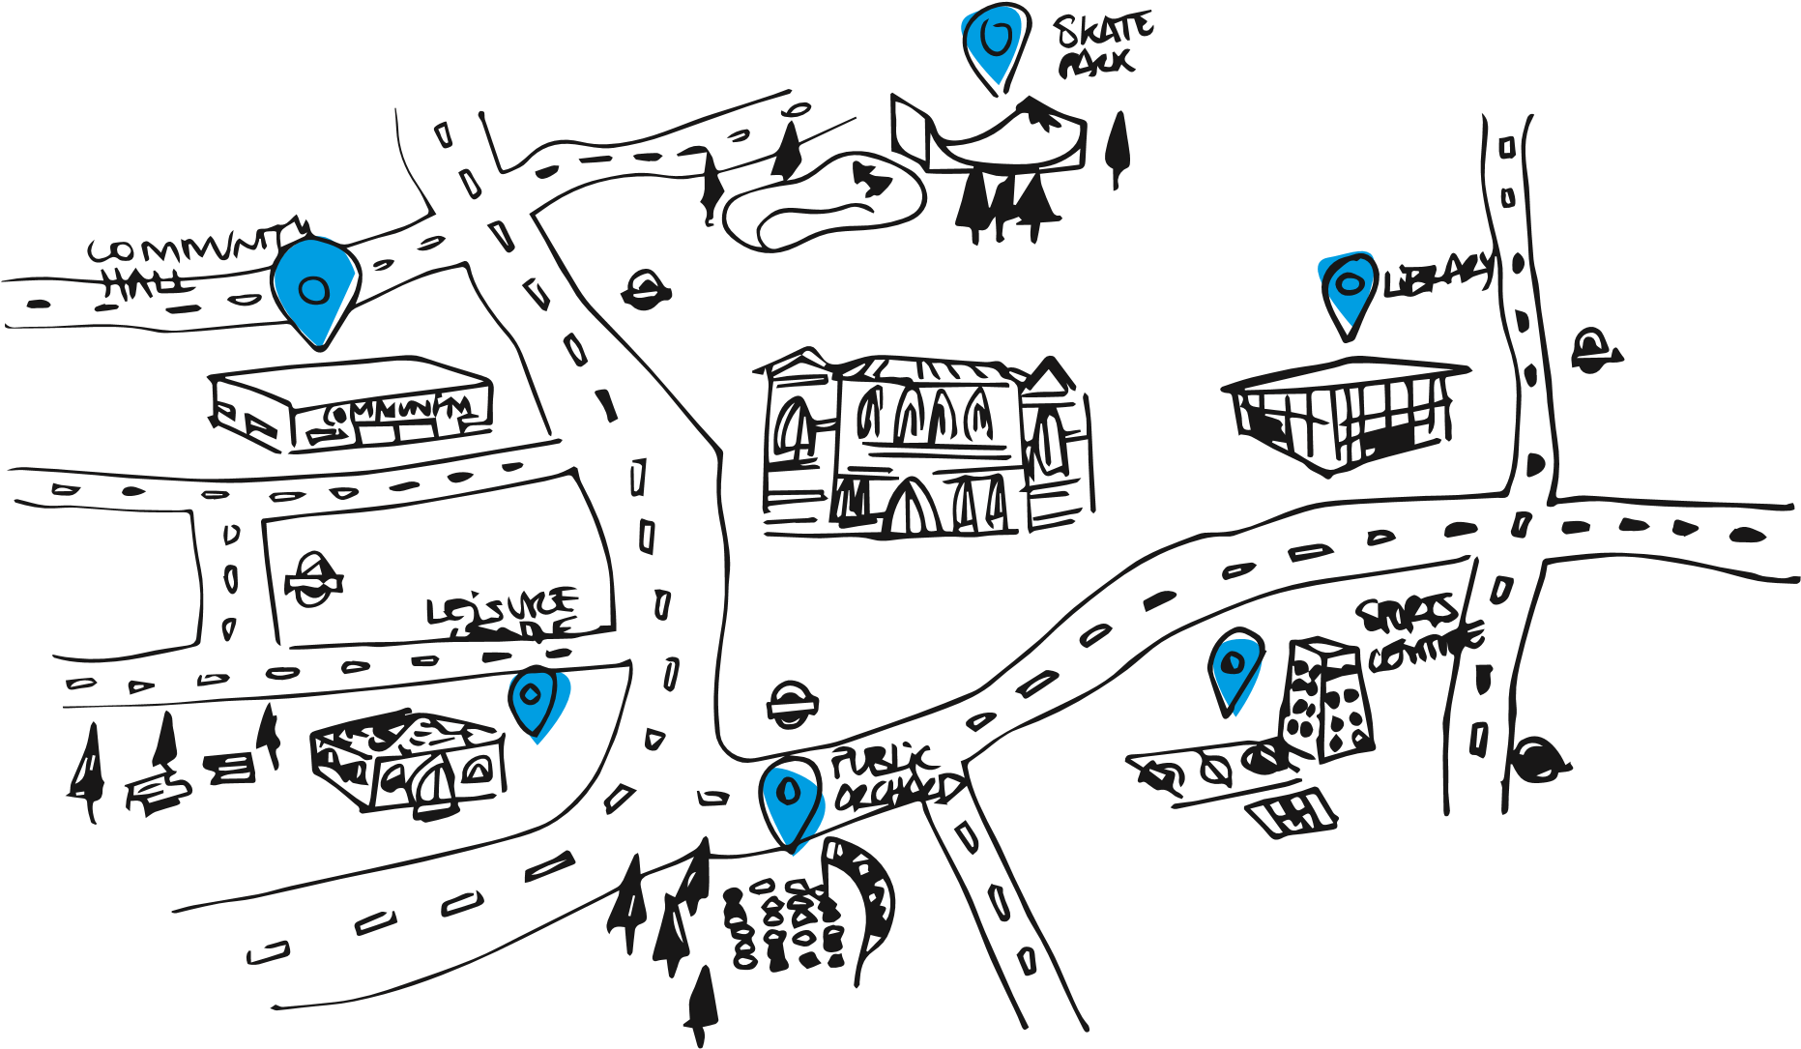

5(&200(1'('1(;767(36

7KHZLGHVWSRVVLEOHGHÀQLWLRQRI¶FRPPXQLW\  DVVHWV·LVUHFRPPHQGHGIRUWKH&$6  &RPPXQLW\JURXSVPDGHLWFOHDUWKDWQRWRQO\  GLGWKH\FRQVLGHUDEURDGUDQJHRIEXLOGLQJV  DVDVVHWVEXWDVVHWVZHUHQRWEXLOGLQJV  DORQH%H\RQGDHVWKHWLFDQGKLVWRULFYDOXH  WKHSULPDU\YDOXHRIEXLOGLQJVDUHWKHVHUYLFH  WKDWDUHUXQIURPWKHPDQGWKHVNLOOVDQG  H[SHULHQFHVJDLQHG7KH&$6QHHGWR  UHFRJQLVHSHRSOHDQGJURXSVZKRSURYLGH  VHUYLFHVDVFRPPXQLW\DVVHWV | 7KLVDOVRH[WHQGVWR%DUQHWHPSOR\HHV,W  ZDVFOHDUIURPUHVLGHQWVWKDW%DUQHWFRXOG  WDNHDPRUH¶FXVWRPHUVHUYLFH·DSSURDFK  WRWKHFRPPXQLW\+DYLQJKLJKO\VNLOOHG  HPSOR\HHVVXSSRUWLQJFRPPXQLWLHVFDQ  GHFUHDVHWKHOLNHOLKRRGRIEXLOGLQJXQGHUXVH  DQGORVWLQFRPH%DUQHWQHHGWRFRQVLGHU  KRZWKH\LQYHVWLQVWDIILQWKHFRXQFLOWR  HQVXUHWKDWWKHDXWKRULW\KDVWKHVNLOOVWRSOD\  DQHQDEOLQJUROHPRUHHIIHFWLYHO\VHH¶UROHV  DQGUHVSRQVLELOLWLHV·
7KHPRUHSHRSOHWHDPVDQGJURXSVDUH LQYHVWHGLQWKHPRUHHIÀFLHQWO\EXLOGLQJVDUH XVHGDQGWKHPRUHOLNHO\%DUQHWZLOOEHDEOH WRPHHWLWVÀQDQFLDOUHVSRQVLELOLWLHVZKLOVW FRQWLQXLQJWRVXSSRUWFRPPXQLWLHV

Objectives and Aims
“We need to move from one party knowing everything and the other needing to ask, to where both parties know what there is to know”

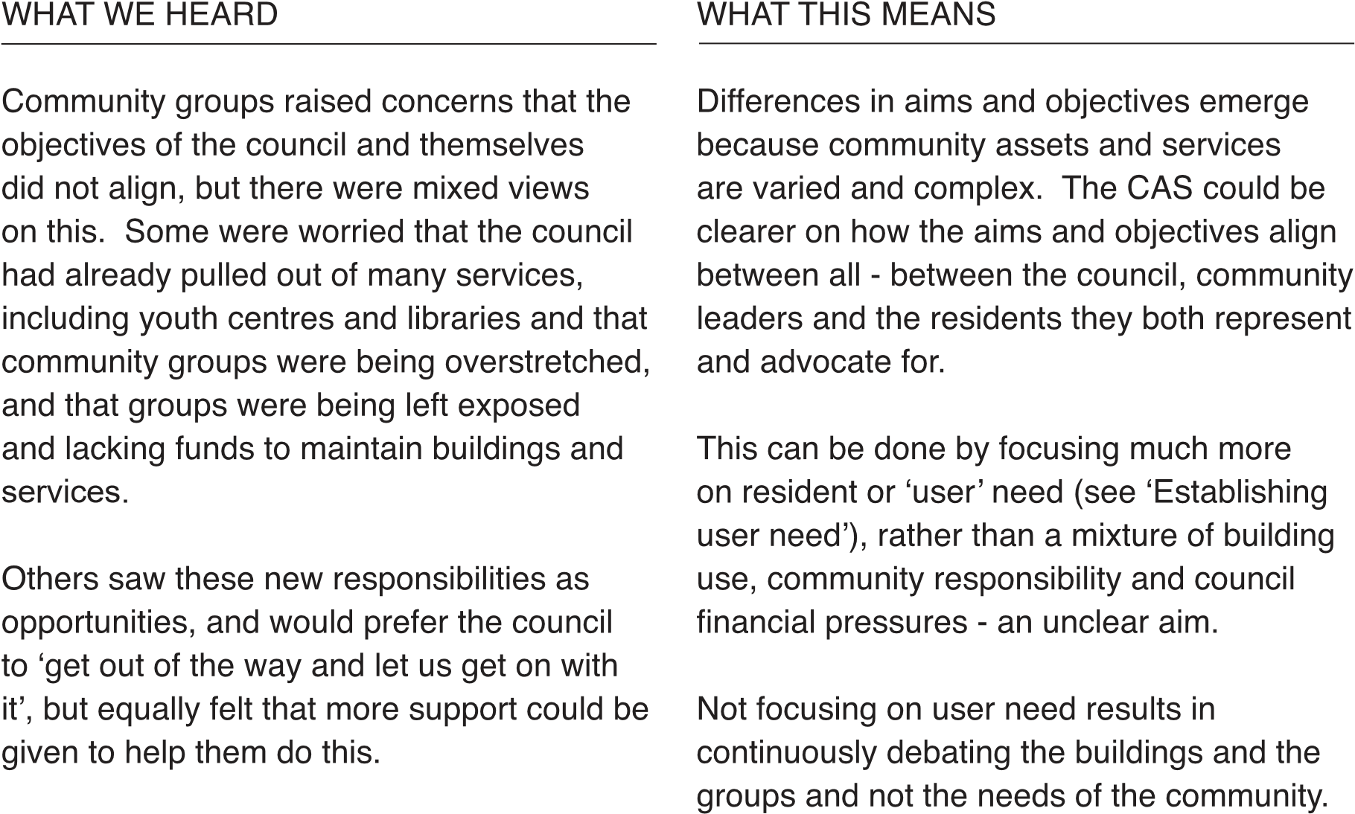


5(&200(1'('1(;767(36

7KDWWKH&$6KDVDQRYHUULGLQJDLPIRFXVLQJ  RQXVHUQHHGV)RUH[DPSOHWKLVFRXOGEH  WRSURYLGHWKHJUHDWHVWUDQJHRIVHUYLFHVWR  WKHJUHDWHVWUDQJHRISHRSOHDWWKHORZHVW  SRVVLEOHFRVWDVDQH[DPSOH2EMHFWLYHV  FDQWKHQÁRZIURPWKLV%DVHGRQWKH  GLVFXVVLRQVZLWKFRPPXQLW\JURXSVWKH\  FRXOGEHWKHIROORZLQJ  7RHQVXUHWKDWWKHFRXQFLODQGFRPPXQLW\  KDYHDJRRGXQGHUVWDQGLQJRIWKHQHHGV  RIDOORI%DUQHW·VUHVLGHQWV | $VWKH&$6PRYHVIURPVWUDWHJ\WRSROLF\  WRGHOLYHU\%DUQHWQHHGVWRHQDEOHDQRSHQ  GLDORJXH7KLVLVDERXWJHWWLQJDGHHSHU  PRUHPHDQLQJIXOXQGHUVWDQGLQJDERXWORFDO  QHHGVHVSHFLDOO\RIWKRVHFXUUHQWO\XQGHU  UHSUHVHQWHG  $VRXWOLQHDERYHWKHFRPPXQLW\KDV  VXJJHVWHGWKDWWKLVRQJRLQJGLDORJXHDQG  GHOLYHU\FDQEHGHOLYHUHGE\DVHUYLFH  IRFXVHGDVVHWWHDPWRVXSSRUW%DUQHW·V
7RVXSSRUWWKHSURYLVLRQRIVHUYLFHVWKDW ¶HQDEOLQJUROH·ZKLFKLQFOXGHVVSHDNLQJZLWK
ZRXOGPHHWWKHVHQHHGV DOOXVHUV7KLVWHDPFDQDOVREHWDVNHGDW
7RHQVXUHWKHÀQDQFLDOVXVWDLQDELOLW\RI LGHQWLI\LQJXQGHUXVHGEXLOGLQJVRUZRUNLQJ
 | WKHVHVHUYLFHVDQGWKHSK\VLFDOVSDFH  IURPZKLFKWKH\RSHUDWH  7RVXSSRUWWUDQVSDUHQF\RSHQQHVV  DQGFROODERUDWLRQZKHQPDNLQJVHUYLFH GHOLYHU\GHFLVLRQV  7KLVFDQLQFOXGHWKHQHHGWRVDYHPRQH\DQG  PDNHWKHXVHRIEXLOGLQJVPRUHHIÀFLHQW  FRPPXQLW\JURXSVDUHDOVRWD[SD\HUV | ZLWKWKHFRPPXQLW\WRFRORFDWH  &XUUHQWO\WKHDLPVDQGREMHFWLYHVDUHQRW  EXLOWDURXQGXVHUQHHGDQGWKHUHLVQRFOHDU  VHQVHWKHWKH&$6LVWKHEHJLQQLQJRID  FRQYHUVDWLRQQRWWKHEHJLQQLQJRIWKHHQG  7KHGDQJHULQQRWWDNLQJDPRUHFRGHVLJQHG LWHUDWLYHDSSURDFKWRDLPVDQGWKHLUGHOLYHU\  ZLOOEHWKDWWKHFRPPXQLW\PD\IHHOWKH\KDYH  OHVVRIDVWDNHLQWKHVWUDWHJ\UHGXFLQJWKH  DELOLW\WRGHOLYHURQLW
Establishing user need  $VNLQJDERXWWKHQHHGVRIUHVLGHQWVERWK  ZKRWKRVHZKRFXUUHQWO\UHFHLYHVHUYLFHVDQG  WKRVHZKRPD\EHQHÀWIURPWKHPLVFUXFLDOLI  %DUQHWLVWRJHWWKHPRVWIURPLW·VDVVHWV  )RUH[DPSOHDIRFXVRQWKHSURYLVLRQRI  OLEUDU\VHUYLFHVDQGEXLOGLQJVWDNHVDZD\  WKHIRFXVRQWKHLUEHQHÀWDQGXVH7KLV  ZRXOGLQFOXGHSURYLGLQJZDUPSODFHVWR PHHWDIDFLOLW\IRUERUURZLQJERRNVLQWHUQHW connections etc. |  |  | 2OGHUDQGPRUHLVRODWHGSHRSOHKDYHD  JUHDWHUQHHGIRUZDUPHUSODFHVWRPHHW  VWXGHQWVQHHGERRNVPRVWWKHFRPPXQLW\  QHHGVJRRGZLÀ  ,QVSLUDWLRQSURYLGHGIXUWKHUEHORZORRNVDW  KRZDSKRQHER[VKDSHGOLEUDU\EULQJVERRNV  WRSHRSOH7KLVSULPDULO\PHHWVWKHQHHG  IRUERRNVLQDUHDVWKDWGRQ·WKDYHWKHPEXW  GRHVQRWPHHWDQHHGIRUZDUPVSDFHRUWKH internet.
Co-Location
Governance Principles
CAS, SECTION 6.0

:+$7:(+($5'

&RPPXQLW\JURXSVZHUHGLYLGHGRQWKHLGHD RIFRORFDWLRQ7KHIROORZLQJUHVHUYDWLRQV DQGRSSRUWXQLWLHVVKRXOGEHFRQVLGHUHG ZLWKLQWKH&$6 6RPHDVVHWVGRQRWKDYHWKHÁH[LELOLW\RI FRORFDWLRQ(JVSRUWVIDFLOLWLHVVXFKDV FULFNHWSLWFKHVRUER[LQJULQJV 6KDULQJWKHEXUGHQ6RPHJURXSV HVSHFLDOO\WKRVHZKRDFWHGDVODQGORUGV KDGUHVHUYDWLRQVDERXWVKDULQJWKHLU DVVHWVZLWKJURXSVZKRGLGQ·WKDYHWKH VDPHUHVSRQVLELOLW\
“We run different groups, early years in the morning, scouts in the evening. We’re full all day, every day. It works”

2FWRSXVLVDQHWZRUNRI
FRPPXQLW\KXEVLQ,VOLQJWRQ

ZKHUHFRPPXQLW\VKDUH UHVRXUFHVWRLPSURYHORFDO services. RFWRSXVFRPPXQLWLHVRUJXN
“Instead of trying to merge places together the council should think: How might we support and help transform this place into a vibrant valuable place that bring more people together”

:+$77+,60($165(&200(1'(' 1(;767(36

&RGHVLJQFRORFDWHGVSDFHVRYHUWKH ORQJHUWHUPWRVHHKRZWKH\ZRXOG EHVWZRUNLQHDFKORFDWLRQLQFOXGLQJ WKHGHVLJQRIWKHVSDFHWKHPRGHORI JRYHUQDQFHWKHXVDJHRIWKHIDFLOLWLHV 0DQ\H[DPSOHVRIFRORFDWLRQH[LVWDQG DUHEXLOGDURXQGFRPSOHPHQWDU\XVHU QHHGVVXFKDV


'HVLJQ)DFWRU\LVD
FRPPXQLW\VSDFH
LQVLGH$DOWRXQLYHUVLW\

&ROODERUDWLRQEHWZHHQORFDO FRPPXQLW\VWXGHQWVDQG
ORFDOHQWUHSUHQHXUV
DDOWRGHVLJQIDFWRU\À

Map the assets
,IWKHFRXQFLOFUHDWHGDQDVVHWPDSLGHDOO\  RQOLQHFRPPXQLW\JURXSVFRXOGZRUN  DPRQJVWWKHPVHOYHVWRZRUNRXWKRZEHVWWR  XVHWKHVHDVVHWVIQFOXGLQJDYDLODELOLW\OHDVH  OHQJWKFRVWVDQGFXUUHQWXVH  7KLVZD\LWFRXOGHQDEOHWKH&RXQFLODQG  HYHU\VWDNHKROGHUWRQRWRQO\WRXQGHUVWDQG  KRZWRPDWFKWRJHWKHUGHPDQGDQGVXSSO\ | LQDVPDUWHUDQGPRUHHIÀFLHQWZD\EXWDW  WKHVDPHWLPHLWZRXOGPDNHWKHVHUYLFHV  DYDLODEOHLQWKHFRPPXQLW\PRUHYLVLEOH  DQGDFFHVVLEOHWRWKHUHVLGHQWV9&6  RUJDQLVDWLRQVDQGWKH&RXQFLO+HOSLQJWKHP  WRPDNHPRUHLQIRUPHGDQGPRUHHIÀFLHQW  GHFLVLRQVDURXQGFRPPXQLW\DVVHWV
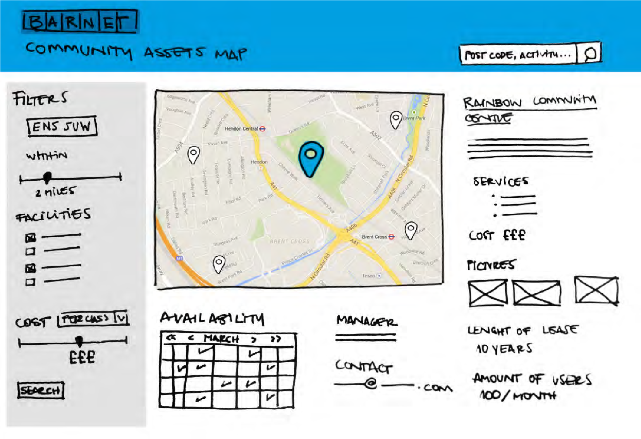
“We can’t create valuable collaborations if we don’t know what other organisations are out there and what they are doing”
Leases and Occupation -
A great customer service
experience

:+$7:(+($5'

&RPPXQLW\JURXSVZHUHQRWFOHDUZKDW VXSSRUWWKHFRXQFLOLQWHQGVWRSURYLGHEXW JHQHUDOO\WKRXJKWLWZDVLQFRQVLVWHQW6RPH JURXSVIHOWFRPPXQLFDWLRQDQGVXSSRUW ZDVYHU\SRRURWKHUVKDGVRPHJRRG H[SHULHQFHVZLWKFRXQFLOVWDIIDQGIHOWWKH DGYLFHZDVJRRG
“It’s common to be in a vicious cycle of not having funding, because you have no space, because you have no funding”
5(&200(1'('1(;767(36*5($7
&86720(56(59,&(

$VSDUWRIWKLVFRQVXOWDWLRQWKHIROORZLQJ DUHDVZRXOGEHZRUWKIRFXVLQJRQ *HWWLQJWKHEDVLFVULJKW(PDLOVZHUHQ·W DOZD\VUHVSRQGHGWRRIÀFHUVGLIÀFXOW WRFDOOLQIRUPDWLRQLQFRQVLVWHQWDQGQRW DOZD\VFOHDUUHJXODUVWDIIWXUQRYHU +RZFDQWKHFRXQFLOEHWWHUVXSSRUW WKH9&6ÀQGLQJDOWHUQDWLYHVRXUFHVRI IXQGLQJ /LQNLQJOHDVHUHQHZDOVWRUROHVDQG UHVSRQVLELOLWLHVVHH¶VXSSRUWLQJ FRPPXQLW\JURXSV·

“I’m new to the borough, but have found the council really helpful”

7KHUDQJHRIH[SHULHQFHDQGIDFWRUVDIIHFWLQJ WKHVWDWHRIOHDVHVPHDQVWKDWWKDWWKH SULPDU\UHFRPPHQGDWLRQLVWRIRFXVRQ JHWWLQJDJRRGEDVLFVWDQGDUGRIFXVWRPHU VHUYLFHSURYLVLRQ$FRPPRQIUXVWUDWLRQIURP FRPPXQLW\OHDGHUVZDVWKHLQFRQVLVWHQW VWDQGDUGVLQFRPPXQLFDWLRQWKHODFNRID QDPHGVWDIIPHPEHURUFRQÁLFWLQJDGYLFH 7KHUHDUHDQXPEHURIUHDVRQVZK\OHDVHV DUHQRWUHQHZHGEXWFRPPXQLFDWLRQQHHGV WREHFOHDUHUDQGGHFLVLRQVPRUHWUDQVSDUHQW
“when I look to lease something in the private sector there is a whole range of data available to help me make a good decision. The council don’t share any of that data”


$SSOH6XSSRUW&RPPXQLW\LV DQRSHQIRUXPZKLFKHQDEOHV SHRSOHWRVKDUHWKHLUGRXEWV DQGFRQFHUQZLWKWKHUHVWRI WKHFRPPXQLW\ZKLFKFUHDWHV
DZDUHQHVVDERXWWKHPRVW
UHFXUUHQWLVVXHVDQGDWWKH
VDPHWLPHFRQQHFWVXVHUV
WRKHOSHDFKRWKHUVROYH

SUREOHPV
KWWSVGLVFXVVLRQVDSSOH
FRPZHOFRPH
Supporting community groups - creating mutual benefit
&$66(&7,21
:+$7:(+($5'

:RUNVKRSDWWHQGHHVIHOWWKDWLI%DUQHWGLG QRWIXOO\XQGHUVWDQGZKDWYDOXHZDVEHLQJ EURXJKWE\HDFKLQGLYLGXDOFRPPXQLW\ JURXSZKDWVXFFHVVORRNHGOLNHDQG ZKHWKHUFRPPXQLW\JURXSVZHUHSHUFHLYHG DVEHLQJ¶VXFFHVVIXO·
“We need to redefine the relationship between the Council and the communities, today is extremely difficult to get things done or even have “We’re not just a football club, we are also providing a place for people to come together around something they love, which effectively addresses social isolation”

7KLVFUHDWHGXQHDVHDPRQJVWWKHJURXSV DQGVRPHIHOWDIHDUWKDWWKHLUVHUYLFHV FRXOGEHFORVHGDWDQ\SRLQWUDWKHUWKDQ EHLQJVXSSRUWHGWRUHPDLQRSHQ
access to information, there are too many intermediaries”
:+$77+,60($16

3URSRVLQJFULWHULDDJDLQVW¶WKHFRXQFLO·V VWUDWHJLFSULRULWLHV·¶GHÀQHGORFDOQHHG·DQG ¶DGGLWLRQDOYDOXH·LVSUREDEO\WRREURDG,WFDQ EHDSSOLHGWRDOPRVWDQ\JURXSRUVHUYLFH DUHD7KLVLVHVSHFLDOO\GLIÀFXOWWRGHÀQHDV FRPPXQLW\HQJDJHPHQWRIWHQKDSSHQVLQ
DQ¶HDUO\LQWHUYHQWLRQ·VSDFHFRQVLVWHQWO\ WULFN\WRPHDVXUHDQGXOWLPDWHO\SULFHDJDLQVW costs.
%DUQHWQHHGWRWDNHDOHDGRQEHWWHUGHÀQLQJ  WKHUROHVDQGUHVSRQVLELOLWLHVRIERWKWKH  FRXQFLODQGFRPPXQLW\OHDGHUV%RWKKDYH  DUHVSRQVLELOLW\WRWKHLUFRPPXQLWLHVKDYH  FRPSHWLQJSUHVVXUHVRQWKHLUÀQDQFHVDQG  GHOLYHUVHUYLFHVXQGHULQFUHDVLQJFRPSOH[LW\  &RPPXQLW\JURXSVZHUHFOHDUWKDWPRUH  GHÀQHGUHODWLRQVKLSVZRXOGKHOSFXWWKURXJK  VRPHRIWKLVFRPSOH[LW\  %DUQHW·V&RUSRUDWH3URSHUW\'HSDUWPHQW  DUHWKHSULPDU\WHDPZKLFKLQWHUDFWZLWK  FRPPXQLW\JURXSVWKHLUUHODWLRQVKLSZLWK  XVHUVLVDNH\GULYHURIRYHUDOOVDWLVIDFWLRQ  ZLWK%DUQHW&RXQFLO$WHDPZLWKDJUHDWHU  UDQJHRIVNLOOVDQGUHVSRQVLELOLWLHVFRXOG  HQVXUHWKDWDVVHWVDUHPRUHHIÀFLHQWO\  PDQDJHGDQGWKHUHODWLRQVKLSZLWK  FRPPXQLW\JURXSVLPSURYHG | 7KLVPRUHURXQGHGWHDPZLOOQHHGWRDGRSW  DPXFKPRUHFXVWRPHUIRFXVHGDSSURDFK  LI%DUQHWLVWRVXFFHVVIXOO\HQDEOHWKH  FRPPXQLW\WREHFRPHPRUHLQGHSHQGHQW  7RHQKDQFHWKHUHODWLRQVKLS%DUQHWQHHGWR  DOORZWKHFRPPXQLW\WRIHHGEDFNDQGKHOS  LPSURYHWKH¶HQDEOLQJ·UROHRIWKHFRXQFLO  7KHUHQHHGRQO\EHWZRNH\FULWHULD  6DWLVIDFWLRQZLWKVXSSRUWSURYLGHG  %XGJHWSRVLWLRQ  %HFDXVHHDFKFDVHLVOLNHO\WREHGLIIHUHQW  WKHUHDVRQVEHKLQGXVHUVDWLVIDFWLRQZLOOEH  GLIIHUHQWEXWFUHDWLQJWUDQVSDUHQF\DQGWUXVW  DQGEHWWHUFXVWRPHUVHUYLFHZLOOUHGXFH  FRVWVDQGFUHDWHDPRUHHQDEOHGFRPPXQLW\

5(&200(1'('1(;767(36

%$51(7·652/((1$%/,1*7+( &20081,7<

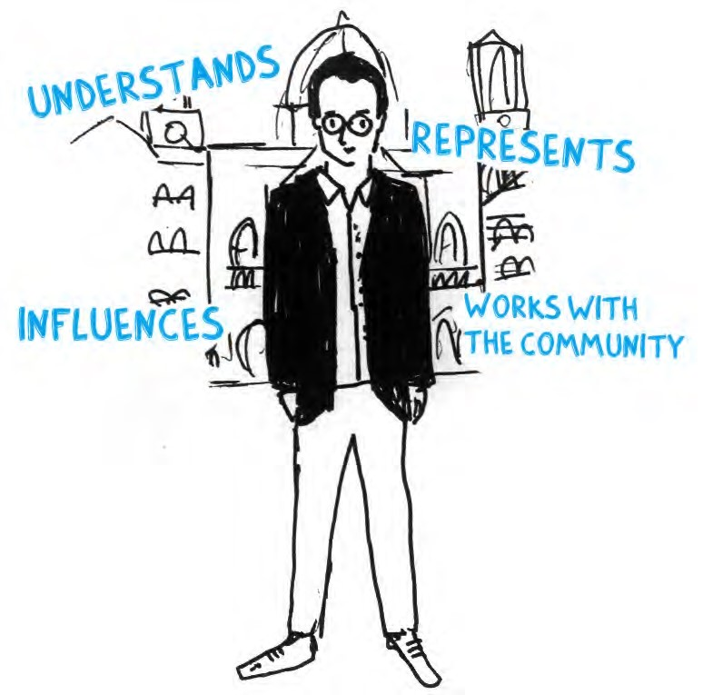
7RSOD\DPRUHHIIHFWLYH¶HQDEOLQJ·UROH%DUQHW QHHGWRFRQVLGHUWKHIROORZLQJVNLOOVHWV :RUNZLWKWKH9&6WRGHÀQHWKHFULWHULD 8QGHUVWDQGWKHFKDOOHQJHVIDFHGZLWKLQ %DUQHW·VPDQ\FRPPXQLWLHV 8QGHUVWDQGWKHEXGJHWFKDOOHQJHVRIWKH FRXQFLODQGWKHLPSDFWRQVHUYLFHVDQG assets 8QGHUVWDQGKRZDVVHWVDUHUXQGHDOZLWK OHDVHVPDLQWHQDQFHUHQWHWF +DYHDQRYHUVLJKWRIWKHVHUYLFHV GHOLYHUHGE\ERWKWKHFRXQFLODQG WKHFRPPXQLW\DFURVVWKHERURXJK FRPPLVVLRQLQJSULRULWLHVDQGIUDPHZRUNV DQGZKHUHWKHUHDUHVHUYLFHJDSV ,QÁXHQFHWRPDNHGHFLVLRQVZLWKLQWKH FRXQFLO

7+(&20081,7<52/(%8,/',1* 3529,6,21
(TXDOO\9&6JURXSVZKRYDU\KXJHO\LQ  VL]HSURYLVLRQUHODWLRQVKLSZLWKWKHFRXQFLO  DQGVRXUFHVRILQFRPHZLOOQHHGWRZRUN  ZLWK%DUQHWWRPRUHFOHDUO\GHÀQHWKHYDOXH  WKH\EULQJDQGKRZWKLVFDQEHHQKDQFHG  &ULWHULDQHHGWREH60$576SHFLÀF | ,QFRPELQDWLRQWKHVHPRUHFOHDUO\GHÀQHG  UROHVDQGUHVSRQVLELOLWLHV  :LOOSURYLGHWKH9&6ZLWKFOHDUO\  GHÀQHGPHWULFVWRVHHNÀQDQFLDO VXSSRUWIURPWKHFRXQFLODQGH[WHUQDO organisations

0HDVXUDEOH$FKLHYDEOH5HDOLVWLFDQG7LPH0DNHWKHFRXQFLODFFRXQWDEOHWRWKH &RQVWUDLQHG&ULWHULDFRXOGLQFOXGHFRPPXQLW\ /HYHORIXVHKRXUVRFFXSLHGQXPEHUVRI 0DNHWKH9&6DFFRXQWDEOHWRWKH XVHUVUDQJHRIDFWLYLWLHVDQGVWHSVWDNHQFRXQFLODQGWKHFRPPXQLW\ WREXLOGSURYLVLRQ$OORZWKHFRXQFLOWRPDNHZHOO $PRXQWRIYROXQWDU\KRXUVSHRSOH LQIRUPHGVWUDWHJLFDVVHWPDQDJHPHQW GHGLFDWHG DQGVHUYLFHSURYLVLRQGHFLVLRQV 1XPEHURIDOWHUQDWLYHVZLWKLQDFHUWDLQ 6XSSRUWVPRUHHIIHFWLYHDVVHWVDOHV GLVWDQFH DQGSXUFKDVHVDVZHOODVFRPPXQLW\ 2SSRUWXQLW\FRVW ULJKWWRELGDQG¶SODQQLQJJDLQ· 8VHUVDWLVIDFWLRQ GHFLVLRQV
“The relationship is currently very paternalistic, it needs to be redefined to be more peer to peer The relationship needs to be redefined to be more peer to peer”

Getting inspired
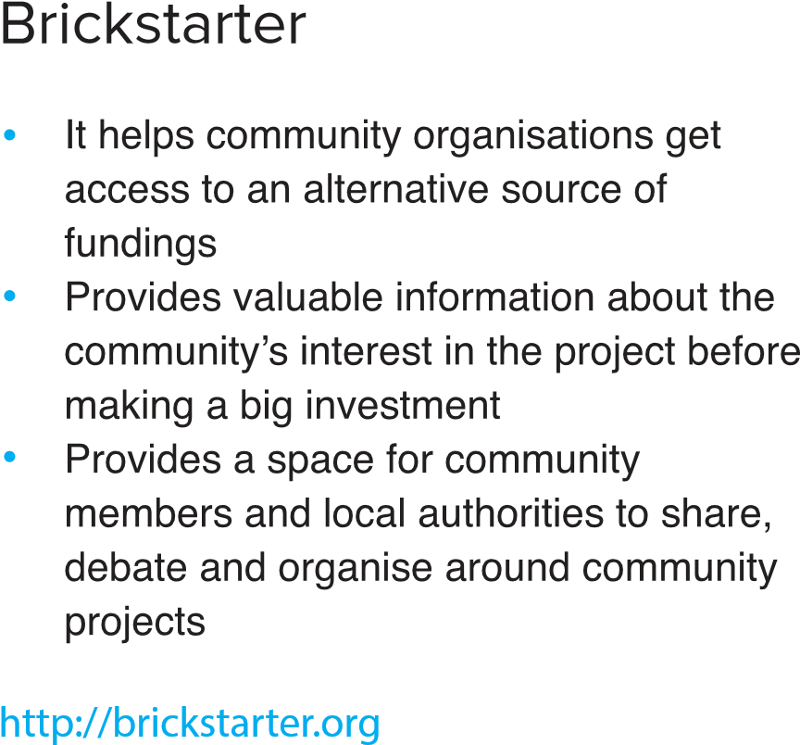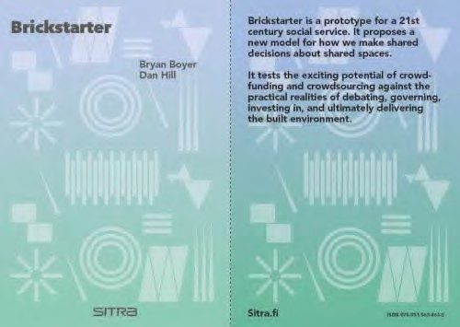
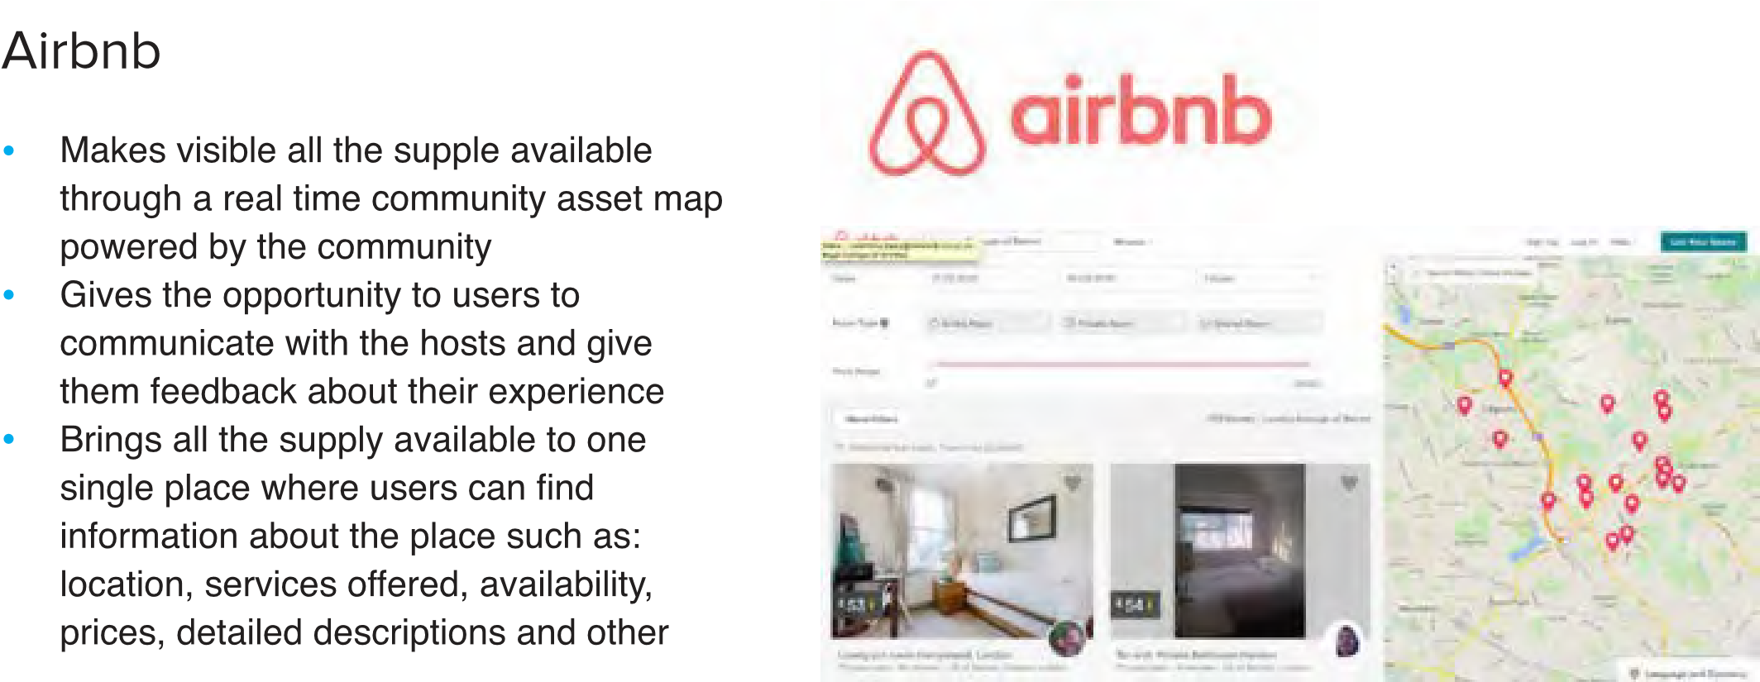
users opinions
Getting inspired
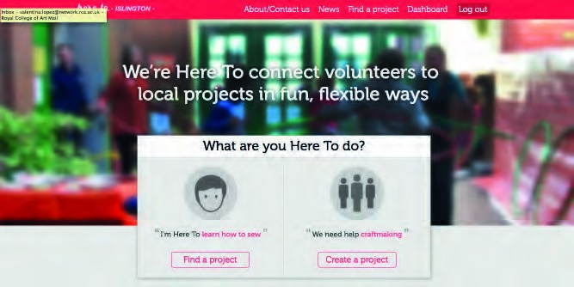

Here To

0DNHVLWHDV\IRUFRPPXQLW\ RUJDQLVDWLRQVYROXQWHHUVDQGXVHUVWR ÀQGDQGFRQQHFWZLWKHDFKRWKHULQDQ K\SHUORFDOOHYHO 0DNHVYLVLEOHIRUHYHU\RQHRWKHU LQLWLDWLYHVLQWKHFRPPXQLW\ http://islington.hereto.org
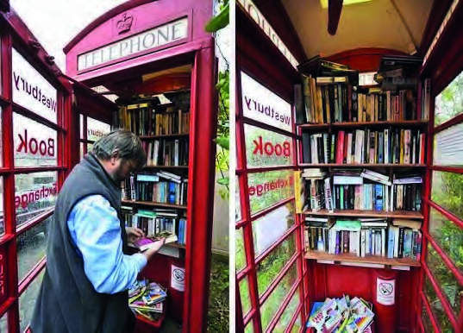
Phone Box Library

5HSXUSRVHVDQREVROHWH\HWYHU\LFRQLF SXEOLFVSDFH $OORZVSHRSOHWRVKDUHWKHLUERRNVDQG get books for free $WWUDFWLYHZD\RIHQJDJLQJSHRSOHLQ UHDGLQJIUHHRQWKHZD\DQGLW·VIXQ
http://www.bbc.co.uk/news/uk-englandlondon-26734859

OpenCloset
*LYHVWKHRSSRUWXQLW\WRSHRSOHZKRGRQ·W KDYHVSDFHLQWKHLUKRPHWRKDYHDIUHH VWRUDJHURRPIRUFORWKHVZKLFKWKH\FDQ DOVRGRQDWH$WWKHVDPHWLPHJLYHVWKHFKDQFHWR XQHPSOR\HGSHRSOHWKHFKDQFHWRERUURZ QLFHUFORWKHVWRJRWRMRELQWHUYLHZV 7KHFRPPXQLW\FDQDOVRVKDUHVNLOOV OLNHWHDFKLQJKRZWRSUHSDUHD&9RUDQ interview https://theopencloset.net

In Summary

Give Community Assets a broad definition
Focus objectives on user need Get the basics right with good customer service
Build capacity over the longer term for an
‘enabling’ role
Continue to work with the broader community to better match needs with services including the potential for hubs

Appendix 3 – A sample Lease Agreement

The precise details of any lease will depend on a range of factors. However, the sample below indicates the areas that all leases must cover.
Example of Best Practice Lease(s)
Basic Heads of Terms for Community Occupiers

The Parties
Landlord; London Borough of Barnet or relevant entity that will enter into the lease.
Code of Leasing Practice; Confirmation that LBB adhere to the Code of Leasing Practice.
Tenant; Clear statement as to occupying entity, correspondence address, ownership structure and financial details.

The Property
The Demise; A correct postal address for the property and plan where available. A clear description of the area to be occupied.
Floor areas; A description in feet and metres of the area to e occupied and confirmation that the demise has been measured in accordance with the latest edition of the RICS code of measuring practice.
Ancillary areas; Details of the ancillary areas or facilities from which the occupier may benefit such as bike storage or car parking spaces.

The Lease/Licence or other instrument
Occupational document; Clear statement as Head Lease/Sub-Lease/Assignment/Licence or other instrument.
Term; A clear statement regarding the term and commencement date.
Break provisions; A clear statement regarding break clauses if relevant.
Rent; A clear statement regarding the initial rent either o he basis that the property is occupied in its present condition or on the basis that LBB refurbishes to an agreed standard.
Rent Free period; A clear statement as to any rent free period and the precise date upon which rent will accrue following expiry.
Rent Reviews; A clear statement regarding the rent review periods and the basis upon which rentals will be increased.
Occupational Rates; The current rateable value and rates payable along with a statement as to whether or not the RV has been appealed.
Repairing Obligations; The repairing clause will clearly state the extent of the occupiers liability and whether internal or external and on full repairing and ensuring terms. In addition the extent of any liability for common parts.
Community Asset Strategy – June 2015 Page 46


Estate and Service Charges; An estimate as to service charge levels, if appropriate and the proposed apportionment for buildings in multi occupation.
Utilities; Confirmation of responsibilities in relation to the payment of utilities for both the main demise and any common parts.
LBB Landlords areas; A statement regarding those areas for which LBB/The landlord retains responsibility.
Future LBB/ Landlords works; A description regarding any planned or anticipated works by LBB.
Insurance; Confirmation regarding who retains primary responsibility for insuring the building and the commercial risks to be covered.
VAT; Confirmation as to whether or not the building has been elected for VAT.
User; A clear statement regarding the permitted use.
Access; A clear statement regarding the hours/regularity of access.
Shared use; A clear statement regarding both current shared use and the potential for shared use at some future date.
Alteration; Not to effect any alterations without the consent of LBB/The landlord save for minor non structural internal works.
Alienation; An absolute bar against assignment except with the prior written consent of LBB or the landlord.
LBB Subsidy; A clear statement as to the level of proposed subsidy, if any, and the time period during which any subsidy will apply.
Legal and Professional costs; A statement regarding who will bear responsibility for fees.
Conditions; A statement as to the conditions of the Heads of Terms including, but not limited to;
- Contract
- Formal LBB approval
- Funding
- Subject to Survey.

Community Asset Strategy – June 2015 Page 47

http://barnet.moderngov.co.uk/documents/s19827/Appendix%201%20%20Strategic%20Asset%20Management%20Plan.pdf
Libraries run directly by the Council are not included in the scope of this strategy as there is a separate approach for these

