

Barnet Community Safety Strategy
Putting the Community First
2015/2020
Final Version

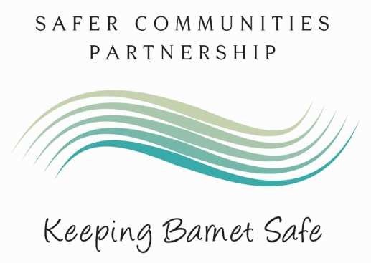

Contents

Barnet Community Safety Strategy (Introduction) 3
Signatories to the Strategy 4
Barnet, one of London’s Safest Boroughs 5 -7
Community Safety Strategy 2011/2014 Achievements 8
2015-2020 Strategic Objectives 9 -29
Delivering the plan 30
Glossary 31

Barnet Community Safety Strategy

The Barnet Safer Communities Partnership (BSCP) brings together agencies involved in crime prevention and community safety. It includes Barnet Council, the Metropolitan Police, Fire Service, the Probation Service, Public Health, Victim Support, Community Barnet, Middlesex University and the Safer Neighbourhood Board. Our aim is that everyone who lives or works in, or visits Barnet will feel and be safe. Barnet is one of London’s safest boroughs in which to live and work. Since 2005 overall crime has fallen by over 25%, and there have been significant reductions in the number of burglaries and robberies.

Barnet Community Safety Strategy 2015-2020

This document outlines how Barnet Safer Communities Partnership will work together to reduce crime, the fear of crime and help ensure Barnet remains one of London’s safest boroughs. The strategy outlines the objectives and outcomes that the Safer Communities Partnership Board will focus on over the next five years. The outcomes have been identified through considering the findings of a detailed assessment of crime and anti-social behaviour trends and a consultation with the people of Barnet conducted from July to October 2014. The consultation included public meetings, an online survey as well as workshops and information stalls across the borough.

BSCP’s Mission:

Our goal is to ensure Barnet remains one of the safest boroughs in London. We will accomplish this by working with the community, local business and our partners. Our strategy will focus on supporting victims of crime, managing offenders to reduce their offending and directing partnership resources to the high crime and ASB areas in the borough. This strategy is underpinned by a commitment to: reduce crime; reduce the fear of crime; and especially working to support the most vulnerable in the community from the fear of crime and anti-social behaviour. Domestic Violence and Violence against Women and Girls will remain one of the key strategic priorities for the Partnership.

Councillor David Longstaff
Community Leadership Committee Chair
Chair of Barnet Safer Communities Partnership Board

Signatories to the Strategy

Statutory organisations
Barnet Safer Community  Partnership Board | Councillor David Longstaff  Chairman
Metropolitan Police | Adrian Usher  Chief Superintendent- Barnet
Barnet Council | Andrew Travers  Chief Executive
London Community  Rehabilitation Company | Cassie Newman  Assistant Chief Officer
National Probation Service | Sam Denman  Assistant Chief Officer
London Fire Brigade | Steve Leader Commander - Barnet
Public Health | TBC
Department for Work and Pensions | Terry Cameron
Invited members
Mayor’s Office for Policing and  Crime (MOPAC) | TBC
Chairman  Barnet SNB | Roger Kemp
Middlesex University | Dr Simon Harding
North West  London Magistrates Court | Tim Harris
CommUnity  Barnet | Julie Pal
Victim Support | Caroline Birkett

Barnet, one of London’s Safest Boroughs

Demographics
Barnet is a vibrant and culturally rich borough, home to a growing and diverse population. With a 2011 population of over 350,000 Barnet is the second most populous borough in London. Barnet comprises of 20 town centres, green belt areas and a significant proportion of densely populated suburban areas. Barnet’s transport infrastructure means that the borough is highly connected with other parts of London and the UK.

Over the next ten to fifteen years there will be further growth in the borough’s elderly population. Major developments will also be taking place which will see significant population growth in new and improved neighbourhoods and significant investment in supporting facilities and infrastructure.

Falling Crime Rates

In 2014, reduced offending translated into less crime and fewer residents of Barnet becoming victims of crime. Based on the 12 months to 25 February 2014 compared to the 2011/12 baseline, in 2014 there were:

- 865 fewer victims of Burglary.
- 603 fewer victims of Theft from Motor Vehicle.
- 462 fewer victims of Criminal Damage.
- 452 fewer victims of Robbery.
- 191 fewer victims of Theft of Motor Vehicle.
- 74 more victims of Theft from Person.

Catching More Offenders

The ‘Sanction Detection Rate’ is a measure which indicates the proportion of crimes which the police are ‘solving’. A high Sanction Detection Rate implies that the police are being effective in identifying and catching the perpetrators of crime. Barnet’s Sanction Detection Rate for Residential Burglary (19.7%) is the highest of all 32 London boroughs.

Strong Community Confidence in the Police and Council

During the last two years over 5,000 responses have been received from residents who have taken part in consultation surveys focused on (or with some relevance to) crime and community safety. The results reflect that:
- Overall community confidence in the police and local authority in Barnet is strong and most indicators show this improving over the last year.
- Confidence in policing is above the London average.
- Community cohesion remains strong.

A Vibrant Voluntary and Community Sector

The borough benefits from the skills and expertise of an active and effective voluntary and community sector. More than 1,000 voluntary and community groups provide vital activities and services, create local job opportunities and enrich lives in Barnet. The Safer Communities Partnership works together with and commissions voluntary and community sector partners to reduce crime. For example:
- Barnet Boroughwatch has over 650 active Neighbourhood Watch groups in the borough – they work with partners and the community to reduce the fear of crime, deliver prevention advice and support crime reduction initiatives.
- Victim Support provides free emotional support and practical help for victims of crime and has been commissioned by the Partnership to deliver the borough’s Restorative Justice Scheme.
- Home Start delivers the borough’s Community Coaches project, providing mentoring to families and individuals to help them develop life skills encouraging more stable lifestyles, reduce truancy, anti-social behaviour and homelessness.
- The Westminster Drugs Project in Barnet is helping people recover from drug and alcohol dependency.

The Future

Barnet has a low crime rate and over the last two years further reductions in crime have been achieved. However, according to the Resident’s Perception Survey (2014) crime remains one of the top three concerns for people who live in Barnet.

With the council and the wider public sector facing the challenge of declining funding from central government it is becoming ever more crucial that Barnet Council, Barnet Police, the Safer Community partners and the voluntary and community sector work together effectively, efficiently and imaginatively to help ensure that Barnet remains one of London’s safest boroughs. The public consultations on community safety, the most recent being carried out between July and October 2014, have highlighted the importance of:

- Supporting victims of crime and anti-social behaviour.
- Tackling repeat, persistent anti-social behaviour victimisation.
- Focusing on hotspots and repeat locations of crime and anti-social behaviour.
- Focusing on repeat offenders.
- Tackling concerns about rubbish and litter.
- Communicating and engaging effectively: this means providing clear information and pathways so people know exactly how and who they can report their issues to; listening to and acting on concerns in a coordinated way; feeding back to the community about what is being done to address concerns; and ensuring the right support is in place.
- Reducing under-reporting of Hate Crime and hidden harm issues such as Domestic Violence, Violence against Women and Girls and Hate Crimes relating to race hate, disability, faith, gender or sexual orientation.
- Preventing burglary and securing convictions for burglary offences.
- Youth Crime Reduction – as part of addressing adult and children safeguarding, the Partnership will focus on keeping young people safe, preventing them from being victims and/or offenders of crime, especially for the more serious offending.

The Partnership

The Barnet Safer Communities Partnership will continue to promote and develop the six principles of effective partnership working:

- Empowered effective leadership.
- Visible and constructive accountability.
- Intelligence-led business approach.
- Effective and responsive delivery structures.
- Engaged communities.
- Appropriate skills and knowledge.

Through the application of these general principles the Partnership will always strive to commission and coordinate resources in the most effective way to meet our aim that everyone who lives or works in, or visits Barnet will feel and be safe.

The SCPB will work in coordination with the Mayor’s Office for Policing and Crime (MOPAC) which sets the strategic direction for policing in London. Barnet SCPB will ensure its community safety initiatives support the strategic direction set out by MOPAC.

The key priorities for London that MOPAC has identified are - strengthening the Metropolitan Police and reviewing focus on street policing, giving victims a greater voice, making London safer for women, developing smarter solutions to alcohol and drug crime, helping London’s vulnerable young people and tackling business crime.

Community Safety Strategy 2011/2014 Achievements

Priority 08/11 | What we have been doing | Results
Property crime with special focus on burglary | - Dismantling criminal networks  - Improving our offender management  - Catching more burglars – Barnet police have a high  ‘Sanction Detection’ rate for burglary | 865 fewer  Burglary victims per year
Anti-social behaviour  (ASB) | - Co-ordinating Multi Agency Problem Solving Groups to tackle long-term ASB problems  - Closing down squats and illegal encampments linked to crime and ASB | 12.7%  reduction in ASB calls  5
Violent crime with specific focus on  Domestic  Violence (DV) | - Concerted efforts to tackle under-reporting and capture the best evidence at scene of crimes  - Supporting high risk victims of domestic abuse through DV services as well as safety plans created at the DV Multi-Agency Risk Assessment Case  Conference | 55.7%  Sanction  Detection Rate  for DV
Improving integrated offender management  (IOM) | • Co-locating police, probation, Job Centre Plus and re-settlement officers in the IOM, Reducing offending by those on the IOM programme (which is translating into less crime and fewer people becoming victims of crime in Barnet) | 36% average reduction in monthly  7 conviction rates
Broader costeffective early  intervention | - Delivering the Troubled Families Programme which aims to turn around the lives of families who have multiple complex needs  - Established the Multi Agency Safeguarding Hub (MASH) - the single point of entry in Barnet for referrals of concerns for a child or young person | 5th highest  performing  borough in  London in the  Troubled  Families pilot
Focus on  where offences take place | - Reducing ASB through Dispersal Zones and Designated Public Place Orders  - Extending our CCTV coverage so it focuses on the areas where crime takes place | 13.2%  reduction in ASB repeat callers
Tackle repeat victimisation | • Making homes more secure (for example fitting more secure locks) to prevent burglary (The Safer  Homes scheme) | 39% fall in  burglary in NW2 hotspot

2015-2020 Strategic Objectives

Objectives
1 | 2 | 3
To provide a victim centred approach to victims of crime and anti-social behaviour. | To maintain reductions in crime and anti-social behaviour. | Improve the perception of Barnet as a safe place to live, work and visit.

In 2015/16 the Safer Communities Partnership will work towards the following outcomes:

Outcome
- Residents and businesses feel confident that the police and council respond to crime and ASB in their area.

- Residents and businesses are engaged and informed about community safety and the action we have taken in their area.

- Victims of Domestic Violence and Hate Crime are confident in reporting incidents and the Partnership intervenes to prevent repeat victimisation.

- The Partnership will work to reduce Serious Youth Violence with a focus on young people as victims and offenders.

- Sustained reductions in re-offending.

- Sustained reductions Burglary and other high volume crime types, such as: Violence with Injury, Robbery, Theft of Motor Vehicle, Theft from
Motor Vehicle, Theft from the person, Criminal damage.

Outcome 1: | Barnet residents and businesses are confident that the police and council respond to crime and ASB in their area

Anti-social behaviour covers a wide range of crime and disorder which affects the quality of life of victims and communities, from litter and vandalism, to public drunkenness or aggressive dogs, to noisy or abusive neighbours. Such a wide range of behaviours means the responsibility for dealing with anti-social behaviour is shared between a number of agencies: Particularly the police, council and social landlords.

In the Barnet Crime and Community Safety Survey (2014) ‘people being drunk/rowdy’ was one of the top responses for features which made people feel unsafe in an area (over 40% of responses). In the same survey a high proportion of residents stated they would like to see ‘reducing levels of ASB and disorder’ as a local priority (48% of respondents – the second highest).

How We Will Make This Happen

1.1 | We will keep victims and communities informed of action taken to tackle ASB in their local area.
1.2 | We will implement the new 2014 ASB legislation to ensure that the Partnership considers and are aware of all available interventions to prevent and deter anti-social behaviour and reduce repeat victimisation.
1.3 | We will promote effective case management underpinning all activity to deal with ASB, starting from when a complaint is received until the matter is resolved. The welfare, safety and wellbeing of victims and witnesses of complaints will form the basis of any action.
1.4 | We will ensure partnership resources, (including CCTV) are focused appropriately on repeat ASB locations, victims and offenders.
1.5 | We will ensure clear lines for reporting incidents of anti-social behaviour are in place and widely publicised.
1.6 | We will introduce the Community Trigger – giving victims and communities the right to request a review of their case and bring appropriate agencies together.
1.7 | We will introduce the Community Remedy locally – this will provide victims a say in the out of court punishment of perpetrators for low level ASB.
1.8 | We will introduce the Community Safety Multi Agency Risk Assessment Conference (Community Safety MARAC) - an ASB focused multi-agency risk assessment case conference which will focus on problem solving high risk, complex and persistent cases of anti-social behaviour.
1.9 | Partners will work together to coordinate a response to crime and anti-social behaviour to minimise the risk to the victim, reduce anti-social behaviour.
1.10 | The Partnership will take appropriate action against those causing ASB.
1.11 | We will collect data from across the Partnership to ensure the Partnership has
 | a good understanding of ASB issues at the neighbourhood level (including graffiti, vandalism, noise, licensing and environmental nuisance).
1.12 | We will engage and consult with residents and businesses to gain a better understanding of their concerns around crime and ASB, provide re-assurance and reduce the perception and fear of crime and ASB.
1.13 | We will ensure that appropriate information sharing processes are in place across the Partnership in order to allow faster identification and response to repeat victim, offenders or locations.
1.14 | We will continue to hold monthly Channel and Problem Solving Meetings to support and protect people who might be susceptible to radicalisation at a very early stage so that they are not drawn into criminal activity which may affect their prospects in later life and to ensure that individuals and communities have the resilience to resist all forms of violent extremism in whatever form it may take.

How We Will Measure Success

Success will be measured by:

- A reduction in repeat victims of anti-social behaviour
- An increase in public confidence that the police and council are dealing with ASB and crime issues that matter in their area.
- An increase in the public perception that the Safer Communities Partnership is successfully dealing with crime and disorder issues in their area
- A reduction in overall crime in Barnet
- A reduction in the ‘MOPAC7’ crimes in Barnet

Progress So Far

Since December 2013, Barnet Community Safety Team has set up Problem Solving Panels to coordinate multi-agency problem solving towards ASB issues that are complex and beyond the scope of a single agency. Working together in this way the partners have been able to resolve issues in a faster and more effective way than would have otherwise been possible.

For example, in 2014, residents were suffering from anti-social behaviour caused by a squat in Legion Way. In order to prevent disorder the Safer Communities Partnership took coordinated steps to:

- Gather information about the site (frequency and nature of incidents that had taken place; identify risks; understand the problems and harm caused to local residents).
- Worked with local residents and stakeholders to identify solutions to the problem.
- Seized equipment that had been creating a noise nuisance.
- Used appropriate legal powers to require squatters to leave the site.
- Carried out a security survey and secured the site.
- Provided onsite security.
- Met with local residents to keep them informed.

The actions taken by the Safer Communities Partners were effective in preventing illegal use of the land and making the site safe. The introduction of the Community Safety MARAC will provide a consistent approach across the partnership and further strengthen our multi-agency problem solving approach.

Outcome 2: | Barnet residents and businesses are engaged and informed about community safety

Overall community confidence in the police and local authority in Barnet is strong and most indicators show this improving over the last year. Community cohesion also remains strong. The strategic assessment and community consultation both highlighted the fact that while crime is low and falling in Barnet, there will be pockets in the borough with higher crime rates, there will also be cases of on-going persistent repeat victimisation or repeat offending.

The following themes emerged from the community safety consultation carried out between July and October 2014:

- Anti-social behaviour - is a common area of concern – especially where the issue involves a victim being targeted or intimidated over a long period of time.
- In comparison to acquisitive crimes (for example theft) victims of ASB face a greater degree of uncertainty about who to report the problem to and who to turn to if the issue is not resolved.
- Litter and rubbish left around is a top ASB concern.
- There are concerns about Hate Crime being under-reported.
- Barnet residents want more feedback about what is being done to tackle local crime and ASB concerns.

We have ensured these concerns are fully reflected in this strategy.

How We Will Make This Happen

2.1 | We will be open and transparent about the work of the Safer Communities Partnership - SCPB meetings are held in public and meeting documents are published on line.
2.2 | We will adopt a problem solving, solution focussed response to crime and ASB, especially in the areas in Barnet that are most affected.
2.3 | We will work to reduce the under-reporting of Hate Crime, with a particular focus on vulnerable communities. We will provide the appropriate support for cases where the victim may have communication difficulties which can present an additional barrier for victims concerns being understood and responded to appropriately.
2.4 | We will continue to respond to residents’ concerns about rubbish and litter.
2.5 | To further enhance our engagement with residents so that together we can work effectively to reduce crime and the fear of crime we will:  - Engage with Barnet residents through the Safer Neighbourhood Board, Community Action Panels, Neighbourhood Policing Teams, public meetings and street briefings.  - Crime and ASB ward priorities will be chosen by the police in consultation with the residents who live and work in the ward to ensure resources are focused on local concerns.
 | • | Conduct an annual assessment of crime and anti-social behaviour, share the findings and consult with local residents and businesses.
 | • | Promote this strategy so residents and businesses are better informed.
 | • | Provide clear and up to date information online through Barnet Council’s web site.
 | • | Promote the use of online reporting tools for street based problems such as graffiti, fly tipping, broken paving slabs, or street lighting.
 | • | Deliver partnership days in crime and ASB hotspots in partnership with the local community.
 | • | Deliver burglary reduction campaigns – to raise awareness amongst the community of preventative steps they can take to reduce the risk of becoming a victim of burglary.

How We Will Measure Success

Success will be measured by:

- An increase in the public perception that the Safer Communities Partnership (SCP) acts effectively on local crime and ASB concerns.
- An increase in the public awareness of the SCP and the work of the Partnership.
- An increase in the public perception that the SCP seeks and listens to the views and concerns of residents.
- An increase in the public perception that the SCP provides feedback to residents about what is being done to tackle crime and ASB issues.

Progress So Far

Mass Community Engagement day (Project Mercury): On the 25th September 2014 Barnet Safer Communities Partnership engaged with over 50,220 people out and about on the borough. This included visiting over 200 streets and engaging with the public at stalls being run in each of the borough’s 21 wards as well as Brent Cross Shopping Centre. The Partnership promoted the ‘Clocks, locks and lights’ burglary crime prevention message, the Community Safety Strategy Consultation and Adult and Children safeguarding messages.

The Community Safety Team was present at eight different locations across the borough and handed out over 700 cards promoting the Community Safety Consultation and engaged with people about crime, ASB and the work of the Partnership.

The Safer Communities Partnership worked with MOPAC to help introduce the Safer Neighbourhood Board to Barnet. The board will help realise the Mayor of London’s proposed reforms to borough-based community engagement giving local Londoners and victims a greater voice. The Safer Neighbourhood Board represents residents of Barnet at the borough level. At ward level, the Community Action Panels provide a
forum for residents to express views and influence ward level priorities.
Outcome 3: | Victims of Domestic Violence and Hate Crime are confident in reporting incidents and the Partnership intervenes to prevent repeat victimisation

Under-reporting and repeat victimisation is a common feature of Domestic Violence and Hate Crime.

3a. Domestic Violence and Violence against Women and Girls

- Women experience an average of 35 incidents of Domestic Violence before reporting an incident to the police (Yearnshaw 1997).
- Victims of Domestic Violence are more likely to experience repeat victimisation than victims of any other type of crime (British Crime Survey reports).
- 76% of Domestic Violence incidents are repeated (Flately, Kershaw, Smith, Chaplin and Moon 2010).

Developing a comprehensive response to Domestic Violence (DV) and Violence against Women and Girls (VAWG) includes working together as a partnership, preventing abuse before it happens, preventing repeat victimisation, providing victims and their families with information and advice and holding perpetrators accountable for their behaviour and supporting them to change their behaviour.

Ensuring agencies have a work force that is knowledgeable, are able to support victims, identify and address potential safeguarding issues, challenge attitudes and beliefs that underpin Domestic Violence and Violence against Women and Girls is essential.

How We Will Make This Happen

Our work on DV and VAWG will be delivered through our DV and VAWG Strategy Delivery Group – a sub group of the SCPB. In 2013 we launched Barnet’s first DV and VAWG strategy which reflects the national position emphasising prevention across the issues of rape and sexual violence, force marriage, prostitution, sexual exploitation, trafficking, honour based violence, female genital mutilation and sexual harassment. The strategy is supported by a delivery plan clearly setting out how the aims of the strategy will be delivered.

3.1 | We will provide interventions that protect and support victims and deliver an effective Criminal Justice process for victims. Specific interventions will include:  - North London Rape Crisis Centre.  - Barnet’s Independent Advocacy Service (IDVA).  - Refuge spaces for victims fleeing DV.  - Specialist Domestic Violence courts.
3.2 | We will work to reduce the under-reporting of DV and VAWG.
3.3 | We will promote, throughout the Partnership, awareness of DV and VAWG and how the Partnership can respond effectively to protect victims.
3.4 | Safeguard victims and children who are subjected to Domestic Violence and VAWG will be at the heart of the DV and VAWG strategy.
3.5 | We will seek to continually improve how our services respond to victims of DV and VAWG.
3.6 | We will seek to develop our understanding about the prevalence and nature of DV and VAWG in the borough.
3.7 | We will focus on reducing repeat victimisation and preventing Domestic Violence homicides through co-ordinating service provision to victims of high risk cases through the Domestic Violence Multi-agency Risk Assessment Case Conference.
3.8 | We will ensure information providing support and advice on DV and VAWG is clearly publicised across the Partnership and accessible to all members of the community.
3.9 | We will scope the extent of Violence against Women and Girls in the borough and develop appropriate interventions, specifically for Domestic Violence, rape and sexual violence, FGM, forced marriage, honour crimes, sexual harassment, stalking, trafficking, prostitution and sexual exploitation.
3.10 | We will review all Domestic Violence homicides in line with the Home Office guidance and implement subsequent recommendations and learning to deliver changes and improve services responding to victims of DV.
3.11 | We will deliver a perpetrator programme holding perpetrators to account and addressing behaviour.
3.12 | We will deliver community engagement events such as the White Ribbon Campaign, Safeguarding Month and International Women’s day to raise the profile on supporting victims of DV and VAWG.

How We Will Measure Success

Success will be measured by:
- An increase in Sanction Detection Rates for DV Violence with Injury.
- An increase in the number of cases referred to the DV MARAC
- A reduction in repeat victimisation

Progress So Far

DV MARAC
The Partnership has focussed on increasing awareness of the role of and referral pathways into, the Domestic Violence MARAC. This has resulted in a substantive increase in the number of DV cases being taken to MARAC each quarter. This is a positive development as an evaluation of Barnet MARAC by ‘Co-ordinated Action against Domestic Abuse’ (CAADA) found that of victims referred to MARAC: 58% experienced a reduction in police call outs in the 12 months after referral.

In addition to this, the severity of incidents reduced. Of the incidents relating to victims referred to MARAC, in the 12 months pre-referral: 35% of incidents were either medium or high severity. In the 12 months post-MARAC referral the proportion of high-medium severity incidents dropped to 7%.

DV Services – Advocacy
In 2013 the number of clients being supported through Barnet’s DV Advocacy Service increased. The police alone referred over 300 cases between Quarter 1 and 3 of 2013/14. The DV Advocacy Service provides support to women and men aged over 16 years who live in the borough. The Advocacy Support Service provides individual advocates offering dedicated short to medium term support (3 months – 6 months) to women and men affected by domestic and sexual violence. This includes support on safety, housing, the Criminal Justice system, benefits, health and immigration issues.

Total Evidence – Be the Victim’s Voice
The police have introduced the Total Evidence programme that aims to make sure officers get it right at the scene of DV crimes in order to have the maximum chance of securing appropriate charges and convictions. The programme, which is also supported by the Crown Prosecution Service, has contributed to the increased Sanction Detection Rate in Barnet for Domestic Violence, therefore ensuring that the Criminal Justice process is effective in supporting victims of DV.

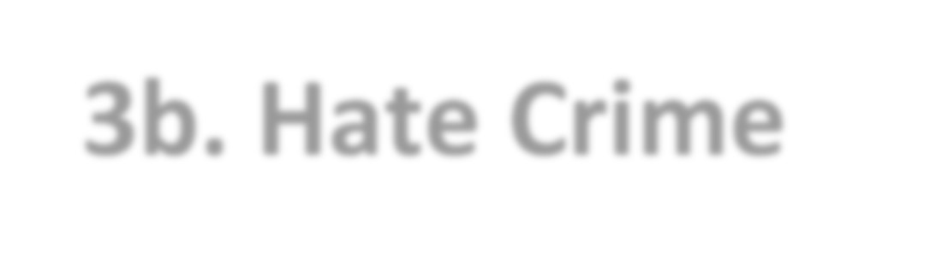
3b. Hate Crime

The Partnership is committed to tackling Hate Crimes such as Race Crime; Faith Hate Crime; Homophobic Crime; and gender, sexual orientation or disability related Hate Crimes. The Safer Communities Partnership will continue working together with partners and the community to tackle Hate Crime and address under-reporting. Community Safety surveys carried out in Barnet have found that verbal abuse and Hate Crime suffer from both high levels of under-reporting and repeat victimisation.

How We Will Make This Happen

3.13 | We will work with the Adult Safeguarding Board and the 5 Partnership Boards on Hate Crime (Older Adults, Physical and Sensory Impairment, Learning Disabilities, Mental Health, Carers) on strategies to address prevention and reduction of Hate Crime, linked to adult safeguarding.
3.14 | We will consider how we can use partnerships and the whole Council to raise awareness, build confidence among vulnerable victims and develop preventative interventions.
3.15 | We will work to develop our understanding of reporting rates of Hate Crime by ‘protected characteristics’.
3.16 | We will develop a deeper understanding of the under-reporting profile on the borough (i.e. in which communities and demographics and crime types is under-reporting most acute).
3.17 | We will promote public awareness of the options available to report Hate Crimes, especially the 3rd party reporting centres.
3.18 | We will work with partners to identify ways to make the 3rd party reporting of Hate Crime more accessible to the public.

How We Will Measure Success

Success will be measured by:

- An increase in the reporting rate of Hate Crimes by protected characteristics.
- An increase in Sanction Detection Rates for Hate Crimes.

Progress So Far

- The Partnership continues to work to strengthen community cohesion through building relationships with partners and community organisations. For example the Communities Together Network which is made up of a wide range of community organisations, including faith groups, youth representatives, schools and key professional partners and reports to the Safer Communities Partnership Board.

- Barnet Police Community Safety Unit is focused on tackling Hate Crime through taking robust action against perpetrators, supporting the needs of victims and working in partnership with external agencies.

- We are reviewing the current provisions of 3rd party reporting sites on the borough in order strengthen the capabilities 3rd party reporting.

- The Safer Communities Partnership recently conducted a public consultation as part of the work to develop the new strategy. Over 250 residents took part in a survey which included several questions of their experiences and perceptions of Hate Crime in the borough. The feedback from this survey and from the public meetings (which were also part of the survey) will help inform how the Partnership can continue to become more effective in tackling Hate Crime.

Outcome 4: | The Partnership will work to reduce Serious Youth Violence with a focus on young people as victims and offenders

Keeping young people safe from the harm caused by violent crime and serious group offending is a nationwide priority as set out in the Home Office’s Ending Gang and Youth Violence Strategy. This priority is endorsed at the London level by the Mayor’s Office of Crime and Policing (MOPAC) which expects that all 32 London boroughs will establish a partnership problem profile of gangs and youth violence in their borough to inform other approaches to youth offenders.

Barnet is one of the safest boroughs in London: Barnet’s rate of violence with injury per 1,000 people is the 2nd lowest out of all London boroughs and the lowest out of the 15 comparison areas in Barnet’s ‘Most Similar Group’.

Young people have told us, through the consultations we have carried out, that safety is one of their top priorities. Our survey results showed that compared to the population average, people aged 19 year or under: were over 55% more likely to feel ‘very worried’ about the risk of being physically assaulted

Some key facts about youth crime in Barnet:

- Young people aged 15 to 20 account for a disproportionately large amount of the victims of crime for offences with violent contact between the victim and offender (Robbery, Violence, Sexual offences).
- For example the peak victim age for Robbery is 14 to 18 years old (33% of male victims in this range).

In order to ensure the Safer Communities Partnership continues to address both adult and children safeguarding, the Partnership will continue to focus on keeping young people safe, preventing them from being victims and/or offenders of crime, especially for the more serious offending.

How We Will Make This Happen

In 2014, Barnet established its first Youth Crime Prevention Strategy which is underpinned by seven principles:

- Strong Leadership;
- Mapping the Problems;
- Responding in Partnership;
- Assessment and Referral;
- Targeted and Effective Interventions; • Criminal Justice – breaking the cycle;
- Mobilising Communities.

Each of these principles has a more detailed set of actions linked to it; the key ones are outlined in brief below.

4.1 | Strong Leadership  - Partners and the community are fully engaged with the strategy to enable effective work to prevent youth crime.  - The Partnership has access to data which helps to provide a measurement of youth crime and the impact of this strategy.
4.2 | Mapping the Problems  - The Partnership has clarity about the problem being tackled.  - The Partnership has access to information from a range of sources which promotes the understanding of the problem of youth crime and gangs in Barnet and support prevention.  - We will build a deeper understanding of the wider impacts of youth crime – focusing on Serious Youth Violence and gangs – including the links to child sexual exploitation, health, exiting gangs and housing implications, in order that we can target interventions effectively.
4.3 | Responding in Partnership  - We will ensure the processes in place enables effective multi-agency partnership working to help prevent youth crime.  - Practitioners will have capacity and awareness of identifying and responding to young people at risk of being involved in youth crime and gang-related activities and ensure where appropriate safeguarding processes are followed.
4.4 | Assessment and Referral  • We will implement a comprehensive identification, assessment and referral tool which will meet the standards of the London Safeguarding Children’s Board guidelines on working with young people at risk of being involved in serious youth crime.
4.5 | Targeted and Effective Interventions  • We will promote interventions which avoid duplication and take account of evidence-based interventions.
4.6 | Criminal Justice – Breaking the Cycle  - We will provide targeted and effective interventions; enforcement, pathways out of gangs and Serious Youth Violence and prevention.  - We will provide opportunities for rehabilitation in order to break the cycle of criminal involvement.
4.7 | Mobilising Communities  - We will work in partnership with local communities to more effectively meet the needs of young people affected by crime.  - We will build trust and positive relationships with community groups and community representatives.  - We will work to enhance the capacity of local community organisations that are working to prevent youth crime and youth violence.

How We Will Measure Success

Success will be measured by:
- Sustained reduction in the rate of serious youth violence
- Sustained reduction in the level of knife crime rate
- A reduction in the number of young people entering the Criminal Justice System
- Sustained reductions in the proportion of young people Not in Education Employment or Training (NEET).

Progress So Far

Our 2014 Community Safety Strategic Assessment showed that although Barnet has a relatively low rate of violence with injury compared to other London boroughs, the violent offences (including violence towards young people) are not distributed uniformly across the borough.

We have therefore secured funding and delivered targeted interventions in the areas in Barnet where young people are more likely to be either victims or offenders of crime.

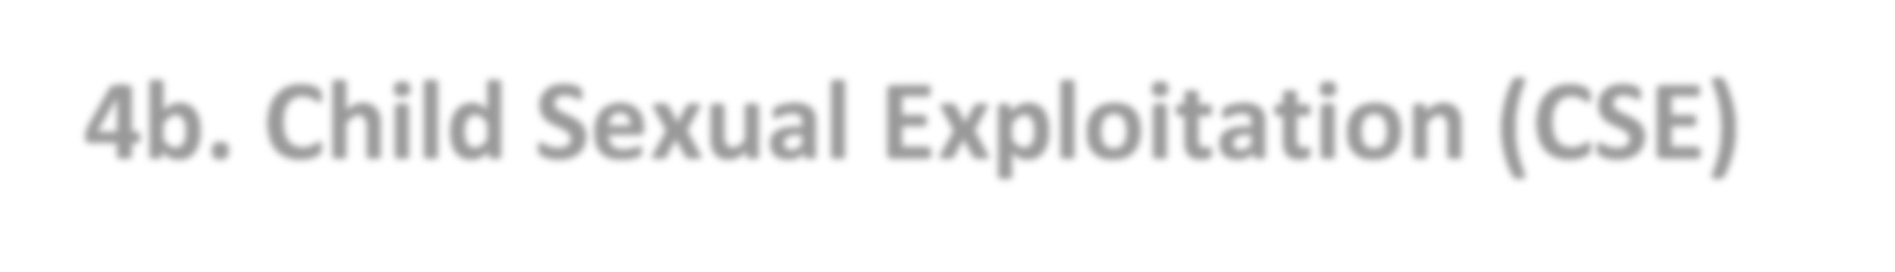
4b. Child Sexual Exploitation (CSE)

Children and young people are entitled to be safeguarded from sexual exploitation. A range of recent national reports and media coverage and a series of high profile investigations and criminal trials resulting in recent convictions in Oxfordshire, Derby, Rochdale and Rotherham and other towns and cities highlight that this form of child abuse is often hidden from sight and preys on the vulnerable in our society.

National research shows children and young people exploited are subject to long term risks to their physical, emotional and psychological wellbeing. The inquiry into the child sexual exploitation (CSE) in Rotherham is a sad reminder as to the extent and devastating effects CSE has upon children and young people, their families and wider communities.

While there is no evidence of anything of this scale in Barnet, we are committed to work in partnership and doing everything possible to prevent child sexual exploitation, therefore this is one of the key priorities of Barnet Safeguarding Children Board.

Progress So Far

- Given the strong links across gangs, child sexual exploitation and missing children a Multi-agency CSE, Missing and Gangs Strategy Group has been established. This group will oversee the delivery of Barnet’s Child Sexual Exploitation Strategy and Youth Crime Prevention Strategy.
- A Multi-Agency Sexual Exploitation (MASE) group is in place to oversee the CSE cases in Barnet. In addition the MASE has a central role in informing prevention strategies, identifying emerging trends, intervening and informing disruption strategies, securing support for victims, and working closely with the police in relation to opportunities to prosecute perpetrators.
- A screening and referral process has been established to support the identification and risk assessment of CSE cases.

The Safer Communities Partnership fully supports the approach of Barnet Safeguarding Children Board and the Multi-agency CSE, Missing and Gangs Strategy
Group

Outcome 5: Sustained reductions in re-offending

In 2013/14 a reduction in offending has translated into less crime, fewer victims of crime and a reduction in the costs relating to crime. We know that a small proportion of the most prolific offenders are responsible for a disproportionately large amount of crime. National studies and local analysis show that substance misuse (drugs and alcohol) is a significant causal factor for both acquisitive and violent offending.

By focusing on reducing the offending of this prolific cohort, in particular through the work of the Integrated Offender Management (IOM) Programme, we have been able to drive down overall crime and so reduce the number of people in Barnet who become victims of crime. We intend to continue developing this programme to deliver further reductions in offending.

In 2014 the Probation Service went through some substantial changes, specifically establishing two separate bodies to manage offenders – the National Probation Service (NPS) which will manage offenders who have been in custody for over twelve months and the Community Rehabilitation Companies (CRC) managing all offenders serving less than twelve months. This means that all offenders released from prison will receive support to rehabilitate them and prevent re-offending regardless of the time spent in prison.

The SCP recognises the challenges this could bring locally and has established the IOM Delivery Group which will ensure co-ordinated partnership working to deliver this outcome.

How We Will Make This Happen

5.1 | When tackling re-offending, we will focus resources where they will have the greatest impact in reducing the cost of crime to the people of Barnet.
5.2 | We will collaborate together to reduce reoffending – minimising waste such as unnecessary duplication and actively exploring new approaches including use of technologies.
5.3 | We will tackle the causes of re-offending, prioritising prevention and using enforcement where necessary.
5.4 | We will expand the IOM cohort - If an expanded IOM is able to deliver the same size reductions in offending as has already been demonstrated by the 2013/14 cohort, this would lead to a significant reductions in crime hence a reduction in the number of people becoming victims of crime in Barnet.
5.5 | We will develop Barnet’s Reducing Offending strategy setting out the Partnership multi-agency approach to managing offenders in line with the Offender Management Act 2007, the Police and Crime Act 2009.
5.6 | We will work with partners including those in the voluntary and community sector to further develop the referral pathways in relation to the causal factors behind offending behaviour, including: Substance misuse, employment, education and training; Mental health; and housing.

How We Will Measure Success

Success will be measured by:

- A reduction in the re-offending rate of offenders in the IOM cohort.
- An increase in the number of offenders supported by the IOM programme.
- A reduction in the ‘Proven adult reoffending rate’

Progress So Far

The Integrated Offender Management programme has helped to reduce reoffending among some of the most prolific offenders (the IOM ‘cohort’) and this is contributing to crime reductions in Barnet.

From April to September 2013 around 60 of the 336 fewer Residential Burglaries in Barnet were likely to have been due to reduced criminal activity by the IOM cohort.

Based on our figures, we estimate that the top 200 offenders in the borough are, between them, committing around 5,000 crimes every two years.

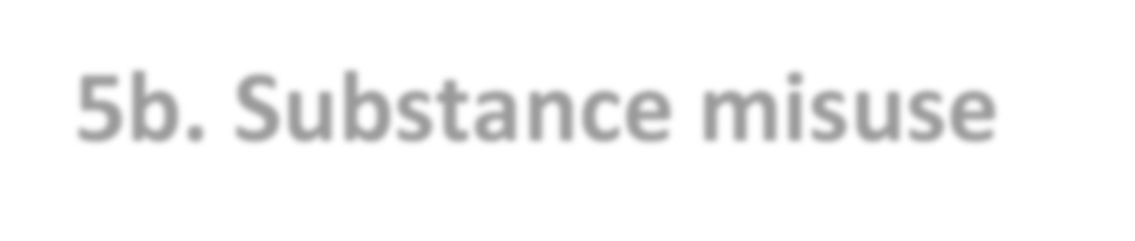
5b. Substance misuse

Drugs are related to crime through the effects they have on the user's behaviour and by generating violence and other illegal activity in connection with drug trafficking. Evidence indicates that problem drug users are responsible for a substantial proportion of acquisitive crime, such as shoplifting and burglary. Research claims that boys who take drugs are five times as likely to commit criminal offences.

Studies reveal that young drinkers are more likely to be involved in violent incidents. In England, each year, around 1.2 million violent incidents are linked to alcohol misuse. It is estimated that 70% of all visits to A&E, at peak times, are due to alcohol misuse.

How We Will Measure Success

We will measure the following indicators:

• An increase the rate of successful completions as a proportion of Criminal Justice clients of all in treatment (for substance misuse)

Progress So Far

Advice, information and support provided to residents who have drug or alcohol problems and who need to access treatment services is proved by multi-disciplinary teams on the borough comprising of (or having access to) clinicians, nurses, key project workers, clinical assistants (GPs), psychologists and therapists.

Referral pathways into drug and alcohol treatment are well established: referrals are sourced from GPs, Social Services, police, Voluntary Services, Mental Health workers / services, family, friends and clients themselves.

Barnet Integrated Offender Management program works with drugs and alcohol substance misuse treatment services to address substance misuse as one of the factors driving repeat offending amounts prolific offenders.

Outcome 6: | Sustained reductions in Burglary and other high volume crime types, such as: Violence with Injury, Robbery, Theft of Motor Vehicle, Theft from motor vehicle, Theft from the person, and Criminal damage

We are pleased, that over the last year Barnet has achieved some of the largest burglary reductions in London (19% reduction in Residential Burglary and 6% reduction in Non-residential Burglary). We recognise however that burglary remains a community concern and that the rate of burglary in Barnet is higher than the London average.

Overall Residential Burglary has fallen in London over the last two years, helped by the favourable recent conditions, i.e. a general reduction in the trend of cross borough boundary vehicle borne burglars stealing gold. Due to the intensity of the police and partnerships focus on burglary, Barnet’s reductions over the last two years have exceeded the reductions seen in London. We are committed to building on the recent successes in order to sustain a long-term reduction in burglary in Barnet.

In 2013/14 the Integrated Offender Management programme has already contributed an estimated 120 fewer burglaries to the borough’s overall annual burglary reductions of 865 fewer victims of burglary. Building on this success will be a central pillar to the burglary reduction plan.

How We Will Make This Happen

The SCP has established a multi-agency Burglary Reduction Group to ensure the Partnership remains focused and delivers a co-ordinated response to burglary where there is strong engagement to encourage local residents and business in Barnet to take steps to prevent them becoming a victim of burglary.
6.1 | We will consider burglary reduction projects from a strategic standpoint that involves identifying and analysing the problem, devising solutions, assessing the likely impact of solutions, reviewing progress, refining approaches and evaluating success.
6.2 | We will seek to work with a range of officers across the Partnership with different skills, experience and knowledge that may be drawn on, through the multi-agency Burglary Reduction Group. This group will work towards devising

 | a sustainable burglary solution.
6.3 | We will ensure the Integrated Offender Management programme focuses on local offenders who continue to commit burglaries.
6.4 | We will make Barnet less vulnerable to cross borough boundary burglars by increasing the use of Automatic Number Plate Recognition (ANPR) cameras being used to help catch offenders.
6.5 | We will continue to raise awareness amongst the community to prevent them from becoming a victim of burglary by:  - Conducting an awareness campaign encouraging residents to check the security of their home and steps they can take to prevent being a victim of burglary.  - Conducting a winter anti-burglary campaign: the winter burglary peak when the clocks go back – is predictable and can be as many as double the rate of offences than the summer months.
6.6 | We will support victims and repeat victims through the Police Victim Care process which includes follow up visits, call backs and referrals to Victim Support where appropriate, providing preventative devices such as property marking and memo cams to the most vulnerable members of our community.
6.7 | We will scope a pilot of the concept of a ‘Bronze, Silver, Gold’ response system towards victims of burglary which has been seen working effectively in other locations. The Bronze, Silver, Gold system is a way of categorising the risk of a repeat offence – bringing repeat victim to the fore and ensuring an appropriate level of response.
6.8 | We will ensure an effective and efficient referral process is in place for repeat victims of burglary to the Safer Homes scheme where victims will receive a free home safety checks, additional locks and target hardening to prevent them from being a victim of burglary. This free service will target the most vulnerable members of our community including the elderly, people with learning disabilities, physical disabilities and those living in areas where burglary has taken place.
6.9 | We will target hotspot areas including using a method called ‘Cocooning’. This process makes sure that households in the areas where a burglary has taken place are aware and that they have taken all measures to be certain their homes are secure.
6.10 | We will work with Barnet Borough Watch (neighbourhood watch).
6.11 | The Multiagency Burglary Reduction Group will scope out a pilot for a cold calling scheme in a location suffering from distraction burglaries. The group will consider how to identify and select a suitable location for the scheme as well as how to communicate effectively about it with residents and businesses.

How We Will Measure Success
Success will be measured by:

- A reduction in the number of local burglars committing burglary.
- A reduction in the number of repeat burglaries.
- An increase in the number of burglary victims referred for Safer Homes or equivalent prevention advice.

Progress So Far

Scanning and analysis identified that a high proportion of burglaries are committed by prolific reoffenders. As part of the response the IOM programme focused its diversion work towards prolific repeat burglars – resulting in an estimated annual reduction of around 120 fewer burglaries in 2014/15.

Delivering the plan

Progress against this strategy will be reported to the SCPB quarterly and annually to the:
- Safeguarding Children’s Board
- Safeguarding Adults Board
- Community Leadership Committee

The Partnership will conduct an annual strategic crime needs assessment and a community safety consultation to track performance of the SCP to understand the crime and ASB trends in Barnet. The analysis and consultation findings will inform the annual refresh of this strategy.

This plan will be delivered through subgroups of the SCPB set out in diagram 1.

Diagram 1
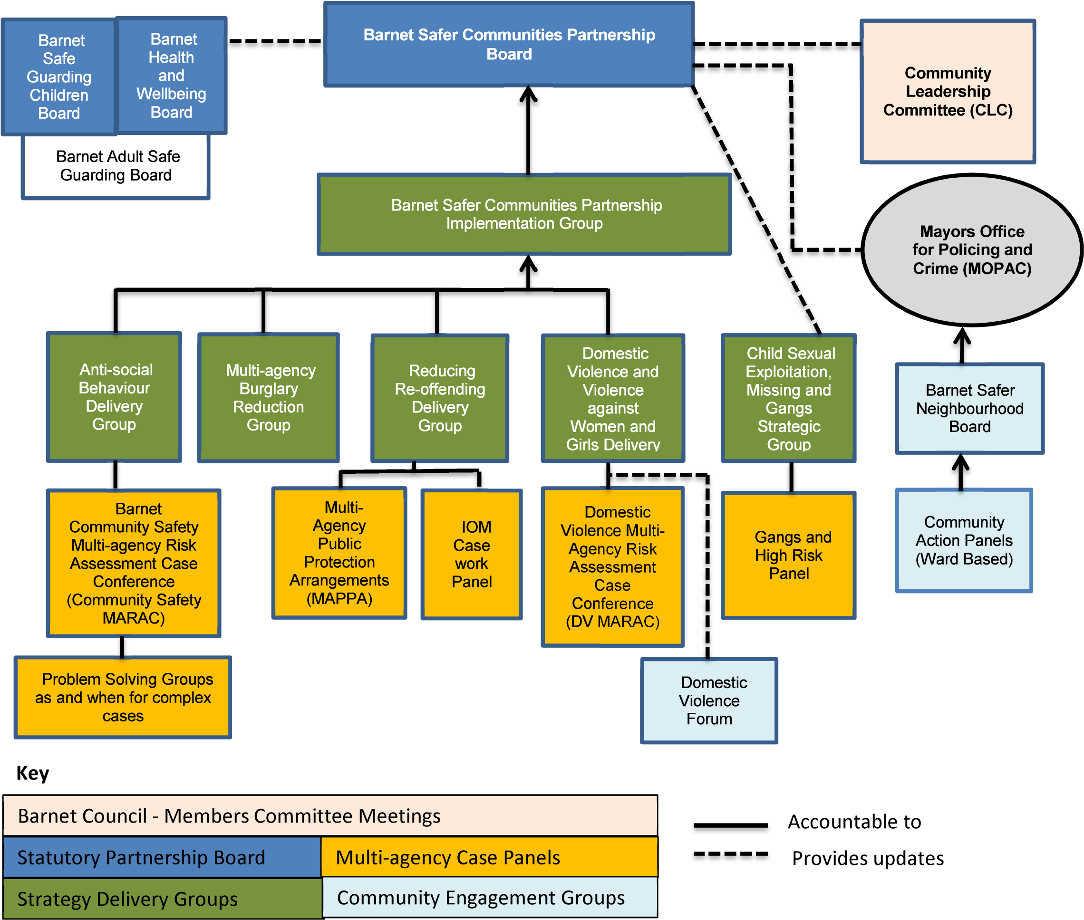

Glossary

Explanation
Anti-social behaviour  (ASB) | Behaviour by a person which causes or is likely to cause harassment, alarm or distress to one or more people, not of the same household as the person. ASB is a key community concern and also a risk generator, i.e. in cases were low level repeat ASB victimisation escalates to the point of resulting in significant harm towards the victim.
CSP | Community safety partnerships (CSPs) are made up of representatives from the ‘responsible authorities’. The responsible authorities work together to protect their local communities from crime and to help people feel safer. They work out how to deal with local issues like anti-social behaviour, drug or alcohol misuse and reoffending. They annually assess local crime priorities and consult partners and the local community about how to deal with them.
London Rank | A peer comparison (as above) comparing Barnet’s rate of crime to the other boroughs in London (1 is best, 32 worst).
MARAC | Multi-Agency Risk Assessment Conferences - creates safety plans to support high risk victims of Domestic Violence.
Most Similar  Group | A peer comparison (see above) comparing Barnet to similar boroughs / areas that have been selected due to demographic similarities (1 is best 15th worst).
Multi Agency  Safeguarding  Hub (MASH) | Multi Agency Safeguarding Hub (MASH) is the single point of entry in Barnet for all referrals regarding concerns for a child or young person or where it is felt they would benefit from additional support.
Public  Attitude  Survey (PAS) | Public Attitude Survey – a London-wide survey of Londoners’ opinions carried out on behalf of the Metropolitan Police, which breaks down results to borough level. It covers a wide range of community safety issues including crime, ASB and public confidence.
Sanction  Detection  Rate (SD  rate) | A Sanctioned Detection occurs when a suspect has been identified and charged, reported for summons, cautioned, issued with a penalty notice or the offence has been taken into consideration when the offender is sentenced. The Sanction Detection Rate is the proportion of offences that result in a sanction detection.
Violence against  Women and  Girls (VAWG) | The United Nations defines violence against women as “any act of genderbased violence that is directed at a woman because she is a woman or acts of violence which are suffered disproportionately by women.”
Page 31 of 32

Page 32 of 32

This page will be signed following agreement by Barnet Safer Communities Partnership Board and Full Council.
2011 Census puts the population at 356,400
Financial year to date Apr 2013 - 16 Feb 2014
Based on the Rolling 12 months to 25 Feb 2014 compared to the 2011/12 baseline
In last 12 months (to 25th Feb 2014) vs. one year ago
Between Apr 2013 to 26th Jan 2014 vs. 55.3% a year ago
After entering IOM programme
In last 12 months (to 25th Feb 2014) vs. one year ago
The seven crime types listed here are known collectively as the ‘MOPAC7’ – a basket of crimes for which reduction targets have been set by the Mayor’s Office of Policing and Crime(MOPAC)
A basket of high volume crime types (monitored by MOPAC): Burglary, Robbery, Theft from Vehicle, Theft of Vehicle, Theft from Person, Criminal Damage and Violence with Injury
Performance indicator for repeat victimisation to be developed
The anonymised recording details of Hate Crime offences include details of the protected characteristics (e.g. specifying if the referral relates to antiemetic, homophobic etc. Hate Crime)
Create problem profile to map an assessment of underreporting against crime types and demographics on the borough
Figures for 12 months to Jan 2014
In the 12 month period Feb 2013 - Jan 2014 compared with one year ago

