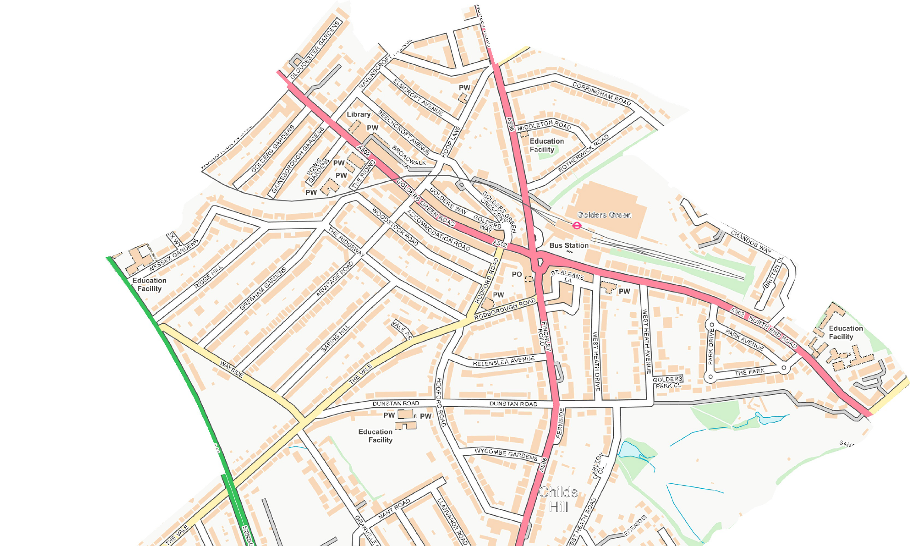
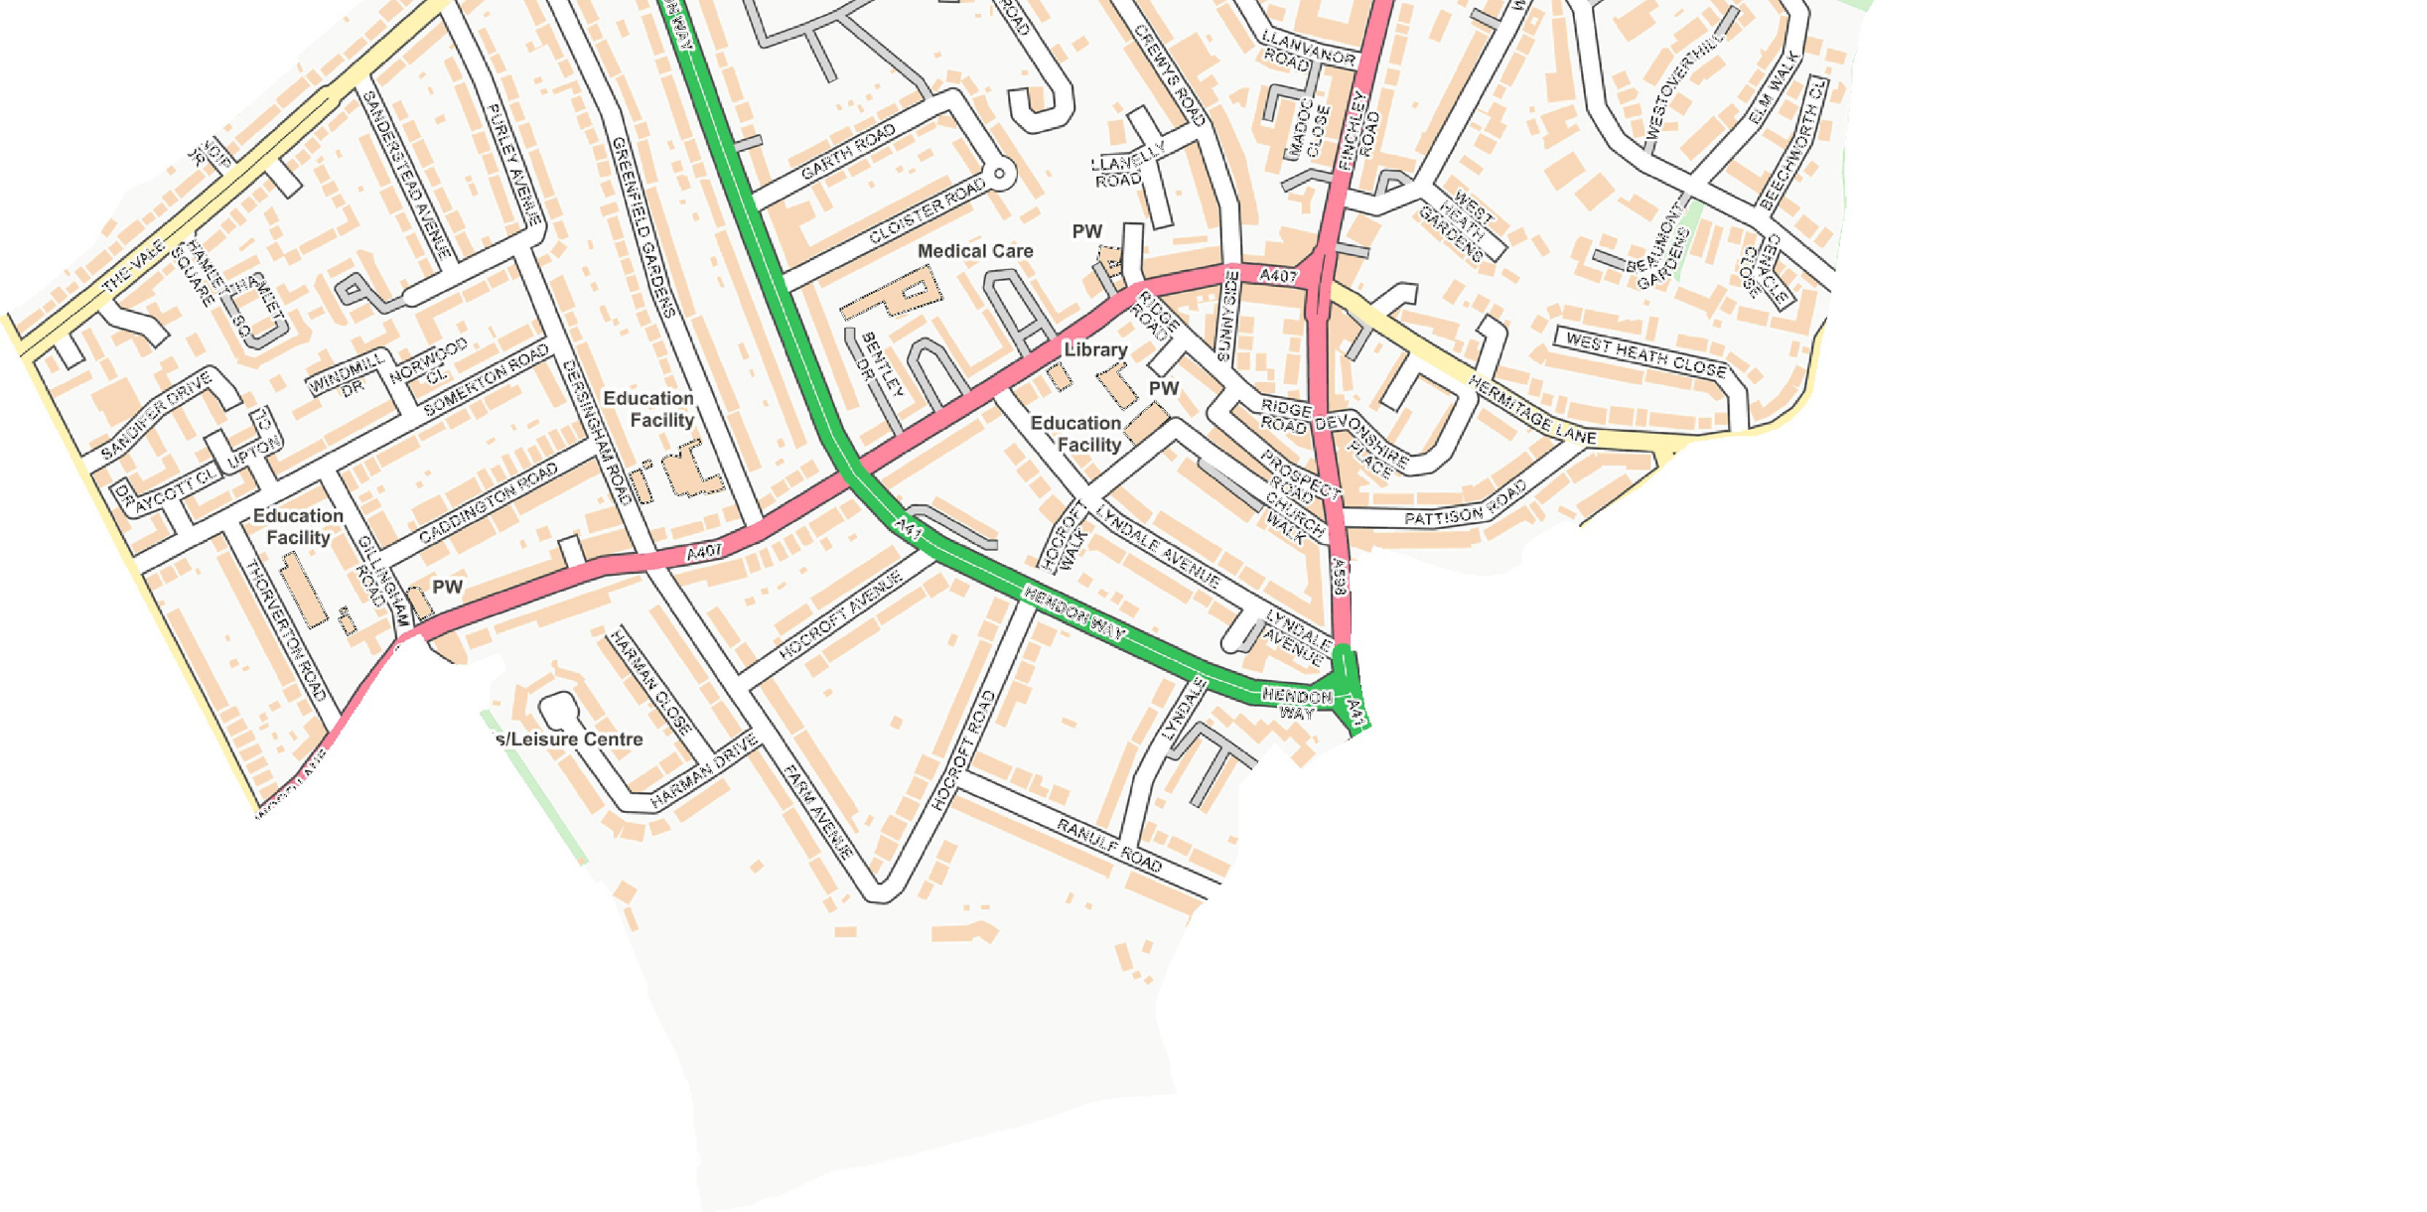
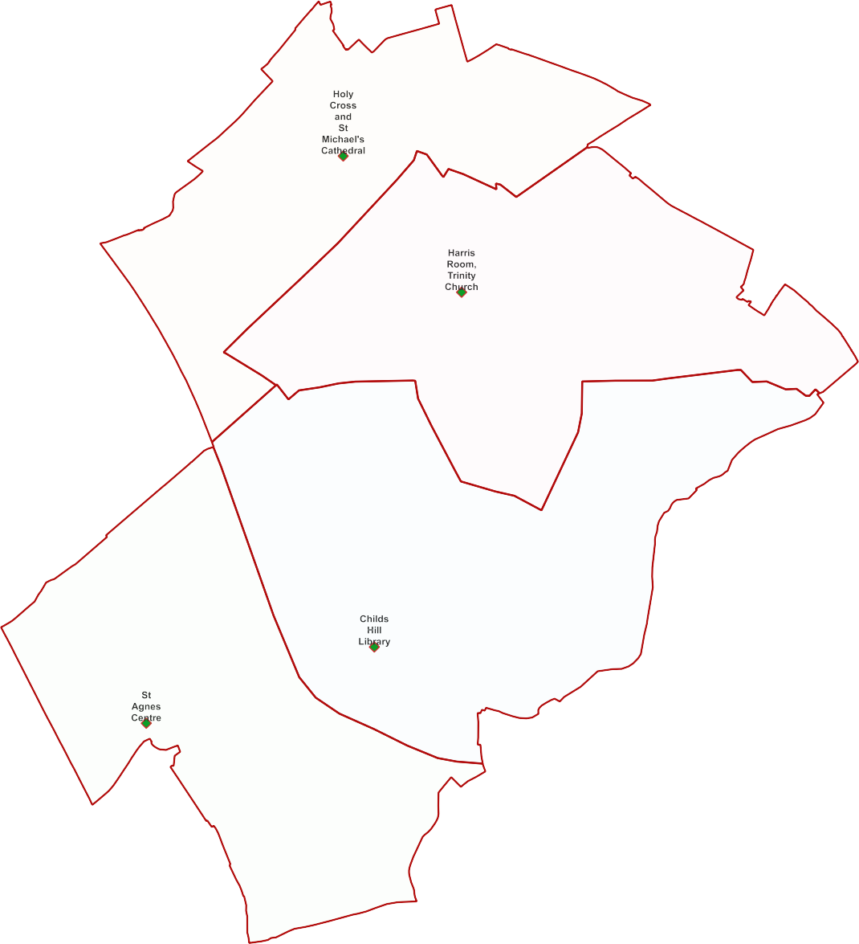
Childs Hill Ward -

Polling Proposals for May 2022
4 x Polling Districts Proposed Polling Places:
- Holy Cross and St Michael's Cathedral Hall (1x Polling Station)
- Harris Room, Trinity Church (2x Polling Stations)
- Childs Hill Library (2x Polling Stations)
- St Agnes Centre (2x Polling Stations)

PDPP_Draft Proposal Public Consultation OctNov 2021

Contains OS data © Crown copyright [and database right] [2021].

