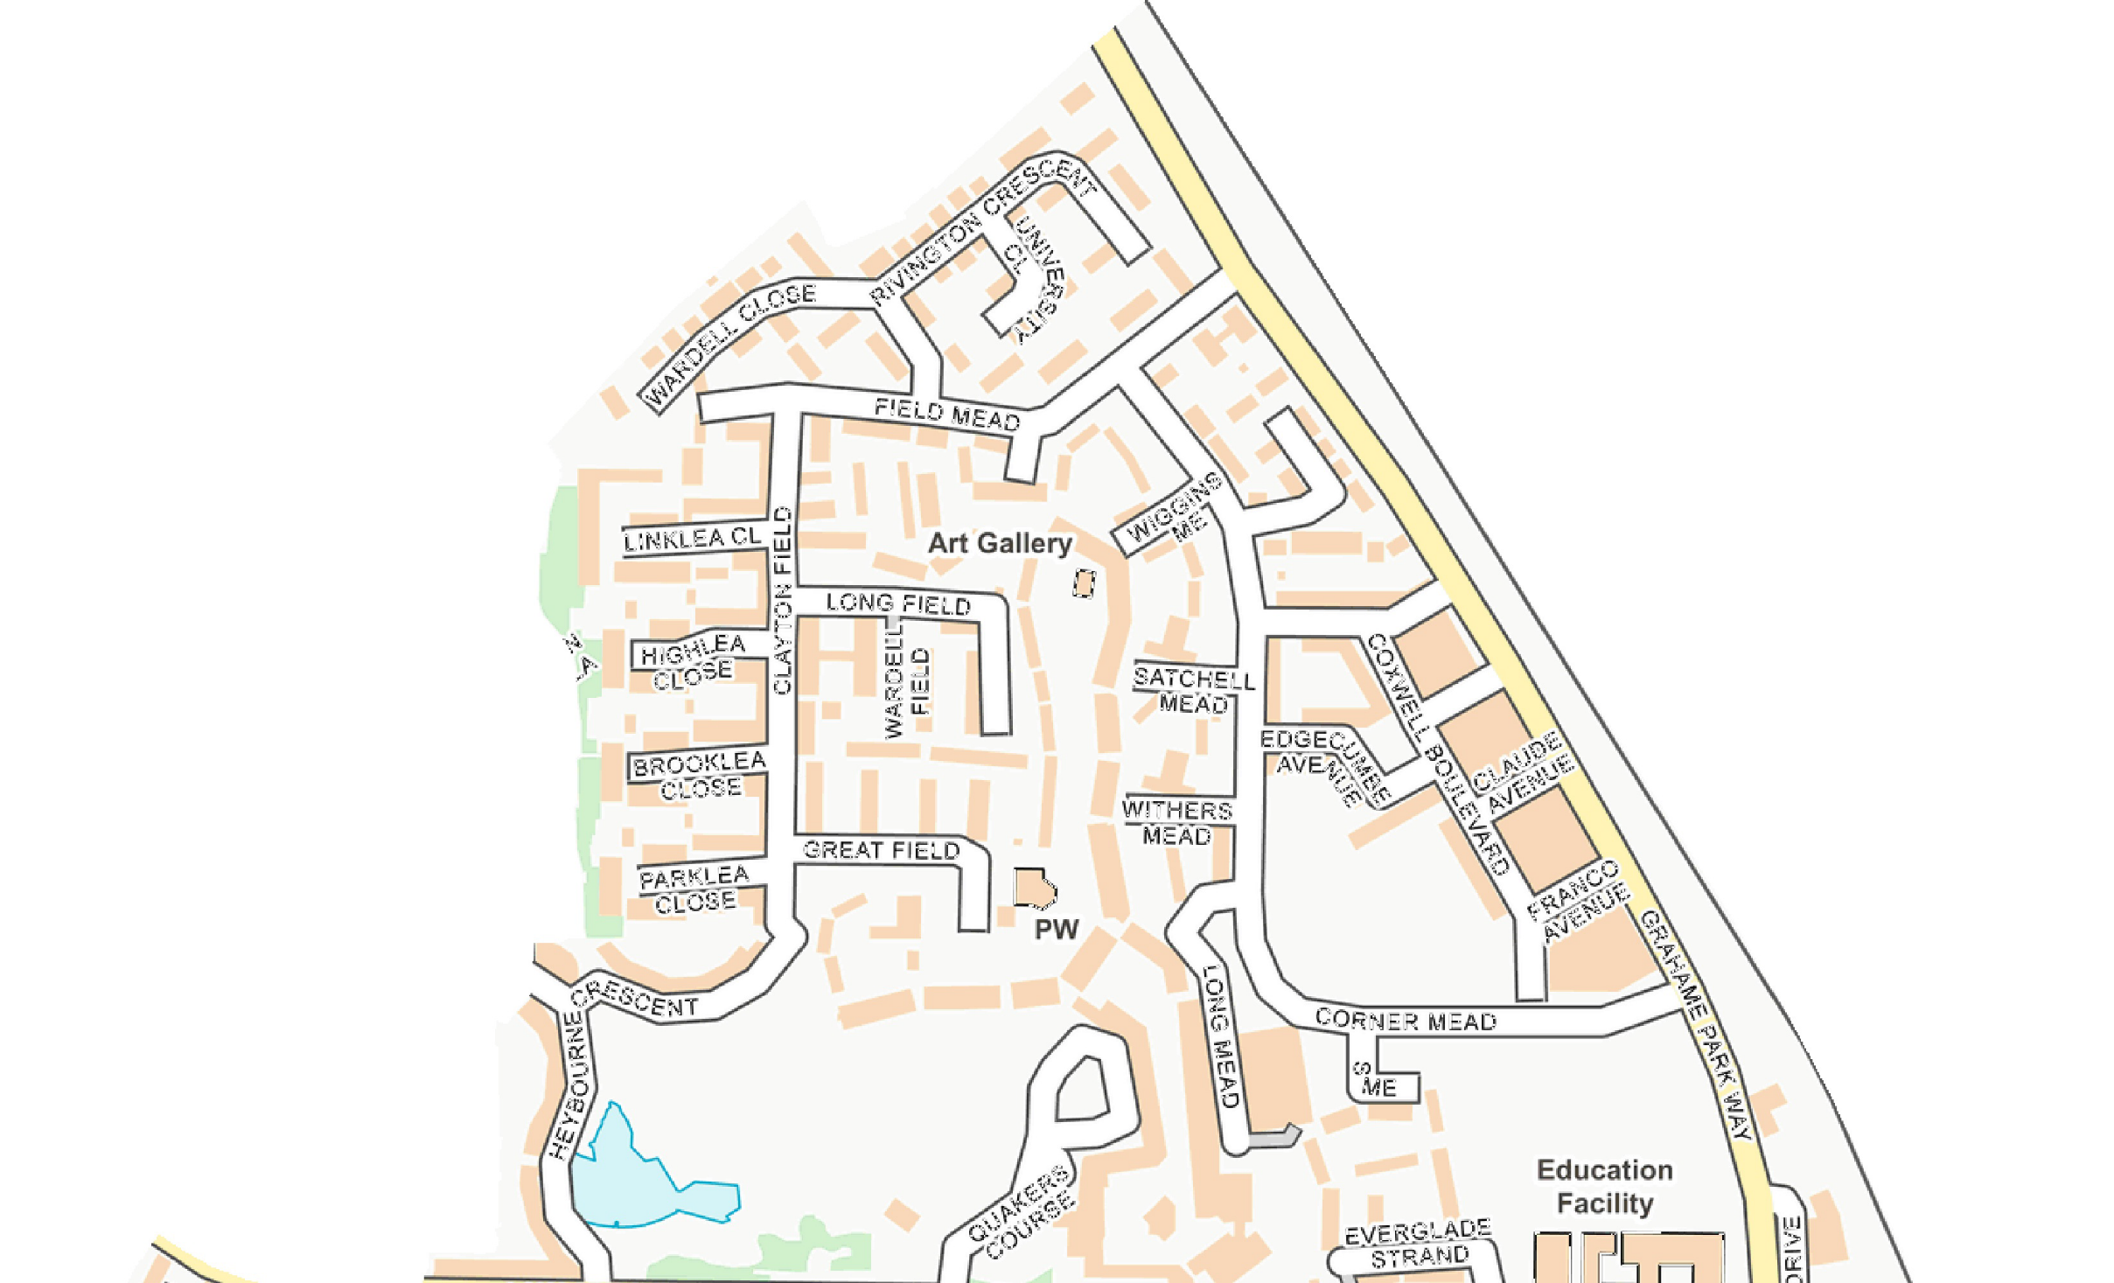
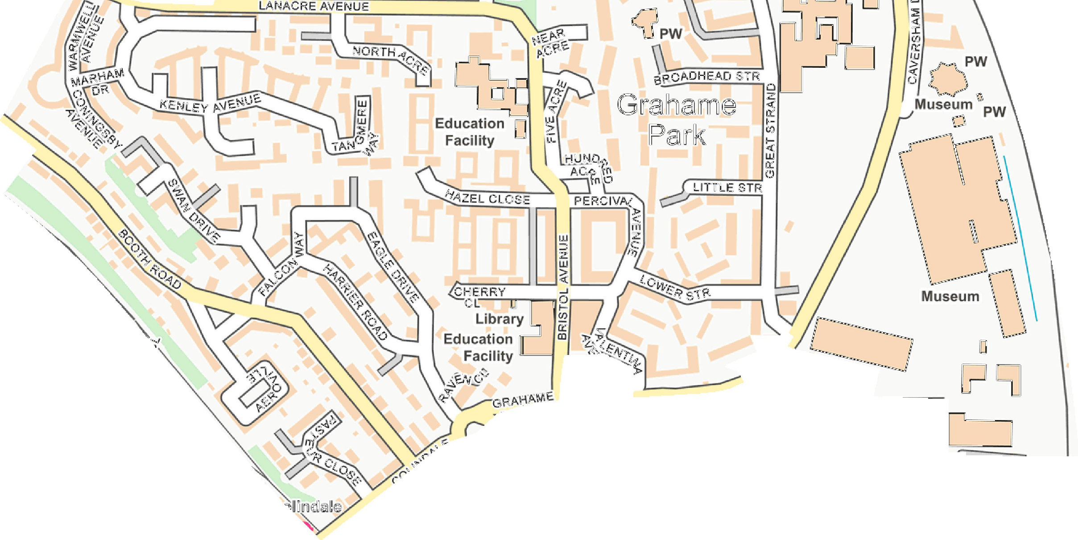
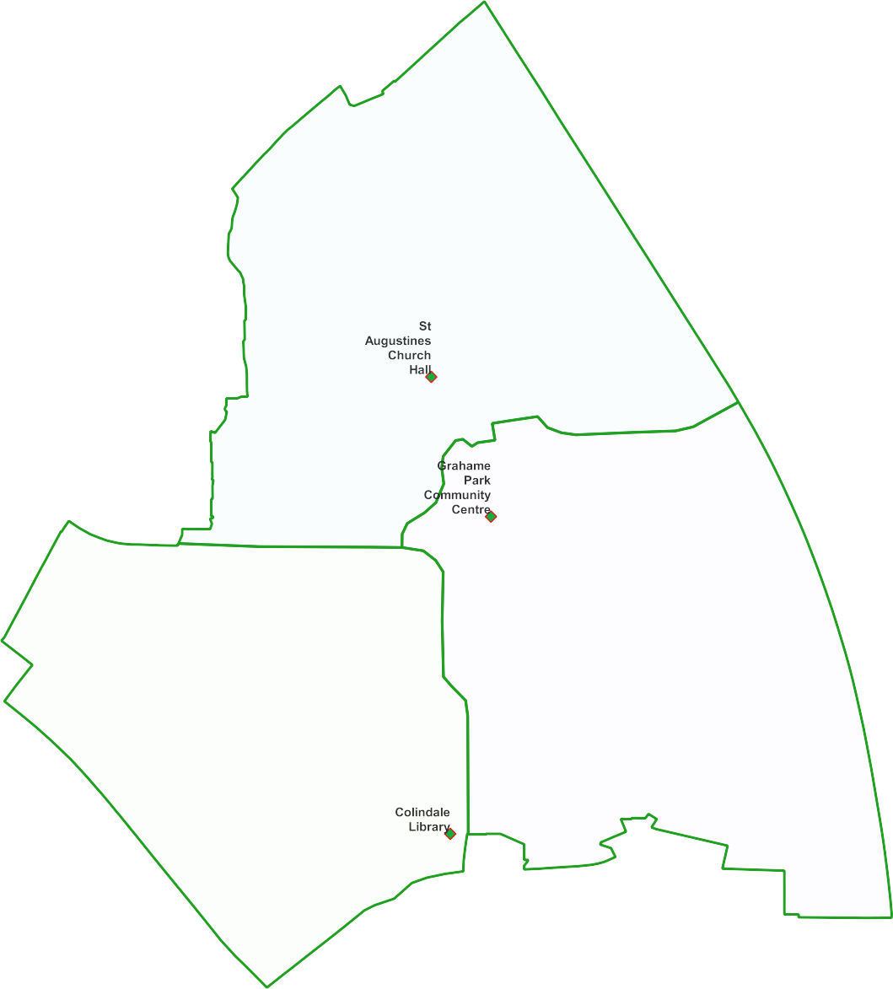
Colindale North Ward -

Proposal for May 2022
3 x Polling Districts Proposed Polling Places:
- St Augustine's Church Hall (2 x Polling Stations)
- Grahame Park Community Centre (1x Polling Station)
- Colindale Library (2x Polling Station)

PDPP_Draft Proposal Public Consultation OctNov 2021

Contains OS data © Crown copyright [and database right] [2021].

