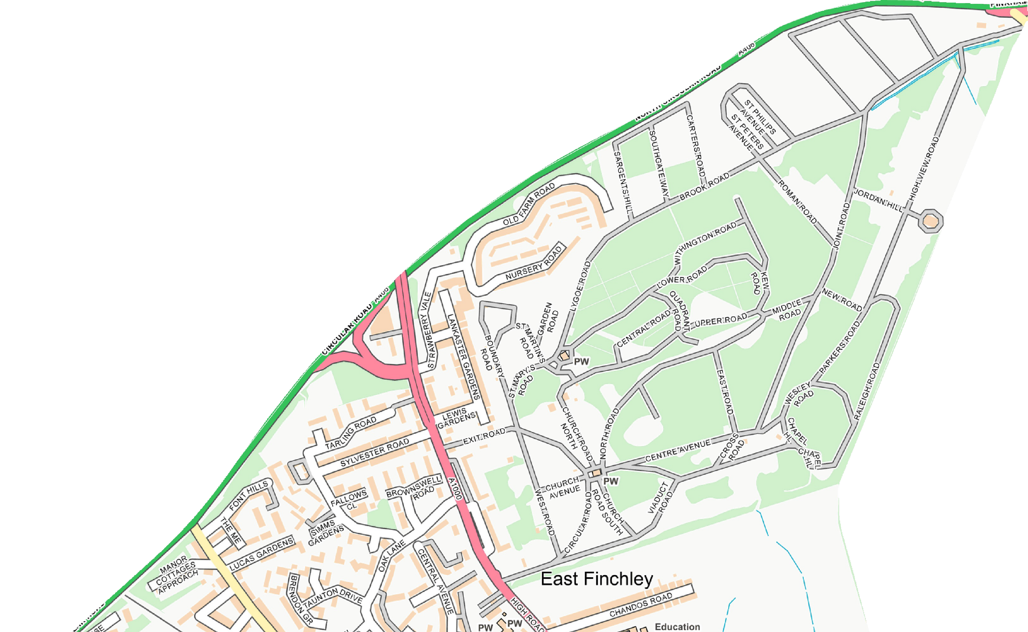
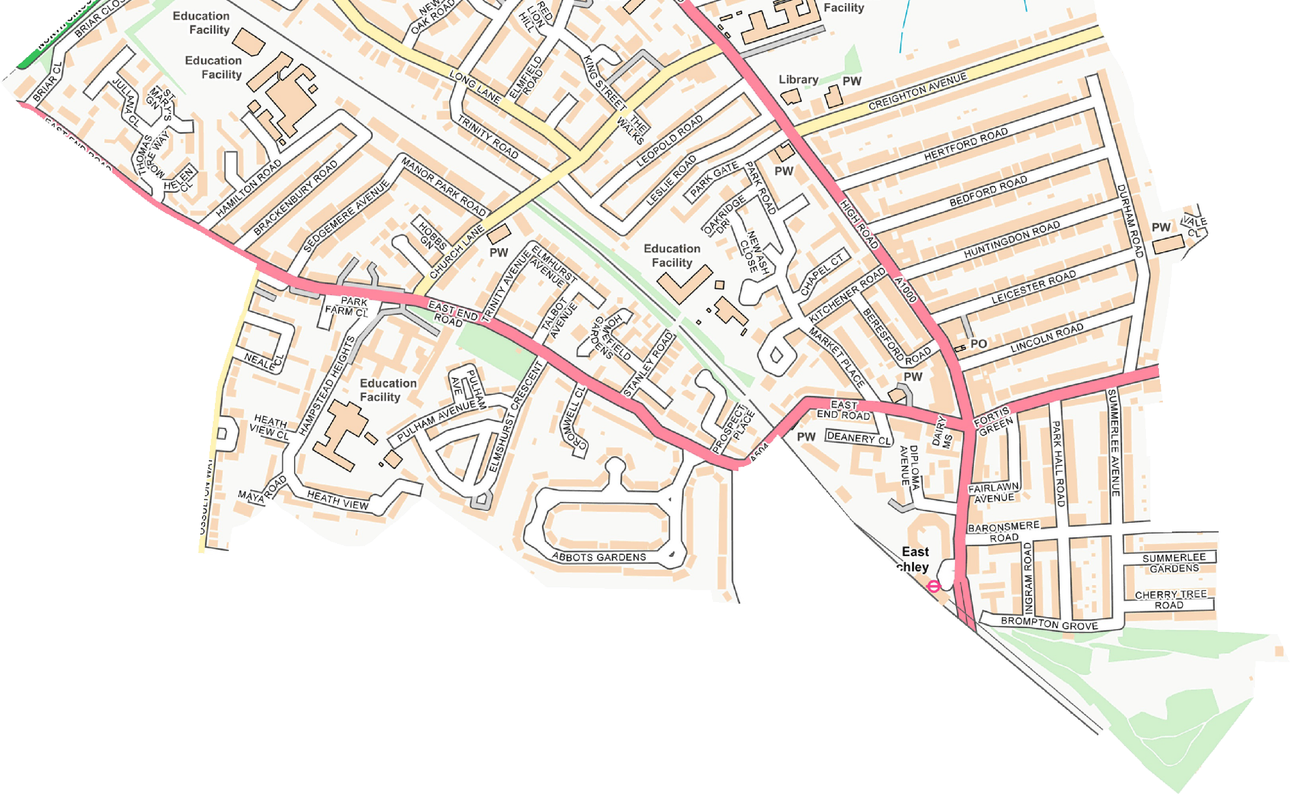
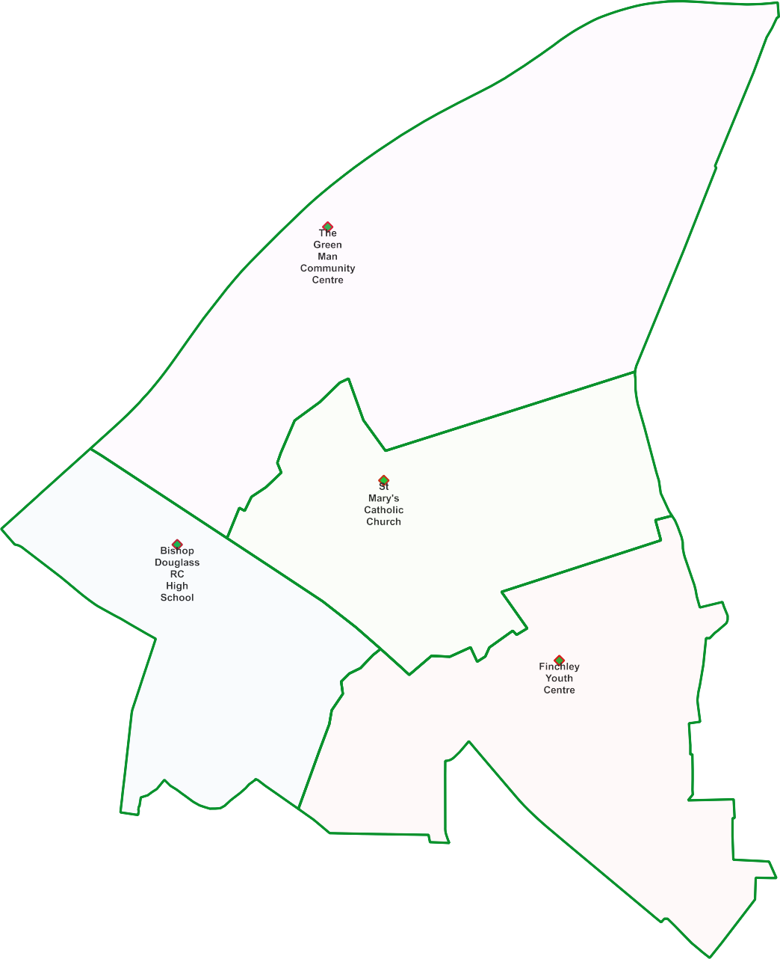
East Finchley Ward -

Polling Proposal for May 2022

4 x Polling Districts Proposed Polling Places:
- Green Man Community Centre (1x Polling Station)
- St Mary's Catholic Church Hall (2x Polling Station)
- Bishop Douglass RC High School (1x Polling Station)
- Finchley Youth Centre (2x polling Stations)

PDPP_Draft Proposal Public Consultation OctNov 2021

Contains OS data © Crown copyright [and database right] [2021].

