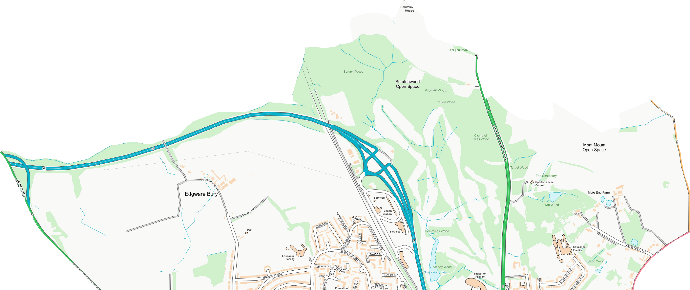
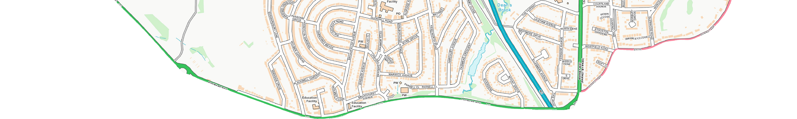
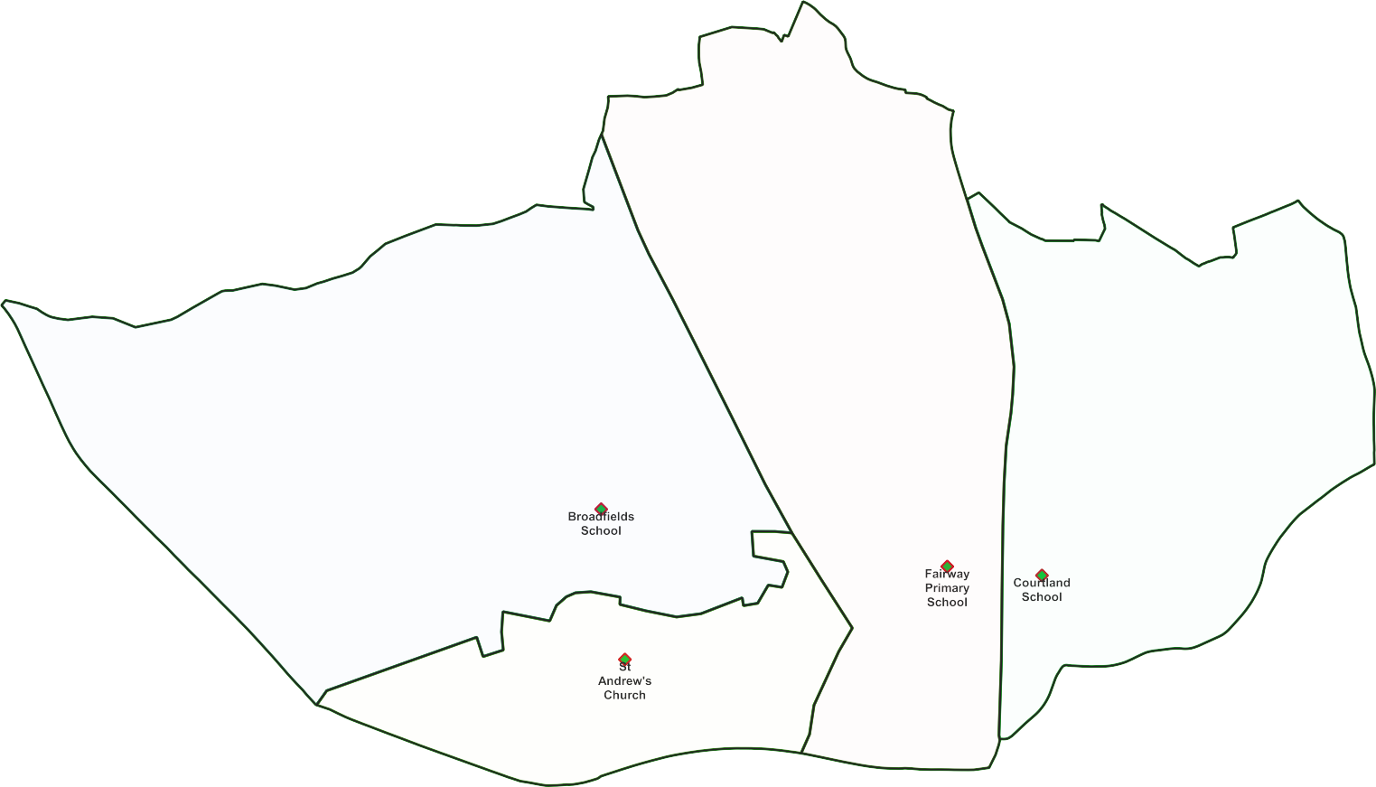
Edgwarebury Ward -

Polling Proposals for May 2022
4 x Polling Districts Proposed Polling Places:
- Broadfields School (2x Polling Stations)
PDPP_Draft Proposal Public Consultation OctNov 2021
- St Stephen's Church Hall (2x Polling Stations)
- Fairway School (1x Polling Station)
- Courtland School (1x Polling Station)

Contains OS data © Crown copyright [and database right] [2021].

