
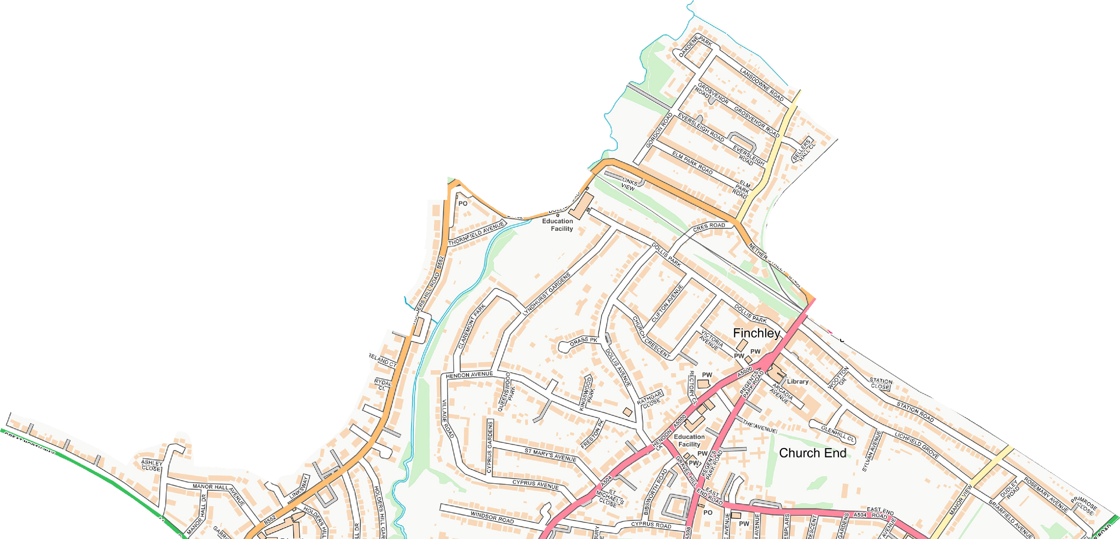
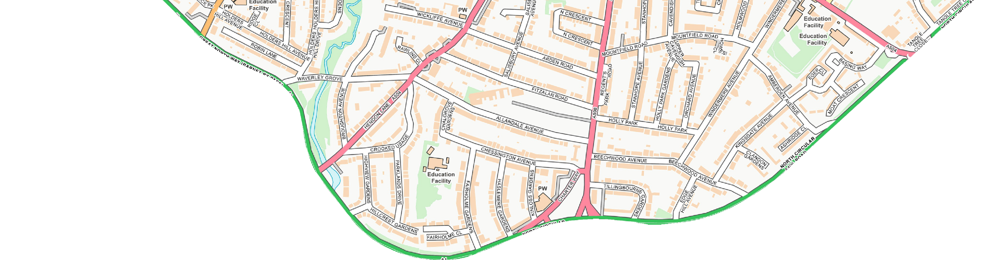
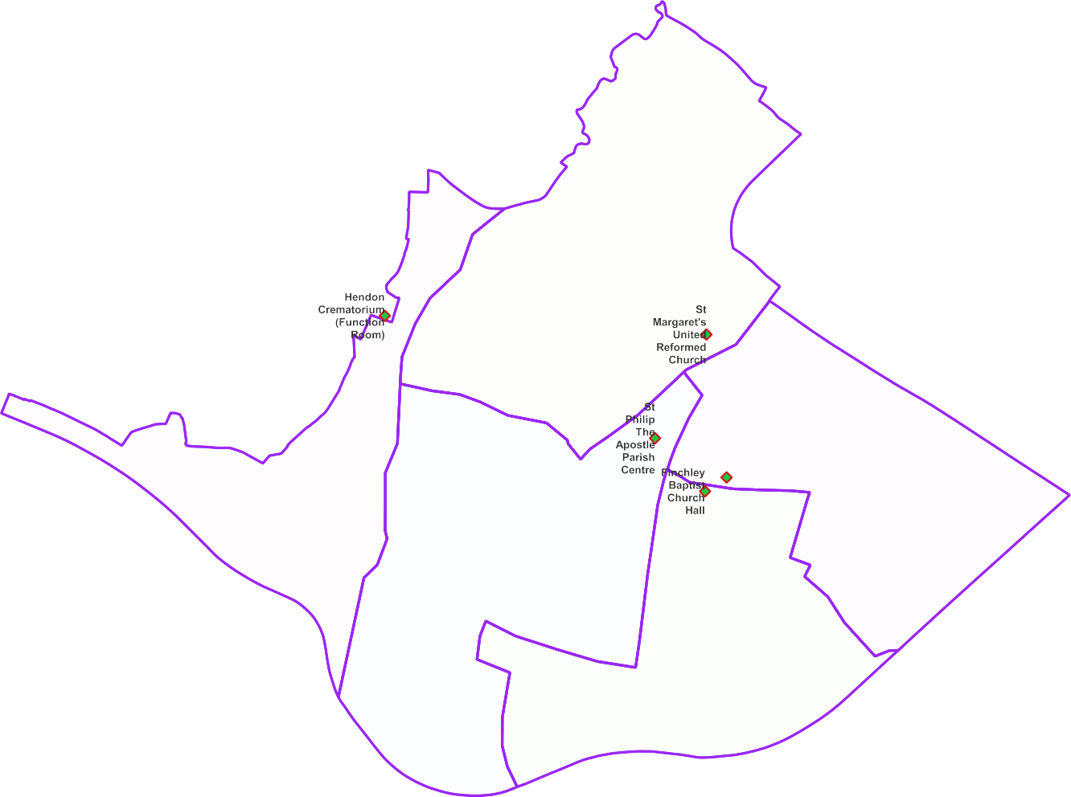

Finchley Church End Ward - Polling Proposal for May 2022

5 x Polling Districts Proposed Polling Places:
- St Margaret's United Reformed Church (2x Polling Stations)
PDPP_Draft Proposal Public Consultation OctNov 2021
- Function Room at Hendon Crematorium (1x Polling Station)
- St Phillip the Apostle Parish Centre (2x Polling Stations)
- Avenue House
(2x Polling Stations)
- Finchley Baptist Church Hall (1x Polling Station)

Avenue House Stephen's House and Garden

Contains OS data © Crown copyright [and database right] [2021].

