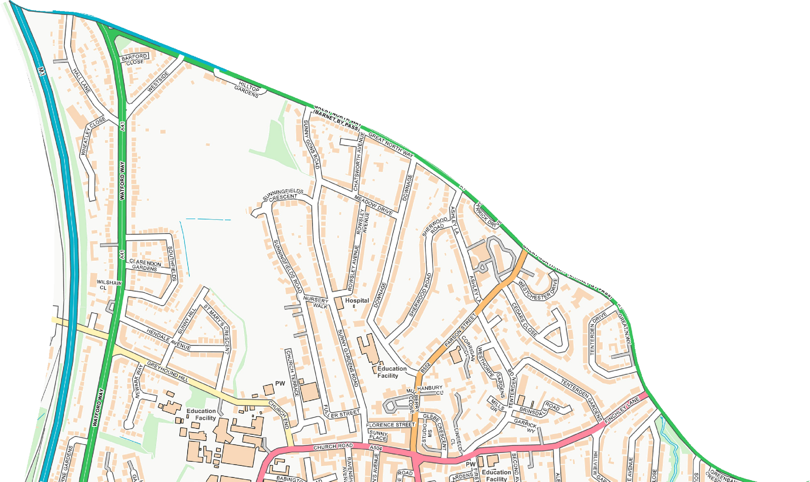
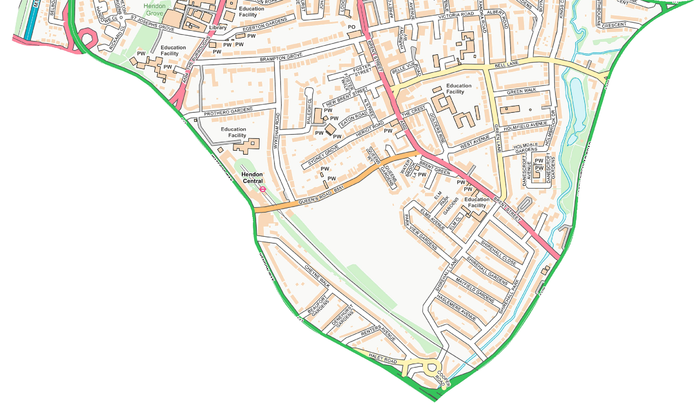
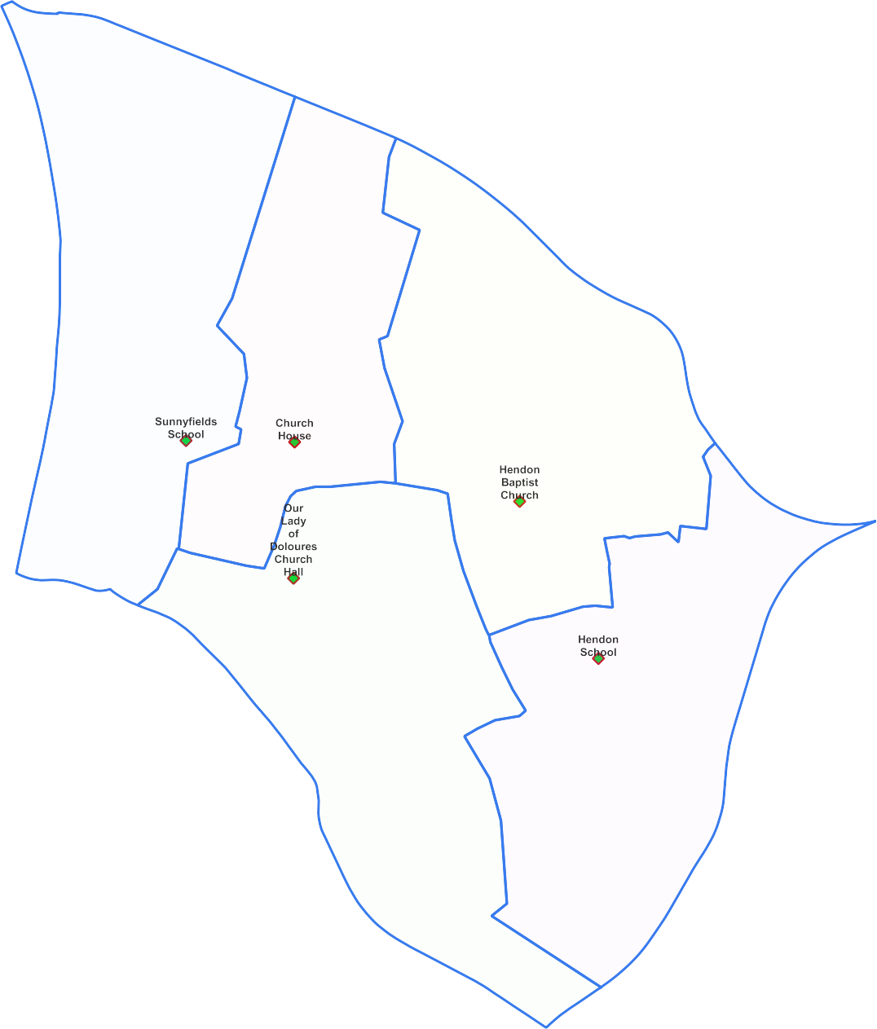
Hendon Ward -

Polling Proposals for May 2022
5 x Polling Districts Proposed Polling Places:
- Sunnyfields Primary School (2x Polling Stations)
- Church House
(1x Polling Station)
- Hendon Baptist Church Hall (2x Polling Stations)
- Our Lady of Doloures Church Hall (2x Polling Stations)
- Hendon School
(2x Polling Stations)

PDPP_Draft Proposal Public Consultation OctNov 2021

Contains OS data © Crown copyright [and database right] [2021].

