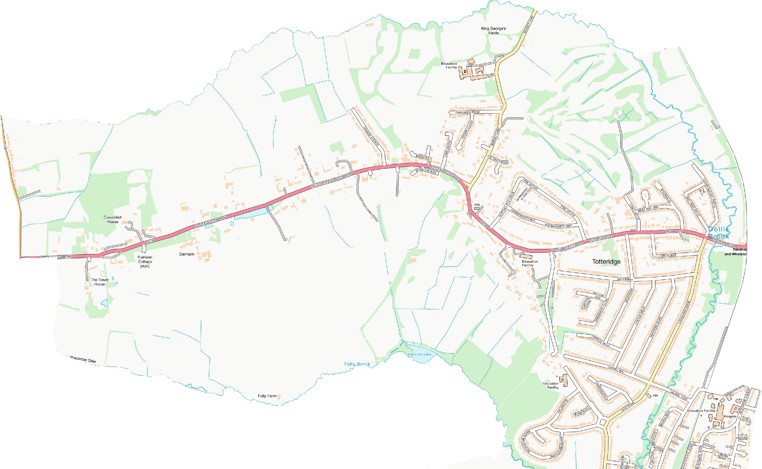

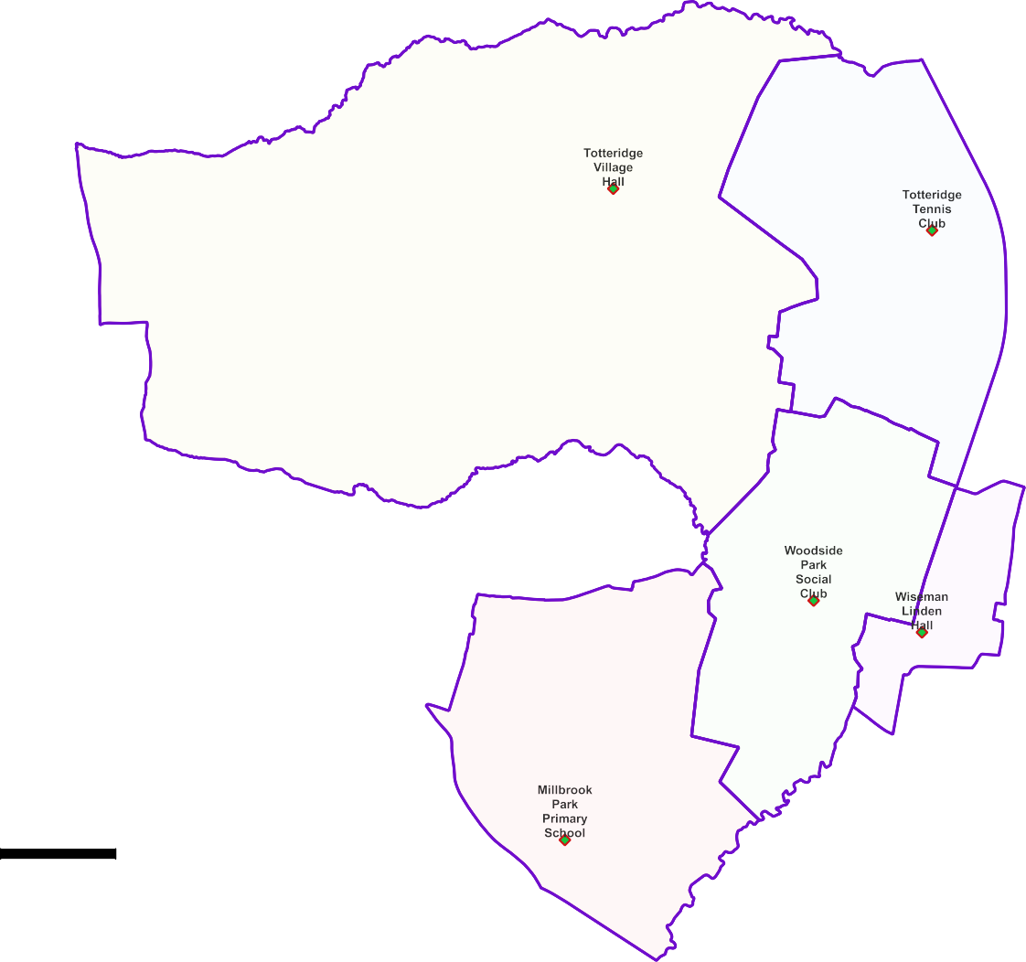
Totteridge and Woodside Ward -

Polling Proposals for May 2022

5 x Polling Districts Proposed Polling Places:
- Totteridge Village Hall (1x Polling Station)
- Totteridge Tennis Club (1x Polling Station)
- Woodside Park Social Club (2x Polling Stations)
- Wiseman Linden Hall (1x Polling Station)
- Millbrook Park Primary School (1x Polling Station)

PDPP_Draft Proposal Public Consultation OctNov 2021

Contains OS data © Crown copyright [and database right] [2021].

