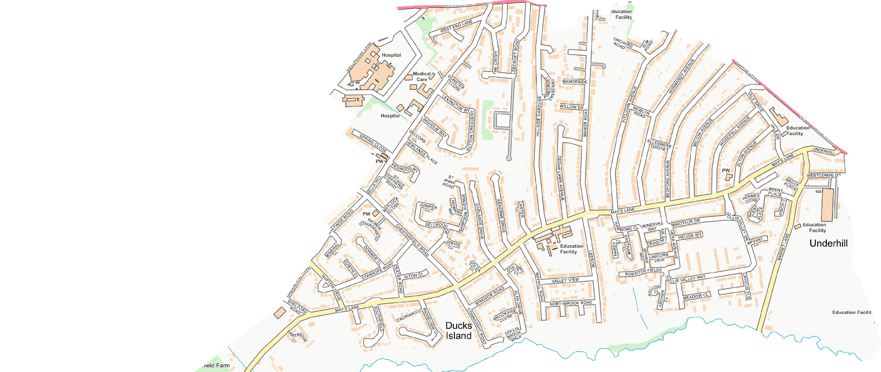
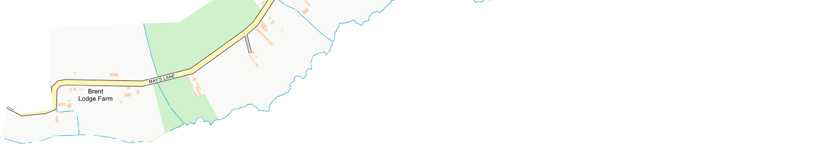
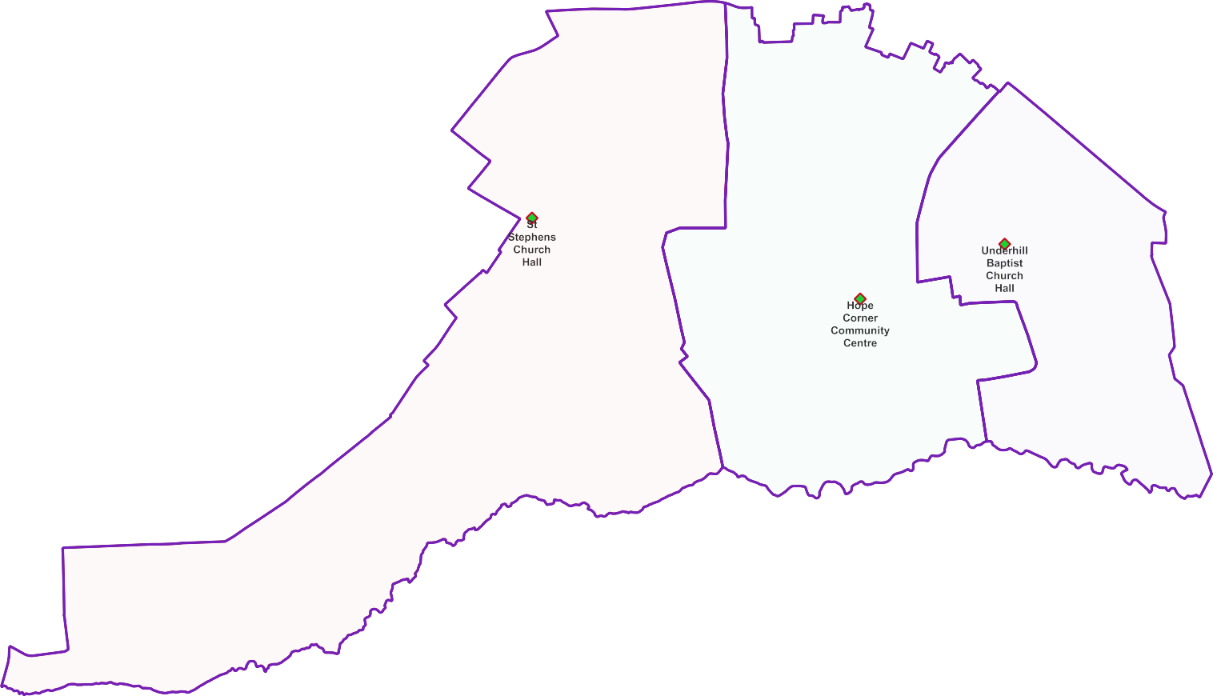
Underhill Ward -

Polling Proposals for May 2022

3 x Polling Districts Proposed Polling Places:
- St Stephen's Church Hall (2x Polling Stations)
- Hope Corner Community Centre (2x Polling Stations)
- Underhill Baptist Church Hall (1x Polling Station)

PDPP_Draft Proposal Public Consultation OctNov 2021

Contains OS data © Crown copyright [and database right] [2021].

