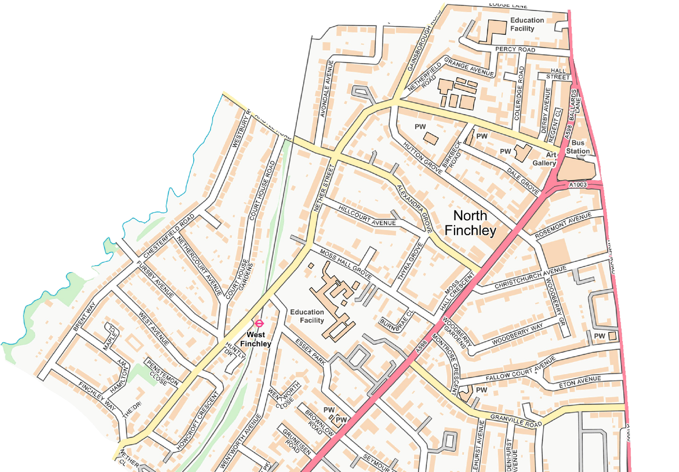
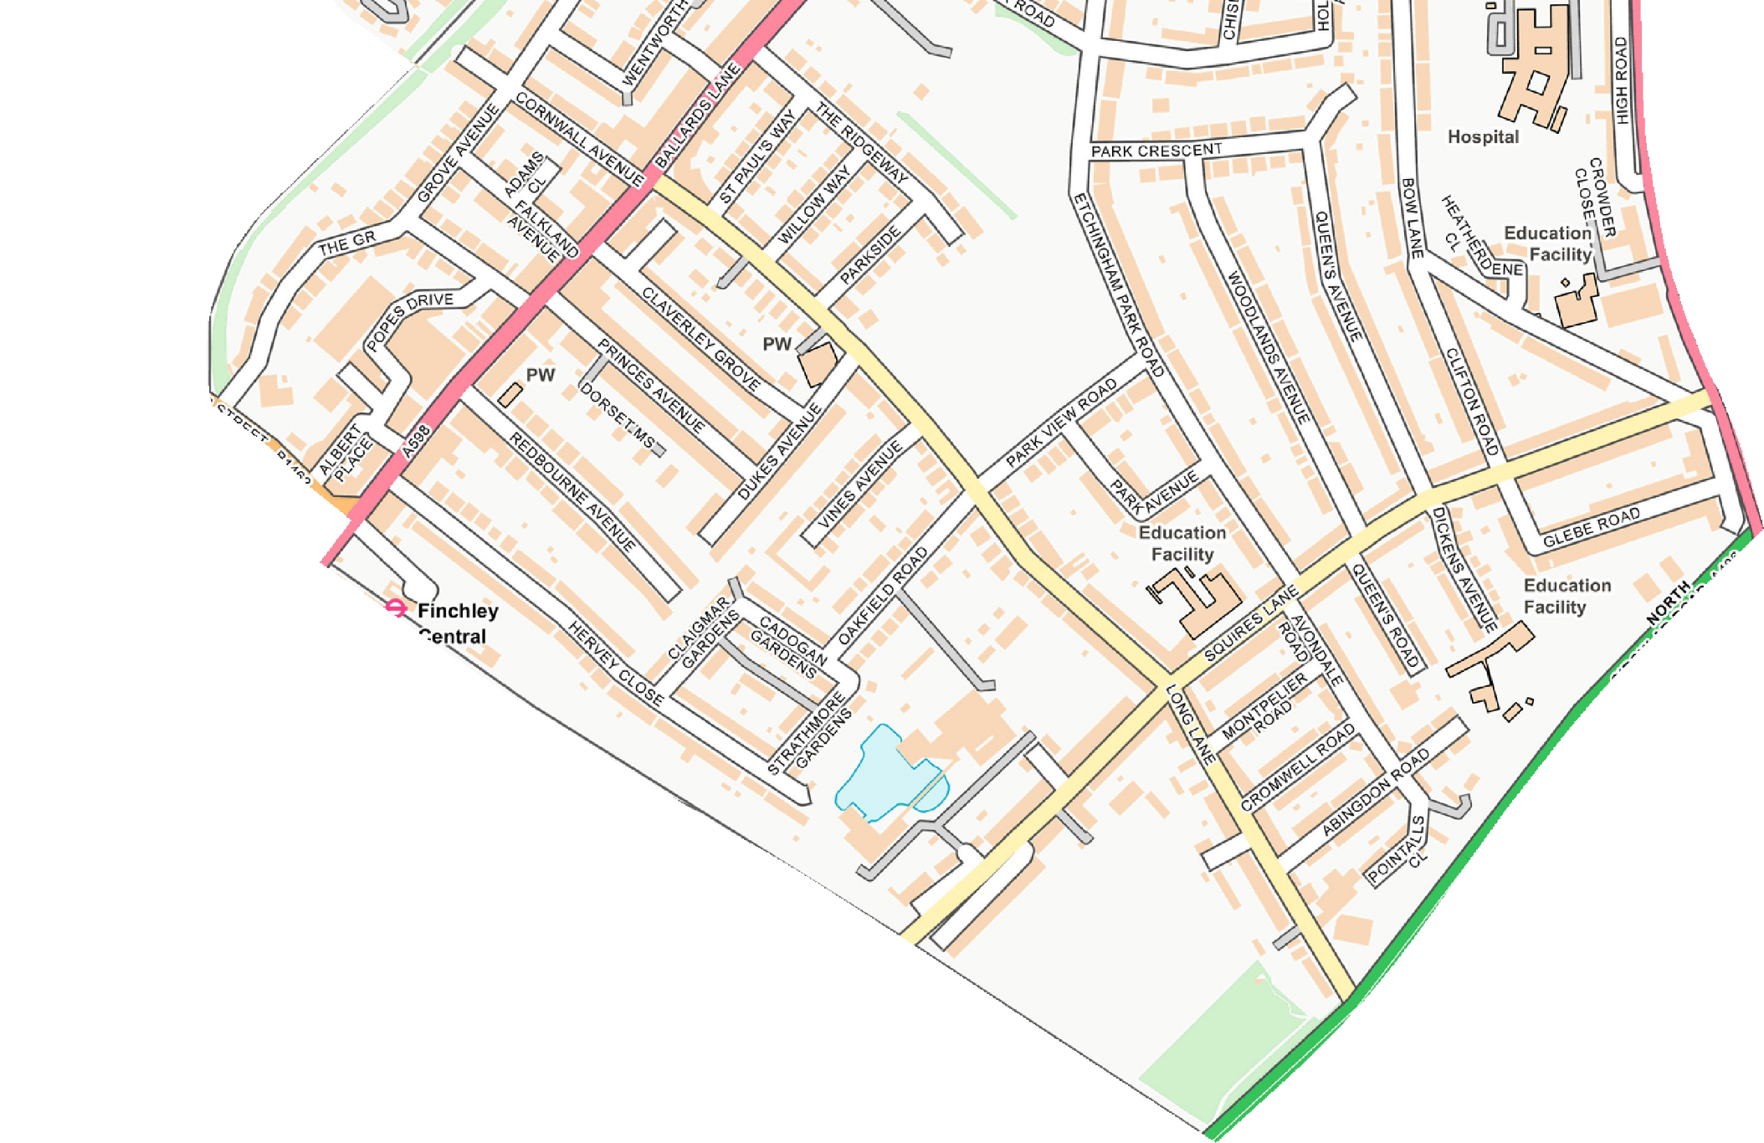
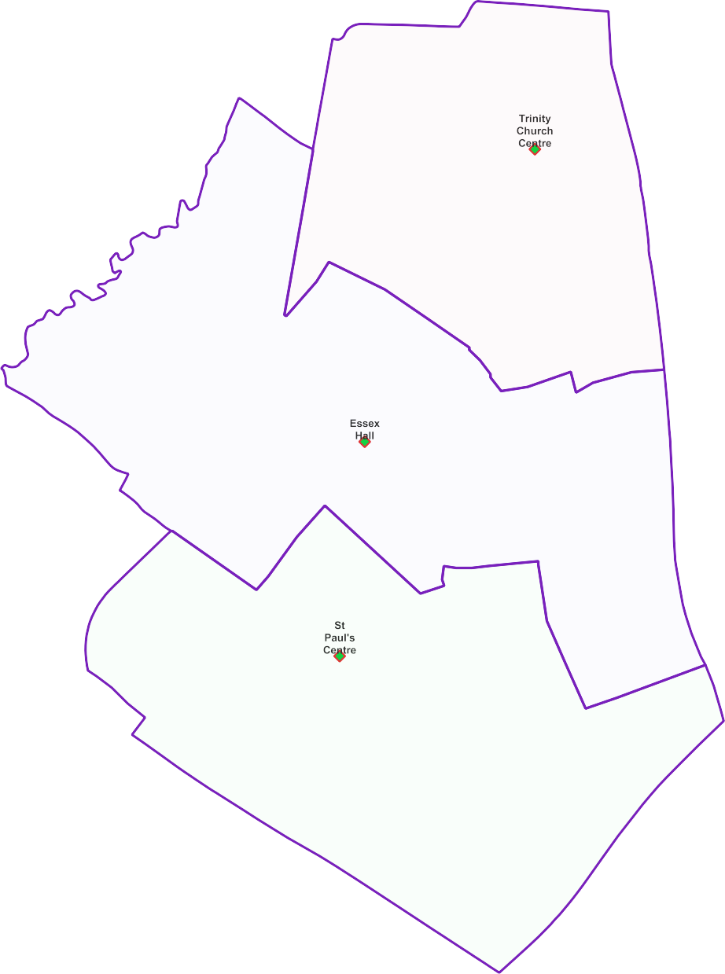
West Finchley Ward -

Polling Proposals for May 2022

3 x Polling Districts Proposed Polling Places:
- Trinity Church Centre (2x Polling Stations)
- Essex Hall
(2x Polling Stations)
- St Paul's Centre
(2x Polling Stations)

PDPP_Draft Proposal Public Consultation OctNov 2021

Contains OS data © Crown copyright [and database right] [2021].

