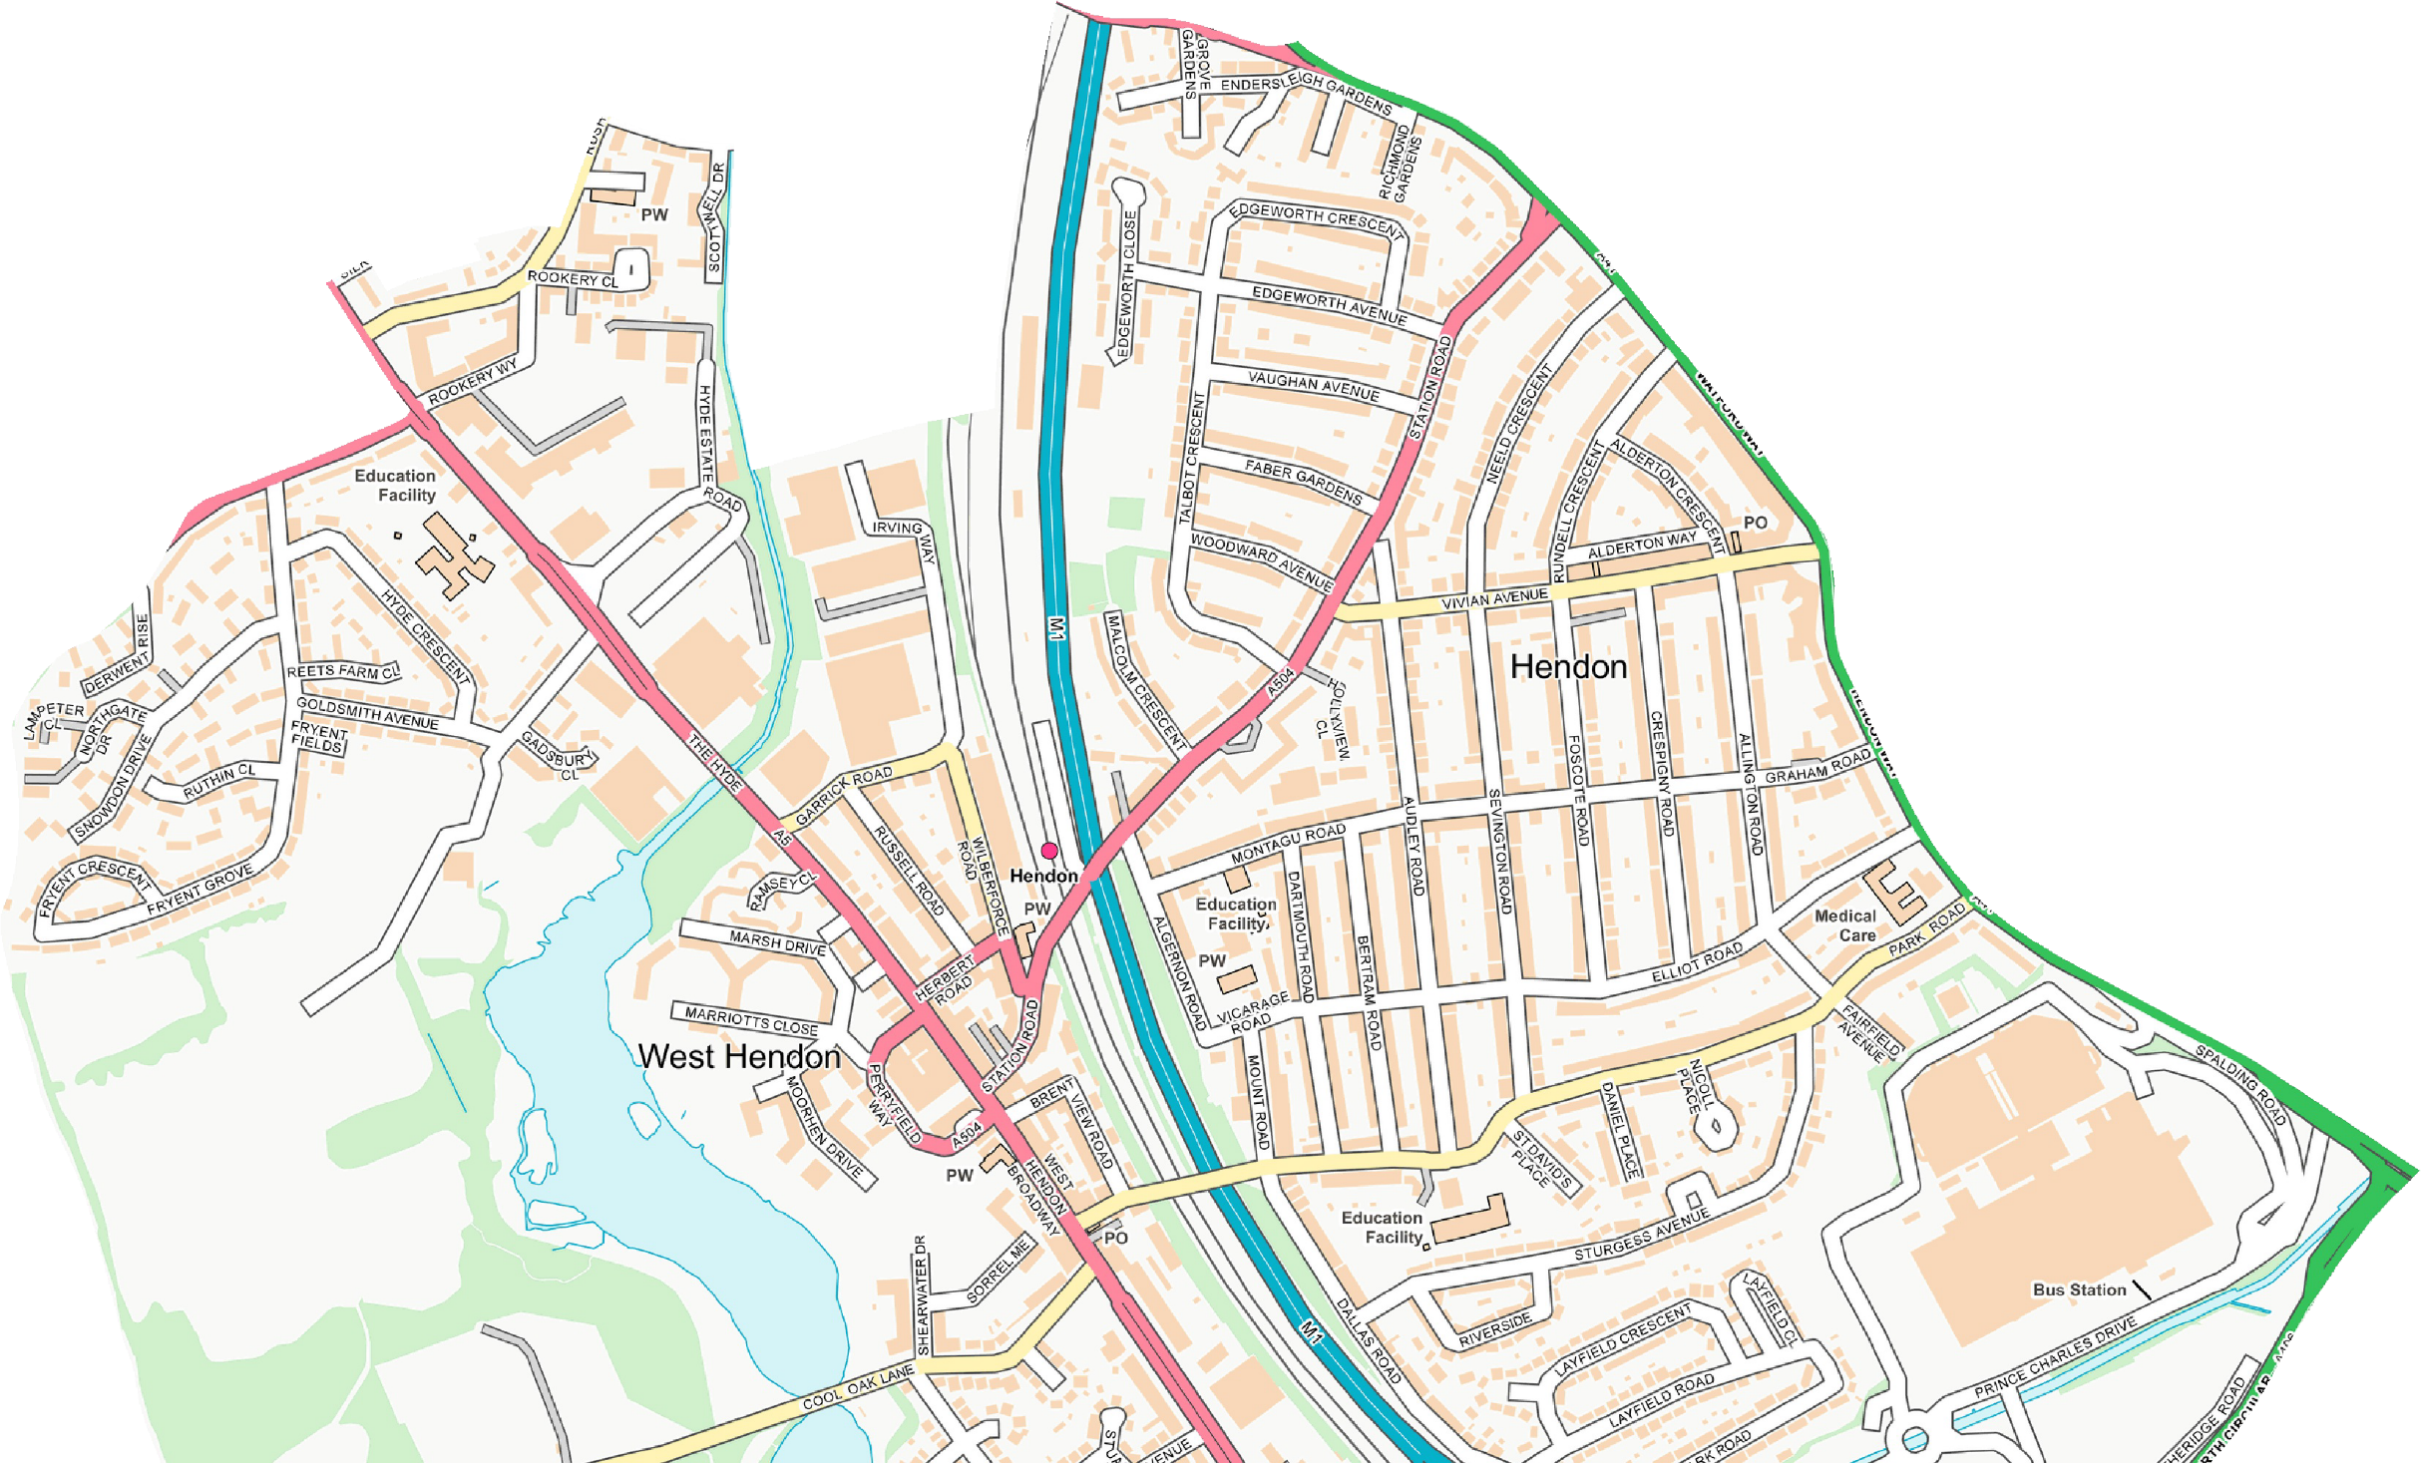
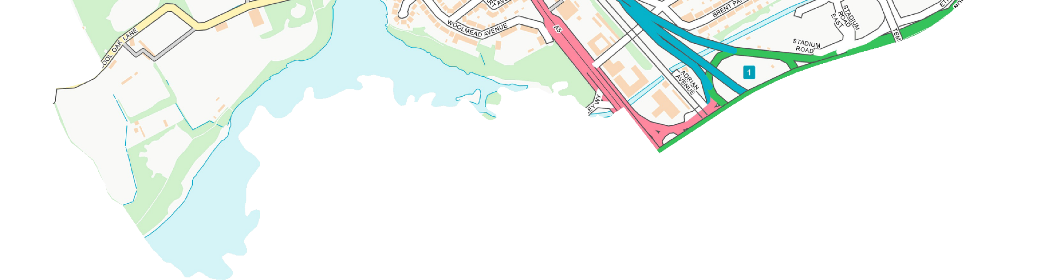
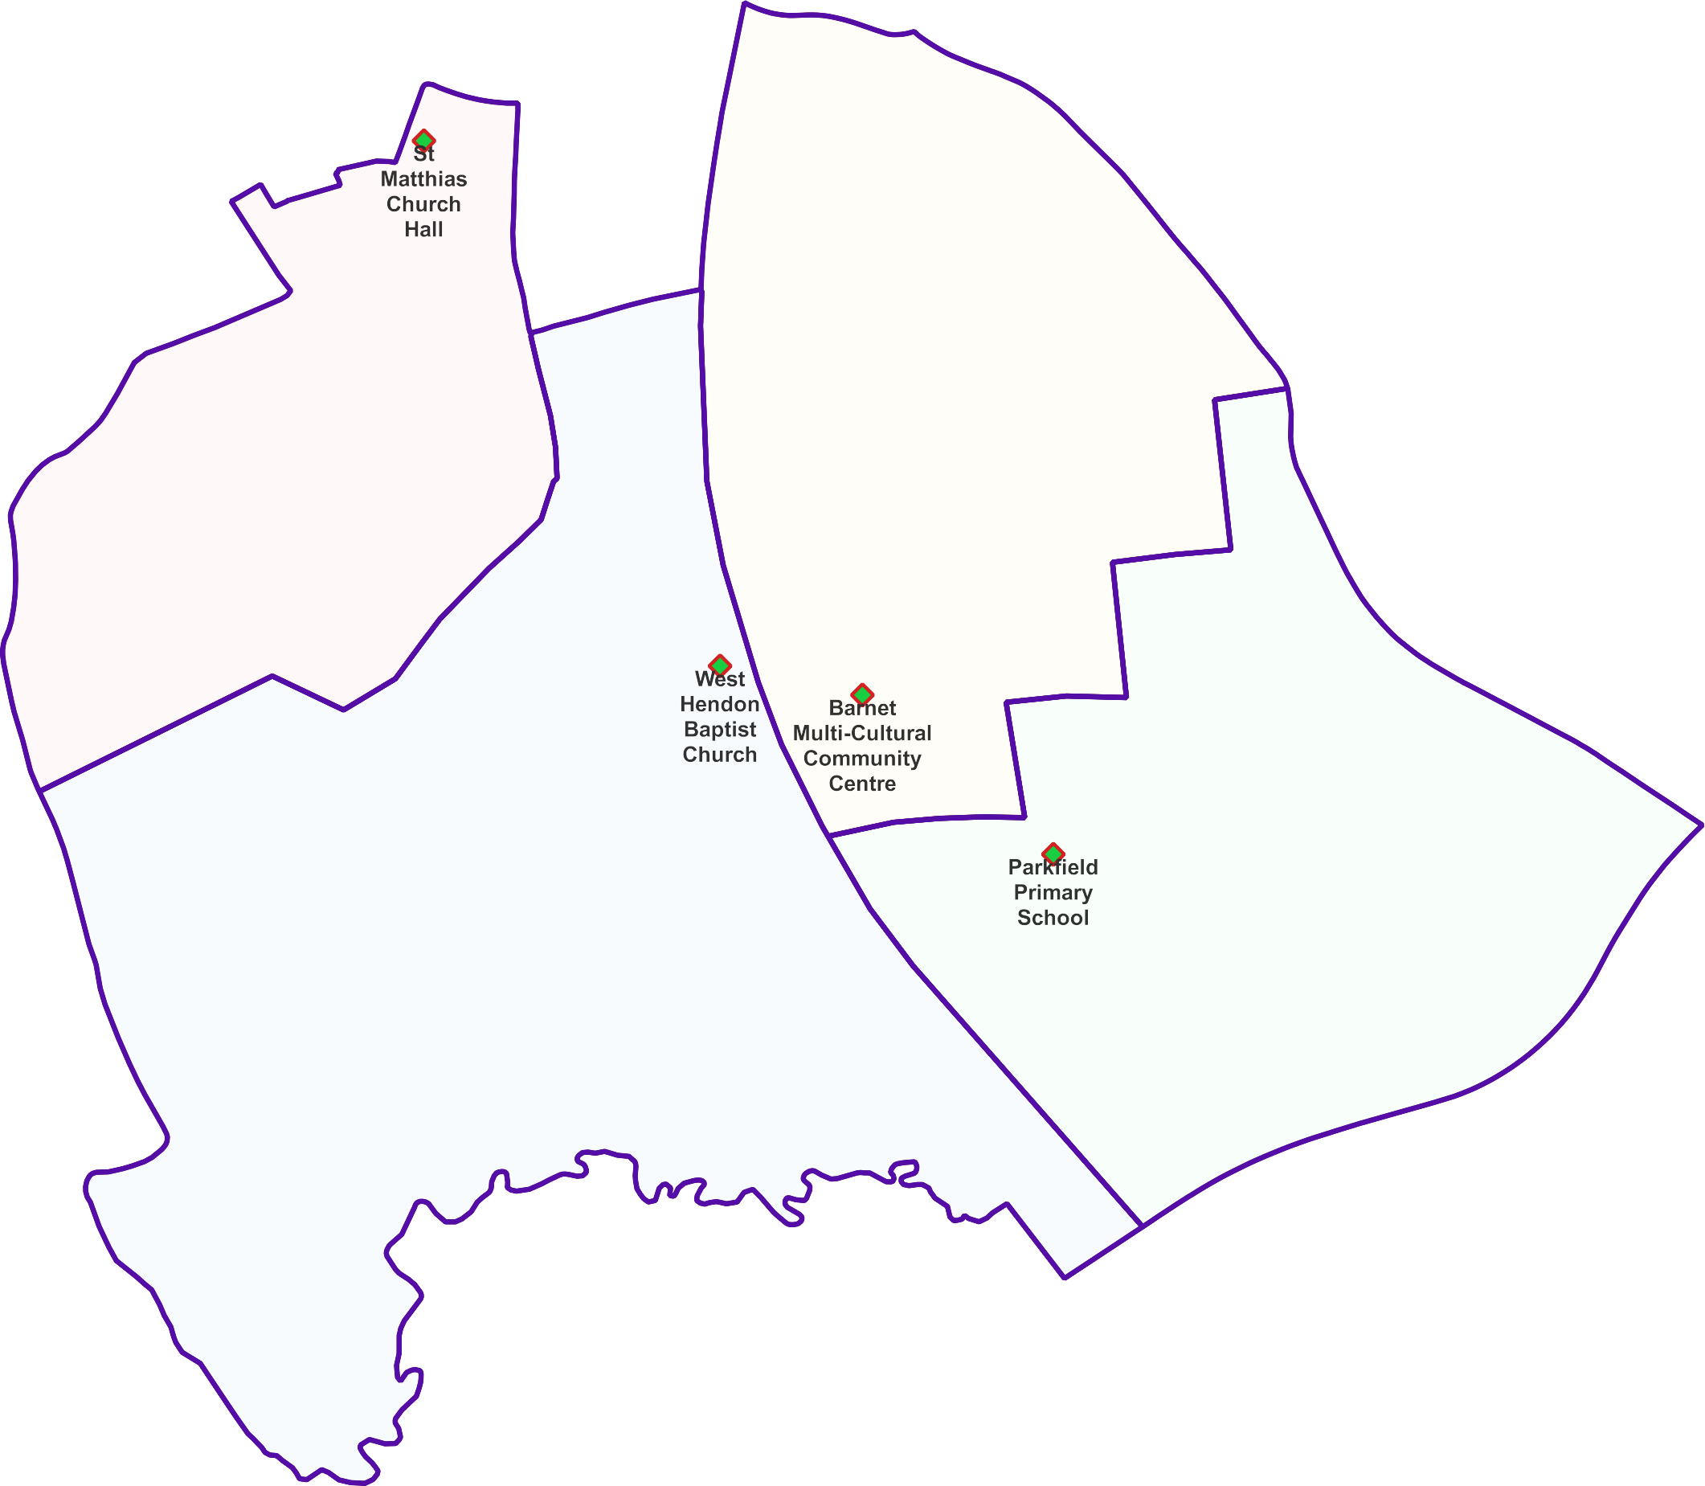
West Hendon Ward -

Polling Proposals for May 2022
4 x Polling Districts Proposed Polling Places:
- St Matthias Church Hall
(1x Polling Station)
- West Hendon Baptist Church Hall (2x Polling Stations)
- Barnet Multi-Cultural Community Centre (2x Polling Stations)
- Parkfield Primary School (1x Polling Station)

PDPP_Draft Proposal Public Consultation OctNov 2021

Contains OS data © Crown copyright [and database right] [2021].

