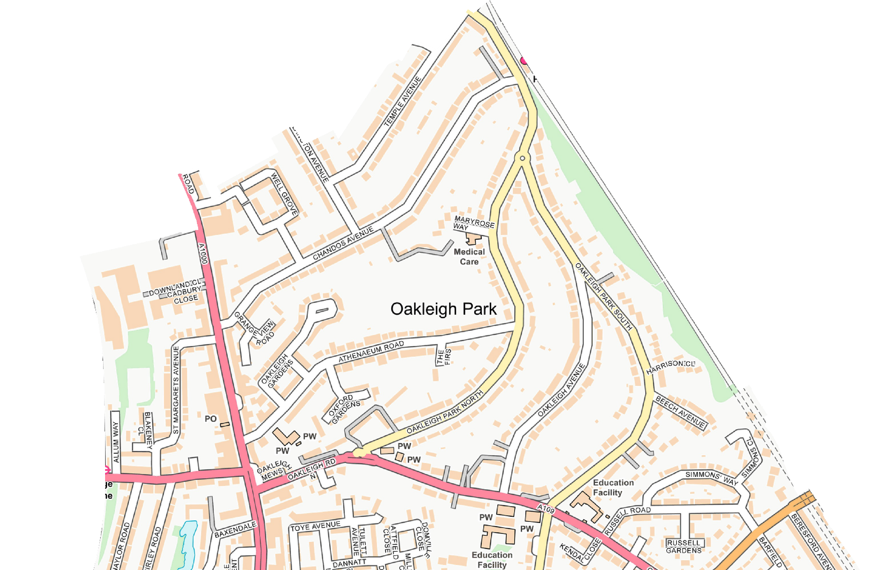
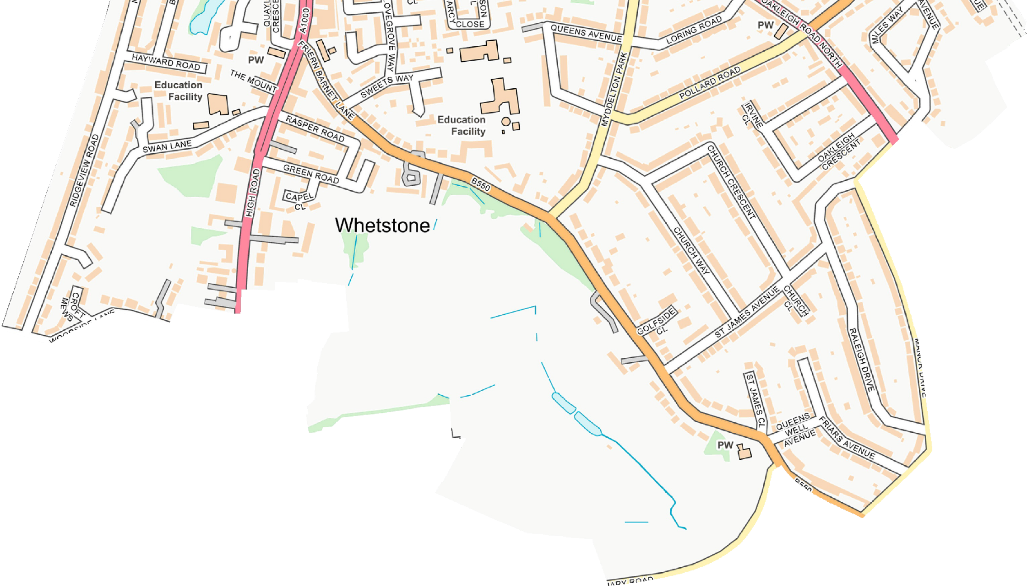
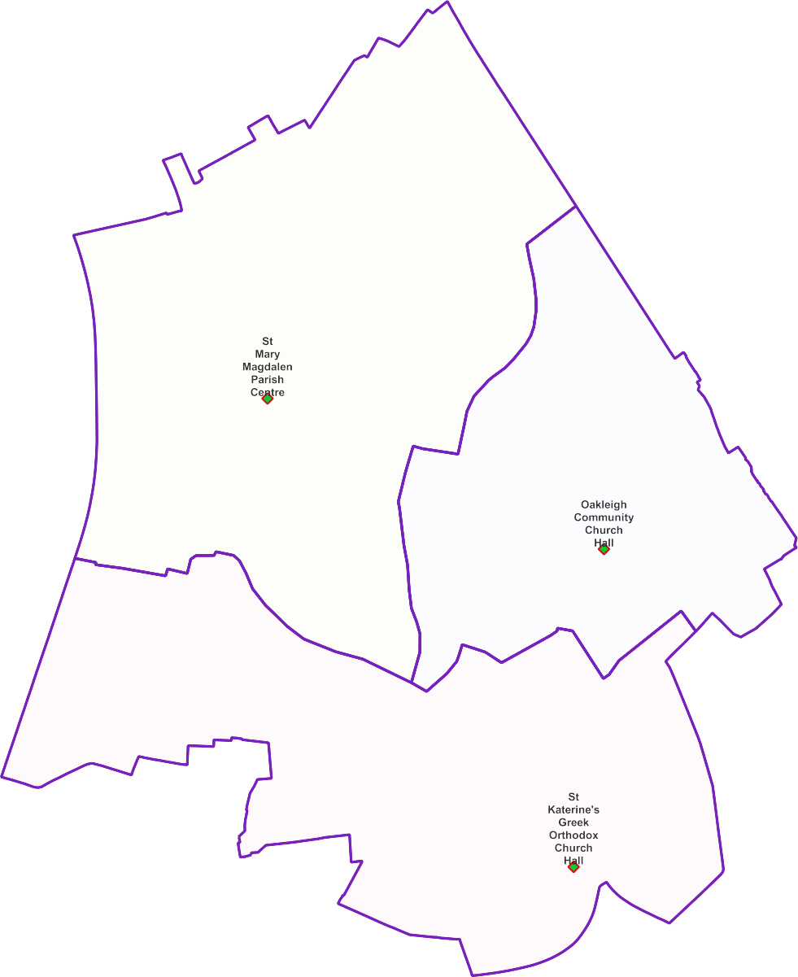
Whetstone Ward -

Polling Proposals for May 2022
3 x Polling Districts Proposed Polling Places:
- St Mary Magdalen Parish Centre (3568 allocated electors)
- Oakleigh Community Church Hall (2113 allocated electors)
- St Katerine's Greek Orthodox Church Hall (2265 allocated electors)

PDPP_Draft Proposal Public Consultation OctNov 2021

Contains OS data © Crown copyright [and database right] [2021].

