London Borough of Barnet
Colindale North Ward
from 5 May 2022

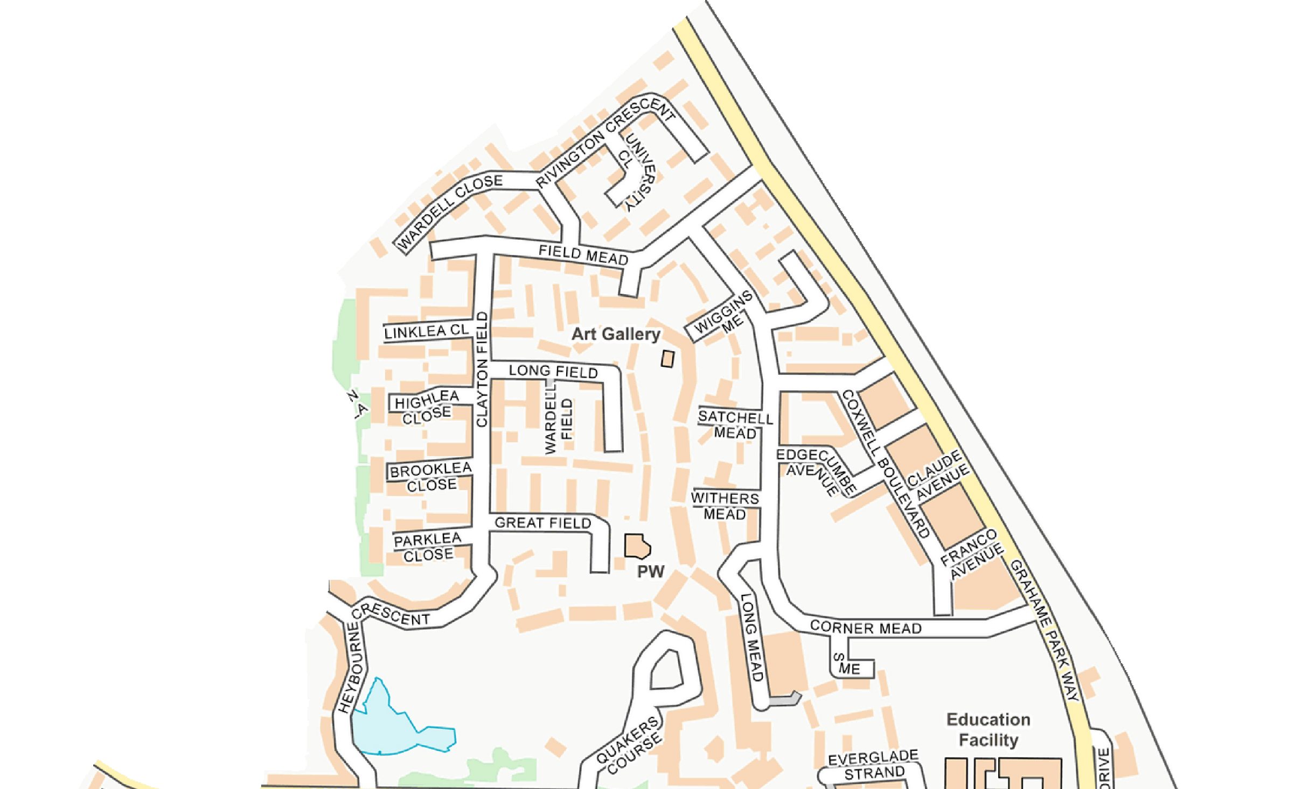
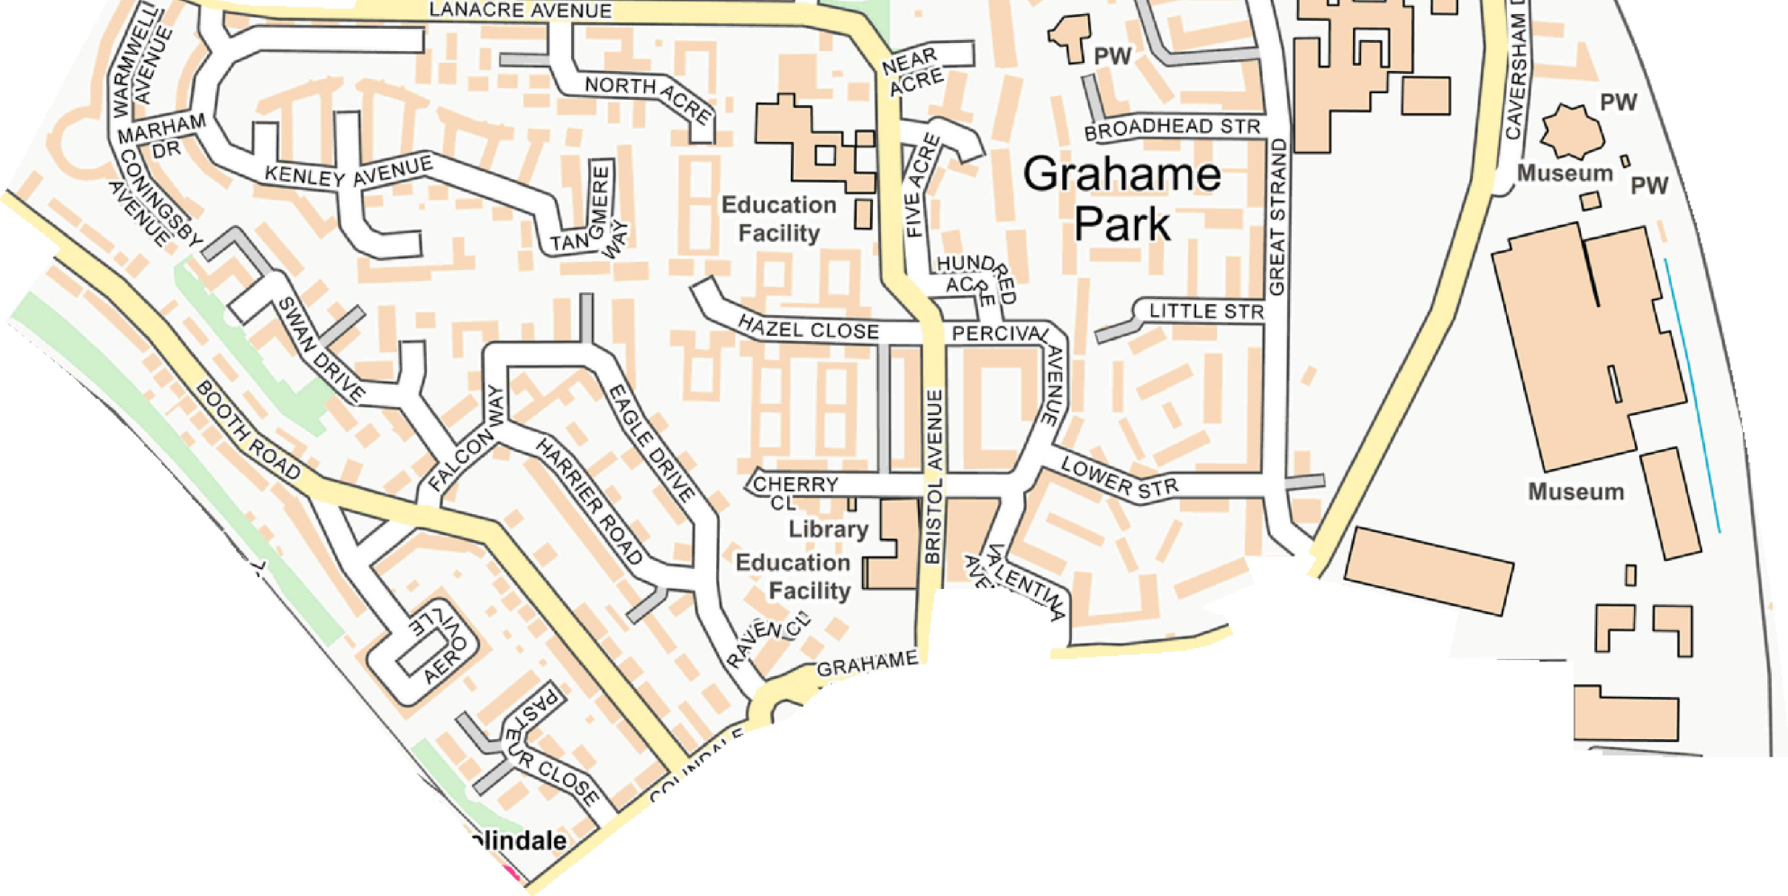
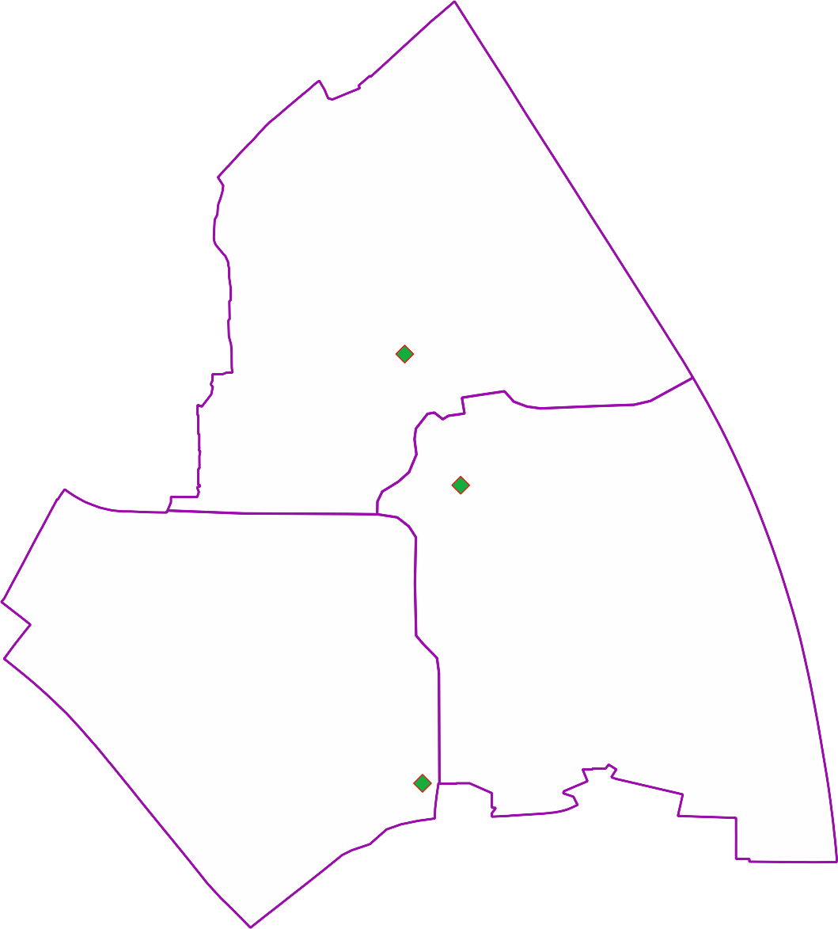
Polling Districts and Polling Places
CNA: St Augustine's Church Hall
CNB: Grahame Park Community Centre CNC: Colindale Library

CNA

St Augustine's Church Hall

Grahame Park Community Centre

CGP Cttee Jan 2022

CNC
CNB

Colindale Library

© Crown copyright and database rights 2021 OS 100071674. You are permitted to use this data solely to enable you to respond to, or interact with, the organisation that provided you with the data. You are not permitted to copy, sub-licence, distribute or sell any of this data to third parties in any form.

