London Borough of Barnet
Golders Green Ward
from 5 May 2022

Polling Districts and Polling Places
GGA: Marquees on Tennis Court - Princes Park GGB: St Edward the Confessor Church Hall GGC: Menorah Primary School

GGA

Marquees on Tennis Court (Princes Park)
CGP Cttee Jan 2022

GGB

GGC
St Edward the Confessor Church Hall
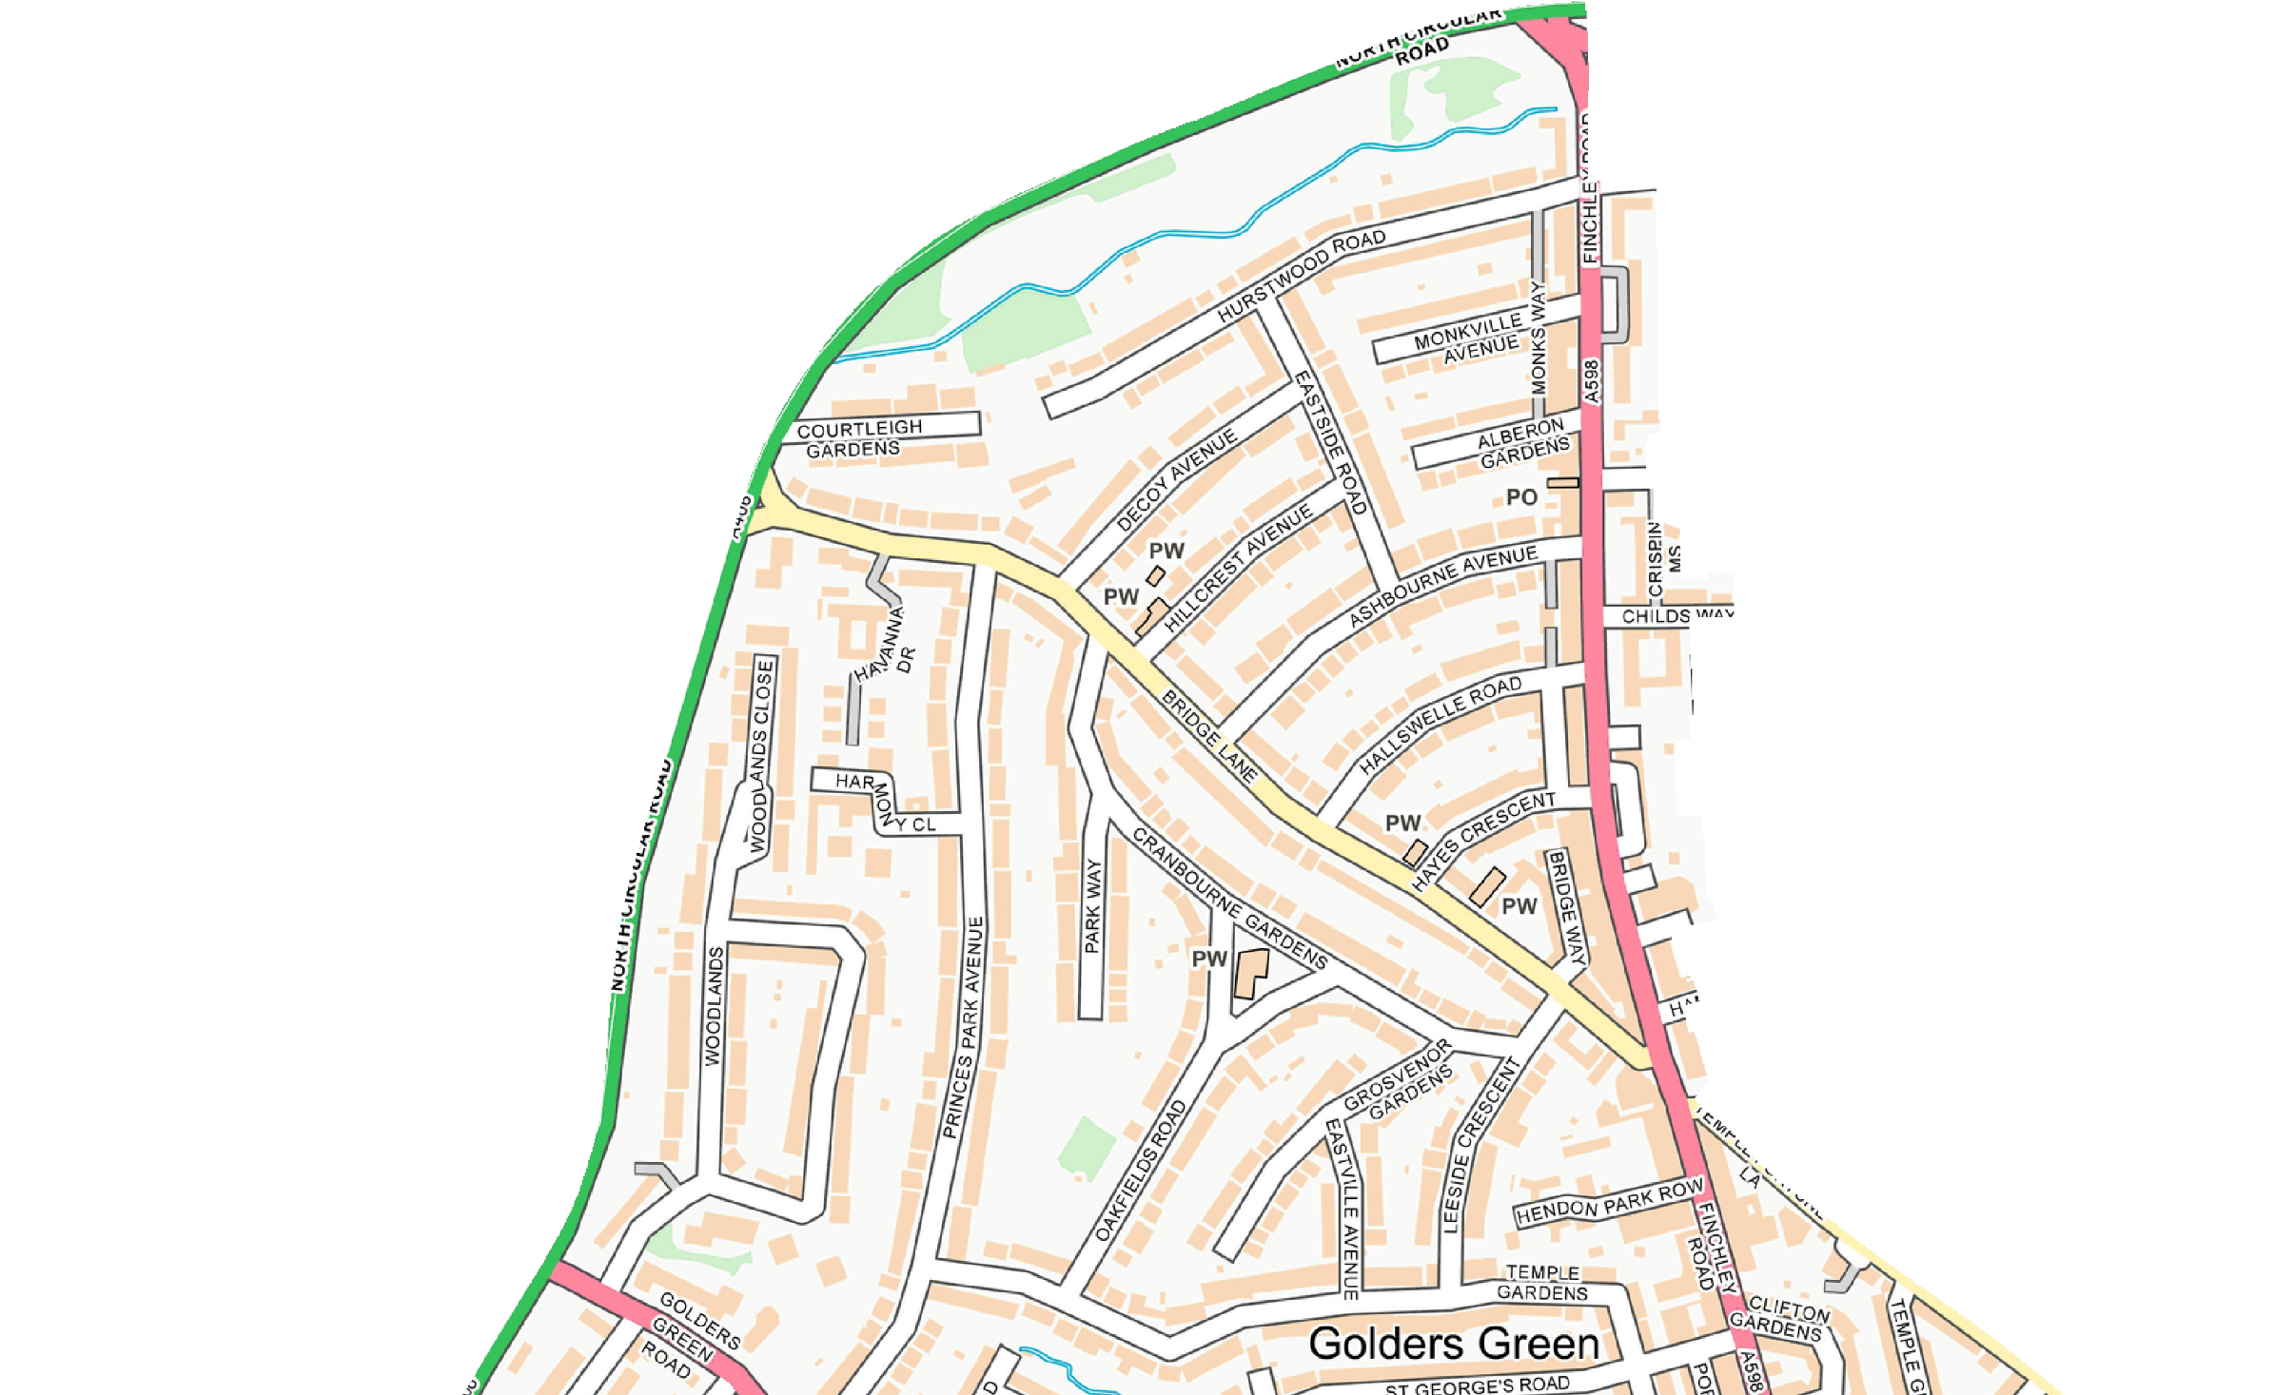
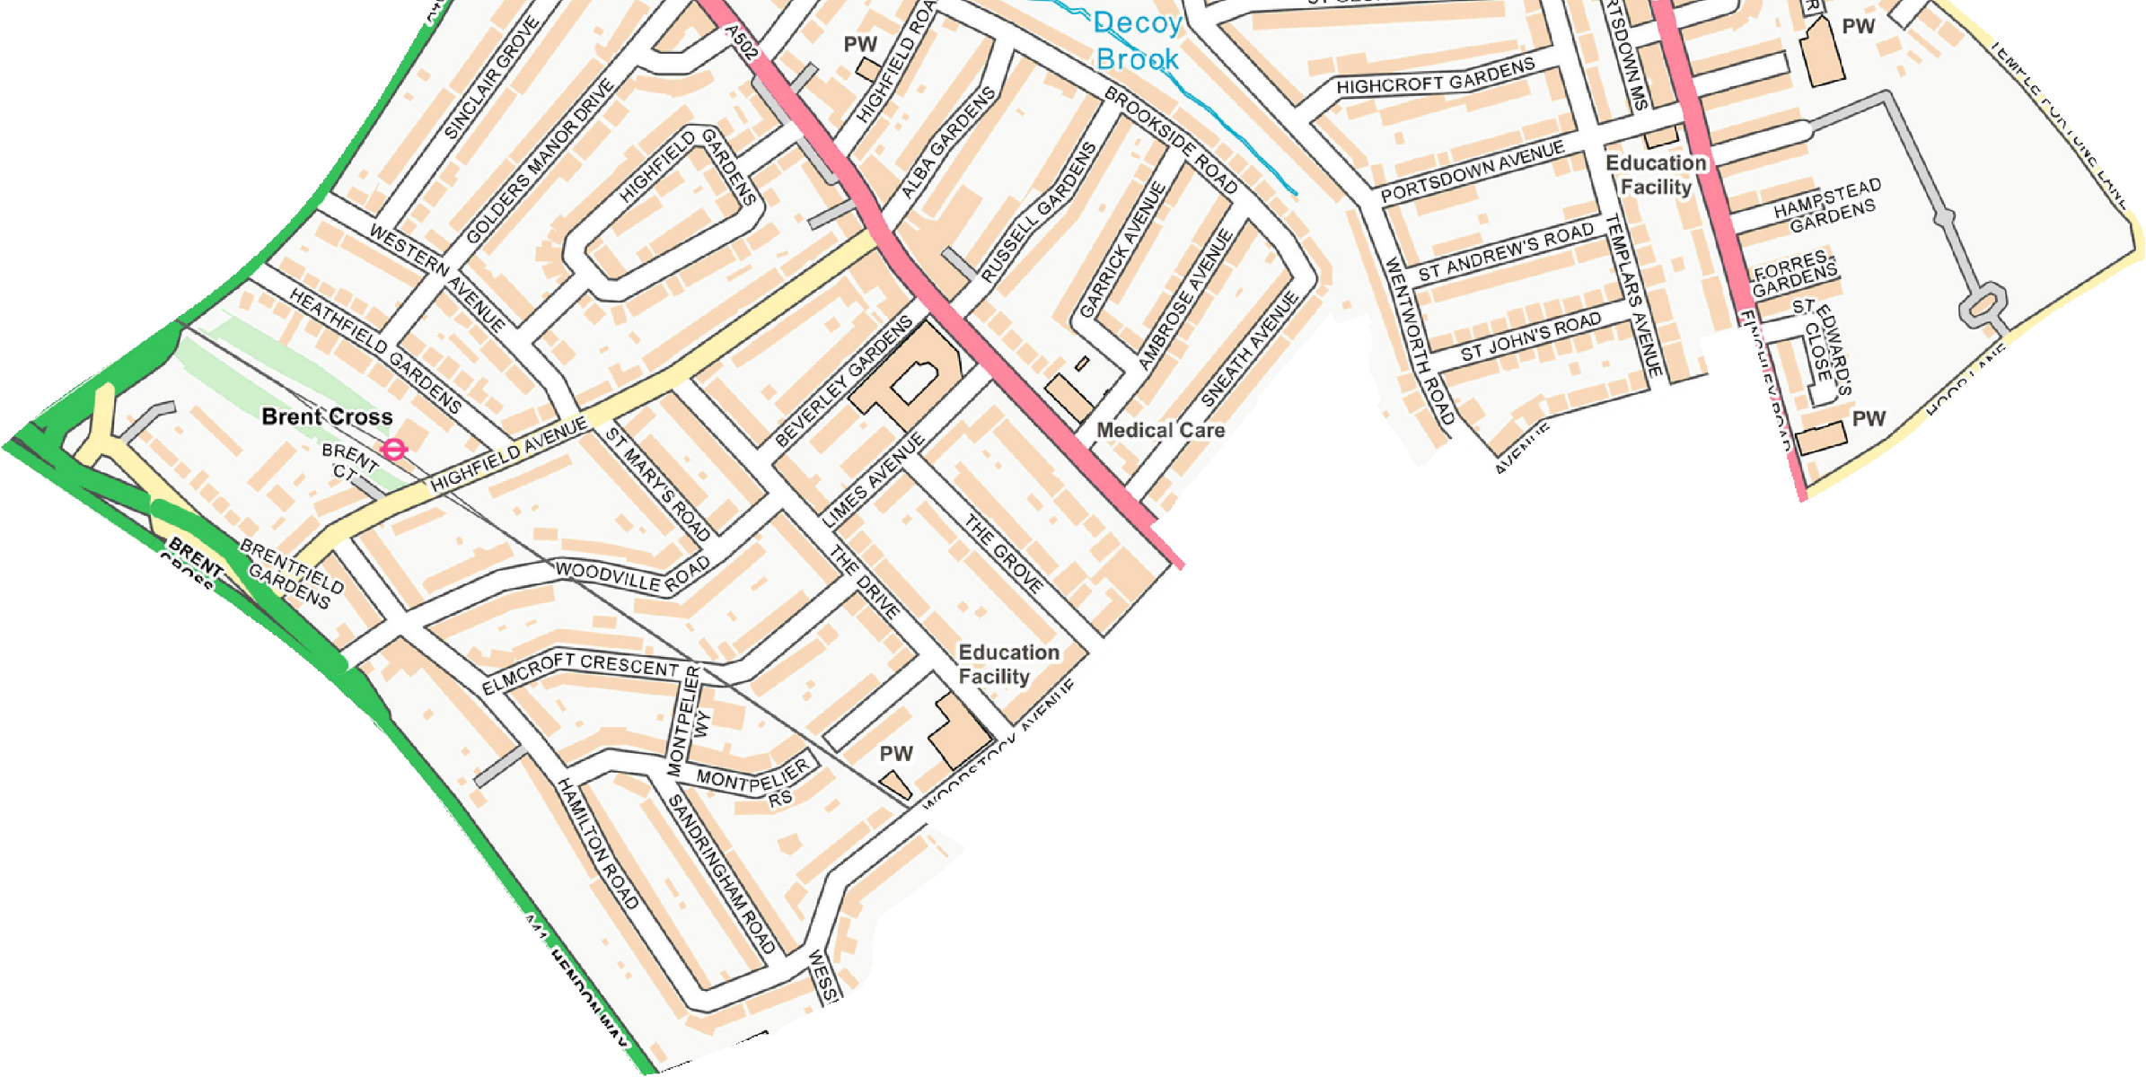
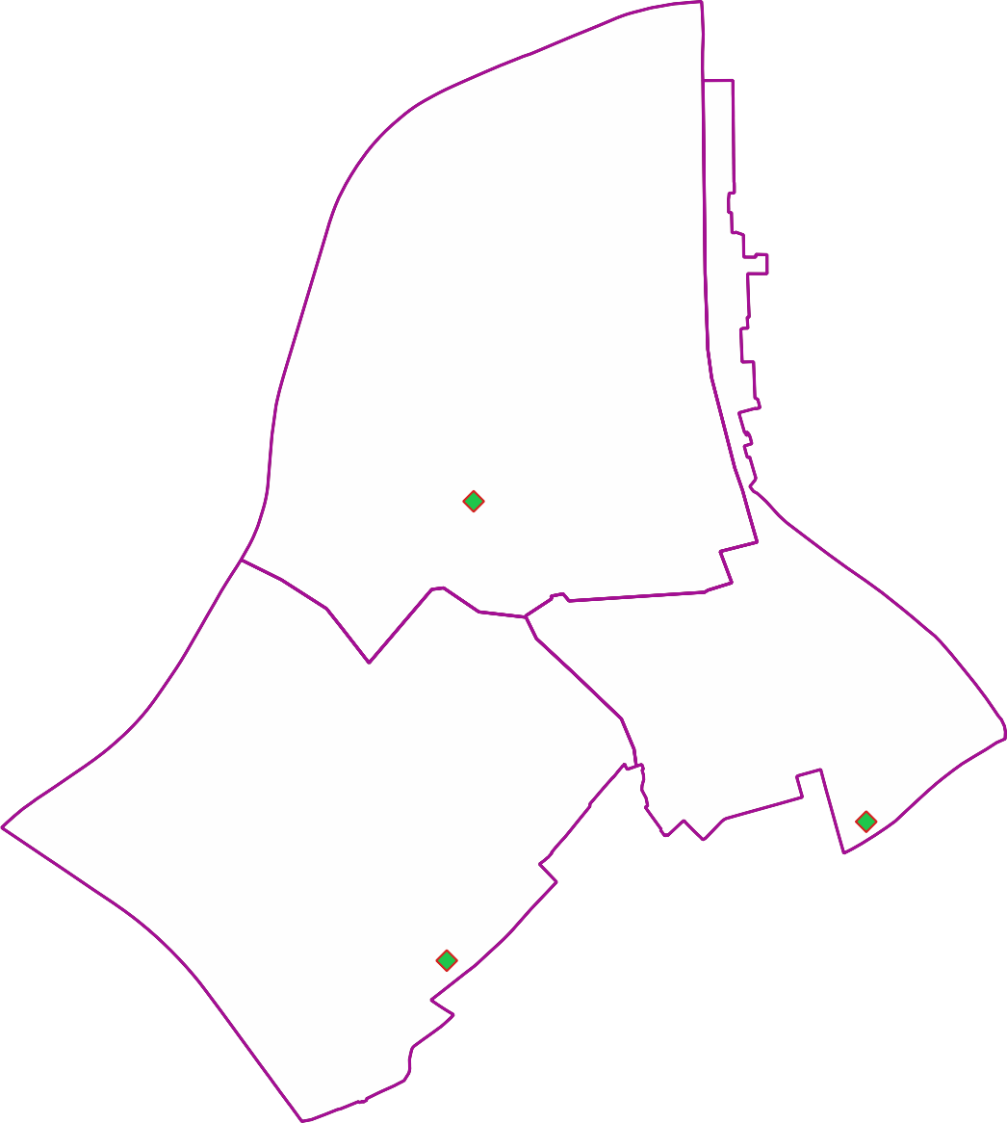

Menorah Primary School

© Crown copyright and database rights 2021 OS 100071674. You are permitted to use this data solely to enable you to respond to, or interact with, the organisation that provided you with the data. You are not permitted to copy, sub-licence, distribute or sell any of this data to third parties in any form.

