London Borough of Barnet
Totteridge and Woodside Ward
from 5 May 2022

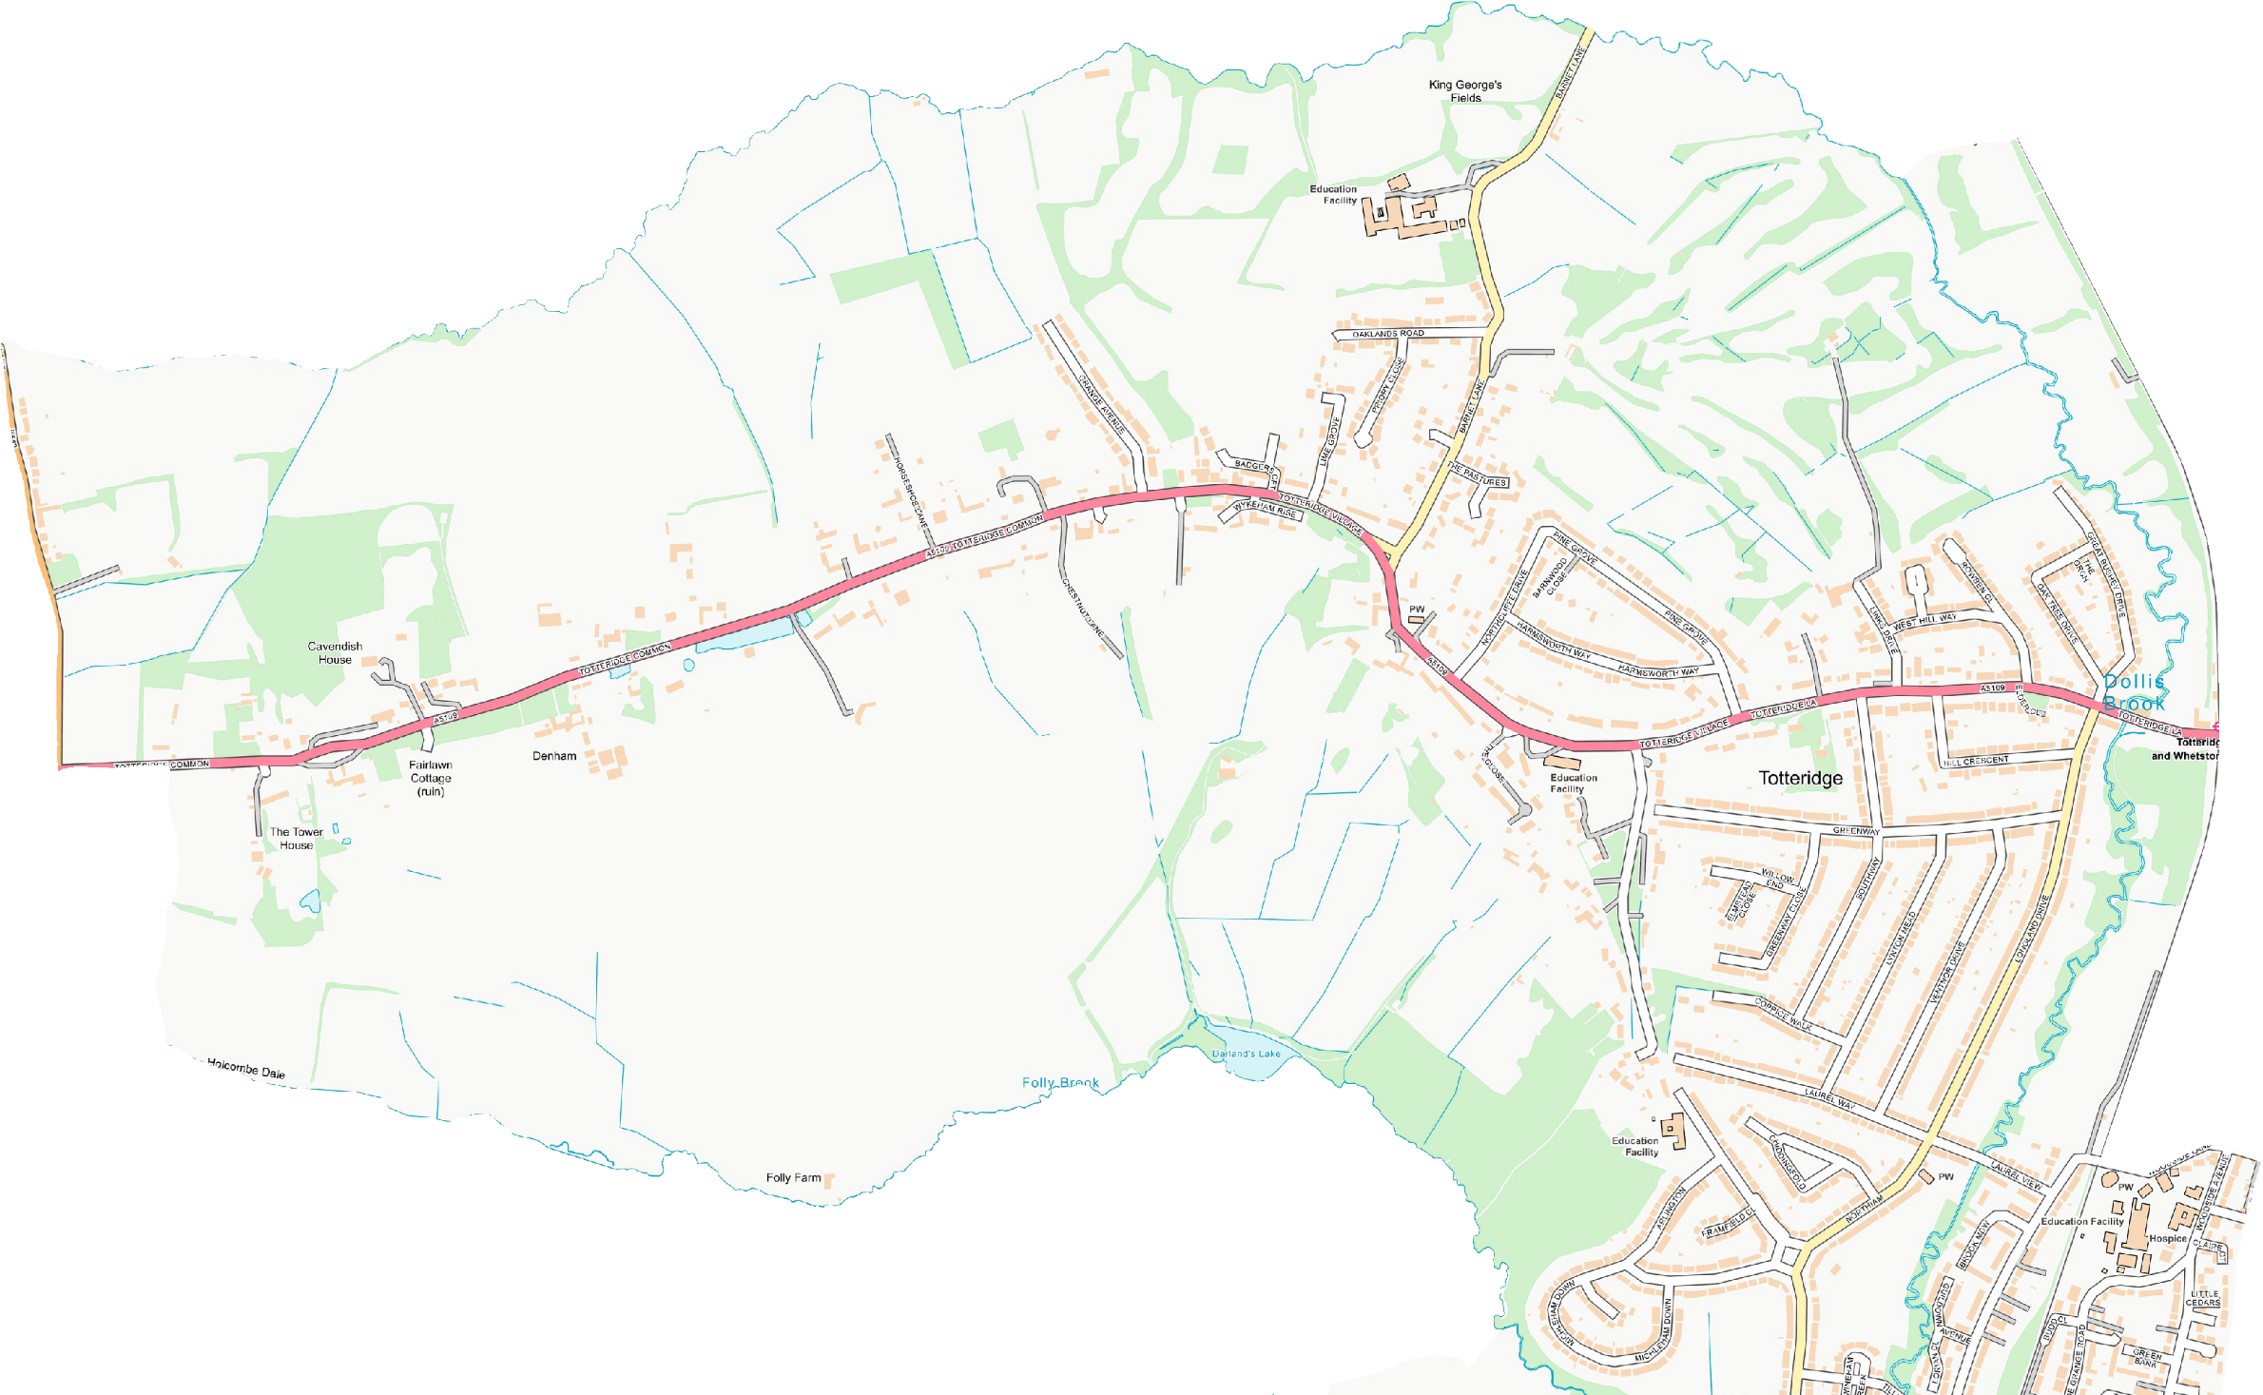
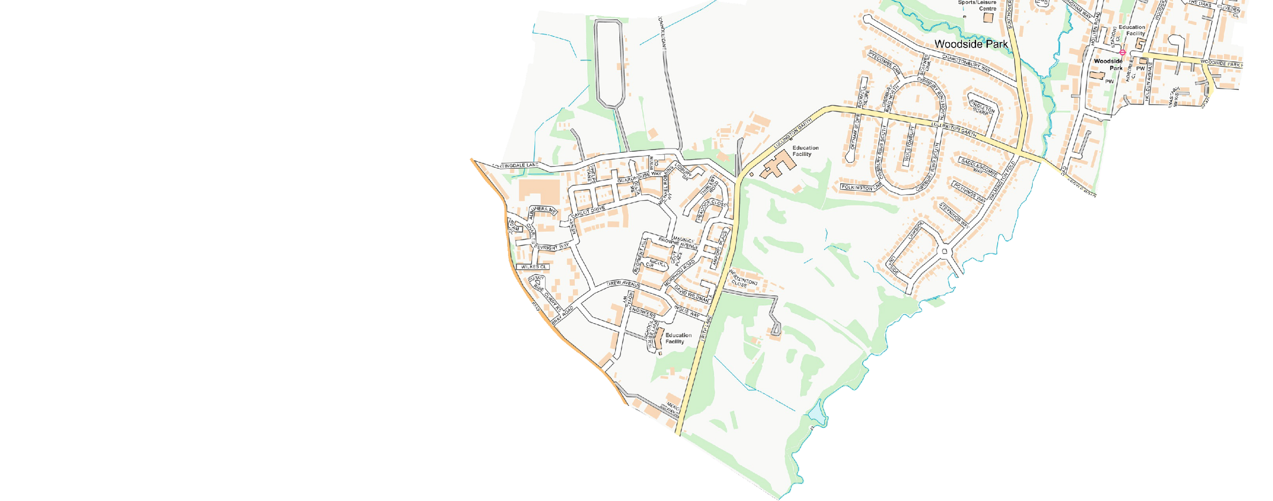
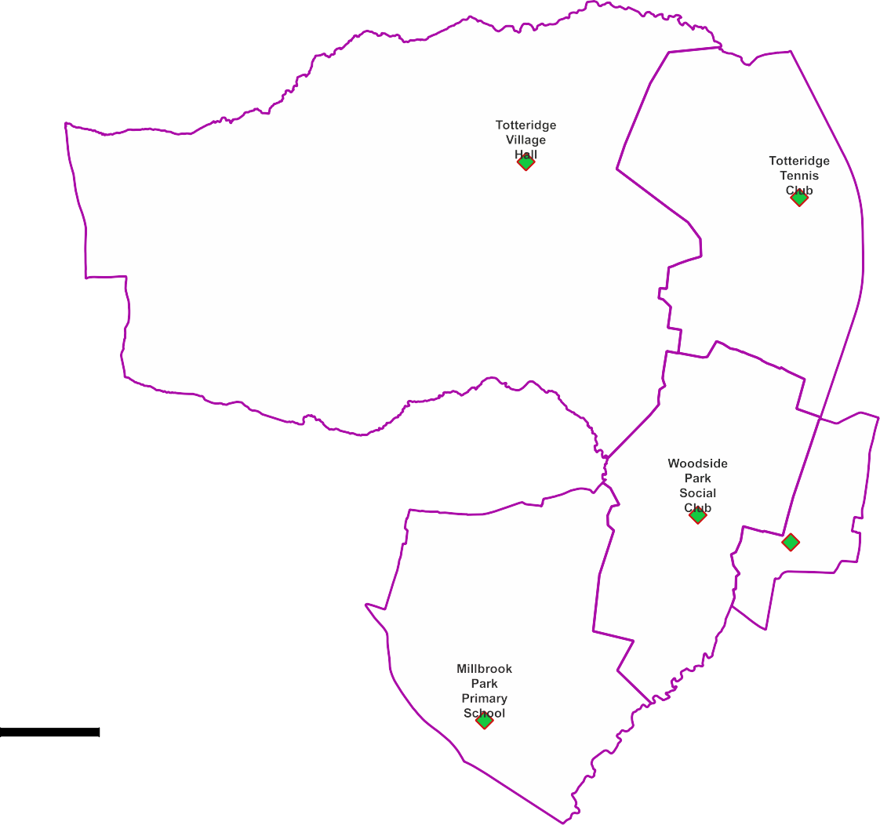
Polling Districts and Polling Places
TWA: Totteridge Village Hall TWB: Totteridge Tennis Club TWC: Woodside Park Social Club TWD: Wiseman Linden Hall
TWE: Millbrook Park Primary School

© Crown copyright and database rights 2021 OS 100071674. You are permitted to use this data solely to enable you to respond to, or interact with, the organisation that provided you with the data. You are not permitted to copy, sub-licence, distribute or sell any of this data to third parties in any form.
TWA

CGP Cttee Jan 2022

TWE
TWB

TWC
TWD

Wiseman Linden Hall

