London Borough of Barnet
Underhill Ward
from 5 May 2022

Polling Districts and Polling Places
UHA: St Stephen's Church Hall UHB: Underhill Baptist Church Hall
UHC: Hope Corner Community Centre

St Stephen's Church Hall

UHA
UHC

Hope Corner Community Centre

Underhill Baptist Church Hall

UHB
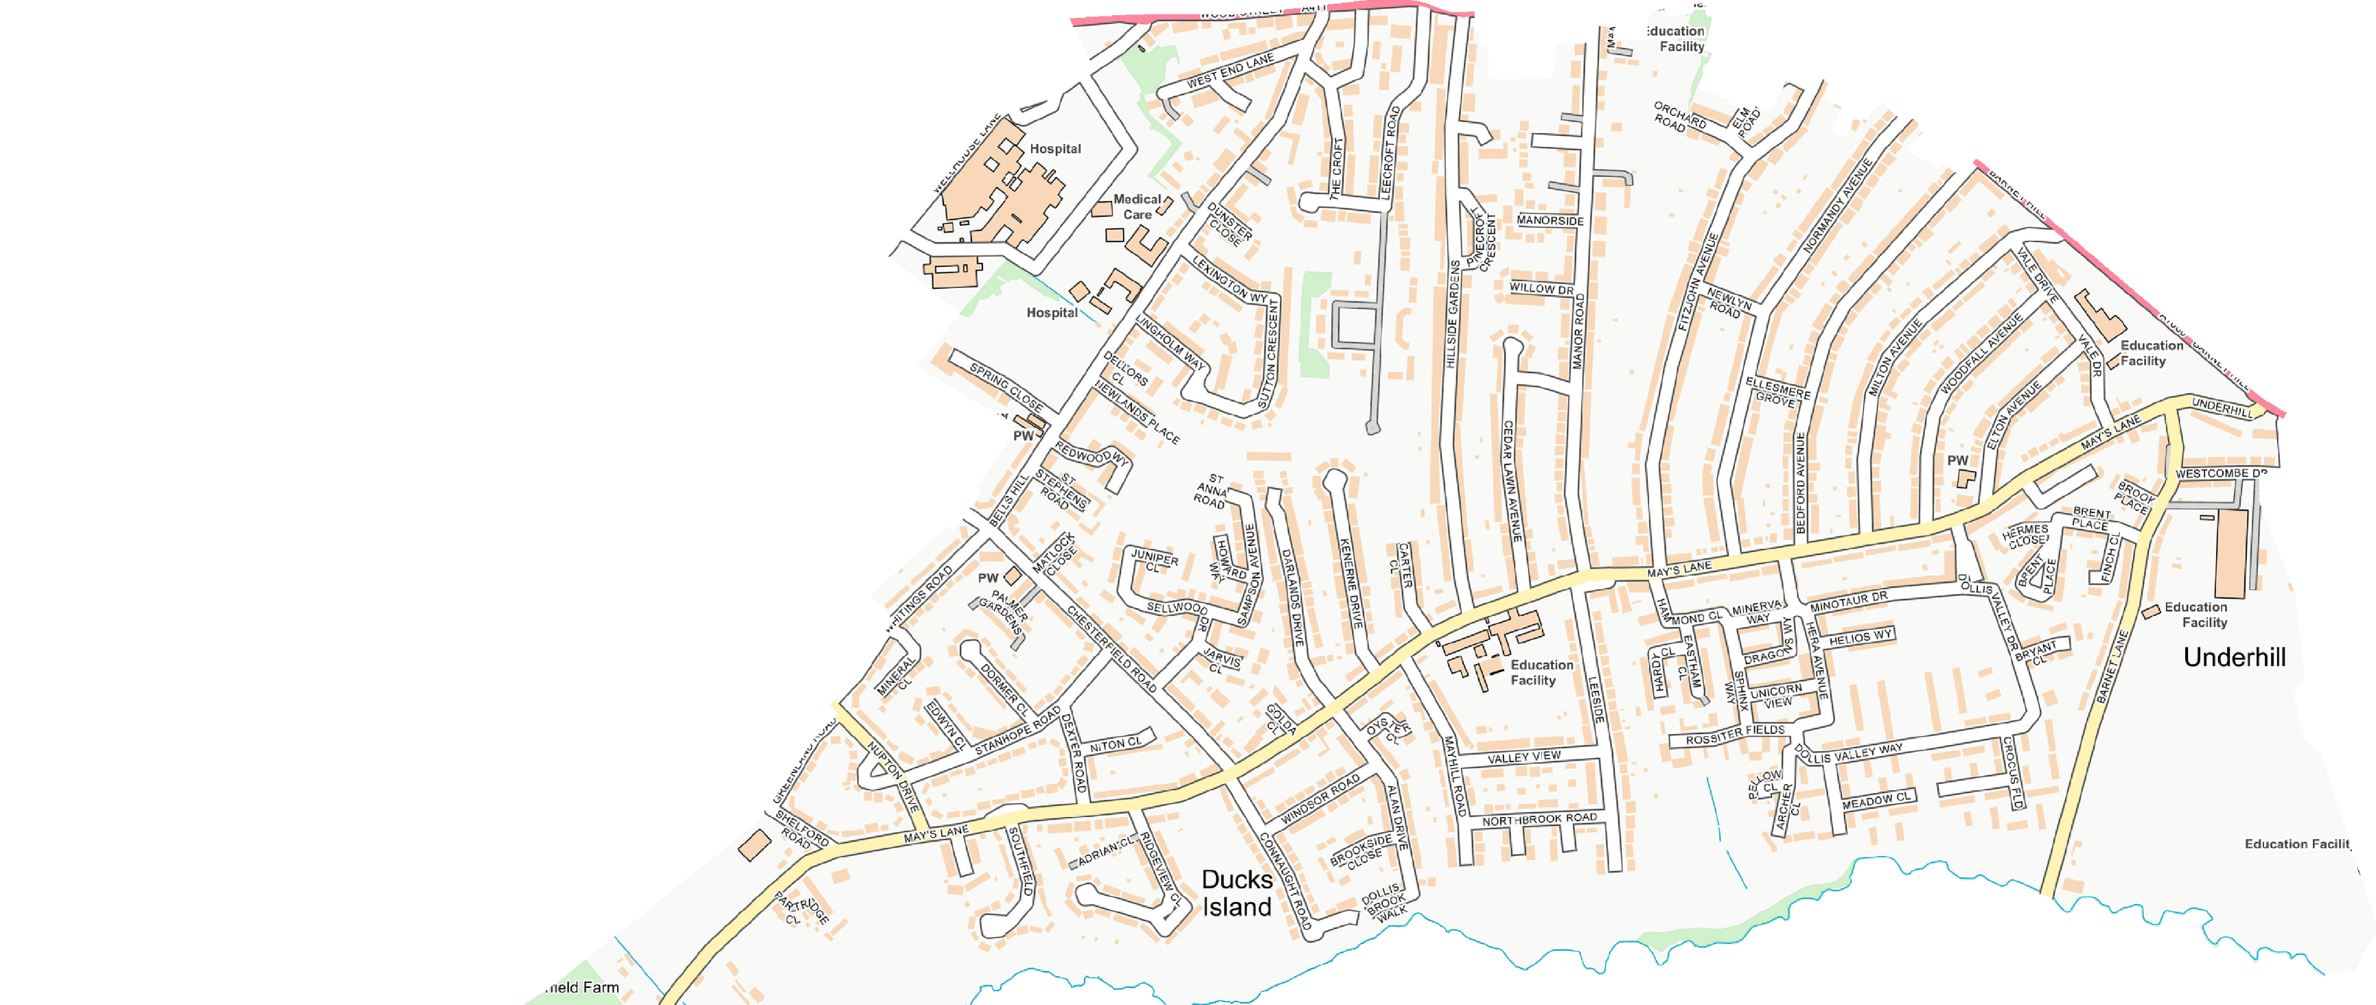
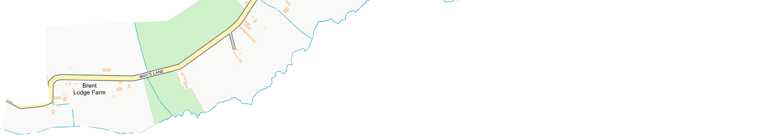
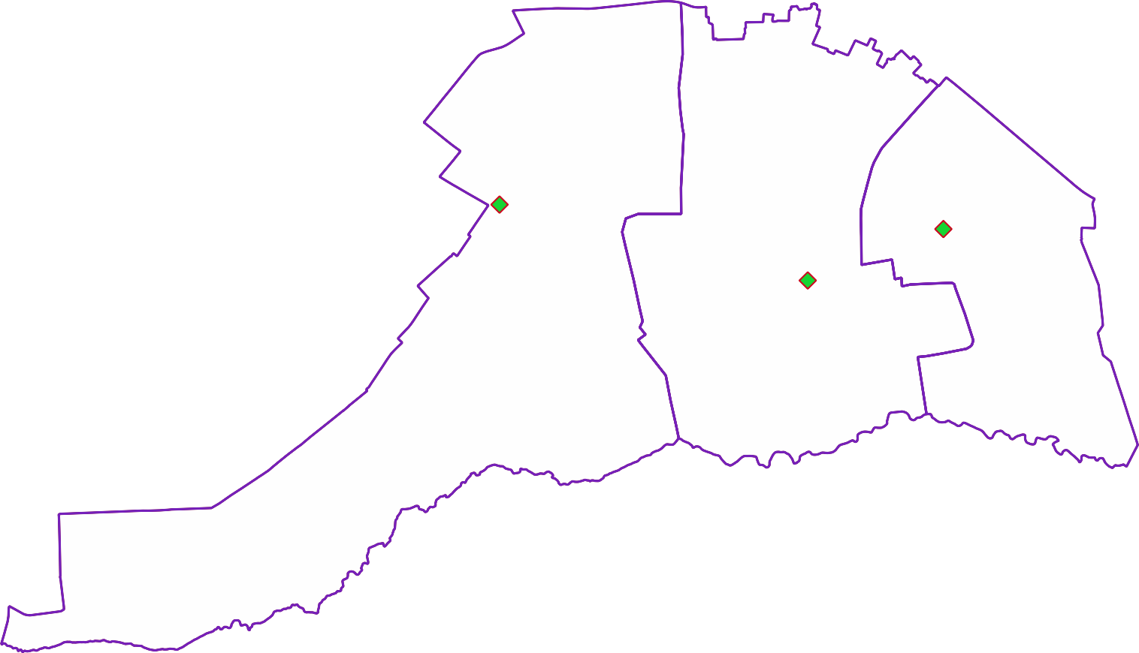

CGP Cttee Jan 2022

© Crown copyright and database rights 2021 OS 100071674. You are permitted to use this data solely to enable you to respond to, or interact with, the organisation that provided you with the data. You are not permitted to copy, sub-licence, distribute or sell any of this data to third parties in any form.

