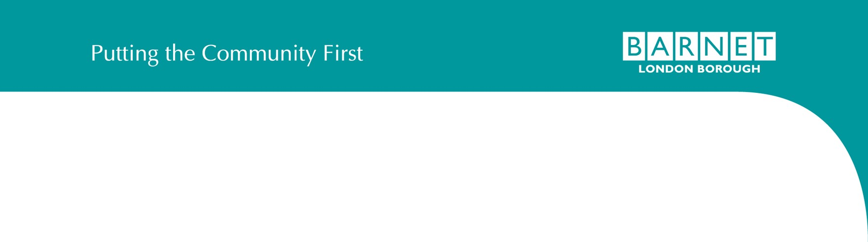





North Finchley Partnership Board – Second Meeting Minutes
21/02/2022 | 18.30 | Location: Arts Depot, North Finchley

Agenda Item | Timing | Minutes
Housekeeping | 18.30 | Attendees
 | –
 | – |  | √ | Cllr Sarah Wardle (SW) | NFPB Chair and Vice-Chair of the Housing and Growth Committee
 | 18.35
 | 18.35 |  | √ | Cllr Danny Rich (DR) | West Finchley Ward Cllr – substituting Cllr Ross Houston
 |  |  | √ | Cllr Anne Hutton (AH) | Woodhouse Ward Cllr
 |  |  | √ | Tim Stevenson (TS) | Lodge Lane Residents Association
 |  |  | √ | Michael Mowlem (MM) | Arts Depot Trustee – substituting for Tracy Cooper CEO
 |  |  |  | Rickardo Stewart (RS) | Founder of Community Souls & Art Against Knives
 |  |  | √ | Nick Goodman (NG) | Local Resident
 |  |  | √ | Liz Longworth (LL) | Northside Primary School Headteacher
 |  |  | √ | Miriam Berger (MB) | Principal Rabbi of Finchley Reform Synagogue
 |  |  | √ | Esmine Puzone (EP) | Local Business: Finishing Touches
 |  |  |  | Jacob Peak (JP) | Youth Representation
 |  |  | √ | Lynn Bresler (LB)_ | The Finchley Society
 |  |  | √ | Pravin Varsani (PV) | Local Business
 |  |  | √ | Steve Harrington (SH) | Regal
 |  |  | √ | Ghislaine Halpenny (GH) | Regal (Invited Guest)
 |  |  | √ | Jonathan Joseph (JJ) | Joseph & Partners
 |  |  | √ | Ashleigh Watkins (AW) | Town Centres Investment Manager at Barnet Council
 |  |  | √ | Zeina Al-Derry (ZA) | Town Centres Senior Project Officer at Barnet Council
 |  |  | √ | David Pierce (DP) | Founder of Dallas–Pierce–Quintero, Barnet Council’s Consultant (Invited Guest)
 |  |  | √ | Kajal Bains (KB) | Assistant at Dallas–Pierce–Quintero, Barnet Council’s Consultant (Invited Guest)

Introductions  - Adoption of the ToRs  - Partnership Board membership | 18.35  –  18.40 | - Note: It was agreed that the TORs had been adopted and will be updated on the Council website along with the minutes from different meetings.  - Note: It was agreed that the Council would look to recruit additional members to fill the remaining vacant positions as outlined within the Terms of Reference. Below are the current vacancies on the NFPB:  - Businesses: Food & Beverage (x1)  - Businesses: Office Tenant (x1)  - Businesses: Service Tenant (x1)  - GP Representative (x1)  - Active Travel Champion (x1)  - Action: NFPB members to inform Zeina (zeina.al-derry@barnet.gov.uk) if they know of anyone local who is suitable to be invited to apply for membership of the board.  - Note: Additional key stakeholders:  - Federation of Small Businesses. Action: Cllr AH to share contact.  - The Bohemia. Action: ZA to contact Seenan of the Bohemia.  - The Elephant Inn  - Julian Hurst of Julian Hurst Interiors, a potential local business representative.
Consolidated Engagement Activities  - Review of the homework assignment  - North Finchley Engagement Plan  - The Developer’s Engagement Activities  - Creative  Placemaking, | 18.40  –  19.30 | General Notes on Engagement Activities:  - Note: Agreed the importance around distinguishing between Council-led and Regal-led initiatives. This will be managed through hosting engagement workshops in different town centre venues, i.e. Regal at the Arts Depot and the Council at Northside Primary School.  - Action: It was agreed that different NFPB members would share engagement materials with their wider networks to encourage wider community engagement.  - Action: A contact phone number to be added to all engagement materials, both physical and digital.  - NG Noted that it is critical to not lose the people participating in the various workshops and keep them in the loop with regular updates after the workshops to keep them engaged.  - NG Noted the importance of clear signposting to ensure continuous engagement and avoid losing people due to confusion over the purpose of different engagement activities.  - Note: There should be clear differentiation between the Council’s and Regal’s branding.  - Action: The Council and Regal to include engagement posters in libraries, tube stations, etc.

Wayfinding and Graphic Identity  - Update on the Public Realm Design Framework  - Business Support and Other Council- Led Initiatives |  | On the Developer’s Engagement Activities:  - Action: Regal to clarify in their visuals which parcels of land are the sites they are looking at to clear any confusion with the Home Base site.  - Action: Regal to circulate an engagement summary report by May/June that summarises the outcomes of the workshop sessions.  - Action: Regal to offer alternative workshop dates and contact details for local people who cannot attend the  first set of workshops. I.e., “Sorry you can’t make it but please join the workshops on xx”  - NG Note: Engagement should be proactive. I.e., “if you missed the last workshop then come to this workshop”
 |  | On the Council-led Creative Placemaking, Wayfinding and Graphic Identity:
- LB Noted that it is critical to have a physical version of the website on the high street to be inclusive of people
who don’t have access to the internet.
- LL Noted that 150 families visit Northside Primary School between 9am and 3.30pm, and she is keen to involve them in engagement activities.
- LL Action: To include the Town Centre website in the school’s newsletter once it goes live.
 |  | Update on the Public Realm Design Framework:
 |  | - Note: Ongoing review of engagement activities is required, ensuring the further layer of the Public Realm Design Framework is also considered carefully in relation to existing initiatives.
 |  | Business Support and Other Council-Led Initiatives:
- Note: Develop a clear distinction between long-term plans for the town centre and what pop-up stalls and different events are specifically about
- Note: The Federation of Small Businesses can help with long-term business support.
Community-led Discussion | 19.30 | Suggested FAQs:  - Action: The Council to add a question around the Home Base site to the FAQs to clear confusion between it and the Regal development.
Points | –
 | 19.50

- Action: The Council to add a question addressing where the parking is going to go, and how are the Council- led commissions interacting with the subject of parking. There is a need to acknowledge that the Council is thinking about the town centre holistically.
- Action: The Council to add a question addressing what is happening with Lodge Lane Car Park
- TS Noted that the community is enquiring on how many years of disruption they will have to undergo. The Council will take this point into consideration when drafting the FAQs.
- Note: The need to learn a lesson from Finchley Church end where the new library is much smaller than the old one.
- Action: The Council to add a question to the FAQs to address the matter of consolidating land ownership and curation of business types and land uses. This is in response to several questions raised on this subject.
AOB/Next Steps | 19.50  –  20.00 | - Action: Zeina to send a reminder to NFPB members to engage with their relevant networks.

