NSL Apply User Guidance
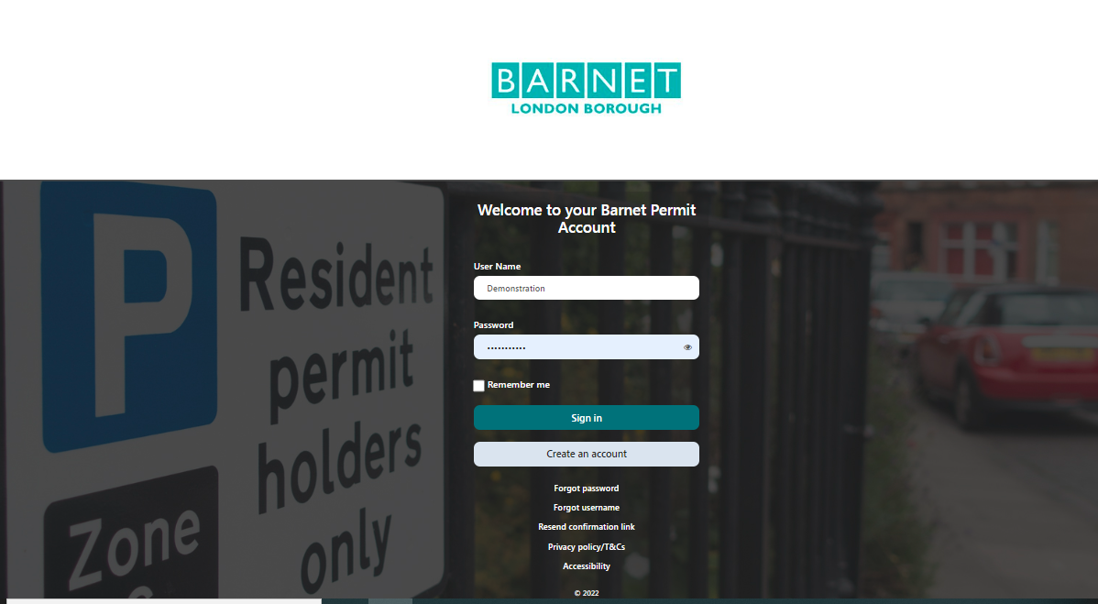

Index

- Temporary Resident Permit

- Temporary Change of Vehicle

- Change of Vehicle

- Update Address

- Add a New Vehicle

- Remove a Vehicle

Temporary Resident Permit

- Log in to your permit account Log in (nsl-apply.co.uk) with your User Name and Password (if you have forgotten your password then you can always reset this by selecting the ‘forgot password’ link on the NSL Apply login page)

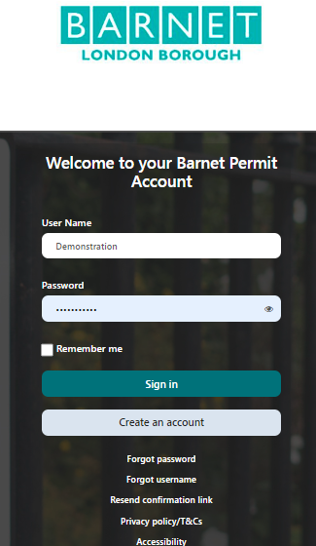

- Once you have logged in to your permit account, go to the Apply for Permit.

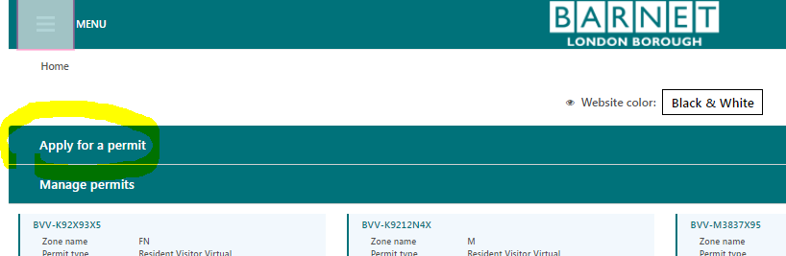

- Once Selected a new window will open called submit your request for a parking permit. Under the Permit Category select the Resident option. Then populate the address fields i.e. Street name, Property Name (drop down) or manually type the Property Number, Town and Postcode fields. Under the Permit Type option select the Temporary Resident Permit option.

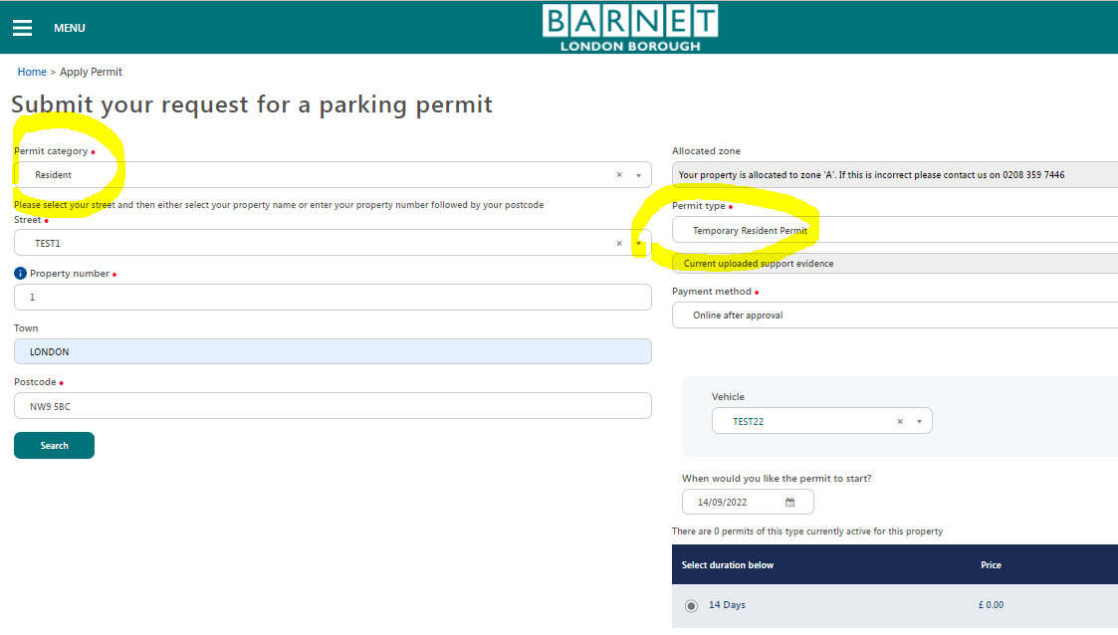

- You will then be required select the vehicle registration that you require the temporary permit for from the drop-down menu (if this has already been added to your permit account). If the vehicle has not already been added select the register a new vehicle green button.

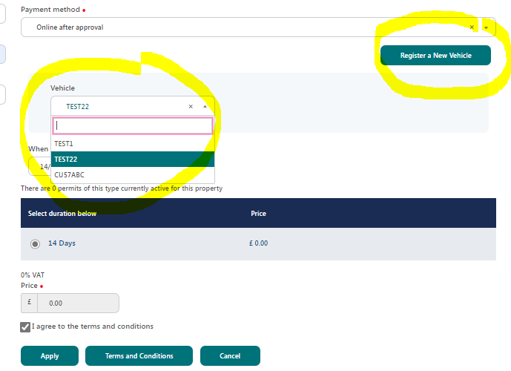

- Once selected, a pop-up window will open called register new vehicle where you will be required to manually enter the vehicle details in the number plate field. I have used vehicle registration (TEST23) as an example. Once you have added the vehicle registration then select the retrieve vehicle details green button. Proving the correct registration details have been entered i.e. the number 0 and not letter zero then the information yielded would be as per the DVLA vehicle records. If no vehicle details have been yielded (this is the case with some brand new vehicles as there is a slight delay with the DVLA records being simultaneously updated with the permit system) then you would be required to refer to your vehicle logbook (V5C document) or the DVLA vehicle check website Get vehicle information from DVLA - GOV.UK (www.gov.uk). You would then be required to enter the missing information manually in each field accordingly.
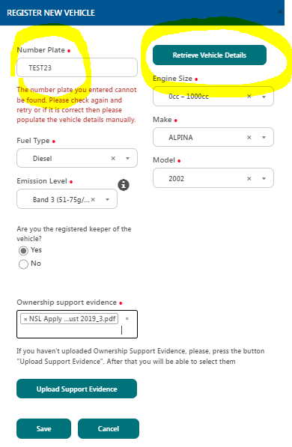
- Once the details have been manually entered or automatically yielded then select yes or no if you are the registered keeper of the vehicle. You will then be required to provide proof of the vehicle as per the qualifying criteria stipulated on the relevant resident permit webpage. Once the vehicle proof has been provided then press the green save press button. Now, that the new vehicle has been added it should appear under the vehicle drop down menu

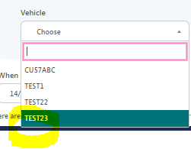

- Once the vehicle has been selected from the vehicle drop down menu proceed with selecting the permit start date. For your information, you can set a future date manually. Select the duration for 14 days. If you select the terms and conditions box and in turn, select the green apply button.

- Once the request has been submitted another pop-up window will appear giving you the opportunity to apply for more permits for the same address or to proceed with just the one application made. In this case select no and once selected you will return to the permit home page.
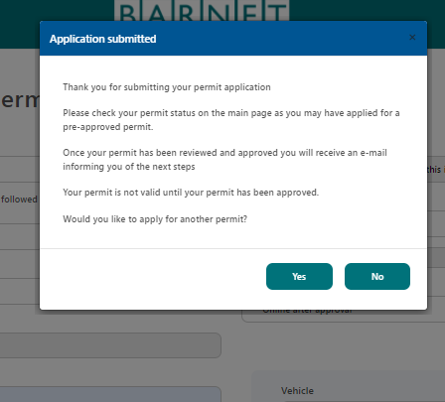

- To check if the temporary permit application was requested successfully, please go to the Manage Permits tab. Under this tab you should see a new permit application with the prefix (TR). In this case (TR-M1832854). This application does need to be verified by the permit team and once approved the status will change from pending approval to active.
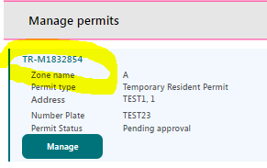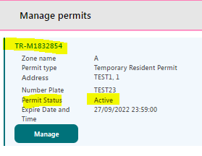

Temporary Change of Vehicle

- Log in to your permit account Log in (nsl-apply.co.uk) with your User Name and Password (if you have forgotten your password then you can always reset this by selecting the ‘forgot password’ link on the NSL Apply login page)

- Once you have logged in to your permit account, go to the Manage Vehicle Details tab to amend the vehicle registration for the respective permit that requires a temporary switch. For example, I am using vehicle registration (TEST23) for permit (BR-M2758735) in the test account.

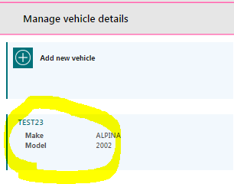

- Once the vehicle registration is selected (TEST23) a new window will open. Freely type the temporary vehicle registration in the temporary vehicle section and then press the green save button.

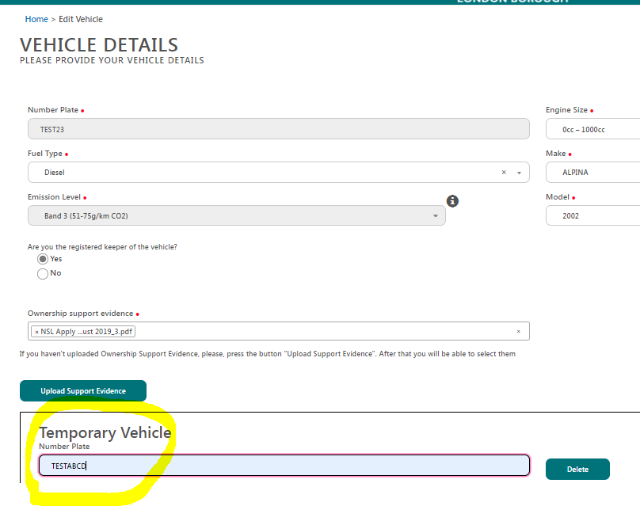

- Once you have saved the changes made in the Manage Vehicle Details section, you will be returned to the permit home page. To ensure the change is now made on the desired permit (BR-M2758735) you will need to go to the Manage Permits tab and select the green manage button.

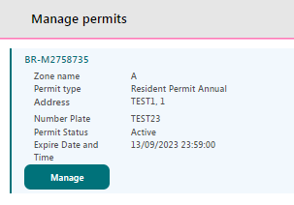

- Once selected a new window will open called Details of permit – BR-M2758735. If you go to the vehicles tab the temporary vehicle cover will show.

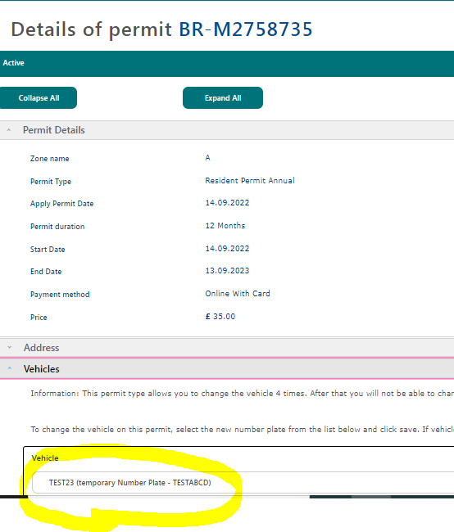

- In the event, that you have received your main vehicle sooner and need to remove the temporary vehicle. All you need to do is go to the Manage Vehicle Details tab. Once selected, and next to the temporary vehicle box there is a green delete button, please select this and make sure that you save the changes. Once saved, you can double check that your permit is now assigned to your main vehicle by going to the Manage Permit section and going to the permit that required the change (BR-M2758735). If you select the green manage button, under the vehicle tab you should now only see your main vehicle registration.

Change of Vehicle

- Login to your permit account Log in (nsl-apply.co.uk) with your User Name and Password (if you have forgotten your password then you can always reset this by selecting the ‘forgot password’ link on the NSL Apply login page)

- Once you have logged in to your permit account, go to the Manage Vehicle Details tab and select the add new vehicle option so that you can add the new vehicle registration.
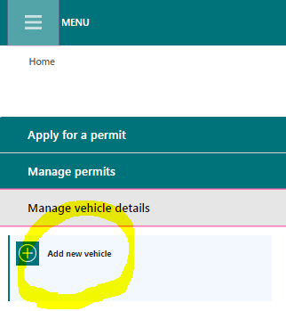
- Once selected, you will be taken to a new page called vehicle details where you will be required to manually enter the vehicle details in the number plate field. I am using registration (TEST24) as an example. Once you have added the vehicle registration then select the retrieve vehicle details green button. If no vehicle details have been yielded (this is the case with some brand new vehicles as there is a slight delay with the DVLA records being simultaneously updated with the permit system) then you would be required to refer to your vehicle logbook (V5C document) or the DVLA vehicle check website Get vehicle information from DVLA - GOV.UK (www.gov.uk). You would then be required to enter the missing information manually in each field accordingly.
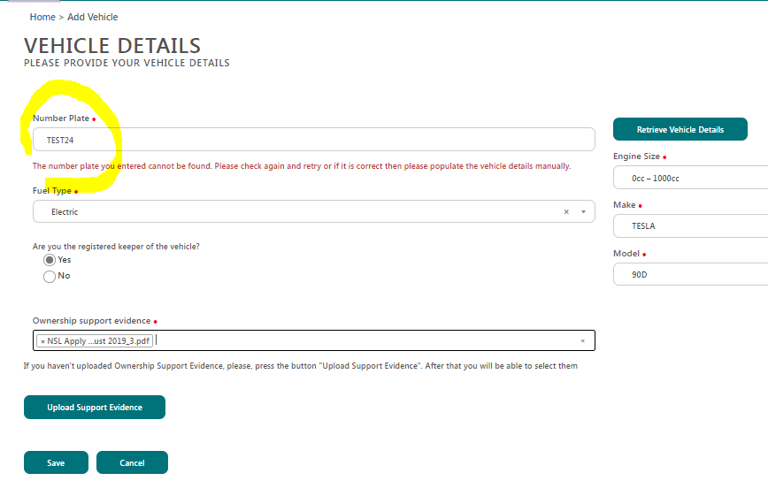

- Once the details have been manually entered then select yes or no if you are the registered keeper of the vehicle. You will then be required to provide proof of the vehicle as per the qualifying criteria stipulated on the relevant resident permit webpage. Once the vehicle proof has been provided then press the green save press button where you will in turn be taken to the permit home page and see the vehicle registration mark under the Manage Vehicle Details tab.

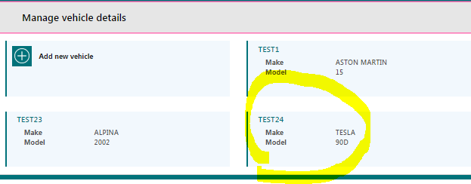

- The next stage will require you to go to the Manage Permits tab so that you can make the necessary change to the relevant permit. In the case of this example, we will use permit (BR-M2758735). For your information, if all the permits you have applied for do not show up then please select the white arrow in the green box in the far-right corner and ensure the arrow is facing downwards.
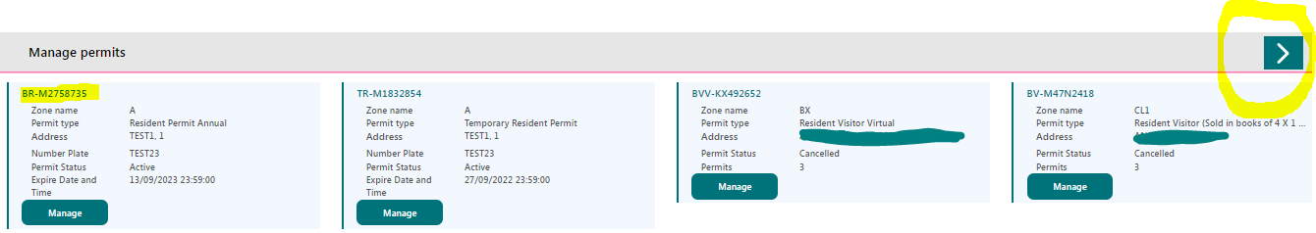

- Select the green manage button under the desired permit that requires the change (BR-M2758735). Once selected a new page called details of permit – BR-M2758735 will open. If you scroll down to the vehicles option, you will see the current vehicle assigned to the permit (TEST23). On the far-right hand corner there is a drop-down menu. Once selected it will reveal all the vehicle registrations registered to your permit account. In this case we are going to select (TEST24) as this is the vehicle, we would like to process the change of vehicle on. Once selected press save.
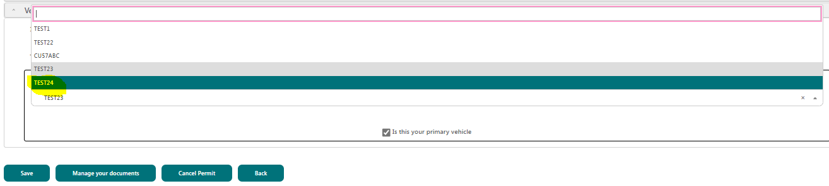

- Once you press save a new window will open called change permit details prompting you to upload proof of vehicle ownership if you have not done so when you added the vehicle registration in the Manage Vehicle Details tab. You will also see a message come up to advise you of a refund or surcharge amount if the new vehicle falls under a lower or higher charge band. If the vehicle falls under the same charge band, then no refund or surcharge is due. Now, if your new vehicle falls under a higher emissions band or has a bigger engine size (if the vehicle was registered before the 23 March 2001) than your new vehicle may cost more, and a payment may be required to process the change of vehicle. If, however, the new vehicle has a lower emissions band or has a smaller engine size (if the vehicle was registered before the 23 March 2001) than you may be due a pro rata refund for the difference.
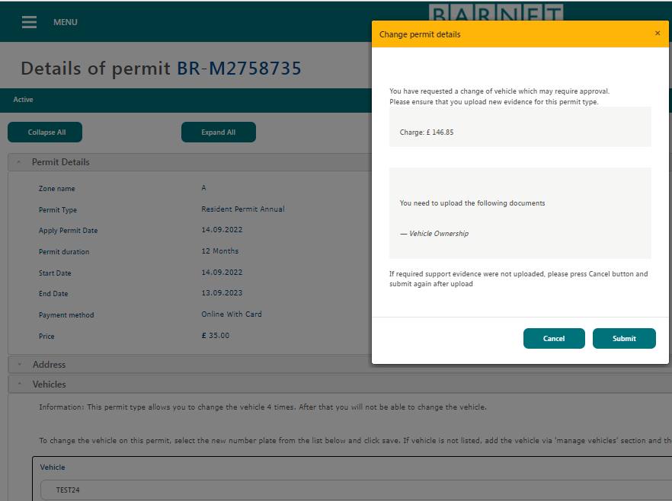
- Once you select the green submit button you will then be taken to the permit account home page. Now if you go to the Manage Permits tab and go to the permit reference where the change of vehicle was requested you will see that the status of the permit is now showing change vehicle.
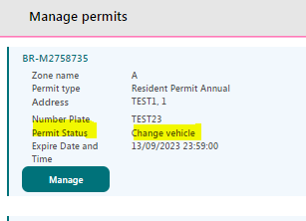
- At this point, a verification check will need to be undertaken by the permit team. Providing you have provided the correct proof of vehicle; the change of vehicle request will be approved and in turn the status will show as active (if the change of vehicle was for a vehicle in a lower or the same charge band). Now if the new vehicle falls under a higher charge band, then the status of the permit will show waiting for payment and at this point you will be required to pay the pro rata surcharge. Once payment has been made the permit status will change to active.
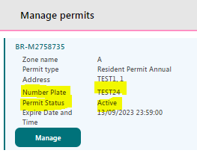
Update Address
1. Log in to your permit account Log in (nsl-apply.co.uk) with your User Name and Password (if you have forgotten your password then you can always reset this by selecting the ‘forgot password’ link on the NSL Apply login page)

- Once you have logged in to your permit account, go to the Manage Permits tab and select the permits one by one that require the change of address. Please be aware that you can only change address if you are moving to a property within the same zone that your current permits are assigned to. If the new address falls in a different zone, please cancel your permits, and apply for new ones.

- Once you have selected the permit that requires the change of vehicle (BR-M2758735), select the green manage button. Once selected the new page will open called details of permit – BR-M2758735 and if you scroll down, you will see the address tab. Once selected, the full address details for the current permit will show.
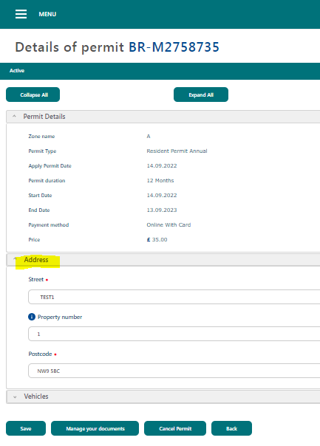
- You can amend the current address details for the new address details by selecting the new street record, followed by the property name (i.e. 17X or Flat XX, BXXXX HOUSE) or manually typing the property number in the property number field (i.e. 17) followed by manually typing the postcode in the postcode field.

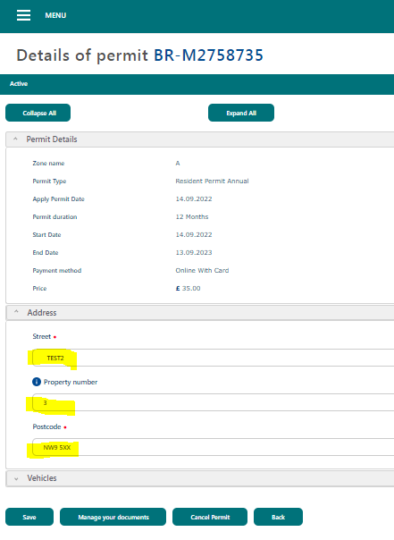
- Once the change has been made then select the manage your documents green button where you will be required to upload proof of your new address as per the qualifying criteria on the resident permit webpage. Once the proof has been uploaded select the green save button. Once save, a new window will open called change permit details prompting you to upload proof of your new address if it has not already been uploaded. You will then be required to select the green submit button to request the change.

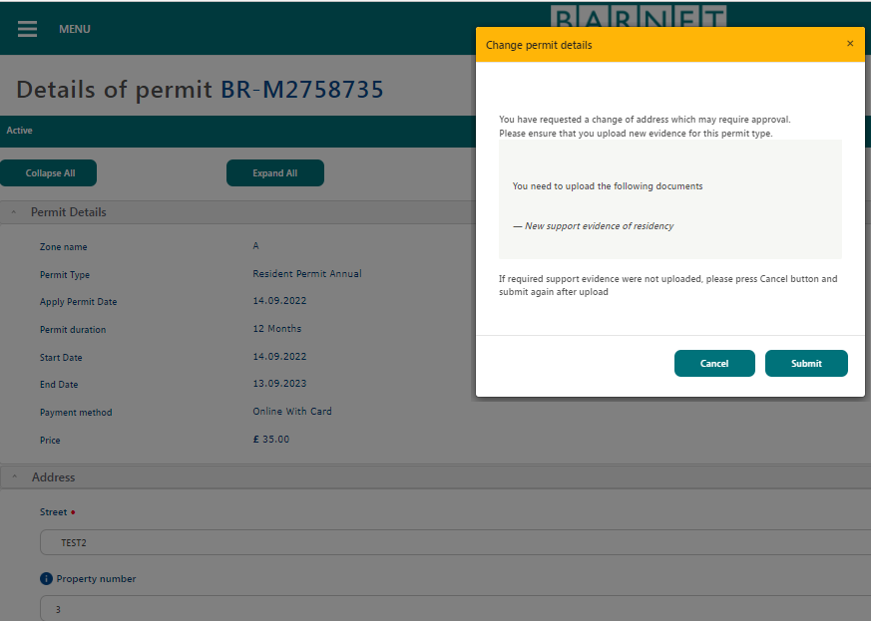

- Once the request has been submitted you will return to the permit account home page. Now to check if the change request has been submitted successfully go to the Manage Permits tab and go to the permit where the change request was made on (BR-M2758735). The status will show change address.
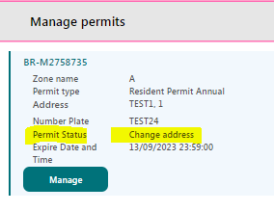
- Proving the required proof has been provided the permit team will be required to verify the documents submitted and if approved the application will be activated and in turn the permit will reflect the new address.
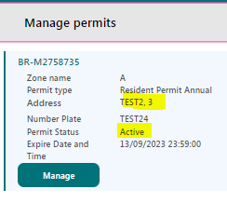
Add a New Vehicle

- Login to your permit account Log in (nsl-apply.co.uk) with your User Name and Password (if you have forgotten your password then you can always reset this by selecting the ‘forgot password’ link on the NSL Apply login page)

- Once you have logged in to your permit account, go to the Manage Vehicle Details tab and select the add new vehicle option so that you can add the new vehicle registration.
- Once selected, you will be taken to a new page called vehicle details where you will be required to manually enter the vehicle details in the number plate field. I have used registration (TEST24) as an example. Once you have added the vehicle registration then select the retrieve vehicle details green button. If no vehicle details have been yielded (this is the case with some brand new vehicles as there is a slight delay with the DVLA records being simultaneously updated with the permit system) then you would be required to refer to your vehicle logbook (V5C document) or the DVLA vehicle check website Get vehicle information from DVLA - GOV.UK (www.gov.uk). You would then be required to enter the missing information manually in each field accordingly.

- Once the details have been manually entered then select yes or no if you are the registered keeper of the vehicle. You will then be required to provide proof of the vehicle as per the qualifying criteria stipulated on the relevant resident permit webpage. Once the vehicle proof has been provided then press the green save press button where you will in turn be taken to the permit home page and see the vehicle registration mark under the Manage Vehicle Details tab.

Remove a Vehicle

- Login to your permit account Log in (nsl-apply.co.uk) with your User Name and Password (if you have forgotten your password then you can always reset this by selecting the ‘forgot password’ link on the NSL Apply login page)

- Once you have logged in to your permit account, go to the Manage Vehicle Details tab and select the vehicle that you want to remove (TEST1). Please be advised, that you cannot remove a vehicle that is assigned to an active permit. You will need to make sure that the change of vehicle request is processed first before removing the vehicle from the permit account.

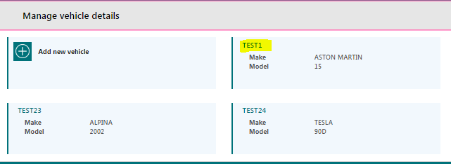
- Once you have selected the vehicle you wish to remove (TEST1) a new page will open called vehicle details and if you scroll down to the bottom of the page there is a green delete button. Please select this.
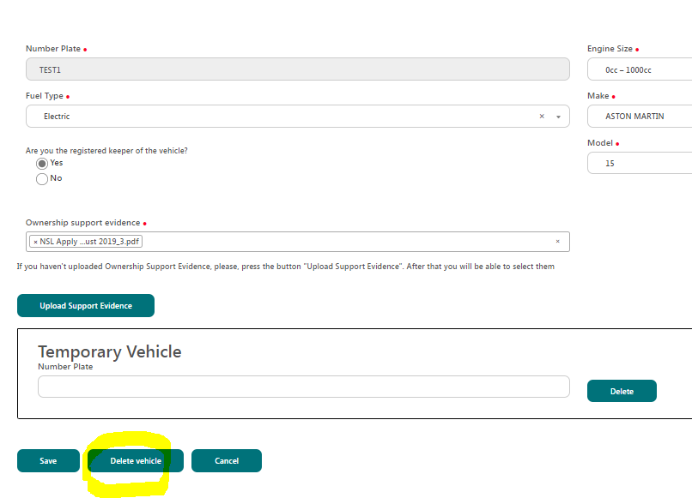
- Once selected, a new pop-up window called delete vehicle will appear and advise that the vehicle will be permanently removed once deleted. Select the green ok button.

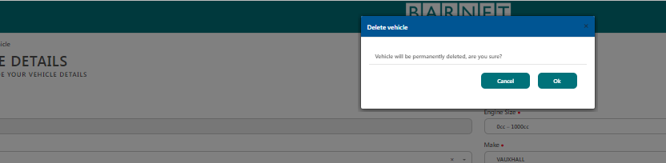

- Once you select ok you will then return to the permit home page. Now to check if the vehicle has successfully been removed from your permit account go to the Manage Vehicles tab. The vehicle registration will not show up in the list of vehicles.

