
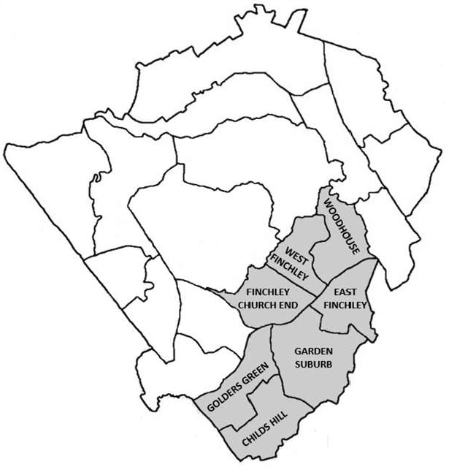

FINCHLEY & GOLDERS GREEN AREA COMMITTEE

Community Infrastructure Levy (CIL) - Budget & Scheme Update
22 March 2022
17








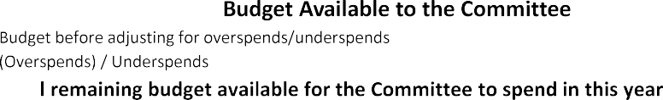
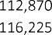
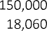
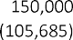
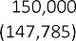
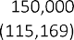
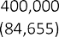
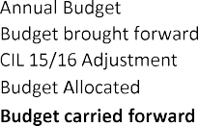
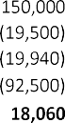
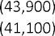
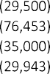
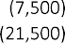
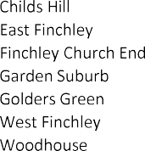
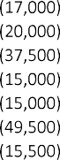
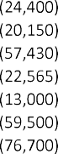
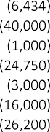
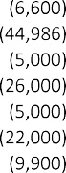
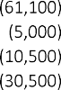
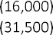
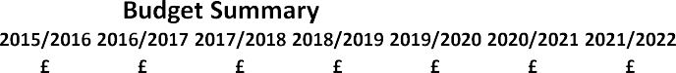
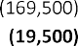
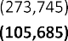
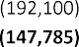
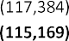
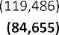
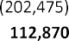
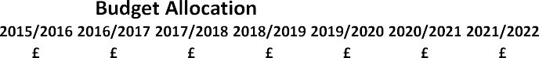
Commentary
The total available budget is £229,094
The under/overspends figure is being finalised as the Re: Highways invoicing is finalised. The net impact is not expected to be material, and the current impact is a net underspend of £116,225.
No future overspends should be committed without either prior approval of the Area Committee Chair or the Area Committee.
Highways schemes funded by CIL which are currently open are tracked for budgeting purposes in this report, and future schemes will form part of the Road Safety and Parking reporting. Highways are preparing final scheme invoices for CIL funded schemes which will provide reporting on spend.

18
Finchley & Golders Green Area Committee - CIL Scheme update (non-Highways)
19

FINCHLEY & GOLDERS GREEN AREA COMMITTEE - CIL OPEN SCHEME UPDATES (non-Highways)

Ward | Financial Year | Committee Date | Scheme Description | Ward Member | Budget Allocation  £ | Overspend to approve  £ | Delivery Service | Commentary | Expected Delivery Date
Childs Hill | 2021/22 | 27/01/2022 | Basing Hill Ballpark Project - Herts Baseball Club | Peter Zinkin | 11,500 |  | Community Grant | March 2022: Community group are agreeing plan with the  suppliers | Q2 22/23
Finchley Church End | 2021/22 | 27/01/2022 | CCTV installation (monitored by the estate only) and paving upgrade at Stephens House and Gardens (part of Avenue House Estate, East End Road, N3) | Daniel Thomas | 35,000 |  | Community Grant | March 2022: Community Grant has been paid to the community group. Awaiting feedback on scheme delivery. | Q2 22/23
East Finchley | 2021/22 | 27/01/2022 | Cherry Tree Wood - children’s play equipment | Claire Farrier | 13,453 |  | Barnet - Greenspaces | March 2022: Order has been raised. Awaiting to hear date of installation. | Apr-22
East Finchley | 2021/22 | 27/01/2022 | East Finchley Planters (Highways & Estates Lands) - Restoration & Improvements with Heritage and  Ecology Signs | Arjun Mittra | 33,000 |  | Community Grant - £2k  Highways - £31k | March 2022: The Community group have cleared the beds and the . now need to . them to allow the  . Council repair  replanting. | Q2 22/23
West Finchley | 2021/22 | 08/11/2021 | Long Lane Pasture - renovation of path from the main gate to the gazebo | Ross Houston | 15,983 |  | Community Grant | March 2022: The gazebo works (slab paving) is completed and relaying of the main path is well underway. A grand opening is planned for Sunday, June 12th | Jun-22
Childs Hill | 2021/22 | 08/11/2021 | The Hope of Childs Hill. Purchase of 10 e bikes to be stored in the park (for community group use) | Shimon Ryde | 18,000 |  | Community Grant | March 2022: Community Grant has been paid to the community group. Awaiting feedback on scheme delivery. | tbc – Q1 22/23
West Finchley | 2021/22 | 30/06/2021 | Friends of Victoria Park - Environmental  Improvement | Danny Rich | 5,000 |  | Barnet - Greenspaces | March 2022: Friends have met tree officer on site, project is progressing. | Jun-22
East Finchley | 2021/22 | 08/04/2021 | Refurbishment and improvement of Market Place  Playground, N2 | Alison Moore | 30,000 |  | Barnet - Greenspaces | March 2022: No Change - awaiting the Friends Group to develop their plans. | Q1 22/23
Garden Suburb | 2020/21 | 23/02/2021 | Improvement of the entrance to Lyttleton Playing Fields & Kingsley Way grass verge | Rohit Grover | 15,000 |  | Barnet - Greenspaces | March 2022: BRE contractors are working on the entrance.  Once complete, BW services will complete their section of works. | Q1 22/23
East Finchley | 2020/21 | 08/10/2020 | Cherry Tree Wood - East Finchley (Friends of Cherry  Tree Wood) | Alison Moore | 19,986 |  | Barnet - Greenspaces | March 2022: Awaiting revised quote from contractor. | Jun-22
Garden Suburb | 2018/19 | 13/06/2018 | Lighting of the Central Square Minyan | John Marshall | 5,000 |  | Community Led | March 2022: Barnet lighting team have agreed a scheme  with the community group - awaiting dates from the service | tbc – Q1 22/23



Long Lane Pasture
Scheme Update

Gazebo
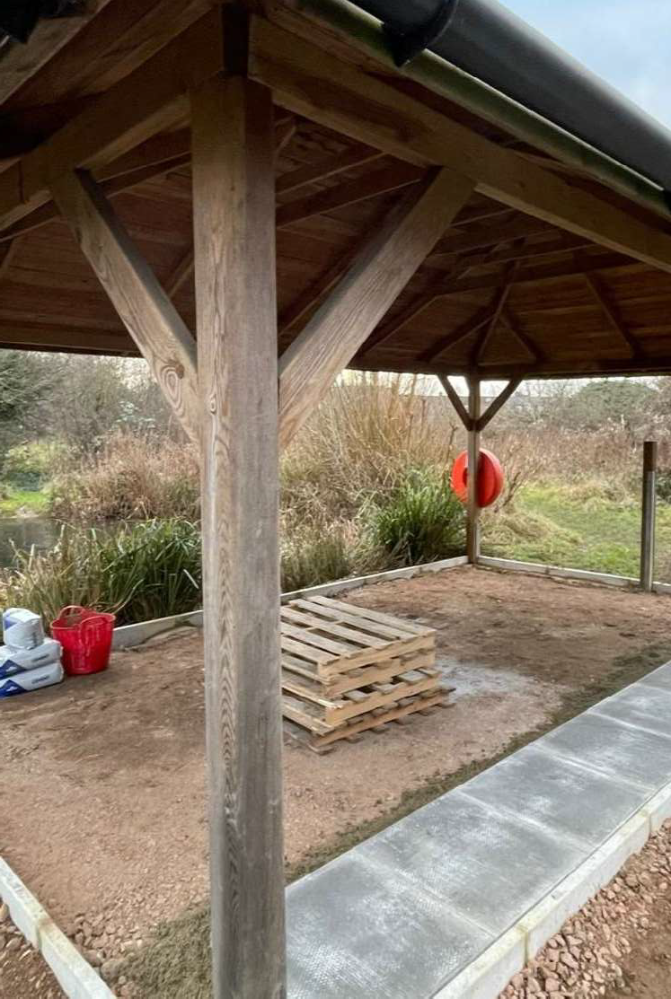
Work in progress to completion
Main Pathway
Previous condition and current work in progress
20
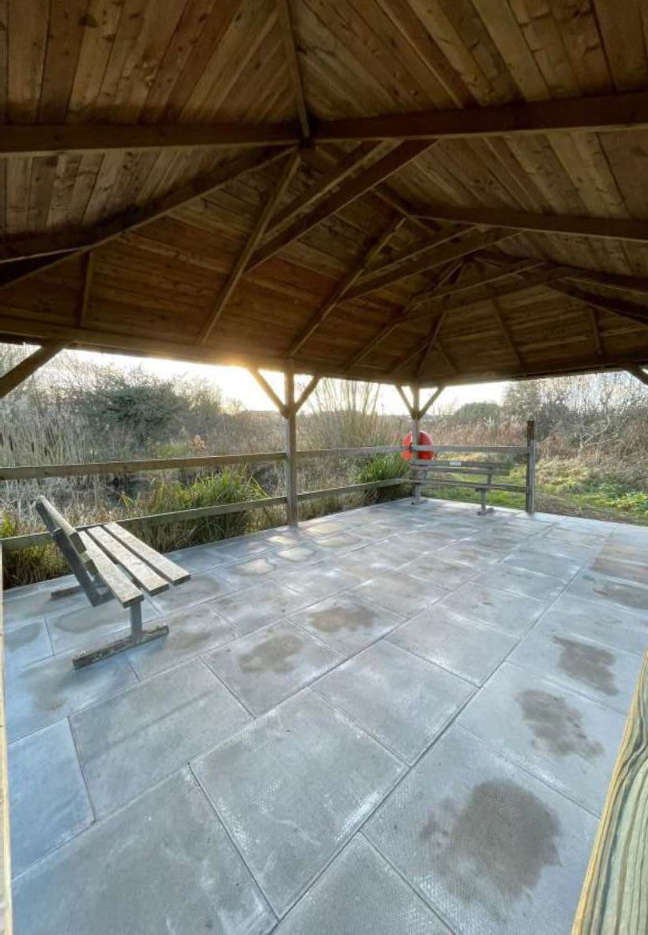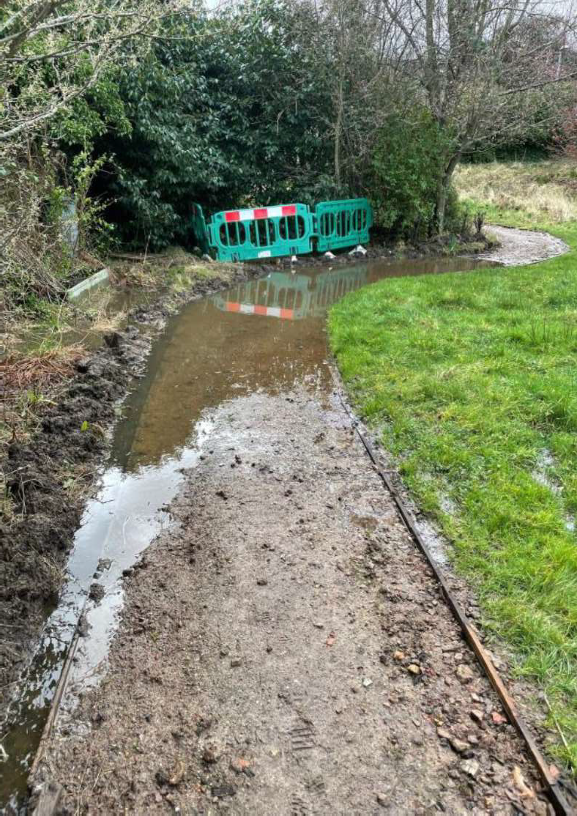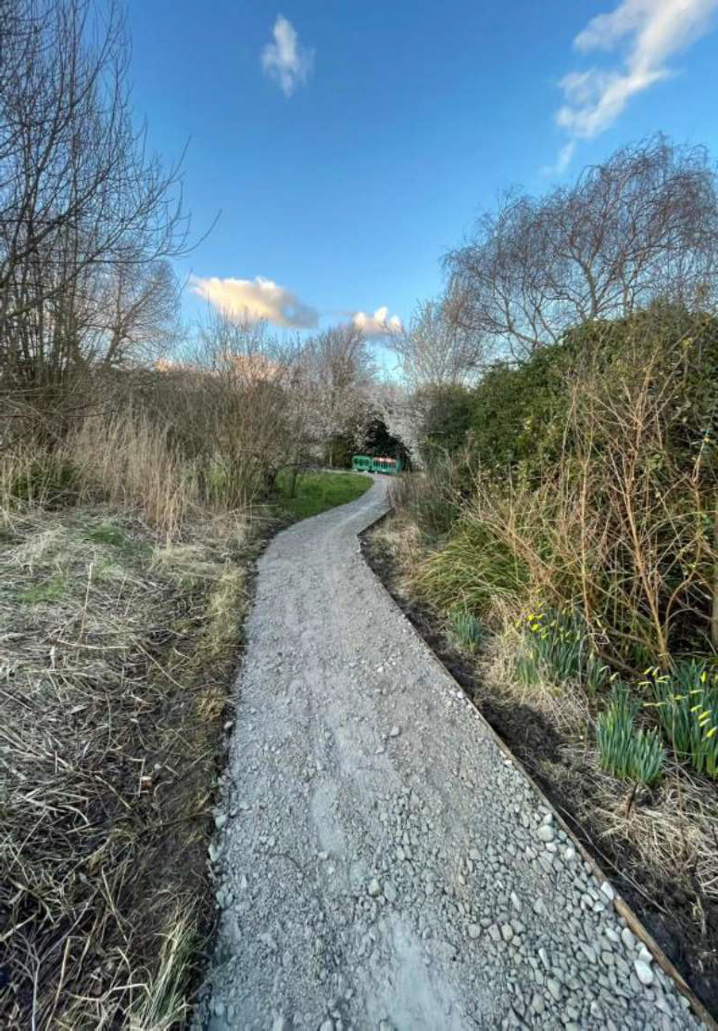
21
Ward | Financial Year | Committee Date | Scheme Description | Ward Member | Budget Allocation  £ | Highways Project | Commentary | Expected Delivery Date
Childs Hill | 2019/20 | Jul-19 | Greenfield Gardens Bay Change and Cycle Storage | Councillor Anne Clarke | 3,500 | BC/001691-02 | Consultation complete. Results being analysed before being made permanent | Mar-22
Garden Suburb | 2015/16 | Jan-16 | Parking Temple Fortune (Oakfield Road) | Committee Report | 20,000 | BC/000742-02 | Implementation package issued to contractor to programme works. Estimated completion Q4 | Mar-22
Garden Suburb | 2018/19 | Jun-18 | Hampstead Way - Pedestrian Improvement | Committee Report | 25,000 | BC/001411-06 | Implementation is on hold as redesign is required due to electrical issues raised by supplier on the original design. Meeting to be set up with LBB Officer to review new proposal. Additional Meeting to  be set up with PH/ SH w/c 21 Feb | On hold
Golders Green | 2019/20 | Apr-19 | Woodlands Close - Bollards | Councillor Dean Cohen | 5,000 | BC/001642-03 | Site meeting took place to review locations of bollards. BOQ in progress and instruction to contractor to follow in the coming weeks. Decision was made to shorten the island and include a bell bollard. Officers have provided the new quote which is currently  under review. | On hold
West Finchley | 2019/20 | Feb-20 | Rosemont Avenue | Committee Report | 16,000 | BC/001609-05-02 | Implementation in progress. Works commenced 21 Feb 22. | Mar-22
West Finchley | 2020/21 | Oct-20 | Gainsborough and Holden Road N12 | Residents Forum | 5,000 | BC/001967-02 | Scheme to be aligned with Gainsborough/ Nether Street Feasibility Study. COD to be produced detailing results of Feasibility to for submission in January and shared with Committee Chair and Cllrs | Mar-22
West Finchley | 2021/22 | Apr-21 | Gainsborough/ Nether Street | Ross Houston | 5,000 | BC/001967-12 | Scheme to be aligned with Gainsborough and Holden Road N12 Feasibility Study. Issues raised by residents, meeting took place with members on 31 Jan and meeting with residents is set up for the following week. Estimated completion Mar 22 | Mar-22
West Finchley | 2020/21 | Oct-20 | Park View Road | Councillor Ross Houston | 6,000 | BC/001967-09 | COD has now approved by Geoff Mee Implementation package issued to contractor to programme works. Expected April 22. | Apr-22

22
Ward | Financial Year | Committee Date | Scheme Description | Ward Member | Budget Allocation  £ | Highways Project | Commentary | Expected Delivery Date
Woodhouse | 2015/16 | Mar-16 | Lambert Way Waiting Restrictions | Committee Report | 3,000 | BC/000742-04 | Scheme Complete | Complete
Woodhouse | 2017/18 | Apr-17 | Buxted Ashurst - Junction | Committee Report | 5,000 | BC/001186-01 | With other cycle proposals in progress the intention is that the cycle route scheme and areas of objection (including this junction) be reviewed in the new financial year to identify possible measures that will also address the committee concerns. | On hold
Woodhouse | 2019/20 | Jul-19 | Glenhurst Road, N12 - One Way Implementation | Committee Report | 19,000 | BC/001348-03 | Implementation commenced on 10 Feb. Awaiting final sign off or works. | Mar-22

FINCHLEY & GOLDERS GREEN AREA COMMITTEE

Road Safety & Parking - Budget & Scheme Update
22nd March 2022
23




24

 |  |  | 
 |  |  |  | 

Commentary
Additional funding of £200,000 was approved at the Policy & Resources Committee on 9th December

25

Area | Financial Year | Committee Date | Scheme Description | Ward Member | Budget Allocation  £ | Highways Project | Commentary | Expected Delivery Date
Finchley & Golders Green | 2021122 | Nov-21 | Long Lane | Committee Report | 8,250 | BC/002065-07 | Consultation to commence on 3 march. followed by the design in April and estimated completion Q2 | Jun-22
Finchley & Golders Green | 2021122 | Nov-21 | Tillingbourne Gardens | Committee Report | 18,700 | BC/002065-09 | Design in Progress. Estimated completion Q2 | Jun-22
Finchley & Golders Green | 2021122 | Nov-21 | Woodgrange Ave | Committee Report | 1,375 | BC/002065-08 | Consultation planned to commence in Feb 22, followed by the design in April and estimated completion Q2 | Jun-22
Finchley & Golders Green | 2021122 | Jun-21 | Hampstead Way/ Meadway | Committee Report | 30,000 | BC/002065-03 | Consultation completed. Recommendations from officers submitted and awaiting final decision | May-22
Finchley & Golders Green | 2021122 | Jun-21 | Cranbourne Gardens & Leeside Crescent | Committee Report | 13,200 | BC/002065-04 | Design in progress. Estimated completion Q1 | Mar-22
Finchley & Golders Green | 2021122 | N/A | Fallowfields Estate, N12 / Fallowfields Drive | Councillor Hutton | 5,000 | BC/002065-06 | Design in progress, consultation currently planned to commence 10 February. Estimated completion Q2 | Jun-22
Finchley & Golders Green | 2021122 | N/A | Cricklewood Lane | Cllr Clarke | 7,500 | TBC | Approved. Scheme to be programmed by officers | TBC
Finchley & alders Green | 2021122 | N/A | Kingsley Way | Cllr Marshall | 5,000 | TBC | Approved. Scheme to be programmed by officers | TBC

26

Area | Financial Year | Committee Date | Scheme Description | Ward Member | Budget Allocation  £ | Highways Project | Commentary | Expected Delivery Date
Finchley &  Golders Green | 2021122 | N/A | Fairlawn Avenue | Cllr Mittra | £15,000 | TBC | Approved. Scheme to be programmed by officers | TBC
Finchley &  Golders Green | 2021122 | N/A | Highfield Avenue | Cllr Cohen | £7,000 | TBC | Approved. Scheme to be programmed by officers | TBC
Finchley &  Golders Green | 2021122 | N/A | The Groves | Cllr Clarke | £5,000 | TBC | Approved Scheme to be programmed by officers | TBC
Finchley &  Golders Green | 2021122 | N/A | Torrington Park/ Woodhouse Road | Cllr Cook | £10,000 | TBC | Approved Scheme to be programmed by officers | TBC
Finchley &  Golders Green | 2021122 | N/A | Woodlands Close - Bollards | Cllr Cohen | £2,200 | BC/001642-03 | Additional funding assigned to NCIL scheme for change of scope | TBC

27

Area | Ward Cllr | Location | Request | Response | Highways  Technical Assessment | LBB Officer Review | Final Approval
Finchley & Golders Green | Cllr Clarke | Finchley Road | Concerns were raised by residents relating to pedestrian crossing points on Finchley Road close to Church Walk. The concerns include children crossing the busy road during their journey to school. There is currently a pedestrian island close to this junction however, officers were advised vehicles rarely stop to allow pedestrians to cross over the road. | During the site visit officers reviewed the location for possibilities of the placement of a zebra crossing. It was noted that there was a pedestrian refuge close to the where the request for the crossing is placed.  It was noted that the location is close to the main junction of Finchley Road and the A41 (Hendon Lane). This location is a busy location and any changes on Finchley Road may possibly have an impact on the TfL network - there is also the possibility of junction remodelling to minimise any  associate impact.  Officers recommend a feasibility study is undertaken to include, traffic count, speed, pedestrian desire line. This may also include liaison with TfL prior to any suggested costs are provided to implement any  measures identified. | Complete

28
Area | Financial Year | Committee Date | Scheme Description | Ward Member | Budget Allocation  £ | Highways Project | Commentary | Expected Delivery Date
Hendon | 2021/22 | N/A | Aerodrome Road | Committee Report | 35,630 | BC/002063-10 | Consultation to commence on 10 March. Design planned to be by April and Implementation June 22. | Jun-22
Hendon | 2021/22 | N/A | Allington Road/ Sevington, Vivian Avenue/Elliot Road - OD Survey | Councillor Don | 9,500 | BC/002063-07 | Surveys planned to commence in March. Estimated completion May | May-22
Hendon | 2021/22 | N/A | Dallas Road NW4 - Speed Survey | Councillor Don | 2,000 | BC/002063-06 | Speed survey to take place in February. Estimated completion March 22. | Mar-22
Hendon | 2021/22 | N/A | Edgwarebury Lane | Committee Report | 34,870 | BC/002063-11 | Consultation to commence on 3 March. Design expected in April and implementation June 22 | Jun-22
Hendon | 2021/22 | N/A | Frith Lane opposite Finchley Golf Club  - Feasibility Study | Residents Forum | 5,000 | BC/002063-09 | Surveys expected to begin in Feb 2022. Estimated completion March 22 | Mar-22
Hendon | 2021/22 | N/A | The Millway | Councillor Duschinsky | £12,400 | TBC | Funding allocated. Scheme to be programmed | TBC
Hendon | 2021/22 | N/A | Saracens School | Councillor Narenthira | 8,000 | TBC | Funding allocated. Scheme to be programmed | TBC
Hendon | 2021/22 | N/A | Cool Oak Lane | Councillor Richman | 8,000 | TBC | Funding allocated. Scheme to be programmed | TBC
Hendon | 2021/22 | N/A | Rushgrove Avenue | Councillor Narenthira | 5,000 | TBC | Funding allocated. Scheme to be programmed | TBC

29
Area | Ward Cllr | Location | Request | Response | Stage
Hendon | Cllr Duschinsky | Woodcroft Ave and Bunns Lane | The need for the introduction of a crossing point around Woodcroft avenue towards Bunns lane NW7 and full junction review will have to be carried out in conjunction with the j/w Lyndhurst and j/w Graham Park Way where 2 mini roundabouts are present at the moment, and it will also require involvement with London Buses in their turning movements and route. | Highways officers reviewing costs for this Feasibility Study. | Technical Assessment  - Highways
Hendon | Cllr Duschinsky | Copthall School | Proposed double yellow lines along upper Page Street and some section with loading restriction Temporary suspended permit holder bays to observe if congestion and traffic problem improves Consider permanently suspended permit holder bays subject to consultation  Speed survey to be carried out to determine speed and possibly install VAS signs Feasibility of 20mph speed limit with option to install speed cushions  Feasibility to install enforcement camera subject to the agreement of parking enforcement team | Currently being reviewed by Officers | Technical Assessment - Highways
Hendon | Councillor Wardle | Hartland  Drive | Installation of double yellow lines on the junction of Hartland Drive and Edgwarebury Lane. | Taken forward with 5106 funding | Other Funding
Hendon | Councillor Conway | The  Greenway | Review of Parking Bays | Currently under investigation with Highways Officers | Technical Assessment - Highways
Hendon | Councillor Conway | Deansbrook Road | Deansbrook Road zebra crossing review of additional measures | Site meeting to be arranged for 4 March with Councillor | Technical Assessment  - Highways

30
Area | Ward Cllr | Location | Request | Response | Stage
Hendon | Councillor Don | Rookery Way | Request for Pedestrian Crossing- Rookery Way junction of The Hyde, Highbury Road, and Rookery way NW9 | note this item will be addressed as part of wider scheme developments.  This is still in the draft LIP programme we have sent to Tfl just recently to seek funding for the design to progress next FY. But it is a significant signals scheme which would be timely and at a high cost  It also has links to the AS parallel cycle route scheme we are in the process of designing and both schemes need to be considered together. So, it has not been 'de-prioritised', and is still something we are pursuing- but it is subject to  availability of funding from Tfl. | Other Funding
Hendon | Cllr Narenthira | Varley Parade | Due to the bollards by the traffic lights on the AS by Varley parade and the presence of so many parked cars, vans and motorbikes, there is no access for pedestrians to walk from the row of shops to reach the pedestrian traffic lights crossing point safely, The dropped kerb area outside the pub to allow access for wheelchairs and push chairs to the signalised crossing on the AS is simply ignored with cars parking and blocking the pedestrian access route all along  this frontage area | Currently being reviewed by Officers | Technical Assessment - Highways
Hendon | Cllr Narenthira | Sheaveshill Avenue | Speeding between AS and Colindeep lane stretch of Sheaveshill Avenue.  This street is used by many parents and kids who attend Colindale School. Cars are parked on both sides. There is a blind bend on this street near Courtway which reduces  visibility for cars approaching the bend from both directions. | Currently being reviewed by Officers | Technical Assessment - Highways

31
Area | Financial Year | Committee Date | Scheme Description | Ward Member | Budget Allocation  £ | Highways Project | Commentary | Expected  Delivery Date
Chipping Barnet | 2021/22 | N/A | Longmore Avenue | Committee Report | 33,100 | BC/002064-10 | Consultation to commence on 10 March. Estimated completion June 22. | Jun-22
Chipping Barnet | 2021/22 | Jun-21 | Barnet Hospital CPZ | Committee Report | 34,890 | BC/002064-09 | Meeting took place with resident to address concerns raised, and it was agreed with LBB Parking Team to proceed with as is.  Implementation package issued to contractor to programme works. Estimated completion Q4 subject to contractor. | Mar-22
Chipping Barnet | 2021/22 | Jun-21 | Barnet Road | Committee Report | 15,000 | BC/002064-03 | Implementation originally scheduled for mid January but electrical supplier has raised issue during implementation. Alternative locations to be reviewed before scheme progresses. | Mar-22
Chipping Barnet | 2021/22 | Jun-21 | Gallants Farm - VAS & Slow Marking | Committee Report | 17,820 | BC/002064-06 | Design in progress, smiley face VAS has been requested for this location. Implementation package to be completed by end of Feb. Estimated completion April 22 | Apr-22
Chipping Barnet | 2021/22 | Jun-21 | Hadley, Clifford and Woodford Roads | Committee Report | 19,800 | BC/002064-08 | Implementation package to be produced and issued to contractor to programme works. | Mar-22
Chipping Barnet | 2021/22 | Jun-21 | Hendon Wood Lane | Committee Report | 12,870 | BC/002064-04 | Detail design completed. Implementation package to be prepared for issue to contractor. Estimated completion April 22. | Apr-22
Chipping Barnet | 2021/22 | Jun-21 | Parkside Gardens | Committee Report | 48,950 | BC/002064-05 | COD being finalised for submission in Feb. Topographical survey now completed and detailed design now in progress for completion late  March Estimated completion Jun-22. | Jun-22
Chipping Barnet | 2021/22 | N/A | York Way, N20 | Members Request | 5,000 | BC/002064-11 | Surveys to commence in 14 March | Apr-22
Chipping Barnet | 2021/22 | N/A | Manor Drive/1-10 Raleigh Drive, Whetstone N20 | Members Request | 7,000 | BC/002064-12 | Surveys to commence in 14 March | Apr-22

32
Area | Ward Cllr | Location | Request | Response | Stage
Chipping  Barnet | Residents Forum | Potters and Plantagenet Road | Various Safety concerns raised at Residents Forum | It was agreed to consultation for YLs has taken place as part a separate funding. Objections received and officers are currently preparing the response and COD to be drafted for submission beg Feb. Estimated completion expected mid Ql. Paul Sears has been contacted with regards to lighting. | Technical Assessment - Highways
Chipping  Barnet | Councillor rutter | Brunswick Park road (junction with the cemetery) | Request for traffic lights at the mini roundabout Junction with Cemetery | Site visit to be undertaken with Highways officers | Technical Assessment - Highways
Chipping  Barnet | Councillor Weeden- Sanz | Hampden Way | Request for Hedges to be planted on Hampden Way | Site visit to be undertaken with Highways officers | Technical Assessment - Highways
Chipping  Barnet | Councillor Smith | Longmore Ave | Speeding issues on Longmore Ave | Speed survey required. Highways officers reviewing costs | Technical Assessment - Highways

