
Equalities Impact Assessment (EIA)
EIAs make services better for everyone and support value for money by getting services right first time.
EIAs enable us to consider all the information about a service, policy or strategy from an equalities perspective and then create an action plan to get the best outcomes for service users and staff.They analyse how all our work as a council might impact differently on different groups protected from discrimination by the Equality Act 2010. They help us make good decisions and evidence how we have reached them.
An EIA needs to be started as a project starts to identify and consider possible differential impacts on people and their lives, inform project planning and, where appropriate, identify mitigating actions. A full EIA must be completed before any decisions are made or policy agreed so that the EIA informs that decision or policy. It is also a live document; you should review and update it along with your project plan throughout.
You should first consider whether you need to complete this full EIA.

Other key points to note:
- Full guidance notes to help you are embedded in this form – see the End Notes or hover the mouse over the numbered notes.
- Please share your EIA with your Equalities Champion and the final/updated version at the end of the project.
- Major EIAs should be reviewed by the relevant Head of Service.
- Examples of completed EIAs can be found on the Equalities Hub

- Responsibility for the EIA
Title of proposal | Fees and Charges 2022/23 & 2023/24
Name and job title of completing officer | Devrim Marriott
Head of service area responsible | Ashley Hughes
Equalities Champion supporting the EIA | Rosie Evangelou
Performance Management rep | N/A
HR rep (for employment related issues) | N/A
Representative (s) from external stakeholders | N/A

- Description of proposal
Is this a: (Please tick all that apply)  New policy /strategy / function / procedure / service ☐ | Review of Policy /strategy / function / procedure / service ☒
Budget Saving ☐  If budget saving, please specify value below: | Other ☒  If other, please specify below:  Review of fees and charges
Please outline in no more than 3 paragraphs:
• The proposal which is being assessed
This EqIA is being conducted on a proposed increase to fees and charges (F&C) from January 2023. This EqIA covers all relevant fees and charges for all services apart from Leisure Services. There is a separate EqIA for Leisure services fees and charges.
A Business Planning Report was received by Policy and Resources Committee on 19 July 2022 outlining the council’s updated Medium-Term Financial Strategy (MTFS) to 2026/27 and the future financial risks and challenges facing the council.
Fees and charges are reviewed on an annual basis to ensure that the costs of chargeable services are covered, and the council is achieving value for money.
All fees and charges should be full cost recovery where the legislative framework allows with:
- consideration being given to how the fees and charges increases will be prioritised.
- noting that some are driven by inflation so should be increased by the August inflation rate (Consumer Price Index (CPI) at around 10.1%.
- noting that others are driven by demand, statutory prescription, and other factors; and
- consideration being given to consultation/ Equalities Impact Assessment (EQIA) requirements.

Fees and Charges have been reviewed by theme committee:

Adults & Safeguarding Committee
The Fees and Charges for Adult Social Care have been frozen at 2022/23 levels where practically possible, if at the discretion of the Committee. One fee has increased and this was partially set by statute and any discretion the council had to increase it was kept to a minimum of . an increase of 2.61%. As such there is not deemed to be any negative impacts across all characteristics.
The Fees and Charges for Leisure Services have been subject to a full EQIA owing to the fee changes and this is appended to the report.

Children, Education & Safeguarding Committee
The fees and charges for Family Resource centre are charged to external clients who need a supervised contact service i.e. other local authorities with CIC placed in our area and families going through private law proceedings. There is not deemed to be any negative impacts on individual residents across all characteristics.
The fees for 0-19 traded services are increasing by 6%, so below inflation (10.1%)
Early Help 0-19 Children’s Centres has an impact, and this is detailed within this document.

Community Leadership and Libraries Committee
Fees and charges for registrars; where prescribed by statute have remained at the same level as 2022/23, discretionary charges have increased by CPI. There would be an impact on those wanting to get married which may include certain religious groups.
Library fees are to increase by a mixture of inflation (10.1%), market competitive prices, those directly set by the British library, or no change from 2022/23. The fees which are increasing by inflation are for advertising within the library. The majority of fees which impact upon an individual have no change from 2022/23 as such there is not deemed to be any negative impacts across all characteristics.
Environment and Climate Change Committee
There is an impact within parking fees and charges, and this is detailed in this document.
For Greenspaces there is an impact on age and this is detailed in this document.
Street Scene have an average proposed increase of 4%, there is not deemed to be any negative impacts across all characteristics.
Street Lighting (advertising), EV Charging: no impact is expected on any protected characteristic.
Cemetery and Crematorium: There is an impact and this is detailed in this document.
Highways: no impact is expected on any protected characteristic.
Trading Standards and Licensing: no impact is expected on any protected characteristic.
Environmental Health: no impact is expected on any protected characteristic.

Housing and Growth Committee
Hendon Town Hall/Colindale Office: no impact is expected on any protected characteristic. This change to a more flexible booking may have a positive impact on those wishing to book rooms for a shorter time saving them money on a day or half days booking.
Land Charges: no impact is expected on any protected characteristic.
Strategic Planning and Regeneration: no impact is expected on any protected characteristic.
Private Sector Housing: no impact is expected on any protected characteristic.

Policy and Resources Committee
Planning: no impact is expected on any protected characteristic.
Building Control: no impact is expected on any protected characteristic.
Electoral register: no impact is expected on any protected characteristic.

- Supporting evidence
What existing data informs your assessment of the impact of the proposal on protected groups of service users and/or staff?
Identify the main sources of evidence, both quantitative and qualitative, that supports your analysis
Protected group | What does the data tell you?  Provide a summary of any relevant demographic data about the borough’s population from the Joint Strategic Needs Assessment, or data about the council’s workforce | What do people tell you ?  Provide a summary of relevant consultation and engagement including surveys and other research with stakeholders, newspaper articles correspondence etc.
Age | There are lower numbers of residents in the older age groups – the table below shows that for both males and females in the borough, the most populous age bands are 30-34 years and 35-39 years and the least populous are 85-89 years and 90+ years.  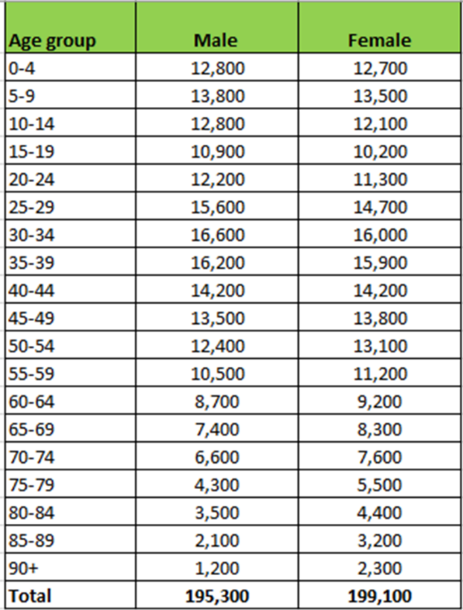 | The response to overall Fees and Charges consultation only received three responses.  Due to the low response to the consultation, it has not been possible to draw out any statistically significant findings in terms of this protected characteristic
Disability | 14.9% of Barnet's population have a disability (Census 2011 last reported data) | The response to overall Fees and Charges consultation only received three responses.  Due to the low response to the consultation, it has not been possible to draw out any statistically significant findings in terms of this protected characteristic
Gender  reassignment | There is limited information available about the number of individuals receiving gender recognition surgery or other forms of medical support. 52% of trans people in the UK are currently undergoing or have undergone medical intervention, but many (47%) who want medical assistance are unable to due to long wait times and (45%) due to lack of financial means. | The response to overall Fees and Charges consultation only received three responses.  Due to the low response to the consultation, it has not been possible to draw out any statistically significant findings in terms of this protected characteristic
Marriage and Civil Partnership | In 2017, there were 834 marriages in Barnet, with 819 of which being between individuals of the opposite sex. Of the 15 same-sex marriages, 11 were between both male partners, and 4 between female partners.  The local statistics for civil partnerships are unavailable online but in 2019 there were 960 civil unions in England, which has been increasing each year by c.4%. | The response to overall Fees and Charges consultation only received three responses.  Due to the low response to the consultation, it has not been possible to draw out any statistically significant findings in terms of this protected characteristic
  Total Marriages | Marriages of opposite-sex couples | Marriage of same-sex couples | Male |  | Female
  834 | 819 | 15 |  | 11 |  | 4
  Year | Total | % Annual Change | Male | Female
  2019 | 960 | 4% | 592 | 368
  2018 | 922 | 5% | 604 | 318
  2017 | 876 | 2% | 584 | 292
  2016 | 859 | - | 584 | 275
  Average | 919 | 4% | 593 | 326
Pregnancy and Maternity | The Pregnancy in Barnet 2016 report states that there were 5,244 births in 2014. The age of mothers is sharply rising to be 40 or older (78% country-wide). Mothers in Barnet are generally happy with care received, with 50% of mothers having their preferred choice for giving birth. Many mothers were not aware of what community support is available by the Borough.  These statistics are to provide context on pregnancy and maternity, the data is purely quoted within the report and do not have an associated breakdown of data. | The response to overall Fees and Charges consultation only received three responses.  Due to the low response to the consultation, it has not been possible to draw out any statistically significant findings in terms of this protected characteristic
Race/  Ethnicity | The Barnet population is projected to become increasingly diverse, with the proportion of Black, Asian and Minority Ethnic (BAME) people in the borough population rising from 40.3% in 2020 to 42.8% in 2030.  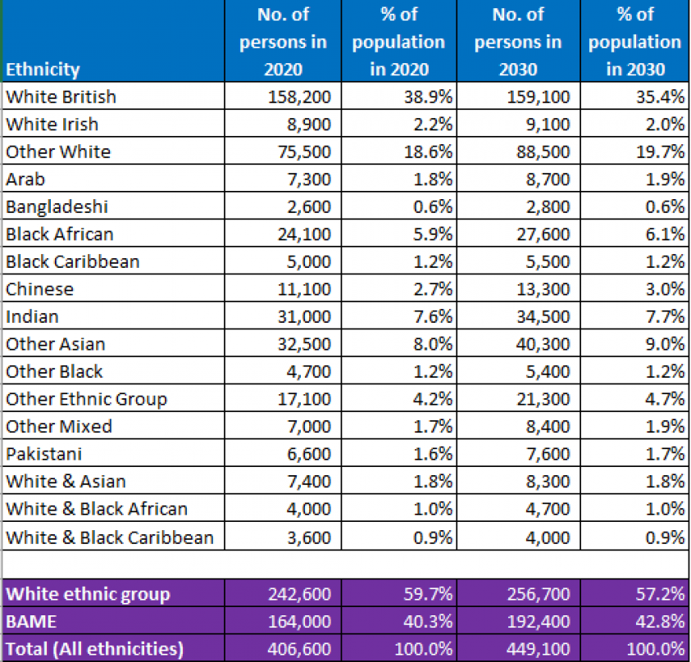 | The response to overall Fees and Charges consultation only received three responses.  Due to the low response to the consultation, it has not been possible to draw out any statistically significant findings in terms of this protected characteristic
Religion or belief | The most common religion in Barnet is Christianity (39.2%), followed by the Jewish (19.2%) and Muslim (11.8%) faiths. Almost one in five people in the borough has no religion (19.4%), which equates to around 75,600 people, compared to the 152,500 Christians in Barnet. Whilst almost a third of people in the borough are either Jewish or Muslim (31%) roughly one in twenty-five are Hindu (4.0%) and Buddhists account for just under one in fifty (1.9%).  The most common religion in Barnet is Christianity (39.2%), followed by the Jewish (19.2%) and Muslim (11.8%) faiths (refer to Figure 1.8). Almost one in five people in the borough has no religion (19.4%), which equates to around 75,600 people, compared to the 152,500 Christians in Barnet. Whilst almost a third of people in the borough are either Jewish or Muslim (31%) roughly one in twenty-five are Hindu (4.0%) and Buddhists account for just under one in fifty (1.9%).  Hendon has particularly strong Jewish presence, with 32-38% of its population. | The response to overall Fees and Charges consultation only received three responses.  Due to the low response to the consultation, it has not been possible to draw out any statistically significant findings in terms of this protected characteristic
Sex | The table below shows the percentage of the Population of Barnet by sex.  The table over the page show 50.4% of the population as of 2020 is female, and 49.6% is male. The most populous age bands for both sexes are 30-39 years.  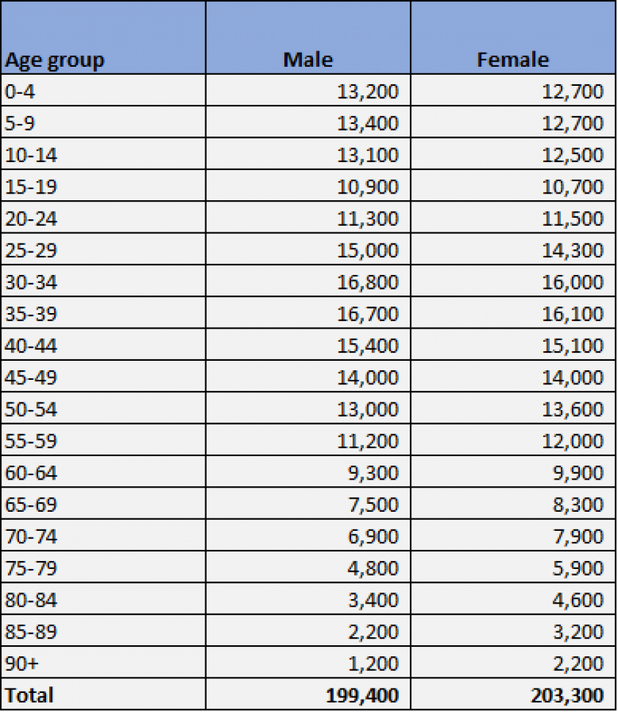 | The response to overall Fees and Charges consultation only received three responses.  Due to the low response to the consultation, it has not been possible to draw out any statistically significant findings in terms of this protected characteristic
  Sex | %
  Female | 50.4%
  Male | 49.6%
  Total | 100%
Sexual Orientation | In 2019 it was reported that 89% of London’s population identified as straight or heterosexual, with 2.6% identifying as gay/lesbian, 1.2% as bisexual, 0.7% as other, and 6.5% unknown or refusing to answer. These statistics have shown a slight increase in the population identifying as LGBTQ+ since 2014 as acceptance grows. There has been an increase in 3% of people who are unsure or refuse to answer. | The response to overall Fees and Charges consultation only received three responses.  Due to the low response to the consultation, it has not been possible to draw out any statistically significant findings in terms of this protected characteristic
  Year | Identity | Estimate | % of Total
  2014 | Heterosexual or straight | 6,240 | 93%
  2014 | Gay or lesbian | 131 | 2%
  2014 | Bisexual | 51 | 1%
  2014 | Other | 21 | 0%
  2014 | Don't know or refuse | 299 | 4%
  2014 | Total | 6,742
  2019 | Heterosexual or straight | 6,326 | 90%
  2019 | Gay or lesbian | 131 | 2%
  2019 | Bisexual | 87 | 1%
  2019 | Other | 53 | 1%
  2019 | Don't know or refuse | 466 | 7%
  2019 | Total | 7,063
Other relevant groups | Data Not Reportable

- Assessing impact
What does the evidence tell you about the impact your proposal may have on groups with protected characteristics ?

Protected characteristic | For each protected characteristic, explain in detail what the evidence is suggesting and the impact of your proposal (if any). Is there an impact on service deliver? Is there an impact on customer satisfaction?  Click the appropriate box on the right to indicate the outcome of your analysis. | Positive impact | Negative  impact |  | No impact
Protected characteristic |  | Positive impact | Minor | Major | No impact
Age | Children’s Centres  There may be a minor impact to age groups, specifically dependents (children and young people). The increase is 6%, which is below inflation. There is a holiday activity fund in place to support vulnerable families.  Greenspaces  There is an increase on fees and charges I relation to sport e.g. football, cricket. This is deemed to have a negative impact on younger age groups. However, the increase is below inflation and capped at 3.5%.  Cemeteries and Crematoriums  There is likely to be an impact on older age groups. | ☐ | ☒ | ☐ | ☐
Disability | Parking  There may be a minor impact to people with a disability and/or long-term health conditions, especially those on low income/in receipt of benefits. This is mitigated by subsidised or free parking for blue badge holders. | ☐ | ☒ | ☐ | ☐
Gender  Reassignment | No impact is expected. | ☐ | ☐ | ☐ | ☒
Marriage and Civil Partnership | Registrars  There would be an impact on those wanting to get married which may include certain religious groups. | ☐ | ☒ | ☐ | ☐
Pregnancy and Maternity | Parking  May have an adverse disproportionate effect, ability to use alternatives methods of transport is hampered. | ☐ | ☒ | ☐ | ☐
Race/  Ethnicity | No reported impact | ☐ | ☐ | ☐ | ☒
Religion or belief | Registrars  There would be an impact on those wanting to get married which may include certain religious groups. | ☐ | ☒ | ☐ | ☐
Sex | No reported impact | ☐ | ☐ | ☐ | ☒
Sexual Orientation | No reported impact | ☐ | ☐ | ☐ | ☒

- Other key groups  Are there any other vulnerable groups that might be affected by the proposal?  These could include carers, people in receipt of care, lone parents, people with low incomes or unemployed |  | Positive impact | Negative  impact |  | No impact
 |  | Positive impact | Minor | Major | No impact
Key groups | Children Centres  There may be an adverse disproportionate effect on lone parents. There is a holiday activities fund to support vulnerable families. | ☐ | ☒ | ☐ | ☐

- Cumulative impact
Considering what else is happening within the council and Barnet could your proposal contribute to a cumulative impact on groups with protected characteristics?
☒ Yes No ☐

There is a possibility this proposal could contribute to a cumulative impact due to the current cost of living crisis. The Council has recently launched the Barnet Resident Support Fund, where residents can apply for financial support to help with the rising cost of living.

- Actions to mitigate or remove negative impact
Only complete this section if your proposals may have a negative impact on groups with protected characteristics. These need to be included in the relevant service plan for mainstreaming and performance management purposes.
Group affected | Potential negative impact | Mitigation measures  If you are unable to identify measures to mitigate impact, please state so and provide a brief explanation. | Monitoring  How will you assess whether these measures are successfully mitigating the impact? | Deadline date | Lead Officer
Age, disability, pregnancy and maternity, religion and belief and marriage and civil partnership. | Minor | The Council has recently launched the Barnet Resident Support Fund, where residents can apply for financial support to help with the rising cost of living. | Individual services will monitor the impact | October 2023 | Individual services

- Outcome of the Equalities Impact Assessment (EIA)
Please select one of the following four outcomes
☒ Proceed with no changes
The EIA has not identified any potential for a disproportionate impact and all opportunities to advance equality of opportunity are being addressed
☐ Proceed with adjustments
Adjustments are required to remove/mitigate negative impacts identified by the assessment
☐ Negative impact but proceed anyway
This EIA has identified negative impacts that are not possible to mitigate. However, it is still reasonable to continue with the activity. Outline the reasons for this and the information used to reach this decision in the space below

☐ Do not proceed
This EIA has identified negative impacts that cannot be mitigated and it is not possible to continue. Outline the reasons for this and the information used to reach this decision in the space below
Reasons for decision

Sign-off
9.Sign off and approval by Head of Service / Strategic lead
Name: Ashley Hughes | Job title: Assistant Director Finance
☒ Tick this box to indicate that you have approved this EIA |  | Date of approval: 28/10/22
☒ Tick this box to indicate if EIA is to be published IF REQUIRED |  | Date of next review: 28/10/23

Footnotes: guidance for completing the EIA template

Trans Report Final – LGBT in Britain, Stonewall Report, 2020
Marriage by Area of occurrence, ONS, 2017
Civil Partnership Formations, ONS, 2020
Sexual Identity by Region, ONS, 2019
The following principles explain what we must do to fulfil our duties under the Equality Act when considering any new policy or change to services. They must all be met or the EIA (and any decision based on it) may be open to challenge: - Knowledge: everyone working for the council must be aware of our equality duties and apply them appropriately - Timeliness: the duty applies at the time of considering proposals and before a final decision is taken - Real Consideration: the duty must be an integral and rigorous part of your decision-making and must influence the process. - Sufficient Information: you must assess what information you have and what is needed to give proper consideration. - No delegation: the council is responsible for ensuring that anyone who provides services on our behalf complies with the equality duty. - Review: the equality duty is a continuing duty – it continues after proposals are implemented/reviewed. - Proper Record Keeping: we must keep records of the process and the impacts identified.
Our duties under the Equality Act 2010 The council has a legal duty under this Act to show that we have identified and considered the impact and potential impact of our activities on all people with ‘protected characteristics’ (see end notes 9-19 for details of the nine protected characteristics). This applies to policies, services (including commissioned services), and our employees. We use this template to do this and evidence our consideration. You must give ‘due regard’ (pay conscious attention) to the need to: - Avoid, reduce or minimise negative impact: if you identify unlawful discrimination, including victimisation and harassment, you must stop the action and take advice immediately. - Promote equality of opportunity: by - Removing or minimising disadvantages suffered by people with a protected characteristic - Taking steps to meet the needs of these groups - Encouraging people with protected characteristics to participate in public life or any other activity where participation is disproportionately low - Consider if there is a need to treat disabled people differently, including more favourable treatment where necessary - Foster good relations between people who share a protected characteristic and those who don’t: e.g. by promoting understanding.
EIAs should always be proportionate to: - The size of the service or scope of the policy/strategy - The resources involved - The size of the likely impact – e.g. the numbers of people affected and their vulnerability The greater the potential adverse impact of the proposal on a protected group (e.g. disabled people) and the more vulnerable the group is, the more thorough and demanding the process required by the Act will be. Unless they contain sensitive data – EIAs are public documents. They are published with Cabinet papers, Panel papers and public consultations. They are available on request.
When to complete an EIA: - When developing a new policy, strategy, or service - When reviewing an existing service, policy or strategy - When making changes that will affect front-line services - When amending budgets which may affect front-line services - When changing the way services are funded and this may impact the quality of the service and who can access it - When making a decision that could have a different impact on different groups of people - When making staff redundant or changing their roles Wherever possible, build the EIA into your usual planning and review processes. Also consider: - Is the policy, decision or service likely to be relevant to any people because of their protected characteristics? - How many people is it likely to affect? - How significant are its impacts? - Does it relate to an area where there are known inequalities? - How vulnerable are the people who will be affected? If there are potential impacts on people but you decide not to complete an EIA you should document your reasons why.
Title of EIA: This should clearly explain what service / policy / strategy / change you are assessing.
Focus of EIA: A member of the public should have a good understanding of the proposals being assessed by the EIA after reading this section. Please use plain English and write any acronyms in full first time - eg: ‘Equality Impact Assessment (EIA)’ This section should explain what you are assessing: - What are the main aims or purpose of the proposed change? - Who implements, carries out or delivers the service or function in the proposal? Please state where this is more than one person or group, and where other organisations deliver it under procurement or partnership arrangements. - How does it fit with other services? - Who is affected by the service, or by how it is delivered? Who are the external and internal service-users, groups, or communities? - What outcomes do you want to achieve, why and for whom? E.g.: what do you want to provide, what changes or improvements, and what should the benefits be? - What do existing or previous inspections of the service tell you? - What is the reason for the proposed change (financial, service, legal etc)? The Act requires us to make these clear.
Data & Information: Your EIA needs to be informed by data. You should consider the following: - What data is relevant to the impact on protected groups is available? (is there an existing EIA?, local service data, national data, community data, similar proposal in another local authority). - What further evidence is needed and how can you get it? (e.g. further research or engagement with the affected groups). - What do you know from service/local data about needs, access and outcomes? Focus on each characteristic in turn. - What might any local demographic changes or trends mean for the service or function? Also consider national data if appropriate. - Does data/monitoring show that any policies or practices create particular problems or difficulties for any group(s)? - Is the service having a positive or negative effect on particular people or groups in the community?
What have people told you about the service, function, area? - Use service user feedback, complaints, audits - Conduct specific consultation or engagement and use the results - Are there patterns or differences in what people from different groups tell you? - Remember, you must consult appropriately and in an inclusive way with those likely to be affected to fulfil the equality duty. - You can read LBB Consultation and Engagement toolkit for full advice or contact the Consultation and Research Manager, rosie.evangelou@barnet.gov.uk for further advise
Age: People of all ages, but consider in particular children and young people, older people and carers, looked after children and young people leaving care. Also consider working age people.
Disability: When looking at disability, consideration should be given to people with different types of impairments: physical (including mobility), learning, aural or sensory (including hearing and vision impairment), visible and non-visible impairment. Consideration should also be given to: people with HIV, people with mental health needs and people with drug and alcohol problems. People with conditions such as diabetes and cancer and some other health conditions also have protection under the Equality Act 2010.
Gender Reassignment: In the Act, a transgender person is someone who proposes to, starts or has completed a process to change their gender. A person does not need to be under medical supervision to be protected. Consider transgender people, transsexual people and transvestites.
Marriage and Civil Partnership: consider married people and civil partners.
Pregnancy and Maternity: When looking at pregnancy and maternity, give consideration to pregnant women, breastfeeding mothers, part-time workers, women with caring responsibilities, women who are lone parents and parents on low incomes, women on maternity leave and ‘keeping in touch’ days.
Race/Ethnicity: Apart from the common ethnic groups, consideration should also be given to Traveller communities, people of other nationalities outside Britain who reside here, refugees and asylum seekers and speakers of other languages.
Religion and Belief: Religion includes any religion with a clear structure and belief system. As a minimum you should consider the most common religious groups (Christian, Muslim, Hindu, Jews, Sikh, Buddhist) and people with no religion or philosophical beliefs.
Sex: Consider girls and women, boys and men, married people, civil partners, part-time workers, carers (both of children with disabilities and older cares), parents (mothers and fathers), in particular lone parents and parents on low incomes.
Sexual Orientation: The Act protects bisexual, heterosexual, gay and lesbian people.
Other relevant groups: You should consider the impact on our service users in other related areas.
Impact: Your EIA must consider fully and properly actual and potential impacts against each protected characteristic: - The equality duty does not stop changes, but means we must fully consider and address the anticipated impacts on people. - Be accurate and transparent, but also realistic: don’t exaggerate speculative risks and negative impacts. - Be detailed and specific where you can so decision-makers have a concrete sense of potential effects. - Questions to ask when assessing whether and how the proposals impact on service users, staff and the wider community: - Are one or more protected groups affected differently and/or disadvantaged? How, and to what extent? - Is there evidence of higher/lower uptake of a service among different groups? Which, and to what extent? - Does the project relate to an area with known inequalities (where national evidence or previous research is available)? - If there are likely to be different impacts on different groups, is that consistent with the overall objective? - If there is negative differential impact, how can you minimise that while taking into account your overall aims? - Do the effects amount to unlawful discrimination? If so the plan must be modified. - Does it relate to an area where equality objectives have been set by LBB in our Barnet 2024 Plan and our Strategic Equality Objective?
Cumulative Impact You will need to look at whether a single decision or series of decisions might have a greater negative impact on a specific group and at ways in which negative impacts across the council might be minimised or avoided.
Mitigating actions - Consider mitigating actions that specifically address the impacts you’ve identified and show how they will remove, reduce or avoid any negative impacts - Explain clearly what any mitigating measures are, and the extent to which you think they will reduce or remove the adverse effect - Will you need to communicate or provide services in different ways for different groups in order to create a ’level playing field’? - State how you can maximise any positive impacts or advance equality of opportunity. - If you do not have sufficient equality information, state how you can fill the gaps.
Monitoring: The Equality Duty is an ongoing duty: policies must be kept under review, continuing to give ‘due regard’ to the duty. If an assessment of a broad proposal leads to more specific proposals, then further monitoring, equality assessment, and consultation are needed.
Outcome: - Make a frank and realistic assessment of the overall extent to which the negative impacts can be reduced or avoided by the mitigating measures. Also explain what positive impacts will result from the actions and how you can make the most of these. - Make it clear if a change is needed to the proposal itself. Is further engagement, research or monitoring needed? - Make it clear if, as a result of the analysis, the policy/proposal should be stopped.
Sign off: Your will need to ensure the EIA is signed off by your Head of Service, agree whether the EIA will be published, and agree when the next review date for the EIA will be.

