
Female Protagonists in Children’s Books 2023
(Ages are indicative only)
Ages: 0 - 5
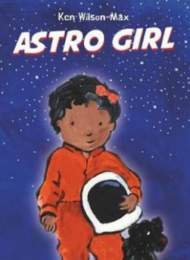 | Astro Girl  By Ken Wilson-Max  Astrid wants to be an astronaut. Her dad tells her all the things she will need to do if she becomes one and her strong self-belief in her abilities is joyfully apparent.
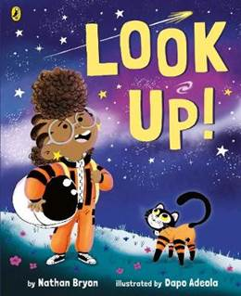 | Look up!  By Nathan Bryon  Rocket wants to be the greatest astronaut, star-catcher and space-traveller who has ever lived, just like Mae Jemison, the first African American woman in space.
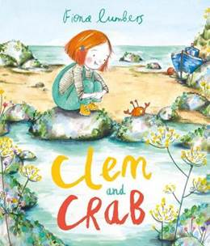 | Clem and Crab  By Fiona Lumbers  This beautiful picture book gently reinforces the message that everyone has a responsibility to care for the environment and demonstrates that lots of small actions can have a big impact.
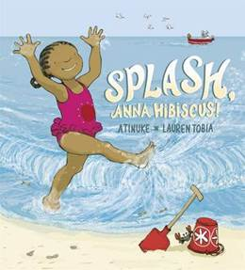 | Splash, Anna Hibiscus!  By Atinuke  Anna Hibiscus wants someone to go in the sea and splash in the waves with her, but her family are all busy doing other things. So Anna Hibiscus decides to splash in the waves anyway - and when the rest of the family see how much fun she is having, they join in too!
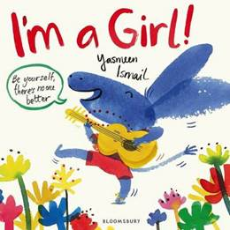 | I’m a Girl!  By Yasmeen Ismail  This little girl is noisy, messy, fast and loud. She's keen to learn everything she can. She's brave and adventurous, she's curious and competitive. Not interested in being sugar and spice, she's 'sweet and sour, not a little flower' - constantly mistaken for a boy, she's loud and she's proud because she's a GIRL!
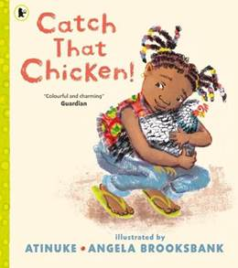 | Catch that Chicken!  By Atinuke  Lami is the best chicken-catcher in the whole village!
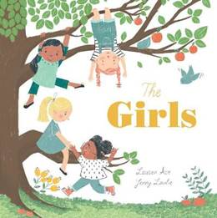 | The Girls  By Lauren Ace  Four good friends find a tree that becomes their Secret Meeting Place. This wonderfully touching picture book perfectly encapsulates the value and joy of female friendship.
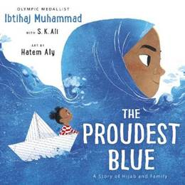 | The Proudest Blue  By Ibtihaj Muhammad and S.K. Ali  Inspired by the experiences of Olympic medallist Ibtihaj Muhammad, this is a beautiful and powerful story about the bond shared between siblings and being proud of yourself and your beliefs.
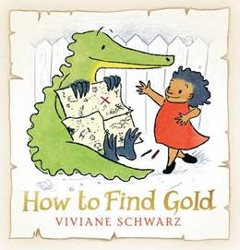 | How to Find Gold  By Viviane Schwarz  Anna decides to go on an adventure in search of gold and is undeterred by any obstacles. Her friend Crocodile suggests the solutions to help them achieve this together.
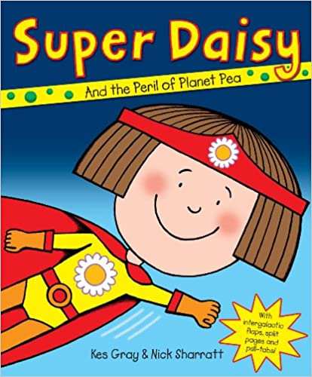 | Super Daisy  By Kes Gray and Nick Sharratt  The fate of dinner-times all over the world, rests with Super Daisy.
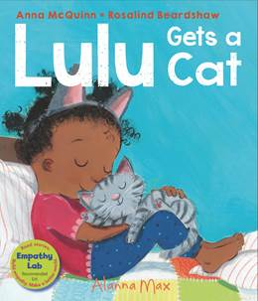 | Lulu Gets a Cat  By Anna McQuinn  This book is part of the useful Lulu series from AlannaMax that covers all sorts of new experiences with Lulu and her little brother Zeki.
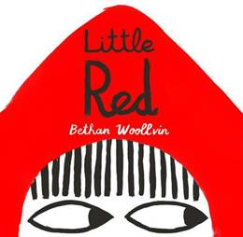 | Little Red  By Beth Woollvin  The wolf takes a sneaky shortcut to Grandma's house, where he gobbles her up, dresses in her clothes and lies in wait for Little Red. However, this wolf has met his match: when Little Red arrives, she is not fooled by his ridiculous disguise and fearlessly formulates a plan of her own. This contemporary interpretation of a familiar classic is a joy to read.
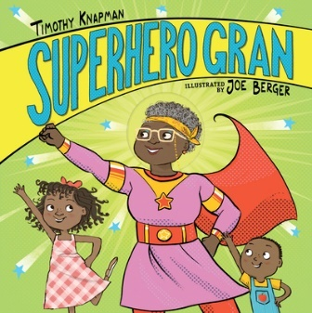 | Superhero Gran  By Timothy Knapman  All grandmothers are wonderful, and this gran is no exception.
Ages 5 - 7

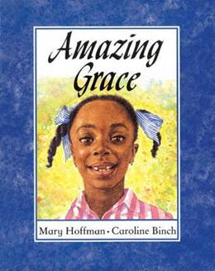 | Amazing Grace  By Mary Hoffman  When her school decides to perform Peter Pan, Grace is longing to play Peter, but her classmates say that Peter was a boy, and besides, he wasn't black... But Grace's Ma and Nana tell her she can be anything she wants if she puts her mind to it...
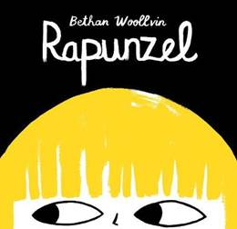 | Rapunzel  By Bethan Woollvin  Bethan Woollvin, winner of The Macmillan Prize for Illustration for Little Red Riding Hood, brings her imaginative flair to another traditional tale, creating a feisty, independent heroine in a landscape free from heroic princes!
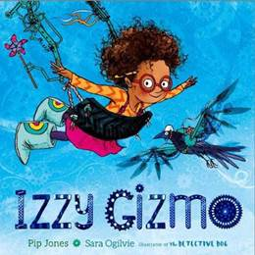 | Izzy Gizmo  By Pip Jones  Izzy Gizmo is a girl that loves inventing things: the Swirly Spagsonic, the Tea-Mendous and the Beardtastic, to name just a few!
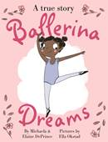 | Ballerina Dreams  By Michaela and Elaine DePrince  Michaela DePrince was born in war-torn Sierra Leone, adopted at a very young age by Elaine DePrince and taken to live in America. Having been inspired by a picture of a ballerina she’d found whilst still at the orphanage, Michaela studied ballet in her new home in the US and grew up to be a famous ballerina, inspiring young black girls that they can be whoever they want to be, too.
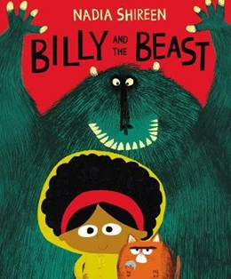 | Billy and the Beast  By Nadia Shireen  A delightful picture book about a little girl outwitting a rather stupid beast!
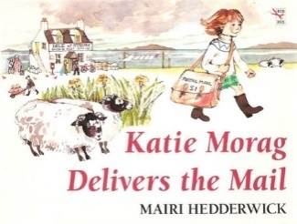 | Katie Morag Delivers the Mail  By Mairi Hedderwick  The first of the wonderful Katie Morag adventures set on Struay island.
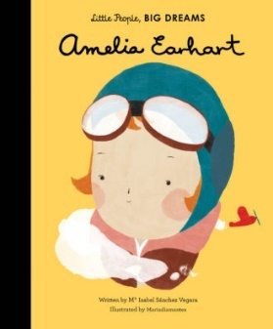 | Amelia Earhart:  Little People Big Dreams Series  by Mª Isabel Sánchez Vegara  One of an accessible series of biographies of women for younger children. Other titles in the Little People, Big Dreams series include: Agatha Christie, Audrey Hepburn, Coco Chanel, Marie Curie, Maya Angelou Rosa Parks Ada Lovelace, Ella Fitzgerald and there are lots more to come!
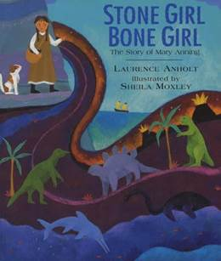 | Stone Girl Bone Girl  By Laurence Anholt  Laurence Anholt takes the real story of fossil hunter Mary Anning and creates a beautiful story, accompanied by vivid illustrations that perfectly evoke the colours and textures of the beach and coast. Essential reading.
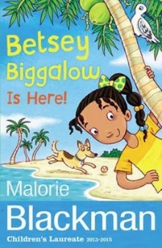 | Betsey Biggalow is Here!  By Marlorie Blackman  This is one of a series of short story collections about the irrepressible Betsey Biggalow, set in the Carribean.
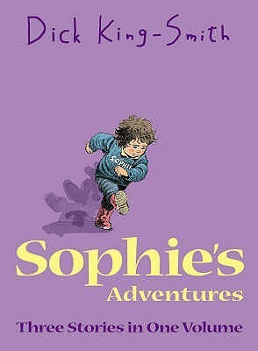 | Sophie’s Adventures  By Dick King-Smith  Sophie is small, determined and loves animals.
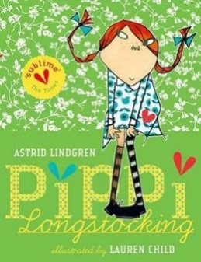 | Pippy Longstocking  By Astrid Lindgren  A modern classic following the adventures of a fabulous heroine.
Ages 7 – 11

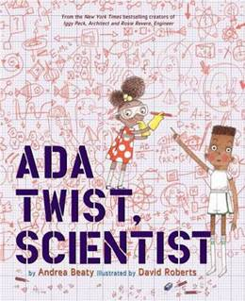 | Ada Twist, Scientist  By Andrea Beaty  A brilliant rhyming book about supporting your child's curiosity, Ada Twist also responds magnificently to the call for greater representation of girls - and girls of colour - in STEM subjects and industries.
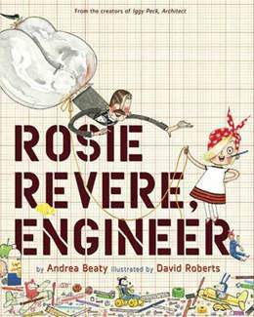 | Rosie Revere, Engineer  By Andrea Beaty  Rosie Revere dreams of becoming a great engineer. She creates wonderful gadgets and gizmos - but only when no one is watching. This inspiring and stylishly illustrated picture book explores the importance of following your dreams.
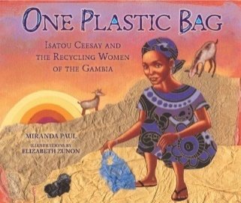 | One Plastic Bag  By Miranda Paul  The true story of Isatou Ceesay who saw the problem that the plastic bags were causing in her country, the Gambia, contaminating the environment and killing the goats that swallowed them. She collaborated with other local women to crochet thread made from the plastic bags to create purses resulting in a thriving trade and reducing pollution.
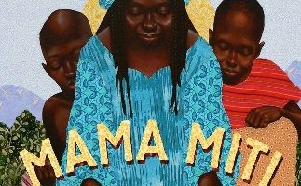 | Mama Miti  By Donna Jo Napoli  The true story of the first ever African woman to win the Nobel Peace Prize whose actions have led to over 30 million trees being planted across Kenya.
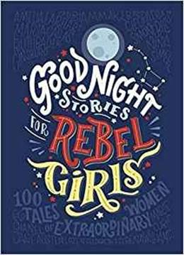 | Goodnight Stories for Rebel Girls  By Elena Favilli & Francesca Cavallo  Featuring a brief summary of the work and lives of 100 historical and contemporary great women, as well as many unknowns, the breadth and diversity - not to mention stunning and varied illustration of this anthology is impressive.
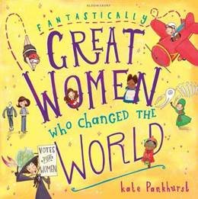 | Great Women who Changed the World  By Kate Pankhurst  Written and illustrated by a direct descendant of suffragette Emmeline Pankhurst, this colourful picture book is full of facts about 13 inspirational women from history. It showcases some of their great achievements in a fun and accessible way for younger readers.
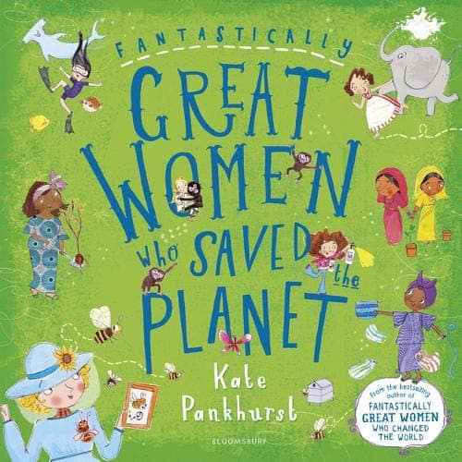 | Great Women who Saved the Planet  By Kate Pankhurst  From bestselling author and illustrator Kate Pankhurst, descendent of suffragette Emmeline Pankhurst, comes another ‘smart, informative, inclusive and accessible’ book about trail-blazing women.
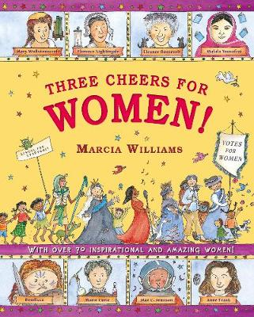 | Three Cheers for Women!  By Marcia Williams  Marcia Williams' much-loved comic-strip style will encourage even the most reluctant reader to enjoy this inspirational book packed with facts, quotes and jokes.
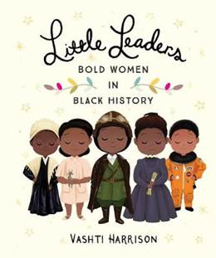 | Little Leaders: Bold Women in Black History  By Vashti Harrison  One Black History Month, Vashti Harrison illustrated one African American woman from history every day and posted the portraits online along with a small biography. It resulted in this fabulous book.
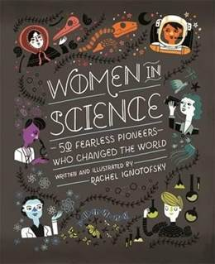 | Women in Science: 50 Fearless Pioneers who Changed the World  By Rachel Ignotofsky  The 50 women profiled in this book are leaders in their fields of science, technology, engineering and mathematics. A must.
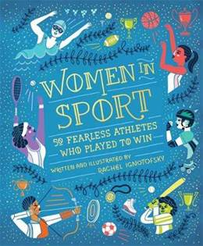 | Women in Sport: 50 Fearless Athletes who Played to Win  By Rachel Ignotofsky  So many women’s achievements in sport have been overlooked in favour of men’s over the years, so it’s a great pleasure to see these 50 women celebrated in this marvellous book.
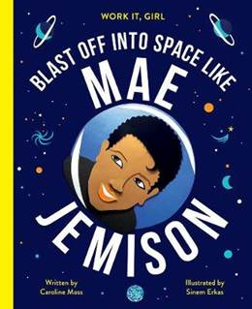 | Work It, Girl: Blast Off Into Space Like Mae Jemison  By Caroline Moss  Mae became the first black woman astronaut at NASA, and on 12 September 1992, she blasted off into space on the space shuttle ENDEAVOUR, watched by millions of people worldwide.
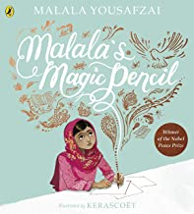 | Malala’s Magic Pencil  This beautifully illustrated picture book tells Malala's story, in her own words, for a younger audience.
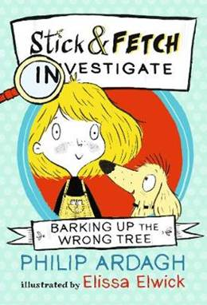 | Stick and Fetch Investigate: Barking up the Wrong Tree  By Philip Ardagh  Sally Stick has decided that she and her faithful pooch Fetch are simply too talented when it comes to solving mysteries to deprive the world of their genius, so she starts her very own detective agency.
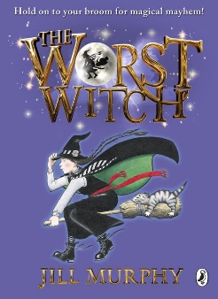 | The Worst Witch  By Jill Murphy  Hold on to your broomstick for magical mayhem with Jill Murphy’s much-loved classic The Worst Witch- the original story of life at a magical boarding school.
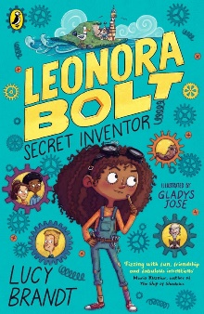 | Leonora Bolt Secret Inventor  By Lucy Brandt  Violet Baudelaire meets Peanut Jones in this epic STEM-themed adventure about believing in your brainpower – and yourself!
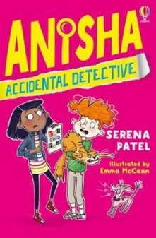 | Anisha Accidental Detective  By Serena Patel  Funny, fast paced detective series for lower KS2 readers.
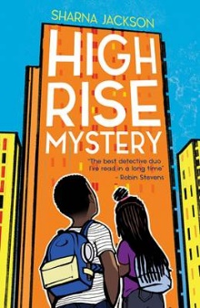 | High Rise Mystery  By Sharna Jackson  After finding their community art teacher murdered on their tower block estate (‘The Tri’), sisters Nik and Norva are determined to solve this terrible crime.
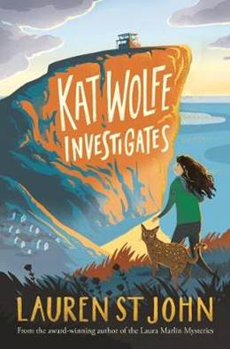 | Kat Wolfe Investigates  By Lauren St John  Kat Wolfe loves her new home in idyllic Bluebell Bay, especially as it comes with a resident wildcat. But when she starts pet-sitting for pocket money, she finds that beneath the town's perfect surface lie some dark and dangerous secrets. The first in a new adventure series by a very popular author.
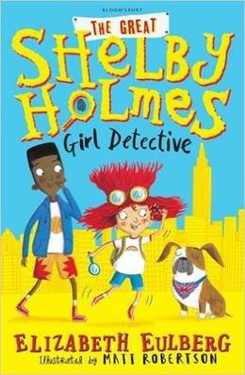 | The Great Shelby Holmes: Girl Detective  By Elizabeth Eulberg  Shelby Holmes is the best detective in her neighbourhood but has never quite learned the knack of making friends. Although used to working alone, Shelby discovers that her new neighbour, John Watson, is not only useful to her investigation but might also become her first real friend. Brilliantly clever characterisation brings the essence of the Conan Doyle stories to life in contemporary New York.
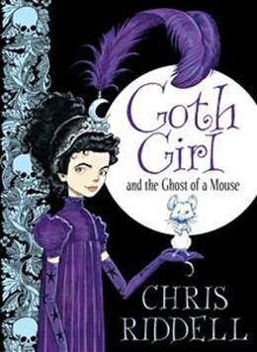 | Goth Girl and the Ghost of a Mouse  By Chris Riddell  Follow the adventures of plucky heroine Ada Goth. Also in the series:  Goth Girl and the Fete Worse Than Death  Goth Girl and the Wuthering Fright
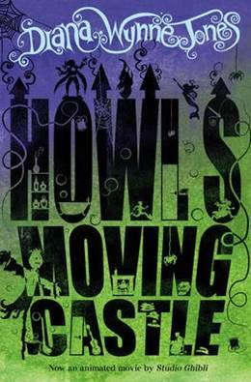 | Howl’s Moving Castle  By Diana Wynn Jones  Sophie Hatter is cursed with an old body by the Witch of the Waste and the spell can only be broken by the dreaded Wizard Howl who lives in his moving castle and likes to eat the souls of young girls.
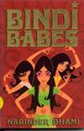 | Bindi Babes  Narinda Dhami  Follow the adventures of the Bindi sisters.
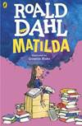 | Matilda  By Roald Dahl  A modern fairy-tale with an inspiring young heroine.
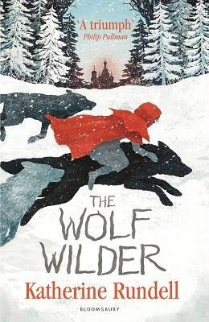 | The Wolf Wilder  By Katherine Rundell  When the corrupt Russian Army threatens her wolves and arrests her mum, Feo is left with no option but to go on the run.
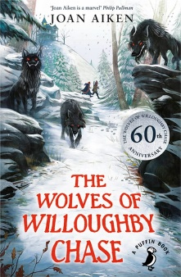 | The Wolves of Willoughby Chase  By Joan Aiken  When orphans Bonnie and Sylvia fall into the hands of evil Miss Slighcarp, they need all their wits – and the help of Simon the goose-boy – to escape unscathed, for the governess is more cruel than the wolves that surround the great house of Willoughby Chase. Modern classic, essential reading.
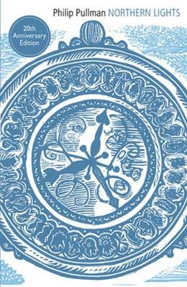 | His Dark Materials Trilogy  By Philip Pullman  Modern fantasy classic following the adventures of Lyra Belacqua and her daemon.
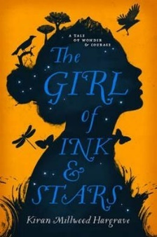 | The Girl of Ink and Stars  By Kiran Millwood  Forbidden to leave her island, Isabella Riosse dreams of the faraway lands her father once mapped. When her closest friend disappears into the island's Forgotten Territories, she volunteers to guide the search.
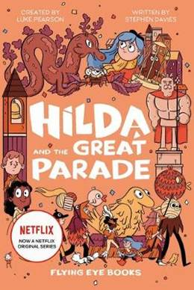 | Hilda and the Great Parade  By Luke Pearson and Stephen Davies  Hilda is a hugely appealing heroine whose magical yet contemporary world is as full of friendship issues, school and community as it is elves, talking birds and trolls.

