Hampden Way phasing plan

To minimise disruption to residents, the Hampden Way reconstruction works will be undertaken in 5 phases. This means that the road will be closed in sections rather than needing to implement and full road closure. Each phase will take approx. 8-9 weeks.

The below outlines the extents of each phase:

Phase one
2 Hampden Way to 39 Hampden Way.

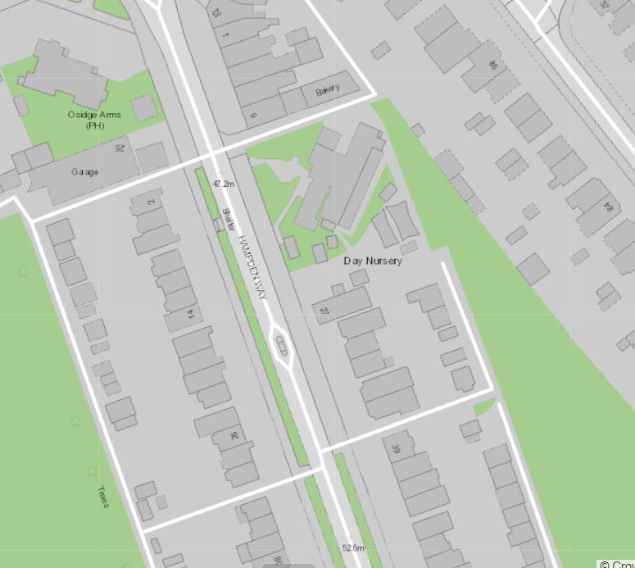
Phase 1 (29/07/2024)

Phase two
39 Hampden Way to 77 Hampden Way.

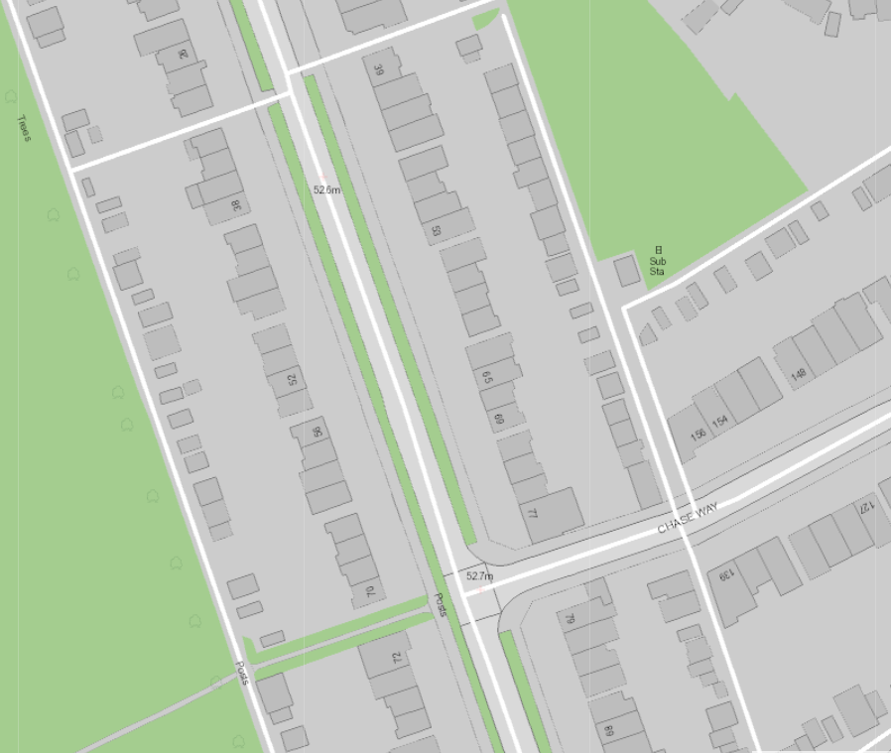
Phase 2 (approx. start date 16/09/2024)

Phase three
Hampden Square, outside of the Osidge Arms to number 2 Hampden Way.

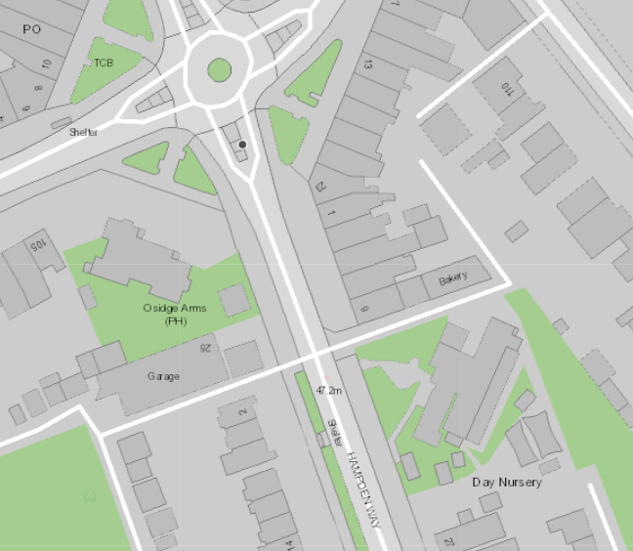
Phase 3 (approx. start date 11/11/2024)

Phase four
72 Hampden Way to 121 Hampden Way.

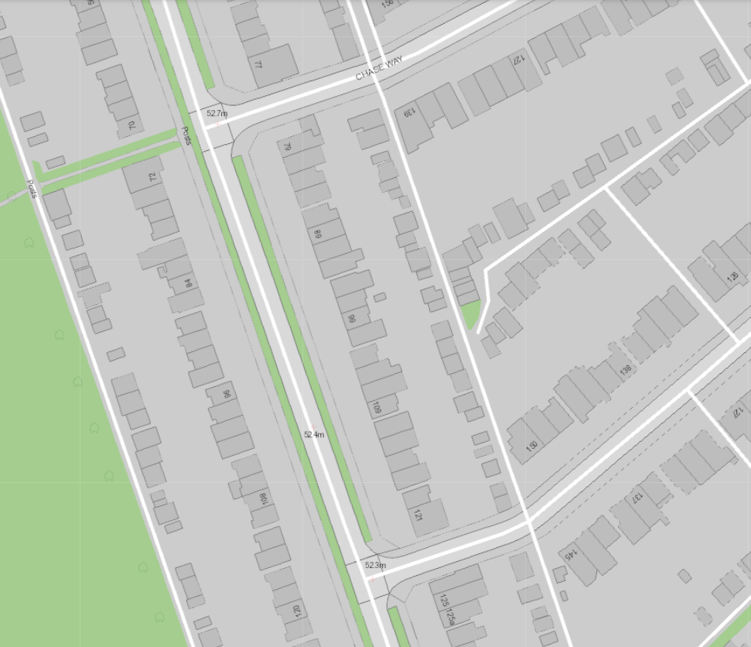
Phase 4. (approx. start date is 06/01/2025

Phase five
125 Hampden Way to 157 Hampden Way.

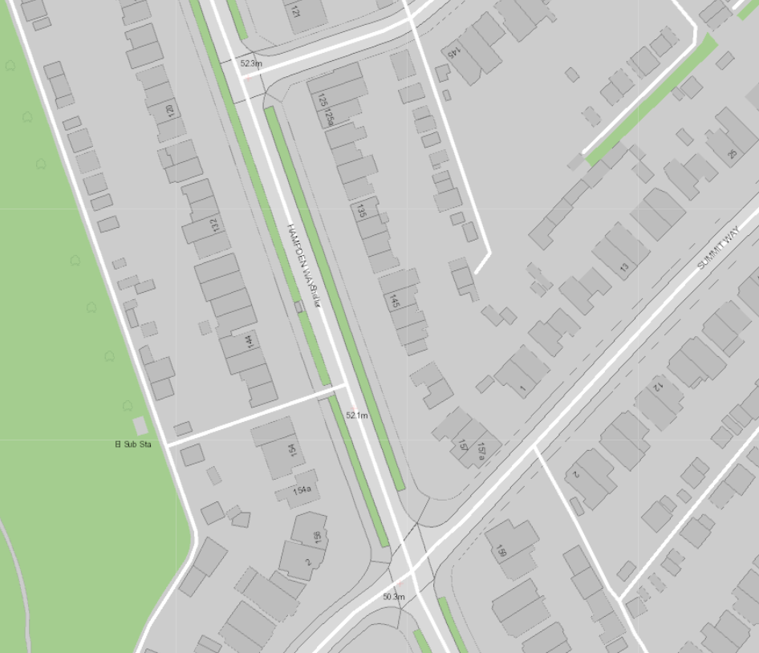
Phase 5. (approx. start date is 6/3/2025)


