EAT MORE HEALTHILY
BE FREE

FACTS AND FIGURES

children in Year 6 are overweight or obese in Barnet
1 in 3

Cardiovascular disease
Unhealthy eating is the biggest behavioural risk factor for CVD

1 tsp/day
is the recommended limit for salt intake for an adult

HELP AND ADVICE
Poor diet is a leading cause of tooth decay

74%
of UK adults have had a
tooth extracted

7 tsps/day
of sugar is the recommended limit for an adult
32%
of Barnet adults eat the recommended 5 portions of fruit and vegetables each day
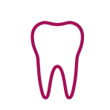
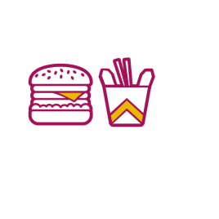
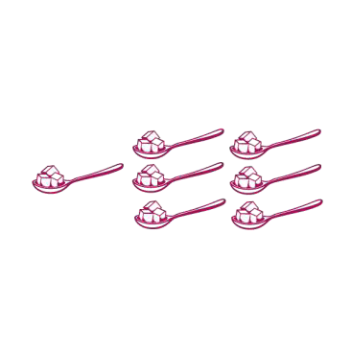

Eating a healthy, balanced diet can improve your physical health and emotional wellbeing, reducing your risk of type 2 diabetes, high blood pressure, cardiovascular disease and some cancers.
Here are some top tips for getting started:
- Eat a variety of fruit and vegetables, aiming for 5 to 10 portions each day. Frozen, tinned and fresh fruit and vegetables all count.
- Try and limit the amount of salt, sugar and unhealthy fats you consume. How can you tell how much is in your food? Use the traffic light system on the front of food packaging as a guide. The red, amber and green colours show at a glance whether a product is high, medium or low for fat, sugars or salt.
- Eating meals that contain a mix of fats, carbohydrates and protein will keep you full for longer, meaning you are less likely to snack on highly processed foods later in the day. Use the Eatwell guide as guide for how much of each you should be consuming.
- Making changes to your diet long term will only work if you enjoy it. Learning to cook simple, quick meals can be an affordable way to try different healthier foods to see what you like.

EAT MORE HEALTHILY
BE FREE
LOCAL SERVICES AND ONLINE SUPPORT
Service | Type | Description | Details
Barnet Council website – Information on healthy eating | - Video  - Website | This website has links to the Eatwell guide, and other useful information about cooking and eating well including a series of videos on healthy eating produced by Bread n Butter. Include advice on store cupboard cooking, healthy eating on a budget and cooking for one, advice on sugar and food labelling as well as a series of recipe cards for you to make these foods at home yourself. | Website:  Eat well | Barnet Council
Better Health Healthier families | - Website | National campaign from the NHS to help children and families become healthier and be more active. | Website:  Healthier Families - Home - NHS (www.nhs.uk)
NHS Eat Well | - Website | Support from the NHS on eating a healthy, balanced diet. This website includes guidance on nutrition, eating on a budget, recipes and tips. | Website:  Eat well - NHS (www.nhs.uk)
Food Security Resource Hub | - Website | Contains information food banks across Barnet, Free School Meals, Healthy Start, and advice and support for older adults. | Website:  Food Security Resource Hub | Barnet Council  Help with food | Barnet Council
Barnet Adult Weight Management Services | - Online  - Face-to- face | If you are struggling with your weight, have certain underlying health condition or have a BMI >30, you may be eligible for an adult weight management service. These services provide a mix of nutrition information, physical activity and behaviour change techniques. | Website:  Adult weight management | Barnet Council
Xplore | - Face-to- face | XPLORE is a FREE 8 week healthy lifestyle programme for 4-13 year olds, delivered in Better leisure centres across Barnet. Self-referrals, referrals from parents and health professionals are all accepted. | Website:  Healthy weight in children | Barnet Council  Email:  xplore.barnet@gll.org

