PERINATAL HEALTH

FACTS AND FIGURES

Perinatal period
refers to the period around
childbirth +

1 in 5
Mothers are affected by perinatal mental health problems

Perinatal mental health problems can have a negative impact on both mother and baby

Perinatal mental health problems requires prompt
access to care

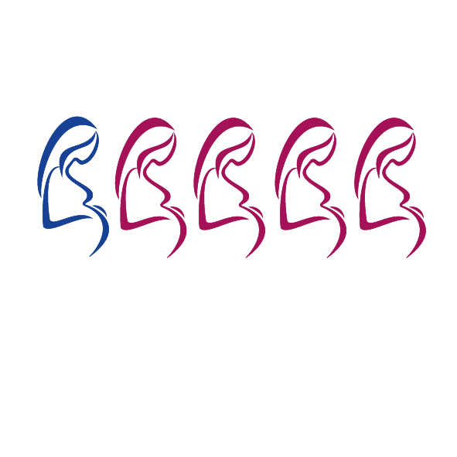
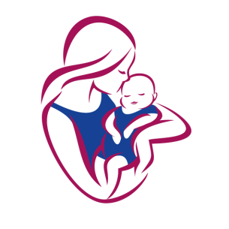

HELP AND ADVICE
- Depression and anxiety are the most common mental health conditions in pregnancy.
- Women who are unwell during their pregnancy:
  - May not be able to take good care of themselves
  - May not attend their antenatal appointments meaning that they may miss out on important care. This can increase the risk of pregnancy-related complications.
  - May remain unwell after birth which can affect their relationship with their baby and make it more difficult to care for them.
- Women with existing or previous mental health problems are more likely to become unwell during pregnancy or within the first year of birth.
- This is more common in women who have had severe mental health problems (e.g. schizophrenia, post-natal depression, severe depression, obsessive compulsive disorder (OCD) or an eating disorder).
- Women who have had a serious mental illness or who have received treatment from mental health services previously should be encouraged to accept the offer of a referral to a specialist during pregnancy, even if they feel well.
- Some women with a mental health problem stop taking their medication during pregnancy due to fears about the effect on their baby. Women should discuss any concerns with their midwife or GP as stopping their medication suddenly may cause their mental health condition to return or deteriorate which can have a negative impact on their baby. The GP or midwife can help them understand the advantages and disadvantages of taking medication.

PERINATAL HEALTH
- Post natal depression usually begins within the first 6 months of giving birth. If left untreated it can last for more than a year. Recovery is better when it is identified and treated earlier.
- ‘Baby blues’ make women feel low and tearful. They normally occur during the first week after
birth and are caused by hormonal changes.
- Talking therapies can be useful for some mental health problems in pregnancy. In some cases, these can be used instead of or alongside medication.
LOCAL SERVICES AND ONLINE SUPPORT
 | Red pathway – Evidence of immediate severe mental health concerns which are likely to detrimentally impact upon the parent-infant relationship and the baby’s development. See PNMH pathway for more detail: https://www.barnet.gov.uk/health-and-wellbeing/pregnancy-and-early-years/mental-health-pregnancy-and- early-motherhood
 | Service | Type | Description | Details
 | Adult Mental Health Crisis Team | - Face-to- face  - Phone | If in crisis or immediate concern / safety of woman or the baby either call Barnet Crisis Team or call 999 for emergency services. If not go to the nearest Emergency Department where you can be seen by Liaison Psychiatry.  Ensure GP, named health visitor or midwife notified. |  | Phone:  0300 0200 500  020 8702 4040
 | North London Partners Specialist Perinatal Mental Health Service | - Face-to- face  - Phone | Generally women over 18 years old by the due date, who are planning a pregnancy, pregnant or up to 6 months postpartum;  - with current or previous severe mental illness; OR  - currently under the care of  psychiatric services; OR  - previous or suspected post-  partum psychosis |  | Phone: 020 3317 7114  Email: cim- tr.ncl.perinatal@nhs.net
 | Acacia Midwives & Unity Midwives | - Phone | The Acacia Team is based at Barnet Hospital. The Unity Team is based at Royal Free Hospital.  The team offer an enhanced, individual care package to meet the woman and family’s specific needs. |  | Acacia Midwives Phone: 020 8216 4141  Email: rf- tr.acaciateam@nhs.net  Unity Midwives Phone: 020 7794 0500  Ext. 31034  Email: rf-  tr.unity.midwife@nhs.net

PERINATAL HEALTH
LOCAL SERVICES AND ONLINE SUPPORT
Amber pathway - Evidence of moderate emotional health concerns or possible attachment issues which may impact negatively on the parent-infant relationship and baby’s development. See PNMH pathway for more detail: https://www.barnet.gov.uk/sites/default/files/barnet_pmh_pathways_guidance_covidv38326.pdf
Service | Type | Description | Details
Let’s Talk IAPT | - Face-to- face  - Phone  - Online | Psychological treatment in the form of counselling or CBT for parents who present with low to moderate anxiety and/or depression.  Face to face counselling is offered for parents suffering from depression and CBT treatment is offered at two levels for depression and/ or anxiety. | Phone: 020 8702 5309  Email: lets-talk- barnet@nhs.net
Barnet Wellbeing Hub | - Online | See the full range of mental health and wellbeing services and support available to you in Barnet. | Phone: 033 3344 9088  Email:  info@barnetwellbeing.org.uk
Home-Start Barnet, Brent, Enfield & Harrow | - Face-to- face  - Phone  - Online | 1:1 support in the home from volunteers to improve the physical and emotional wellbeing of mums to be and new mums, and their babies, using a holistic life coaching model. Currently a remote service. | Phone: 07759 206012/  020 8371 0674  Email:  admin@homestartbarnet.org
Health Visitor Hub | - Face-to- face  - Phone  - Online | Health Visiting services in Barnet are run by Central London Community Healthcare (CLCH). Health Matters is a digital hub that supports the health visiting services. | Phone: 0800 772 3110 /  0203 633 4049  Email: hcp.4barnet@nhs.net  Website: https://healthychildprogram me4barnet.co.uk

PERINATAL HEALTH

LOCAL SERVICES AND ONLINE SUPPORT

Green Pathway - No evidence of significant wellbeing concerns or prospective attachment issues. See PNMH pathway for more detail: https://www.barnet.gov.uk/sites/default/files/barnet_pmh_pathways_guidance_covidv38326.pdf
Service | Type | Description | Details
Children’s  Centres | - Face-to-face  - Phone | Provide an important source of information and support for new parents. | Website: https://www.barnet.gov.uk/direct ories/childrens-centres-in-barnet
NHS Choices | - Online | Reliable information on postnatal depression and related concerns | Website: www.nhs.uk/mental- health/conditions/post-natal- depression/overview
Pandas Foundation | - Online  - Phone | PANDAS is a community offering peer-to-peer support for you, your family and your network through their website, helpline, support groups, social media and Facebook groups. | Website: www.pandasfoundation.org.uk Helpline: 08081961776 11am- 10pm every day  Email:  info@pandasfoundation.org.uk
National childbirth trust | - Online | Information on pregnancy, childbirth and parenthood and post-natal support groups. | Website: www.nct.org.uk

