Growth Strategy Annual Report 2020-21
Contents
Introduction 1
Structure of the delivery plan 1
Theme: A Growing Borough 2
Theme: A Connected Borough 6
Theme: An Entrepreneurial Borough 9
Theme: A Borough of Thriving Town Centres 13
Theme: A Great Borough to Live in and Visit 17

Introduction
The annual report 2020-21 has two main purposes; principally to review what has been delivered over the past 12 months, and secondly to set out the projects and programmes that the council will focus its energies on delivering as part of the Growth Strategy over the coming year.
Following the approval of the Growth Strategy by Housing and Growth Committee in January 2020, a number of the projects and schemes referenced within the report have been affected by the COVID-19 pandemic., Over the last year we have focused on delivering projects that have directly helped our communities and businesses to adapt and respond to COVID-19 in addition to progressing the existing regeneration and affordable housing schemes.
The projects set out in the plan for 2021-22 will continue to be shaped by the council’s response to COVID-19, whilst keeping a clear focus on delivering the Growth Strategy originally agreed by the Committee.

Structure of the delivery plan
The delivery plan has been structured to reflect the key aspects of the council’s approach to growth as set out within the Growth Strategy 2020-2030.
This delivery plan recognises that the council broadly has three main roles / mechanisms for securing delivery of outcomes:
Policies – Through statutory and non-statutory policy-making processes the council can influence and guide the behaviour of landowners, developers, businesses and residents.
Partnerships – Through formal and informal partnerships and networks the council can encourage work towards the delivery of specific outcomes.
Direct Delivery – As a commissioner and deliverer of services, and also as a landowner and developer of housing and other developments the council can specifically deliver outcomes.
The projects set out in the Delivery Plan for 2021-22 will be subject to the approval of business cases by the appropriate Committee.

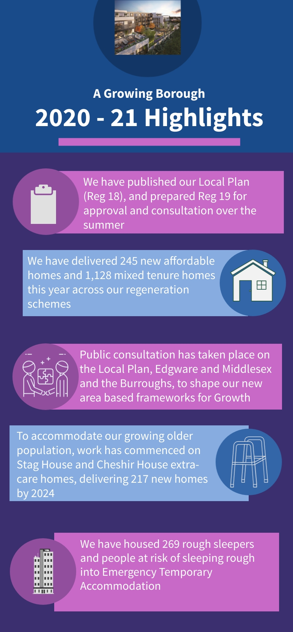
Theme: A Growing Borough

What have we achieved this year?
Delivery:
- Delivered 245 new affordable homes across our regeneration schemes, and supported Opendoor Homes to deliver 145 affordable homes in 20/21.
- Delivered 1,128 mixed tenure homes (private for sale, affordable rent, social rent, shared ownership) across our regeneration estates.
- Full Business case approved, start on site achieved and development agreement with Sage Housing Limited signed, for scheme at Upper and Lower Fosters in Hendon,
- Sustained development activity at sites across the borough despite COVID 19 restrictions.
- 103 homes acquired by The Barnet Group in 20/21.
- Construction work commenced to deliver new extra care homes at Stag House in Burnt Oak, and build contract in place to deliver Cheshir House.
- Outline business case approval for Hendon Hub project to deliver nearly 700 student homes in partnership with Middlesex University.
- Commenced construction of Phase 4 of the West Hendon regeneration scheme.
- Commenced construction of Phase 3 of the Dollis Valley regeneration scheme.

Policy-setting:
- Published the Draft Local Plan (Regulation 18) and commenced preparation of the Regulation 19 stage Local Plan for submission to Committee. To support the development of these, the Stage 2 Strategic Flood Risk Assessment, the Infrastructure Delivery Plan, and a Strategic Transport Assessment have been published.
- Consulted on a new Community Infrastructure Levy (CIL) charging schedule, to support the development of the Local Plan (Reg 19).
- Public consultation undertaken on area-based SPD frameworks for Edgware Growth Area and the Burroughs and Middlesex University.
- Approved the masterplan for plot 10 of the Grahame Park regeneration scheme.
- Full Business Case approval for Hermitage Lane and Burnt Oak Broadway Flats to deliver 70 new homes.
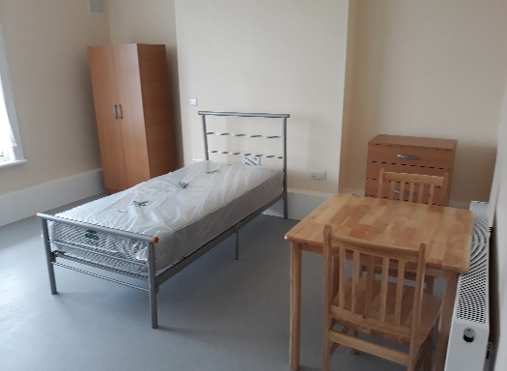
Rough Sleeping “Everyone in”

In response to the COVID-19 pandemic and the Government’s “Everyone In” request, Barnet Homes have housed 269 rough sleepers and people at risk of sleeping rough within emergency temporary accommodation. Of these clients, 72 have been supported into settled accommodation, and a further 63 have moved on and made their own arrangements. Over half of these rough sleeps have only been moved once, and work is continuing to support the remaining rough sleepers, as well as any that are newly identified.

Our ambition is to ensure that all rough sleepers in emergency accommodation are given the opportunity to end their rough sleeping either through a move into longer term accommodation, or through reconnection with friends or family. With funding from MHCLG Barnet Homes are, through Open Door Homes, acquiring 15 studio flats in the borough to be used as move-on accommodation for rough sleepers, who will be provided with ongoing floating support. Three of these have now been allocated, with further units in the pipeline. Alongside these we are establishing our Somewhere Safe to Stay Hub. The Hub, which opened on 26th April, is an assessment centre providing short-stay accommodation of up to six weeks for rough sleepers direct from the streets, and will allow for detailed housing and support needs assessments to support longer term move-on plans.

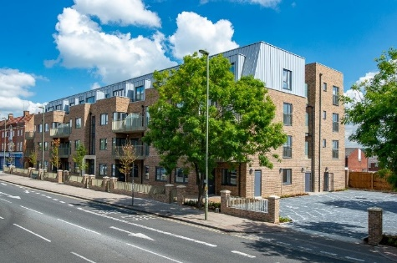
2020 – 21 Delivery of the Housing Programme

The total programme of new build homes being directly delivered by The Barnet Group’s (TBG) development team now covers some 1,188 homes. Of these 297 were completed during 2020/21, representing the largest individual year of completions since building re-commenced with 145 homes all for affordable rent being completed in year.

The Barnet Group team develops new homes for its own Registered Provider subsidiary Opendoor Homes and council housing for Barnet Council. To meet our homelessness needs in Barnet, 90% of the homes being built are affordable rent, and less than 3% of the total are currently for outright market sale with positive use being made of both Right to Buy receipts and GLA grant to support the programmes. The programmes themselves include a rich diversity of projects ranging from a small 2 bungalow scheme in High Barnet through to a 50-home tower block at Prospect Ring in East Finchley.

An innovative roof top development of 18 homes for affordable rent also entered contract in March 2021 which may create an alternative approach to delivery at a time when land availability continues to be a challenge. Alongside this are three extra care schemes delivering 179 homes. The first in Mill Hill has already completed. The second at Stag House in Burnt Oak is progressing well, with completion due in early 2024. The third is part of our largest single scheme on the Fosters Estate in Hendon, where start on site was achieved in March 2021. The Fosters Estate scheme will also deliver 142 new homes in addition to the 75-home extra care scheme.

Looking ahead the main objective is to seek to develop an approach to regeneration that will support the fast track delivery of new homes with an emphasis on quality of design including the creation of excellent places.

What will we deliver next?
Objectives | Projects and Deliverables | Timing
Increase the supply of housing | - Provide the annual update to the ‘Housing Delivery Action Plan’ to help deliver new housing and target resources to address issues that are delaying the completion of homes.  - Continue the Local Plan review, including Regulation 19 ‘publication’ stage consultation in summer 2021, and submission in Autumn 2021, ahead of Autumn 2022 adoption.  - Consider the scope for planning guidance to foster growth and shape improvements within areas of development opportunity including all main town centres, major thoroughfares, and emerging growth opportunities.  - Submit for approval The Burroughs and Middlesex University SPD  - Submit for approval Edgware Growth Area SPD  - Review and update the Planning Obligations SPD  - Review and Produce the Building Heights SPD, ensuring that the right heights for development occur in the most appropriate parts of the borough.  - Adopt the North London Waste Plan DPD  - Publish an updated Local Development Scheme  - Adopt revised Community Infrastructure Levy (CIL) rates to ensure new homes demonstrate support for infrastructure.  - Conduct assessment of sites in the borough and engage with developers and landowners to bring forward delivery.  - Commence work on site at Hermitage Lane, the first of Opendoor Homes mixed tenure schemes. | 2021 - 22  2021 – 23  Ongoing  2021 - 22  2021 - 22  2021 - 23  2021 - 22  2021 - 22  2021 - 22  2021 – 22  Ongoing  2021-22
Deliver more homes that people can afford | - Identify opportunities for new affordable homes to be secured within town centre regeneration schemes.  - Work with The Barnet Group to identify opportunities for delivering infill affordable housing within existing estates, bringing forward at least 2 schemes to outline business case in 21/22.  - Support the Barnet Group to deliver over 1700 new affordable homes within existing estates, infill sites, top hatting and through up to 600 housing acquisitions.  - Work with development partners to continue delivery of new and replacement affordable homes in regeneration estates.  - Continue work with the Mayor of London and Housing Associations to secure new affordable homes within Barnet.  - 63 homes to be completed by Opendoor Homes.  - 296 homes to be delivered through the estate and estate infill regeneration programme, 49 for affordable rent.  - Continue to deliver on 546 on-site homes across our Estate Regeneration Programme, 100 for affordable rent. | Ongoing  Ongoing  Ongoing  Ongoing  Ongoing  2021 - 22  2021 – 22  2021 - 26
Support our growing older population | - Work to deliver 126 extra-care homes; 51 at Stag House (Burnt Oak) and 75 at Cheshir House (Hendon) to continue on site.  - Prepare the business case for a new nursing care home capacity for people with complex needs (up to 100 places).  - Deliver against policy of 10% of new homes, in developments with more than 10 units, to be wheelchair accessible.  - Work with Adults Services to develop a forward programme in response to the adopted needs assessment and action plan. | 2021 - 24  Ongoing  Ongoing  Ongoing
Deliver homes on public sector land | - Continue to work with development partners to bring forward delivery of new homes within regeneration schemes.  - Bring forward business cases for schemes at Watling Car Park, Bunns Lane Car Park and Northway/Fairway.  - Provide leadership through the One Public Estate (OPE) Board to unlock new homes through key strategic partnerships such as with the NHS and TfL.  - Undertake an Options Appraisal for 40-unit scheme at Osidge Lane  - Identify pipeline of future projects and strategic interventions. | Ongoing  2021 – 22  Ongoing  2021 - 22  Ongoing

Theme: A Connected Borough
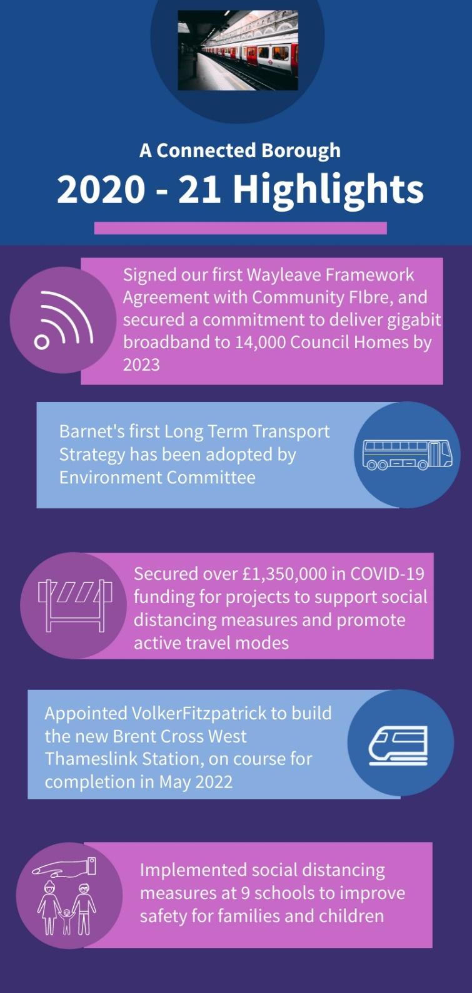
What have we achieved this year?
Delivery:
- Implemented social distancing measures at nine schools and around town centres.
- Signed our first Wayleave Framework Agreement with Community Fibre Limited to bring gigabit broadband to all council properties, alongside other social value benefits, with 977 connections made at Grahame Park estate.
- Continued to develop our Digital Inclusion Programme, through the provision of 240 laptops to adults and schools.
- Worked with TfL to introduce step free access at Mill Hill East Station which supports passengers, especially disabled people, older people and those with young children.
- Ongoing construction at Brent Cross West railway station has progressed, with VolkerFitzpatrick awarded the contract to build the new station in January 2020, who completed the new sidings and level crossing in March 2021, following the installation of a temporary footbridge in December 2020.
- Completed first phase of highway improvements to Southern Junction at Cricklewood Broadway.
- Installed a trial cycle way along the A1000 to promote active travel from North Finchley Town Centre to East Finchley to connect with the emerging Cycle Superhighway 12 in Haringey.
Policy-setting:
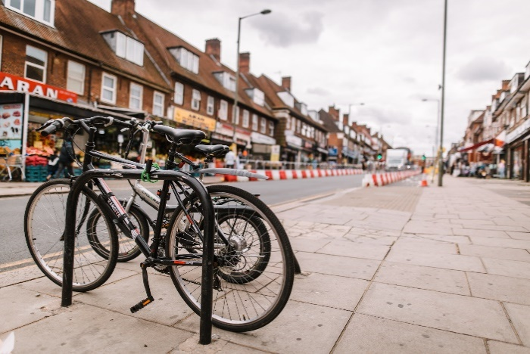
- Produced the borough’s first Long Term Transport Strategy 2020 - 2041 adopted by Environment Committee in September 2020.
- Secured over £1.3m in Covid-19 funding from for projects to support social distancing, and encourage active modes of travel including walking and cycling.
- Secured additional funding from Round 2 of the Go Ultra Low City Scheme (GULCS), which has enabled the installation of two community electric vehicle charging hubs at Watling Avenue and Lodge Lane Car Parks.

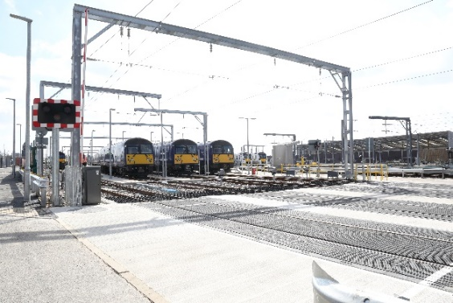
Brent Cross West Station

Works on Brent Cross West reached a £180million landmark in March, when the new sidings and level crossing were completed. This was a major milestone, which over the preceding 17 months had required almost 800,000 hours of labour, with up to 300 people working on sidings construction at any time. Work was carried out by Amey, and project managed by Mace, on behalf of Barnet Council.

The sidings replaced the old Brent/Cricklewood sidings, which had been used as a marshalling yard for trains since the 1860s when the Midland Main Line was built. Moving them was crucial in clearing space for the new station to be built. These sidings can be reached from the new level crossing, which was completed over the same weekend. Adjacent to the train operators’ compound (TOC) which opened in December 2019, it allows staff to cross the tracks safely to get to and from the trains. Work continues on Brent Cross West, and is due to be completed in May 2022, with the station to open in December 2022. It will offer services to central London in just 12 minutes, as well as direct links to both Luton and Gatwick airports, plus Eurostar trains from St Pancras International.

There is now agreement for the new station to have passive provision for the West London Orbital line which would further promote active and accessible travel, cutting journeys between Brent Cross and Harlesden from hours to a few minutes and taking vehicles off some of the country’s busiest roads including the North Circular.

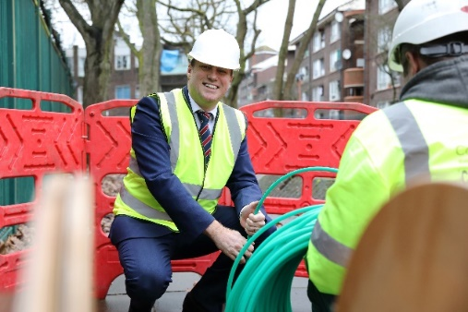
Gigabit Broadband Programme

Following the approval of the Growth Strategy, the council has worked collaboratively with neighbouring boroughs across the West London Alliance to establish the Gigabit Broadband Programme. In September 2020, Housing and Growth unanimously approved the programme for council officers to remove barriers to investment in digital connectivity and improved broadband infrastructure.

An overarching Wayleave Framework Legal Agreement has been finalised to make it easier for broadband network operators to invest in new fibreoptic cable networks across the borough, that will enable the faster roll-out of gigabit speed broadband services for residents and businesses. One network operator, Community Fibre Ltd, had signed up to the Wayleave Framework Agreement by Spring 2021; and the council is actively working with several other operators to unlock competition and further accelerate the pace of installation.

The programme will directly benefit residents living in council-owned properties, as the council has secured commitment to all 13,709 properties receiving access to affordable and reliable high-speed gigabit broadband connections by 2023. In the final quarter of 2020-21 the pilot phase to install Gigabit Broadband to 977 properties in Grahame Park was completed, and planning and delivery for a further 4,300 properties across Colindale, Burnt Oak, Edgware, Hendon and West Hendon was underway to ensure delivery of new connections by December 2021. Neighbouring businesses and residents will also benefit from the programme as the operators expand their investments beyond the council’s own estate. Our aim is for properties across the borough to be connected by 2025. As part of unlocking the broadband investments, the council is seeking to secure a variety of social value benefits, including jobs, training and skills opportunities, and free connections for new digital inclusion hubs in local community facilities.
What will we deliver next?
Objectives | Projects and Deliverables | Timing
Enable new and enhanced public transport connections | - Secure funding through TfL for greater capacity to engage on and champion public transport matters in the borough, particularly following Covid-19 uncertainty.  - Investigate proposals for improvements associated with the Long-Term Transport Strategy, including express and orbital bus routes, Improvements to existing bus routes, improvements to existing rail services, and on-demand services.  - Subject to the confirmation of funding, working with TfL to undertake feasibility studies to improve orbital travel.  - Support continued delivery of the West London Orbital Line with TfL and our partners across the West London Alliance.  - Working with TfL and Network Rail to continue to introduce Step Free access to tube and rail stations across the borough, including Mill Hill Broadway Station.  - Deliver Brent Cross West Thameslink Station by December 2022. | 2021 - 30  2021 - 25  2021 - 30  2021 - 25  2021 - 30  2021 – 23
Deliver healthier street design to support all forms of travel | - Investigate proposals for improvements associated with the Long-Term Transport Strategy, including signage and wayfinding, investing to improve the footway network, cycle parking and cycle network.  - Commence work with partners on active corridor improvements at Edgware-Mill Hill-Finchley Central. | 2021 – 25  2021 - 22
Deliver a cleaner, greener, and more pleasant borough | - Investigate proposals for improvements associated with the Long-Term Transport Strategy, including a new controlled parking zone programme and policy principles, car club and car sharing opportunities and behaviour change activities to support proposals.  - Develop proposals to expand the network of electric vehicle charge points, including increasing our network of freestanding and lamp column charge points, and installing the first rapid charge points. Continue to bid for funding when available and explore innovative ways in which we can continue to support our residents in a shift to Electric Vehicle.  - Refresh our Parking Policies to ensure a balance of kerbspace across road users, to encourage cycling, use of car clubs, and electric vehicles. | 2021 - 25  Ongoing  Ongoing
State of the art digital infrastructure | - Support measures to ensure continued gigabit broadband rollout across council Estates.  - Support programme to deliver new Ultrafast Broadband network to communities and businesses via grant and private-sector funded investment programme for upgrading public assets.  - Work with West London Alliance on 5G rollout needs and the market for small cell investments across the region.  - Work with partners to identify priority steps for the council in relation to 5G technologies (e.g. construction, social care and transport).  - Ensure digital infrastructure investment is complemented with a resident-focused programme for Digital Inclusion. | 2021 – 23  2021 – 23  2021 – 23  2021 – 23  2021 - 23

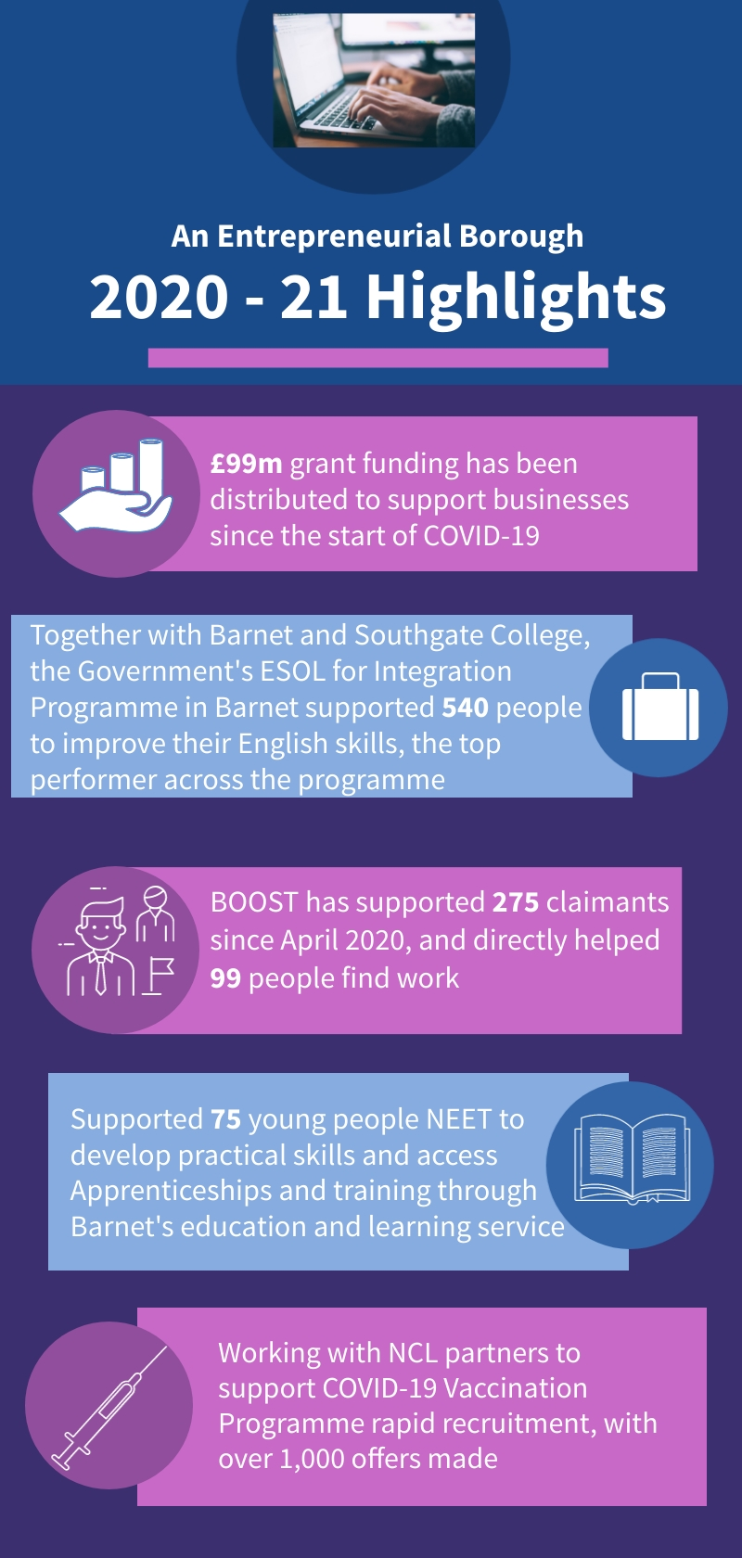
Theme: An Entrepreneurial Borough

What have we achieved this year?
Delivery:
- Secured Gateway status for the government’s Kickstart Programme and secured roles for three cohorts within the council (98 job placements) throughout 2021/22, as well as 500 roles across the borough more broadly.
- Supported Argent to engage local residents in developing early employment and skills opportunities on the Brent Cross Town site.
- Created a gateway Jobs, Skills and Training webpage which has provided residents with skills and employment opportunities during COVID-19, and achieved 25,000 page views by April 2021.
- Local Hubs at West Hendon, Grahame Park and Dollis Valley are ready to be launched once lockdown restrictions are lifted; these will deliver a range of employment and skills services onsite, including BOOST and DWP programmes.
- Continued to facilitate the Barnet Employability Group, bringing together 300 partners from across the borough to share information and collaborate in supporting skills development.
- Provided ongoing support to our start-up businesses despite COVID-19, with initiatives like the Pop-up Business School attracting over 100 participants.
- Worked in partnership with WLA boroughs on a range of cross-borough initiatives, including collaboration on S106 activities and new funding opportunities.
- Brent Cross Team launched the Brent Cross Office Strategy in January 2021, revealing the first three office buildings at Brent Cross Town.

Policy-setting:
- New Work, Skills and Productivity Action Plan developed in association with council services and external partners, setting clear priorities and principles for how the council will target employment support while rising to the challenges posed by the pandemic.
- Provided BOOST and BELS with funding through 2021/22 thus sustaining important supports to borough residents furthest from employment during the pandemic and its lockdowns.


Impact of COVID-19 on Employment and Skills in Barnet

The past 12 months has been a uniquely challenging period for residents and employers in Barnet, with COVID 19 having far-reaching impacts on the working lives of people from every background, age group and skill level. Barnet’s economy is relatively exposed to the short-term impacts of the pandemic, and the borough has seen an increase in unemployment, with 19,135 people out of work in March 2021.

Over the year, we have kept a close eye on this impact, and have taken steps to support our residents, particularly across four main areas: supporting young people between 16 and 24, who are more likely to be out of work than other groups; working directly with those furthest from the labour market to unlock opportunities to access employment; improve pathways into work by prioritising high growth sectors; and delivering at scale and pace to ensure a fast recovery and prevent many residents from falling out of work.

Some examples of this include encouraging young people into apprenticeships and supporting local businesses to train and support them. For example, Adam has recently completed an apprenticeship in the construction industry as a Level 6 Project Manager and Civil Engineer apprentice. Commenting on his experience he said ‘I am grateful for the support myself and fellow apprentices are receiving though the difficult times by the London Brough of Barnet, and to the construction industry. Their efforts are fully felt by me and other Apprentices’. Over the next few months, we are particularly focussed upon delivering the borough’s new Work, Skills and Productivity Action Plan, which runs up to 2025, and will join up our priorities and measures taken to support our residents as our economy begins to recover.

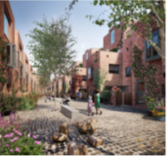
Beechwood Mews - Partnership working with Kuropatwa

Despite COVID 19, the council has continued to deliver on the Entrepreneurial borough theme and, in particular, to create and promote employment and apprenticeship opportunities for local residents. Kuropatwa Ltd, a London based developer-contractor, has been delivering on Beechwood Mews in Finchley, an award-winning development programme that forms part of Transport for London’s current 10,000 home pipeline, following a decision taken at Planning Committee in March 2019. Using a unique, street-based, celebrated design, the scheme is creating 97 homes and two commercial spaces around a new, cobbled, pedestrianised mews street.

Kuropatwa has fully committed to working with Transport for London to invest in skills and employment opportunities through their Mayor’s Construction Academy Hub across London and within Barnet. This approach helps to maximise the social and economic impact locally by supporting local Barnet residents’ and businesses access to opportunities on development projects. Working with Transport for London, Kuropatwa has achieved successful apprenticeship and work experience placements, as well as employment opportunities for candidates to progress into full time work on the Beechwood Mews project in construction, traffic, and office management. We have engaged positively with local apprentice and labour candidates to provide four apprentices and six back-to-employment opportunities, together with local school and college work experience and training days.

Louis, a Level 2 Mechanical and Engineering Apprentice, has recently completed an apprenticeship with Kuropatwa. When asked if he would recommend an apprenticeship he said ‘Yes 100% it’s the best option, I think. It’s the best way to learn a trade, seeing it first-hand’. This work will continue for the duration of the project with further opportunities also being created.

What will we deliver next?

Objectives | Projects and Deliverables | Timing
Deliver first class customer service to the borough’s businesses | - Produce an annual Business Health Report to measure and understand the vitality of Barnet’s economy, and to assess the impact of services provided to businesses by the council.  - Convene regular business events to directly engage with and understand the needs of Barnet-based businesses. | 2022 – 23  Ongoing
Identify and support growing business sectors across the borough | - Identify and engage with strategically important sectors, and those of potential greater future importance in Barnet’s local economy, to assess ways that the council can support them to maintain and grow their contribution to the borough. Initial sectors of focus are:  - Health and Social Care  - Recreation and Leisure  - Construction  - Creative Industries  - “Green” economy jobs e.g. upgrading buildings energy efficiency  - Ongoing work with Higher and Further Education institutions, and other partners, to launch a new programme of support focused on these key sectors.  - Develop and implement proposals as set out in the draft Work, Skills and Productivity Action Plan 2021 – 25, including:  - Encourage developers to actively create new local job opportunities alongside upskilling their existing workforce  - Develop effective partnerships between training providers and businesses so that residents are able to develop the skills employers need in growing sectors. | 2021 – 25  2020 – 25  2021 – 25  2021 – 22  2021 - 22
Maximise employment opportunities through growth | - Continue delivery of targeted programmes to support entrepreneurs.  - Continue delivery and support for projects such as BOOST and BELS that support those furthest from employment, those on low incomes and key groups including NEETs and care leavers, into growing sectors.  - Develop and implement proposals as set out in the draft Work, Skills and Productivity Action Plan 2021 – 25, including:  - Ensure that essential training opportunities and support is available to those who need it, including to residents who have lost their job for the first time as a result of the pandemic  - Work with our partners (DWP and the WLA) to ensure Barnet residents are able to fully access the JETS programme  - Expand our existing provision of digital skills to help break down the biggest barrier to employment  - Continue to work with closely with our partners (DWP and JCP) to continue the successful rollout of the Work and Health Programme  - Support young people into work through the Kickstart Programme, both as an employer and a facilitator  - Work with Brent Cross Employment and Skills Steering Group partners to progress actions, including:  - Construction phase employment skills support  - Supply chain opportunities  - Support in relation to end user jobs  - Continue to secure further employment and skills outcomes through obligations relating to new development.  - Increase the number of apprenticeship opportunities available across the council and key partners.  - Revise the council’s Delivering Skills, Employment, Enterprise and Training SPD (Supplementary Planning Document) from Development to increase and improve delivery of outcomes from new developments relating to employment and skills.  - Work with partners (The Barnet Group, Cambridge Education and DWP) to implement actions identified in the employment and skills needs assessment, ensuring council resources are targeted at those most in need, including:  - People on low incomes  - People not in employment, education, or training  - Young people leaving the care system  - Promote and deliver skills and productivity initiatives with partner boroughs through the West London Alliance.  - Collaborate with BELS and council services to contribute to the coordinate delivery of the post-16 Strategy. | Ongoing  Ongoing  2021 - 25  Ongoing  Ongoing  2021 - 25  2021 - 22  2021 - 25  2021 – 22  2021 – 25  2021 – 25
Support the local economy including promotion of local supply chains | - Work with council services, as appropriate, to develop a more targeted approach to local supplier procurement.  - Enhance delivery of local supply chain commitments through potential policy changes, new regeneration scheme contracts, and council-wide social value contractual commitments.  - Develop a new supply chain initiative to better promote the opportunities for, and benefits to, local businesses in relation to the regeneration of Brent Cross Cricklewood. | 2022 – 25  Ongoing  2021 - 22

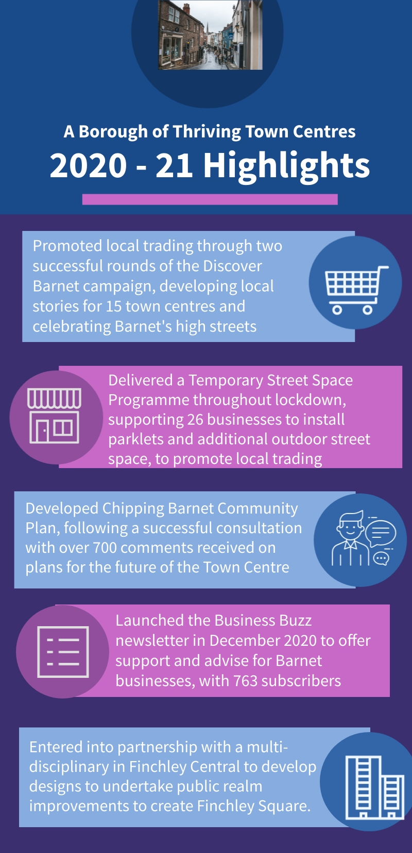
Theme: A Borough of Thriving Town Centres

What have we achieved this year?
Delivery:
- Installed 26 parklets to provide space for outdoor seating for businesses.
- Launched a raft of support for town centre businesses to help address the impacts of Covid-19, including facilitating new street trading measures to enable them to remain open while adhering to social distancing rules.
- Established a ‘Team around the Town’ partnership with neighbouring boroughs, including LB Brent and LB Harrow, to address cross-borough issues impacting Burnt Oak town centre and joint delivery of initiatives.
- Created local community networks and working groups in Burnt Oak and Finchley Central to provide a consultation and engagement platform to implement Town Centre strategies.
- Taken initial steps towards delivery of a new workspace community hub at the old railway house site in Cricklewood by commissioning a feasibility study.
- Formed a new town team for Finchley central and engaged with the local community through workshops, business and community surveys and on street pop up market events, to inform the design of Finchley Square.
- Led a ‘Virtual Workspace Tour’ bringing together flexible workspace operators and developers/owners to promote Barnet
Policy-setting:
- Developed new Supplementary Planning Document for Edgware Town Centre to support a shared vision for adoption and developed a parallel Town Centre Partnership Board with Ballymore, Transport for London and local businesses to deliver town centre improvements in advance of development.
- Established an action plan for West Hendon Broadway to deliver shop front improvement and business support, as set out within the adopted West Hendon Strategy.

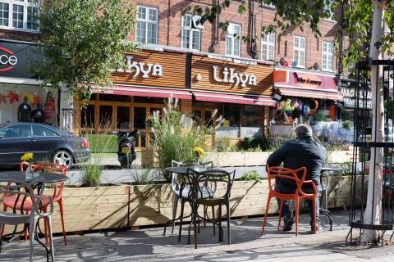
Business support across our Town Centres

Covid-19 has had a major impact on businesses across our town centres, however throughout the pandemic our independent businesses have shown great resilience and gone above and beyond to continue to serve the needs of our communities.

The council has played a prominent role in supporting local businesses. One of the measures has been the distribution of government funding grants, including Local Authority Discretionary Grants, Additional Restrictions Grant, National Business Restart Grant, and Local Restriction Support Grant. Over the past 12 months the council has distributed over £99m to businesses to support them through this unprecedented challenging period.

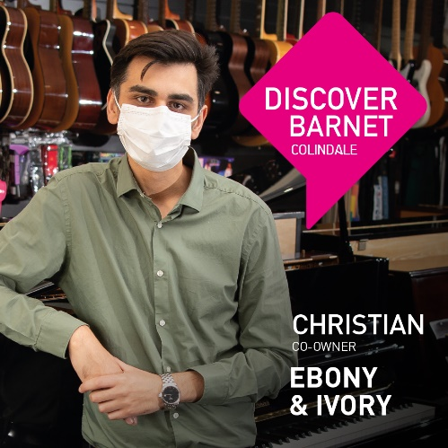
As well as distributing grants, the council has also led and delivered a major ‘Shop Local, Shop Safely’ campaign as a part of the Discover Barnet Programme. This has featured 15 local independent businesses, including Ebony & Ivory, a music shop and school owned by Christian, which has been a prominent feature of Colindale’s high street for over 40 years. Phase two of the campaign reached almost 200,000 people through digital engagement channels, and the council will continue this messaging in the coming months to encourage and celebrate the diverse offerings across our town centres as town centres begin to re-open. We have also created a monthly newsletter Barnet Business Buzz to ensure our businesses remain aware of any support available at this challenging time.

A Town Centres Volunteer Programme has also been established by the council to support the public and businesses. Once trained, volunteers offer support and reassurance to residents on the high streets, and to support and direct them to the correct council service to assist with any queries arising relating to changing COVID-19 regulations and safety concerns.

Alongside this, the council has undertaken a number of measures to support our residents to visit their town centres safely across the pandemic, putting temporary barriers in to widen the footway in areas of high-use and/or narrow areas of paving and installing new temporary cycle lanes; to ensure our residents were able to social distance and remain safe when visiting our town centres.

Finally, following undertaking engagement with local businesses across the London Borough of Barnet, it was identified that a number of businesses, in particular hospitality businesses, were under significant pressure due to spatial implications COVID-19 has had on their operational viability. In response the council issued a series of fast-track and affordable street trading licenses and also set up the Temporary Town Centre Street Space fund to help businesses to access additional outdoor trading space in front of their premises so customers could follow social distancing rules.
Since implementation, the scheme has supported over 30 businesses to access additional space across 10 town centres in the borough. The council will continue to work with these and new businesses to support and grow this initiative in the coming year.

What will we deliver next?
Objectives | Projects and Deliverables | Timing
Strengthen and diversity town centres to ensure they are fit for the future | - Plan and deliver town centre public space and public realm improvement projects including:  - Shop front and public realm improvements, installation of public Art and 1-2-1 business support in Burnt Oak  - Improvements to West Hendon Broadway  - Finchley Square Public Realm to activate Finchley Central  - Work with development partners on proposals for the comprehensive revitalisation of town centres (account for financial viability and deliver a joined-up approach including more effective community engagement), following a Pilot in North Finchley.  - Deliver projects and improvements identified within adopted Town Centre Strategies and Community Plans:  - Develop the business case for priority projects in the Golders Green Town Centre Strategy  - Work with newly set up steering groups - The Barnet Group, local businesses and communities to deliver improvements in Edgware and Burnt Oak Town Centres  - Adopt and work with the community and businesses to deliver priority projects identified within the Chipping Barnet Community Plan  - Promote and celebrate the unique characteristics of the borough’s town centres through work with partners to improved identity, wayfinding and centre promotion.  - Work with local communities, businesses, developers and others to implement Town Centre Strategies, bringing forward economic development opportunities, better public realm and an improved mix of uses, including homes, workspace, leisure and community facilities.  - Ensure ongoing support for Town Teams in the borough, helping to signpost services when they deal with the council and supporting their growth and sustainability through new tools and resources.  - Support existing Town Teams  - Test the appetite for Town Teams where they do not currently exist  - Continue to host the Town Centre Community Forum  - Launch a crowdfunding initiative aimed at established Town Teams and community groups.  - Work to scope and pilot a new approach to land use within town centres through development of new Area Frameworks:  - Finchley Central  - Golders Green  - Work with local communities and businesses to launch the Community Toilets programme for residents across our Town Centres.  - Promote initiatives to support business to operate more effectively and sustainably:  - Pilot schemes in Finchley Central, North Finchley and East Finchley | Ongoing  2021 – 23  2021 – 23  2021 – 23  Ongoing  Ongoing  2021 – 23  Ongoing  Ongoing  Ongoing  Ongoing  Ongoing  Ongoing  Ongoing  Ongoing  2021 – 25  2021 – 25  Ongoing  Ongoing  2021 – 22  Ongoing  2021 - 23
Support joined-up service delivery across the council for healthier high streets | - Establish new council officer group to address needs in relation to individual town centres, aligning:  - Services, strategies and activities  - Action to address issues including planning and other enforcement activities, licensing, street cleansing, and waste collection  - Consider concerns about parking arrangements  - Provide input to the council’s MARAC group and take a joined-up approach to addressing community safety in town centres, starting with cases in Burnt Oak.  - Work with partners to launch a programme to address the impact of empty shops on the borough’s high streets, and scope a programme to repurposing vacant retail units in town centres through meanwhile uses such as pop-up shops, arts and community.  - Consider a more active council approach to assessing and improving the health outcomes of town centres:  - Pilot in the Finchley Area  - Work with planning colleagues at pre-application stage to ensure proposed development in town centres will fully support and help to deliver the council’s ambitions in relation to both the Local Plan and the Growth Strategy.  - Partner with neighbouring boroughs to address cross-borough issues impacting town centres. | 2021 – 25  2021 – 22  Ongoing  Ongoing  2021 – 23  2021 – 25  Ongoing  2021 – 23  Ongoing  2021 - 25
Deliver high quality workspace | - Conduct a workspace viability assessment to identify demand and target locations.  - Engage real estate agents and landowners to unlock and improve access to commercial stock.  - Align main town centres approach with local plan classifications (major, district and local centres etc).  - Deliver new, specialist SME, creative and light industrial workspace aimed at key sectors through investment in council assets and by influencing private development.  - Revise the council’s Delivering Skills, Employment, Enterprise and Training SPD (Supplementary Planning Document) from Development to increase outcomes and to improve delivery of affordable and flexible workspace. Deliver on flexible and community workspace through existing proposals at:  - Feasibility Study at Cricklewood Workspace Community Hub  - Feasibility Study at Finchley Workspace Hub  - Feasibility Study at Golders Green Pump House Square | Ongoing  Ongoing  2021 – 23  Ongoing  2021 - 22  2021 – 22  2021 – 23  2021 - 23
Build on existing strengths to create a thriving evening economy | - Support preparation of Regulation 19 stage Local Plan and the Visitor Economy Plan by using best practice to identify locations and activities that best support new ‘evening economy zones’ to enable joined-up regulatory support for cafes, bars, festivals and activities.  - Ensure Barnet's town centres remain safe and antisocial behaviour is minimised  - Support the enhancement of existing and development of new markets in town centres to animate public space.  - Support community-led initiatives to promote the distinctive cultural and heritage merits of town centres.  - Pilot in Finchley Central as a part of the Finchley Square project  - Deliver a significant ‘Welcome Back’ programme to activate town centres, promote the safe return. | 2021 – 22  Ongoing  Ongoing  2021 - 23

Theme: A Great Borough to Live in and Visit

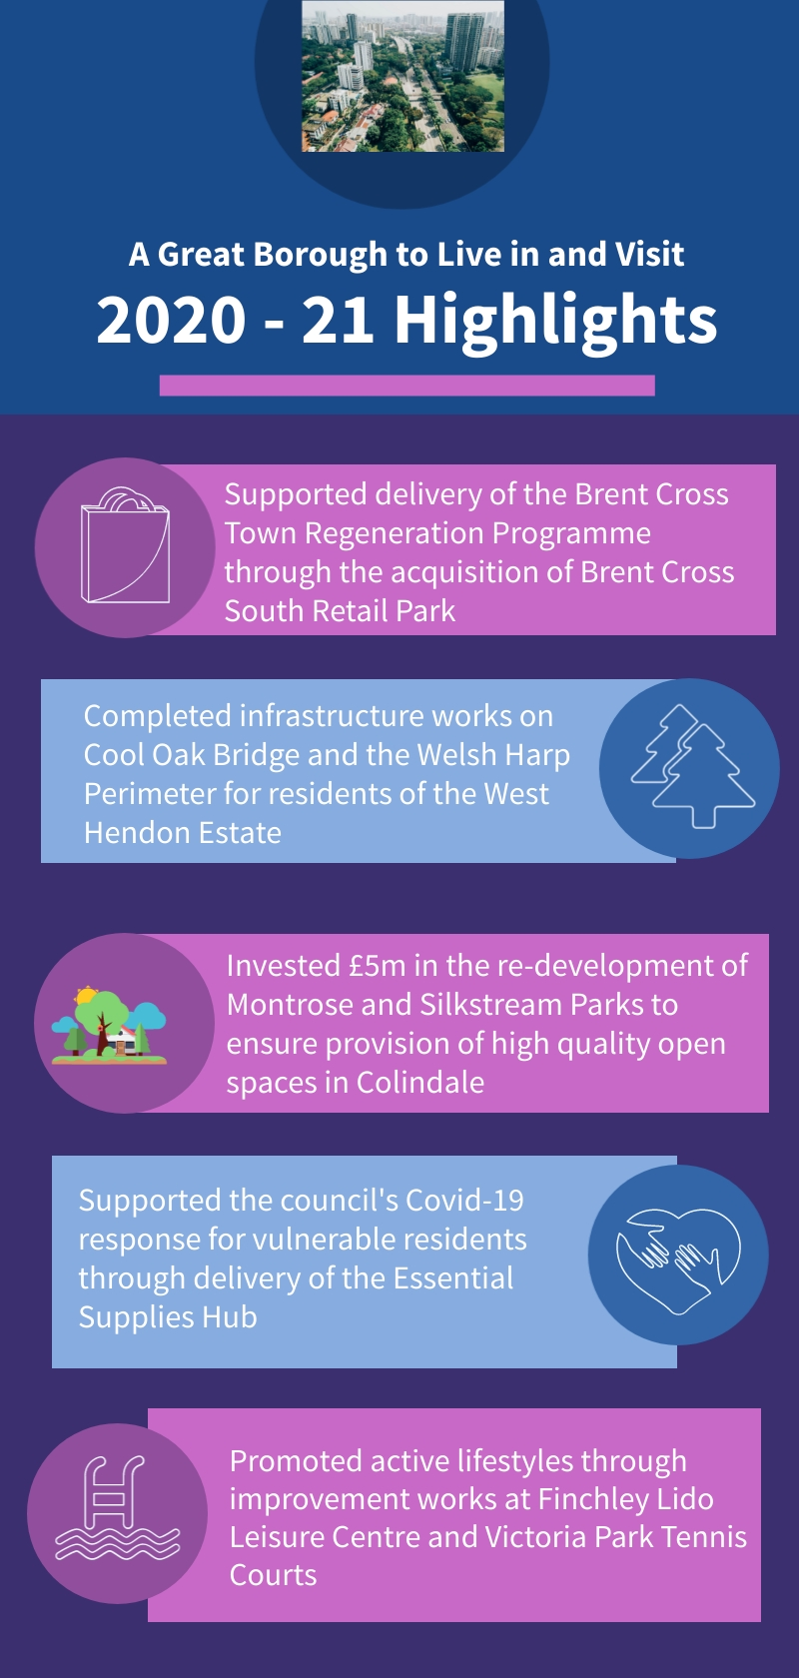
What have we achieved this year?
- Launched the vision for Brent Cross Town as a new park town centre at Brent Cross South.
- Completed the £5m park investment transformation of Montrose and Silk Stream Parks in Colindale.
- Opened the new Exploratory Park and the Workshop exhibition space at Brent Cross Town.
- Completed the acquisition of Brent Cross South Retail Park to unlock the potential for earlier Brent Cross Town redevelopment.
- Supported closure and reopening processes and COVID compliance across leisure services, creative industries and the visitor attractions.
- Completed Gaelic football pitch improvement works at King George V Playing Fields.
- Completed improvement works on Cool Oak Lane pedestrian and cycle Bridge and West Hendon Perimeter.
- Continued a programme of park improvements through the enhancement of play equipment at Victoria Recreation Ground and Friary Park.
- Supported health and leisure opportunities across our Greenspaces through the delivery of improvements to the tennis courts and play area at Victoria Park, installation of table tennis tables at Sunny Hill and Mill Hill Park, and upgrade of court areas at Lyttleton Playing Fields and Cherry Tree Woods.
- Commenced investment project at Childs Hill Park as part of masterplan, and completed improvement works at Swan Lane Open Space.
- Developed opportunities to support increased education needs within our growth areas through ongoing work to expand capacity at Blessed Dominic Primary School.
- Completed improvement works to Finchley Lido Leisure Centre.
Delivering a new park town at Brent Cross
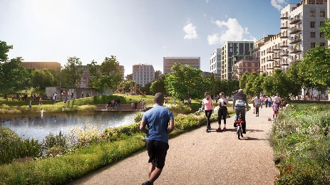
The Brent Cross Cricklewood team, in partnership with Argent Related, revealed the vision for the new park town at Brent Cross in Autumn 2020. Embedded within the vision is the objective of being London’s biggest ’15-minute town’, where shops, offices, restaurants, parks and the train station are all fitted within close proximity.

Set amongst 50 acres of parks and playing fields, the area will be transformed into an inclusive, accessible town centre that will enable new and existing communities to thrive. The town centre will deliver 6,700 new homes and will be a major office destination providing jobs for 25,000 employees, as well as delivering new student accommodation and the redevelopment of three local schools. It will incorporate 50 acres of parks and playing fields, including eight public squares, and seven new and improved parks, landscaped to encourage walking and cycling. The public spaces created will act as a springboard for public performances, with acoustics designed specifically for live performances.

Over 2020, the programme has also seen a number of immediate successes and community benefits that help make Barnet a great place to live. Brent Cross Town’s Community Fund gave support to 11 community initiatives, including libraries, community farms and allotments. The opening of the Exploratory Park in August also saw the first open space arrive as part of the park town vision to create the place in London to participate in and play sports, delivering a landscaped open space designed to promote health and leisure for all ages, as well as planting 41 new trees and flowers to bring the area to life in a sustainable way.

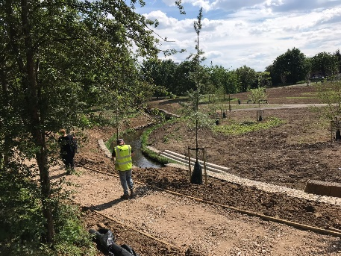
Montrose and Silkstream Parks Transformation

The lockdown restrictions triggered by Covid-19 has highlighted the role of having a great portfolio of parks and open spaces across Barnet, and the rest of the United Kingdom, in supporting new homes and ways of living for families and maximising the opportunities for improved health and wellbeing.

In the summer of 2020, our Regeneration and Greenspaces services completed work on Montrose and Silkstream Parks, a £5m transformation of the Silk stream Valley Park to form a green corridor connecting Colindale and Burnt Oak. The enhancement of the area has been funded primarily from development contributions to infrastructure, as well as funding from the Mayor of London, Environment Agency, and London Marathon Trust. Alongside other features, a string of new facilities has been completed across the two parks for families to enjoy, including an ‘Active Zone’ and playground in Montrose Playing Fields, in proximity to the UNITAS Youth Zone, a new pavilion and café, and a wetland area fostering biodiversity.

Looking forwards to the next 12 months, Colindale’s Parks continue to be a key focus of regeneration activity and will continue to support the objectives of our Parks and Open Spaces Strategy. On site works have already started in redeveloping Colindale Park, with key features including a new reading room, playground, and picnic tables and communal space to enable residents to enjoy the borough’s cultural and natural heritage, with the scheme due to complete in the autumn. In addition, proposals are also being developed for neighbouring Rushgrove and Heybourne Parks in later years.

What will we deliver next?
Objectives | Projects and Deliverables | Timing
Delivering social infrastructure | - Deliver Grahame Park and West Hendon community centres and digital support hubs at Brent Cross Cricklewood, Grahame Park and West Hendon.  - Explore the potential of a new programme of leisure services investment, including at Finchley Lido, Hendon Leisure Centre and Burnt Oak Leisure Centres.  - Support the delivery of new and improved schools, healthcare, early years provision and community facilities to facilitate regeneration and growth as set out within the Infrastructure Delivery Plan. | 2021-22  Ongoing  Ongoing
Get the best out of the borough’s green assets | - Develop an Outline Business Case for West Hendon Playing Fields, reporting next steps for delivery to Policy & Resources Committee.  - In partnership with the Canals & Rivers Trust, the Environment Agency and LB Brent support the development of a vision for the Welsh Harp.  - As part of Colindale Parks Improvement Programme; complete capital investment project for Colindale Park.  - Subject to planning approval, commence the delivery of the masterplan for Rushgrove Park.  - In partnership with stakeholders, continue to develop the design proposals for Heybourne Park for delivery.  - Working in partnership with stakeholders, continue to develop the Copthall and Mill Hill Open Spaces Masterplan for delivery.  - Working with commissioned providers, deliver a diverse events programme across parks and open spaces.  - Complete a Borough wide review of parks infrastructure (eg bins, benches) to support investment proposals. | 2021 - 22  2021 - 22  2021 - 22  2021 – 22  2021 - 22  2021 - 22  2021 – 22  2021 - 22
Grow the visitor economy | - Work with development partners to deliver and launch the Brent Cross Visitor Pavilion.  - Commence work to prepare the ‘Visitor Economy Plan’ (incorporating update and replacement of the Arts and Culture Strategy) by undertaking a visitor asset mapping exercise. | 2021 - 22  2021 - 22
Provide a broader canvas for creative industries | - Conduct a cultural audit, mapping the borough’s existing creative industries assets and identifying gaps in access:  - Consider the opportunities for and barriers to growth of the creative industries sector  - Explore need for arts provision in west of Barnet  - Identify gaps in support for creative industries  - Implement recommendations of the cultural audit. | 2021 - 22  2021 - 22

