LONDON BOROUGH OF BARNET
Web Tasks Support Document

Web Tasks Support Document

Document Number:
Author: Tom O’Brien
Owner: Steve Boardman/Katherine Lyon
Client: London Borough of Barnet
Release Type: Version 0.7
Release Date:

Published by Capita
Part of the Capita Group Plc, 71 Victoria Street, Westminster, London, SW1H 0XA
Registered in England no. 2299747

Document History

Document Location
The source of this printed document can be found in the Capita SharePoint site, or with the author if in an unapproved status.

Revision History
Revision Date | Revision Number | Author | Summary of Changes | Changes Marked
13/07/15 | 0.1 | Tom O’Brien | Initial draft | No
15/07/15 | 0.2 | Tom O’Brien | Initial Draft | No
17/07/15 | 0.3 | Katherine Lyon | Suggested amendments | No
17/07/15 | 0.4 | Tom O’Brien | Initial Draft | No
22/07/15 | 0.5 | Tom O’Brien | Initial Draft – further changes | No
22/7/15 | 0.6 | Tom O’Brien | Further amendments | No
27/7/15 | 0.7 | Tom O’Brien | Further amendments | No

Approvals
This document requires the following approvals
Name | Title | Signature | Issue Date | Revision
Kari Manovitch | Head of Customer Strategy & Programmes  Commercial, Commissioning Group
Alasdair Maclean | Web Officer, LBB
Jim Gibbs | Customer Services Operations Director, Capita
Katherine Lyon | Head of Customer Services & Transformation, Capita
Chris Melia | Customer Experience Manager, Capita

Distribution
This document has also been distributed to the following people, as well as the approvers:
Name | Title & Organisation | Issue Date | Revision
Steve Boardman | Customer Services Director, Capita | 22/7/15
Liv Brown | Service and Channel Development Manager, Capita | 22/7/15
Andrew Gee | Service Delivery Manager, Capita | 22/7/15
Kirit Patel | Application Support Team Manager, Capita | 22/7/15

Contents
1 Document History 2
1.1 Document Location 2
1.2 Revision History 2
1.3 Approvals 2
1.4 Distribution 2
2 Introduction 5
3 BAU versus Change Request 5
3.1 Business as Usual (BAU) 5
3.2 Change Request 5
4 Identifying and Fixing Website Faults 6
4.1 Identifying and Fixing Faults reported by Website Users 6
4.1.2 Adviser Action 9
4.1.3 Channel Development Team (CDT) Action 10
4.1.4 IT Service Desk Action 12
4.1.5 Resolution Timescales 13
4.1.6 Content Issues 13
4.2 Identifying and Fixing Faults reported by Service 13
5 Web Task Support Processes 16
5.1 Editorial Tasks 16
5.1.1 Editorial Task Model 16
5.1.2 Process 17
5.2 Training Tasks 17
5.2.1 Producing and updating training material 17
5.2.2 CMS training 17
5.2.3 “Writing for the web” training 17
5.3 User Administration 17
5.3.1 Request New user/Amend User permissions 17
5.4 Web Forms 18
5.4.1 Maintain Existing Forms 18
5.4.2 New/Enhance Existing Forms 19
5.5 Database Queries 22
5.5.1 Run Database Queries 22
5.6 Transversal 23
5.6.1 Transversal Search Management (New) 23
5.6.2 Solr Search Management 23
5.7 Analysis and Reporting 24
5.7.1 GovMetrics 24
6 Appendices 26
Appendix A. Hours of Operation 26
Appendix B. Consolidated list of Web Tasks 26
Appendix C. Lagan CRM Classifications 29
Appendix D. Schedule of Rates 32
Appendix E. Change Request Forms 32
Appendix F. Web Support Tasks – Priorities 32
Appendix G. Service Request Priorities 33
Appendix H. Web Forms - Priorities 34
Appendix I. Extract from Output Specification 39
Appendix J. Extract from Method statement 40
Appendix K. Forms 41

Introduction
This document has been prepared to outline the principles and processes involved in maintaining and improving the London Borough of Barnet Council Website. The report will provide clarity of the processes and management of expectations in respect of resolution times.
This report will clarify the following:
- The processes to be followed by the council’s services in order to request website fixes or changes (e.g. content, web forms)
- The roles of the key parties involved (LBB Comms, IT Helpdesk, Channel Development Team, G2G3 Digital)
- What constitutes a “business as usual” request (which will be dealt with as part of existing support arrangements) and one which is a change request and thus attracts a charge
- Expected response and resolution times, based on set priorities or the value of the request
This report is to be viewed in conjunction with other elements of IT Service Desk in place, and will provide confidence that there is a robust and comprehensive system in place.

KPI
The London Borough of Barnet’s website is listed as one of the council’s critical systems and services, with an availability target of 99.5% over supported hours.
There is also a target of 91% of all incidents reported to the IT service desk to be resolved within the following timescales (see Appendix A for extract from contract):
Incident Priority | Logged & Acknowledged | Resolved
P1 | 30min | 4 hours
P2 | 4 hours | 8 hours
P3 | 12 hours | 24 hours
P4 | 20 hours | 40 hours

BAU versus Change Request

Business as Usual (BAU)
Any part of the website (form, link, content etc) is considered as “Business As Usual” (BAU) having satisfied the following:
- Been approved for go live following a suitable UAT
- Been successfully deployed and accepted into Production
- Passed through a suitable period of early life support / hyper-care
Therefore BAU support is applied to keep the website element running as it was at the point it was accepted as being BAU.
E.g. a web form which has been successfully tested, deployed to the live website and observed working successfully is now failing to open as expected.
This form would be fixed under BAU support agreement.

Change Request

All enhancements to current functionality will be logged as a Change Request. An enhancement has the following attributes:
- New functionality that does not exist following the implementation of Release 4.2
- Has not been previously requested
- Is an improvement or change to existing functionality
- Will improve the user experience
- Responds to an emerging business need
- Any upgrade to the web platform, which includes upgrades to Magnolia.

A straightforward example of this is a request for an existing web form to be amended to reflect new legislation released AFTER the form had been accepted as BAU. A change request would have to be submitted price for creation, testing and deployment of the form would be provided based on the amount of time and resource it would require. The service would have to agree to this before work would commence.

Identifying and Fixing Website Faults
This section describes the different processes followed to capture and resolve faults reported with the website either from website users or from within the council services.

Identifying and Fixing Faults reported by Website Users
This section details the processes followed to resolve website faults reported by Barnet website users. For details of processes followed to resolve issues identified and reported internally (i.e. council services) please see section 4.2.
Customers are able to notify the council of problems they are experiencing in a number of ways;
- By telephone via Contact Centre Coventry
- By e mail (first.contact@barnet.gov.uk)
- Via the @BarnetCouncil Twitter account
- Via the Barnet Council Facebook page

Content or Technical Faults with My Account
The following table shows the types of My Account issues that could be reported by website users. If the report is made via telephone or e mail, 1st Line Support is provided by the Contact Centre Coventry agent, 2nd Line Support by the Channel Development Team, and 3rd Line Support by Kana or G2G3 Digital.

For a task priority list, please see the table Appendix G
Dashboard | Issue
Benefits | Content Incorrect
Benefits | Unable to view enrolled services
Benefits | Unable to enrol
Council Tax | Content Incorrect
Council Tax | Unable to view enrolled services
Council Tax | Unable to enrol
E-Form | E-Form Not Working
Libraries | Content Incorrect
Libraries | Unable to view enrolled services
Libraries | Unable to enrol
Registration | Unable to register
Registration | Registration e-mail not received/not working
Log-In Issue | Account Locked
Log-In Issue | E-mail address already in use
Log-In Issue | Forgot password/Unable to reset password
Log-In Issue | Forgotten User ID
Log-In Issue | Missing e-mail recovered
Log-In Issue | Password not recognised
Log-In Issue | Unable to register
Log-In Issue | User ID not working
Parking | Content Incorrect
Parking | Unable to view enrolled services
Parking | Unable to enrol
Payment | Unable to make payment
Re | Content Incorrect
SBS | Content Incorrect
SBS | Collection Details not showing
Unable to self serve | E-form not working
Unable to self serve | Forgotten password
Unable to self serve | Forgotten password and unable to reset
Unable to self serve | Forgotten user ID
Unable to self serve | My Account is not working
Unable to self serve | Other issue
Unable to self serve | Other issue – referred to technical support
Unable to self serve | Unable to access a PC currently
Unable to self serve | Website not working

Content or Technical Faults with Website
The following table shows the types of general website issues that could be reported by website users.
For technical issues reported by telephone or e mail, 1st Line Support is provided by the Contact Centre Coventry agent, 2nd Line Support by the Channel Development Team, and 3rd Line Support by G2G3 Digital.
For content issues, 2nd and 3rd Line support is provided by LBB Comms Team/Content authors within the council.

Area | issue
Content | FAQ Content incorrect
Content | Website content incorrect
Content Error | Referred to support
E-form | E-form not working
Hand off to service area | Hand off to service area
Technical error | FAQ not working
Technical error | Unable to make Payment
Technical error | Website not working

Adviser Action
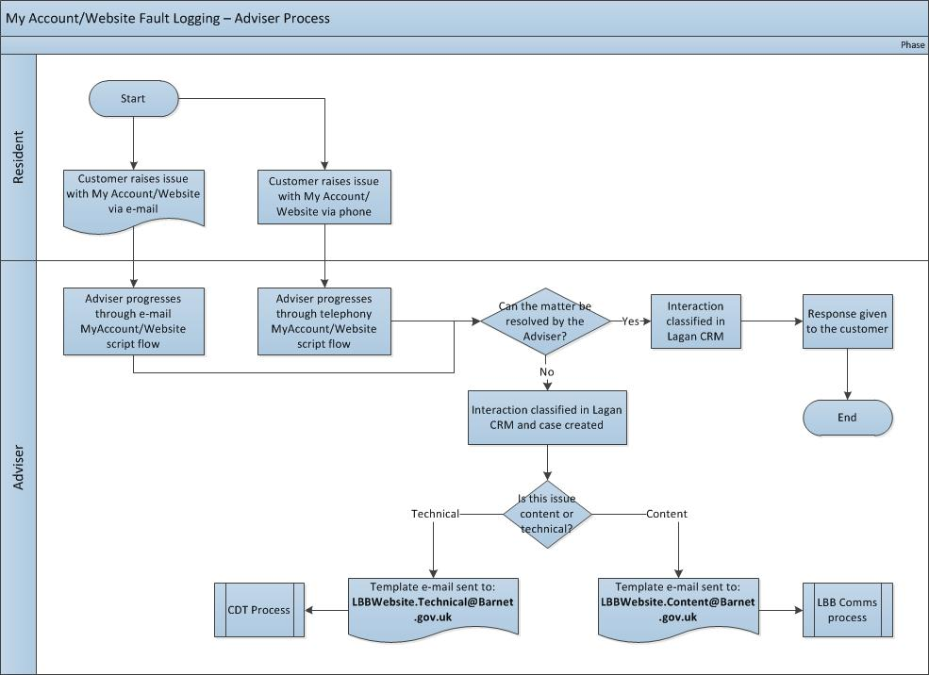

- The Contact Centre Coventry adviser offers 1st line support for customers reporting problems by telephone or emailing First.Contact@barnet.gov.uk. The contact centre agent receiving the query will follow the appropriate Lagan CRM scriptflow depending on the channel of the report.
- The Lagan CRM scriptflows are designed to help the adviser get to the root of the problem: talking the customer through correct steps may identify it was a temporary outage, user error, or a fault with the customer’s computer or internet connection. In these cases, there is no need to refer the call onwards, however the report is still classified in Lagan and the data can be used for Channel Development Team (CDT) to identify patterns or intermittent faults that could point to a wider issue.
- For a full list of Lagan CRM classifications please see Appendix D
- If the report is a genuine or still-existing fault, the adviser has two considerations:
- Fulfilling the customer need
- Ensuring the website fault is captured, and if a genuine fault, ensuring it is referred on for resolution
- The adviser may be able to fulfil the customer need (for example take details of a change of address for Council Tax if there is a problem submitting the form). In these instances, no further contact with the customer is required regarding the problem with the web site, however the adviser would still need to ensure the fault is progressed to CDT for further action.
- The adviser would also refer to the “Known Issues” log issued IS Support Team and distributed by CDT. This includes:
- Issues raised – including date raised
- Planned resolution
- Current position
- Expected timescales for remedy
- This may satisfy the customer depending on their individual need at that point.
- If the website fault cannot be resolved by the advisor the adviser progresses the issue for further action. The issue is emailed to one of the following email addresses based on it being either technical or content related:
- If technical – email LBBWebsite.technical@barnet.gov.uk - URL/Screenshot is included with referral. These cases will go to Channel Development Team for 2nd line support.
- If content – email LBBWebsite.content@barnet.gov.uk - URL/Screenshot is included with referral. These emails route directly to the LBB Comms team for resolution. This is another example where the customer would not require any further follow-up communication

Channel Development Team (CDT) Action
The Channel Development Team carries out a key role as they offer the 2nd line support function for technical issues reported by telephone and e mail. This includes taking steps to resolve the issue or escalating it for 3rd line support. They also monitor the resolution of technical issues and ensure customers receive an appropriate response.
The Channel Development Team also takes a proactive approach to managing and improving the website and may identify and resolve or escalate issues highlighted by GovMetric feedback, Survey Monkey feedback and other routine “housekeeping” tasks. For these issues, CDT provides 1st and 2nd Line Support.
Further to this they are also responsible for the updating all Lagan CRM scripts where necessary, and making any additions to Transversal where new or improved FAQ’s are required.
This section describes the process as if the issue has been reported by e mail or telephone.
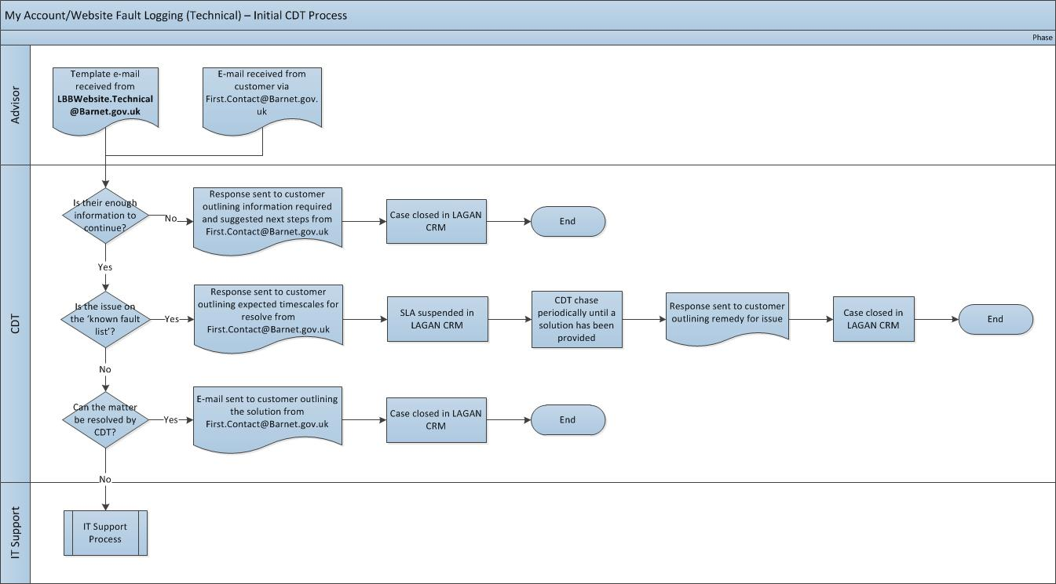

- CDT will triage the referral and if possible will resolve the issue, and contact the customer by email or telephone depending on contact details provided)
- If unable to resolve, CDT will refer the case to IT Service Desk by emailing ITservicedesk@barnet.gov.uk
- CDT keep the customer informed of progress on the resolution of the issue
- CDT will update the Lagan CRM case created to track progress of the call, and also have access to the Service Now system to view the call once it has been raised by IT Service desk (see next section)

CDT Escalation Process for Unresolved calls

Chase Type | Description | Frequency | Format
Follow Up | Chasing an unresolved case with IS support for latest update/resolution | Daily – starting day two of SLA | E-mail or call with follow up e-mail as required
Escalation | Chasing an unresolved case with IS support after two ‘Follow Up’ have been completed.  Escalations will be passed to the Service And Channel Development Manager in the first instance | Daily after initial escalation | E-mail or call with follow up e-mail as required

IT Service Desk Action
The role of IT Support is to provide 2nd line triage of all incidents raised in relation to issues with the LBB website, and establish if it is within their abilities to resolve the issue raised. If not they will refer the issue to the relevant area, whether that is an internal or external supplier, and manage the issue resolution in accordance with the agreed timescales.
They will then provide confirmation to the Channel Development Team that the issue has been resolved or provide the information/advice which needs to be relayed to the customer (by updating the Service Now system and issuing e mail updates to CDT@capita.co.uk).

- IT Service Desk raise an incident on the Service Now system (e mailing CDT@capita.co.uk)
- They triage the referral and if possible resolve the issue as 2nd line support
- If resolved, they inform CDT team by updating the Service Now call (which can be viewed by CDT) and by e mailing CDT@capita.co.uk.
- If unable to resolve, IT Service Desk refer the case on to relevant 3rd Party (G2G3 DIGITAL, Kana, LBB Comms team). Again, this would result in an update to the Service Now call and an e mail to CDT.
- IT Service Desk monitor/chase progress and update the Service Now call and e mail CDT team regularly until the matter is resolved. A weekly “known Issues” report is to be produced and emailed to CDT, which will include:
- Issues raised against the Citizen Portal tab (including date raised)
- Planned resolution
- Current position
- Expected timescales for remedy

Resolution Timescales
Reported faults will be resolved within the following timescales:

Incident Priority | Logged & Acknowledged | Resolved
P1 | 30min | 4 hours
P2 | 4 hours | 8 hours
P3 | 12 hours | 24 hours
P4 | 20 hours | 40 hours
Note that the G2G3 Digital support agreement stipulates that:
- If a code change is required, the incident will be moved to a Problem Record; code changes need to be fully developed, tested, approved and deployed to both UAT and Production which requires a significant investment of resource.
- If 4th line support is engaged the incident will be moved to a Problem Record; if Magnolia (or any other 3rd Party) are engaged in helping to resolve an incident then G2G3 Digital will not be held responsible for the time it takes for them to respond.
In all cases where an incident is moved to a Problem Record, and the KPIs do not apply, G2G3 Digital will keep relevant Capita teams fully up to date with progress and will endeavour to provide a short term workaround, whilst the resolution is being developed.

Content Issues
Where the call is categorised as a content issue by the adviser, the issue is dealt with by the LBB Comms team as per the other editorial tasks described in section 5.
TBC – queried resolution times for editorial issues with Alasdair

Identifying and Fixing Faults reported by Service
This section describes the correct process to be followed by services within the council who wish to report a fault with the website. Note that this section must be read in conjunction with the previous section, as the resolution of the issues follows the same process as those reported by website users once the issue has been defined.
For issues identified internally by council services, LBB Comms team offer 1st line support, It Service Desk provide 2nd line support (CDT if it is a My Account issue), and 3rd parties (Kana, G2G3) offering 3rd line support.
For a full list of scenarios, please see Appendix G and Appendix H

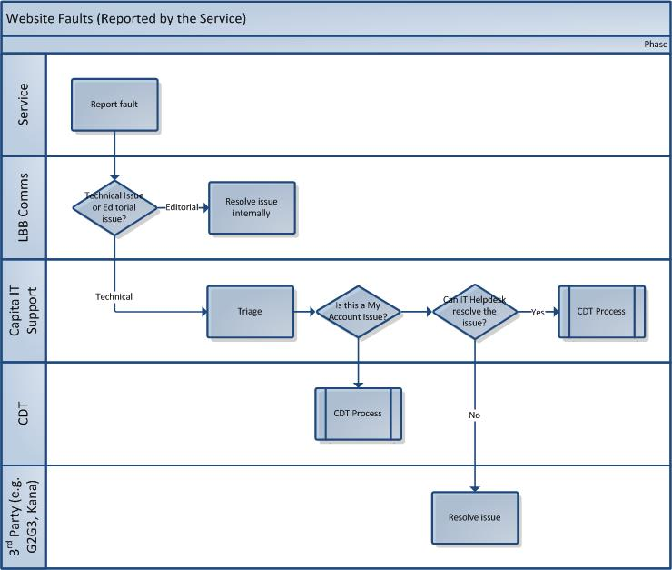

Process
- Service Email webmaster@barnet.gov.uk with details of the fault
- LBB Comms team triage the request, and decide whether it is a content fault or a technical fault
  - Content fault – referred to Content author to make the required changes ( See Editorial Process)
  - Technical fault – referred to IT Service desk (ITservicedesk@barnet.gov.uk)
- IT Service Desk acknowledge receipt
- If the reported issue is a My Account Issue, It service Desk will forward the call onto CDT (CDT@capita.co.uk). CDT will provide 2nd line support for these queries, and will either fix the issue or forward to G2G3 or Kana for resolution. CDT will update the Service Now call to enable IT Service Desk to provide updates to LBB Comms Team/Service
- IT Service Desk will make every effort to repair the fault, however if they are unable to, they will refer the call onto relevant 3rd party e.g. G2G3 Digital
- G2G3 will resolve the issue under the existing support arrangements. The progress and outcomes will be communicated to IT Service desk who will update Service Now and provide progress updates to LBB Comms and the Service.

Resolution Timescales

In line with KPI, reported faults will be resolved within the following timescales:

Incident Priority | Logged & Acknowledged | Resolved
P1 | 30min | 4 hours
P2 | 4 hours | 8 hours
P3 | 12 hours | 24 hours
P4 | 20 hours | 40 hours

Note that the G2G3 Digital support agreement stipulates that:
- If a code change is required, the incident will be moved to a Problem Record; code changes need to be fully developed, tested, approved and deployed to both UAT and Production which requires a significant investment of resource.
- If 4th line support is engaged the incident will be moved to a Problem Record; if Magnolia (or any other 3rd Party) are engaged in helping to resolve an incident then G2G3 Digital will not be held responsible for the time it takes for them to respond.
In all cases where an incident is moved to a Problem Record, and the KPIs do not apply, G2G3 Digital will keep relevant Capita teams fully up to date with progress and will endeavour to provide a short term workaround, whilst the resolution is being developed.

Escalation Process
IT Service Desk will provide the first point of contact should the service wish to chase up progress on an outstanding issue, by emailing the IT Service desk, quoting the reference number of the original call.
The Service Desk will escalate the call either to the third party supplier (G2G3, Kana) or the Service and Channel Development Manager (Livingstone Brown), BAU Project Team depending on which party is responsible for delivery of the resolution.
A response will be provided to the service within 24 hours.
If the above process fails to provide a satisfactory outcome, the issue can be escalated via the Customer Services Working Group (CSWG).

Web Task Support Processes

Editorial Tasks

Editorial Task Model
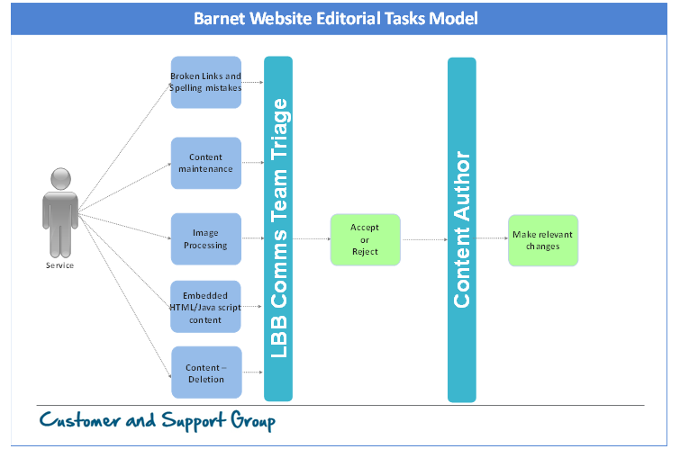
The editorial responsibility for the London Borough of Barnet website lies with the LBB Comms team. This ensures that the content of the site is appropriate and adheres to council policies. It also protects against accidental deletion of content.
The following are covered under the banner of editorial tasks:
- Editorial gatekeeping: review, approval and advice
- Content maintenance
- Image processing
- Embedded html \ java script content
- Content deletion
- Broken links and spelling mistakes
Note that all of these tasks do not require interaction with Capita IT Services.
The LBB Comms team also have editorial input in other processes, such as Request for new e forms, Solr search management and Transversal search management.

Process
- Content author in the relevant service submits changes for approval to the LBB Comms Team (via CMS)
- LBB Comms Team triage the request, and publish or reject as appropriate

Training Tasks

Producing and updating training material
The responsibility for production and updating of training materials is split between Capita and LBB. LBB own the editorial responsibility for training materials, whilst Capita own and update the technical aspects.

CMS training
CMS training is delivered by LBB Comms team

“Writing for the web” training
Training on writing for the web is owned by LBB, ensuring consistency and adherence to policy during the creation of content for the website.

User Administration

Request New user/Amend User permissions
Responsibility for setting up new users or amending user permissions on CMS is the responsibility of the IT Service Desk.
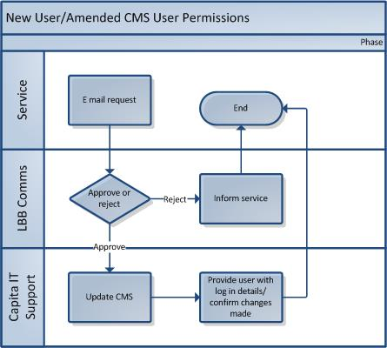
- Service email webmaster@barnet.gov.uk requesting new user/amended permissions
- Request is sent on to IT Service Desk (ITservicedesk@barnet.gov.uk)
- IT Service Desk make relevant amendments to CMS
- IT Service Desk Helpdesk send user log in details
The SLA for these requests is 5 working days

Web Forms

Maintain Existing Forms
There are currently 102 web forms on the LBB Website. The majority of these forms are Magnolia, with a small number being Lagan forms (see Appendix G)
Maintenance of existing form content (e.g. spelling mistakes, broken links etc) and maintenance of functionality (e.g. calculations, validations, and branching rules) will be supported under BAU arrangements.
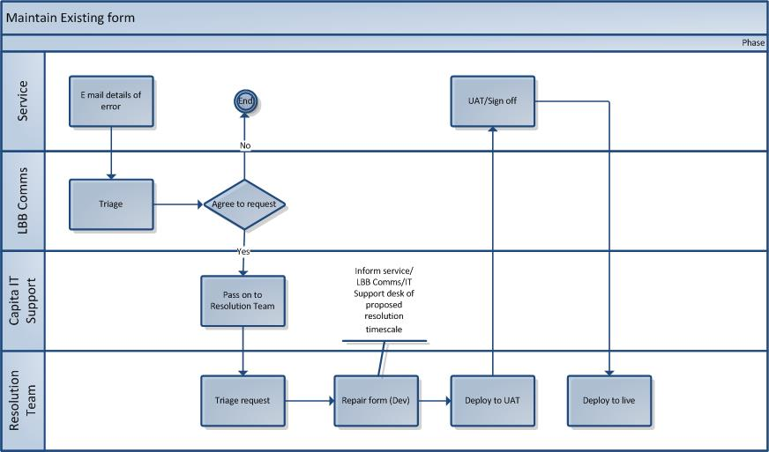
- Service email webmaster@barnet.gov.uk with details of e form issue requiring resolution
- LBB Comms triage the request to ensure it is necessary
- LBB Comms refer the request to IT Service Desk team (ITservicedesk@barnet.gov.uk)
- IT Service Desk record the issue on Service Now system and forward it to G2G3 DIGITAL.
- G2G3 DIGITAL
- also update the IT Service Desk call throughout the process

Faults with e forms will be resolved in line with the priority of the e form (see table below
Incident Priority | Logged & Acknowledged | Resolved | No. of web forms (see Appendix G)
P1 | 30min | 4 hours | 28
P2 | 4 hours | 8 hours | 19
P3 | 12 hours | 24 hours | 22
P4 | 20 hours | 40 hours | 33
Note that where G2G3 investigation reveals that the web form problem will require further development work such as a code change, the issue will be removed and placed on a “problem log”, which is not covered by these resolution times (as with other reported faults).

New/Enhance Existing Forms
Caveat: this process could be subject to amendment as it is based on the principles of a web form support proposal from G2G3 Digital that has not yet been signed off.
The process for creating new forms or enhancing existing forms is a joint Capita/LBB responsibility:
- LBB Comms are responsible for assessing the need for and priority of the new form and clearly defining the requirements
- Capita are responsible for the supplying a cost estimate (where a cost will apply) and delivery of the new/enhanced form, using either the Channel development Team or G2G3 DIGITAL to develop the form depending on the complexity and individual requirements.

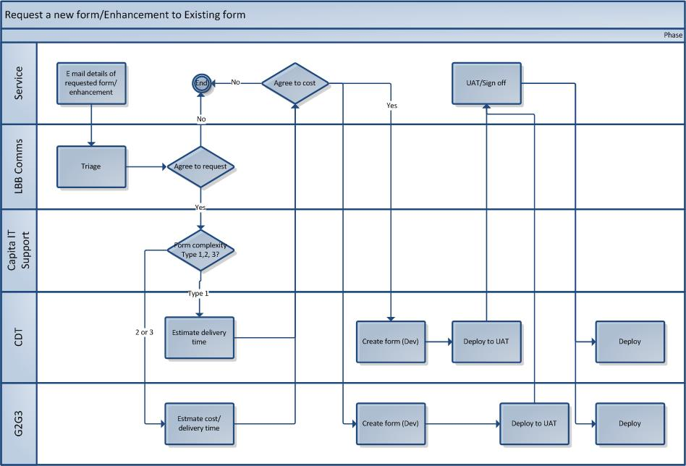
- The individual council services email webmaster@barnet.gov.uk with requests for new e form/ enhancement
- LBB Comms triage the request to ensure it is necessary. A specific form for web form requests will be created and supplied to LBB Comms Team. The form will capture comprehensive requirements and categorise the form to help estimate the delivery time and cost of new forms:
Form Type 1 - simple data collection forms
The form captures information supplied by the customer and the details are passed onto a nominated email address. Examples of these are feedback, contact forms, or offline information requests.
Delivery effort required will normally be measured in hours.
It is probable that forms of this type will not attract a cost to the service.
Form Type 2 - single stage application forms
Where there is a single question set that includes no validation or dependencies, however there may be data from other sources used to populate the form – e.g. post code look up.
Delivery effort required will be measured in hours or days, and there will be a cost to the service. The cost will be the responsibility of the service making the request.
Form Type 3 - multi stage forms
Where there is a complex set of requirements, which could include some or all of the following:
- multi-page,
- branching
- use of other data sources
- integrations with other systems
Delivery effort required will normally be measured in days or weeks. There will be a cost to the service.
- LBB Comms refer the request to IT Service Desk team (ITServicedesk@barnet.gov.uk)
IT Service Desk Action
- IT Service Desk team will perform an initial triage the request:
- Ensure the form has been correctly categorised based on complexity
- Forward the request to CDT (type 1 request) via Service now and e mail to CDT@capita.co.uk
- Forward request to G2G3 DIGITAL (if type 2 or 3) barnet.support@G2G3 Digital.Digital.com. Placeholder – CR process TBC
CDT Action
- CDT will provide IT Service desk with a confirmation of deliverables and an estimate of resource required. The estimated delivery date for the form will be based on the available resource within CDT, taking into consideration the priority of the form from the LBB perspective.
G2G3 DIGITAL Action
- G2G3 DIGITAL will respond with a formal acknowledgement to requests in line with agreed SLAs.
- A Statement of Work will be drafted and submitted by G2G3 Digital that includes: confirmation of deliverables, estimate of resource required and a project plan.
IT Service Desk Action (2)
- IT Service Desk will forward the statement of work to LBB Comms and Service
- If the work package is agreed, CDT will communicate this to CDT/G2G3 DIGITAL (via channels above)
- For more complex forms (type 3) ITES BAU project team may manage the work package
The new form will be tested in the UAT environment with the service to ensure it meets the requirements detailed in the original request. Once the service have tested form in test environment, and have signed off that it meets requirements, the form is deployed to Live.
Escalation Process
IT Support and CDT will provide progress updates regularly during the process of building and deploying a new form, and if there has been an underestimation of time required to build a form, will ensure that a revised work package and delivery date is communicated to the service via the LBB Comms team.
However, should the service wish to chase up progress on the delivery of a form, they should initially contact LBB Comms team, who will email the IT Service desk, quoting the reference number of the original call.
The Service Desk will escalate the call either to the Service and Channel Development Manager (Livingstone Brown), BAU Project Team or G2G3 DIGITAL (Claire Wall) depending on which party is responsible for delivery.
A response will be provided to LBB Comms team within 24 hours.
If the above process fails to provide a satisfactory outcome, the issue can be escalated via the Customer Services Working Group (CSWG).

Database Queries

Run Database Queries
Placeholder – the Barnet database is a Mongo database, which is a different syntax to SQL, therefore further investigation required as to process of running queries (access to database may be different to SQL).
Section to include:
- List of existing queries including a priority for completion
- Estimation of completion time (this will require capturing of full requirements

Request New Database Queries
Placeholder for agreed process

Transversal

Transversal Search Management (New)
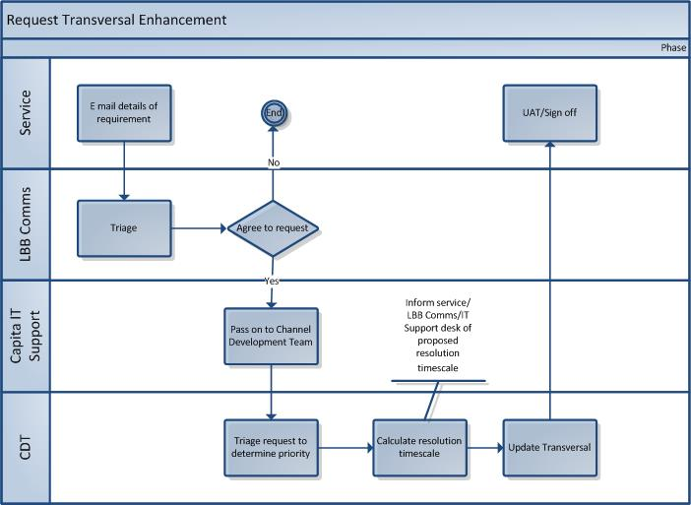

Process
- Service email webmaster@barnet.gov.uk with details of new search/ enhancement
- LBB Comms triage the request to ensure it is necessary
- LBB Comms refer the request to IT Service Desk team (ITServicedesk@barnet.gov.uk)
- IT Service Desk team pass the request onto CDT (e mail and through Service Now)
- New search is tested by CDT in Dev environment, then released to Test
- Once service have tested the new search in test environment, it is deployed to Live
- CDT Team will also update the IT Service Desk call throughout the process

Solr Search Management
Solr provides the search facility within the LBB website, allowing customers to locate pages and forms based on typing in key words or phrases..

Fault reporting
Any faults with the Solr search engine would be reported as per the processes described in sections 4.1 and 4.2.
Note that G2G3 will endeavour to fix any faults reported with the search engine, however, as Solr is supplied on a license-free, open sourced basis (and therefore G2G3 Digital hold no contract with Solr). G2G3 Digital’s ability to resolve incidents is bound within the limitations of the application.
The impact of this is that in the eventuality of the G2G3 Digital being unable to resolve an incident, there is no formal support available from the application provider.
In this scenario, G2G3 Digital will recommend alternative resolutions that may involve a change to existing user journeys, functionality or requirements. G2G3 Digital will always endeavour to suggest alternative solutions that match current requirements as closely as possible; however this may not always be possible.
Full approval will always be sought in any situation where a change in requirements is recommended.

Search Improvements
- Service email webmaster@barnet.gov.uk with details of search improvement required
- LBB Comms triage the request to ensure it is necessary
- LBB Comms refer the request to IT Service Desk team (ITServicedesk@barnet.gov.uk)
- IT Service Desk team use analytics to determine the value of the proposed improvement, and schedule it based on value and need
- The request is e mailed to G2G3 for action
- G2G3 will provide IT Service desk with details of when the change to the search will be released
- Service Desk will also update the IT Service Desk call throughout the process

This task is classified as a Service Request and has an agreed 5 day SLA (see Appendix H)

Analysis and Reporting

GovMetrics
The following suite of GovMetric reports are provided
Report Name | Frequency | Content
Top Ten Report by Month | Monthly | - Detailed Narrative of highlights  - Top 10 “most complained about” url visited  - Cumulative Transactional v Gateway pages results
Daily GovMetric Report for Barnet | Daily | - Channel Satisfaction Index  - Daily Volumes by Channel  - Weekly volumes by channel to date  - Monthly performance by channel to date  - Quarterly Performance by channel to date
Ad hoc requests for GovMetric reports outside of the reports listed above are the responsibility of the Channel Development Team, and will attract a cost .

- Service email the request, including full description of the content required, to ITSupport@barnet.gov.uk
- IT Service Desk will forward the request to CDT for action
- CDT will triage the request, and inform the service of an expected delivery time
- CDT will also update the IT Service Desk call

Appendices
- Contract Extract - Availability
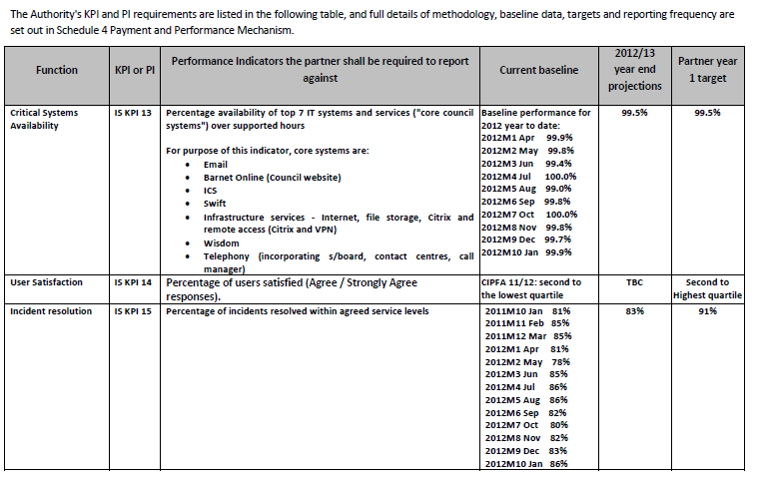
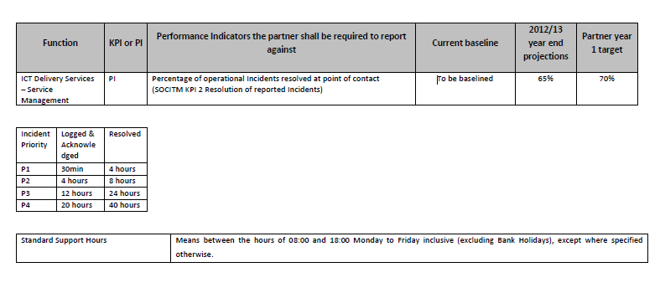
- Hours of Operation
- IT Service Desk emails are monitored Monday to Friday between 08.00 and 18.00
- Channel Development team emails are monitored Monday to Friday between 09.00 and 05.30
- G2G3 Digital monitor emails from IT Service Desk Monday to Friday between 08.00 and 17.00
- LBB Comms Team emails are monitored Monday to Friday between 9.00 and 5.30 (TBC)
- Consolidated list of Web Tasks
The table below shows the web tasks and the agreed ownership of the maintenance and issue management of each area of the website.
 |  | CAPITA
Task | LBB | ITES | CS | G2G3 DIGITAL | Ownership status as of 20th May 2016 | Notes - Clarifications
EDITORIAL TASKS
Editorial review, approval and advice | √ |  |  |  | Agreed | Gatekeeping : Dialogue with LBB comms back into the council to ensure requests are sanitised and put through appropriate channels.
Homepage maintenance | √ |  |  |  | Agreed
Image processing | √ |  |  |  | Agreed | Ensuring the council control all images published (e.g. To ensure copyright restrictions are maintained).
Embedded html \ JavaScript content | √ |  |  |  | Agreed | Ensuring the council control release of embedded content from other sources
Content deletion | √ |  |  |  | Agreed | To ensure content is not mistakenly deleted
Broken links and spelling mistakes | √ |  |  |  | Agreed
TRAINING TASKS
Producing and updating training material | √ | √ |  |  | Agreed | ● LBB own editorial training materials  ● Capita own and keep updated the technical aspects of training material,
CMS training | √ |  |  |  | Agreed
Writing for the web training | √ |  |  |  | Agreed
TECHNICAL TASKS - 1
Identifying and fixing faults | √ | √ |  | √ | Agreed | Reflects need for cooperation between CSG and Barnet Comms  issues flagged by one side shared with the other and fixed editorially or technically.  ● Technical fix covered under break fix support is a responsibility of CAPITA  ● Editorial fix is LBB.
User administration |  | √ |  |  | Agreed | Providing user accounts and setting people up with profiles is purely a CAPITA responsibility under standard system support agreements
Workflow management | √ |  |  |  | Agreed | 2 tier workflow for content:  Approvals is the responsibility of LBB. Now configurable by Barnet comms through Magnolia
Taxonomy changes | √ |  |  |  | Agreed | Now configurable by Barnet comms through Magnolia
E Forms | √  editorial sanity check only |  | √ | √ | Agreed pending formal agreement of the position reached | Pending change process (see actions): LBB comms are responsible for the governance around the following -  (a) the need and (b) the requirements.  There are several strands to support & change:  1. Maintenance of existing form content (e.g. spelling mistakes, broken links etc) functionality (e.g. calculations, validations, and branching rules) will be covered under support  2. Creation of new and enhancement of existing forms will be covered under change: The cost of change or new development will be the responsibility of the service (e.g. Revs & Bens = CAPITA, Planning = Re, Children’s = LBB)  3 .Storage of data submitted should allow for read only access by LBB but maintenance will be responsibility of CAPITA under Data Protection guidelines. Covered under support  4. Mechanism for sending data from forms to services (e.g. alerts via email). Responsibility on the LBB side is to inform CAPITA of changes made to forms that might impact how email alerts would be sent. Covered under support
Galaxies | √ | √ |  |  | Agreed | ● Maintenance covered under support.  ● Editorial responsibility sits with LBB  Evidence would suggest the continued use of Galaxies need a re-think / engagement with stakeholders by CEX team – very little traffic.
Directories | √ | √ |  | √ | Agreed | ● LBB responsible for content  ● CAPITA responsible for Tech Maintenance under Support
Styling |  |  |  | √ | Agreed | Style sheets 100% developed and maintained by G2G3 DIGITAL
TECHNICAL TASKS - 2
Friendly URLs | √ |  |  |  | Agreed | Now available to comms in Magnolia
URL Redirects |  |  |  | √ | Agreed | Redirect files owned by G2G3 DIGITAL
SQL Queries (run) | √ | √ |  | √ | Agreed | Tool to find out about what’s happening on the web site. LBB need read only access.  Responsibility : LBB to run queries  Capita to maintain and provide read only access to my PHPadmin database.  CSG need access to database from G2G3 DIGITAL to run queries – queries a pivotal tool in determining user behaviour and content strategy
SQL Queries (create) |  |  |  |  |  | Requires further definition
Solar search management. |  |  |  |  |  | Example:  ● LBB ask for a search to be improved  ● CAPITA use analytics to determine value of making improvement  ● Change then scheduled against value/need  ● Tuning of search function owned by CAPITA covered under support
Transversal Search Management (new) |  |  |  |  |  | Requires further definition
ANALYSIS & REPORTING
GovMetrics | √ |  |  |  | ? | Requires further definition

- Lagan CRM Classifications
The following classifications are used to log a ‘content’ or ‘technical’ issue for My Account through LAGAN CRM script flows. All cases raised using these classifications are sent to the My Account – Support work queue.

Subject | Reason | Type | Creates Case?
My Account | Benefits | Content Incorrect | Yes
My Account | Benefits | Unable to view enrolled services | Yes
My Account | Benefits | Unable to enrol – Resolved by agent | No
My Account | Benefits | Unable to enrol new services | Yes
My Account | Council Tax | Content Incorrect | Yes
My Account | Council Tax | Unable to view enrolled services | Yes
My Account | Council Tax | Unable to enrol – Resolved by agent | No
My Account | Council Tax | Unable to enrol new services | Yes
My Account | E-Form | E-Form Not Working | Yes
My Account | First Contact | Content | Yes
My Account | First Contact | Technical | Yes
My Account | Hand off to service area | Hand off to service area | No
My Account | Libraries | Content Incorrect | Yes
My Account | Libraries | Unable to view enrolled services | Yes
My Account | Libraries | Unable to enrol – Resolved by agent | No
My Account | Libraries | Unable to enrol new services | Yes
My Account | Log-In Issue | Account Locked | Yes
My Account | Log-In Issue | E-mail address already in use | No
My Account | Log-In Issue | Forgot password/Unable to reset password | Yes
My Account | Log-In Issue | Forgotten User ID | No
My Account | Log-In Issue | Missing e-mail recovered from junk | No
My Account | Log-In Issue | Password not recognised | No
My Account | Log-In Issue | Unable to register | Yes
My Account | Log-In Issue | User ID not working | Yes
My Account | Other | Other Issue | Yes
My Account | Parking | Content Incorrect | Yes
My Account | Parking | Unable to view enrolled services | Yes
My Account | Parking | Unable to enrol – Resolved by agent | No
My Account | Parking | Unable to enrol new services | Yes
My Account | Payment | Payment taken and referred to support | Yes
My Account | Payment | Referred to support | Yes
My Account | Re | Content Incorrect | Yes
My Account | SBS | Content Incorrect | Yes
My Account | SBS | Unable to enrol – resolved by agent | No
My Account | Unable to self serve | E-form not working | Yes
My Account | Unable to self serve | Forgotten password | No
My Account | Unable to self serve | Forgotten password and unable to reset | No
My Account | Unable to self serve | Forgotten user ID | No
My Account | Unable to self serve | My Account is not working | Yes
My Account | Unable to self serve | Other issue | No
My Account | Unable to self serve | Other issue – referred to technical support | Yes
My Account | Unable to self serve | Unable to access a PC currently | No
My Account | Unable to self serve | Website not working | Yes
The following classifications are used for My Account promotion or for registration details to be resent to the resident. All cases raised are sent to the My Account work queue in LAGAN CRM

Subject | Reason | Type | Creates Case?
My Account | Registration | Automated e-mail sent | Yes
My Account | Registration | Automated e-mail sent - Parking | Yes
My Account | Registration | Registration e-mail not received | Yes
My Account | Registration | Registration e-mail not received – recovered in junk | No

The following classifications are used to log a ‘content’ or ‘technical’ issue for the Barnet website through LAGAN script flow:

Subject | Reason | Type | Creates Case?
Website | Content | FAQ Content incorrect | Yes
Website | Content | Website content incorrect | Yes
Website | Content Error | Referred to support | Yes
Website | E-form | E-form not working | Yes
Website | First Contact | Content | Yes
Website | First Contact | Technical | Yes
Website | Hand off to service area | Hand off to service area | No
Website | Technical error | FAQ not working | Yes
Website | Technical error | Payment taken and referred to support – Agent Res | Yes
Website | Technical error | Referred to support | Yes
Website | Technical error | Unable to make payment referred to technical support | Yes
Website | Technical error | Unsupported browser | Yes
Website | Technical error | Unsupported browser – agent resolution | No
Website | Technical error | Website down agent resolution | No
Website | Technical error | Website not working | Yes

- Schedule of Rates
Placeholder – this may not appear in final version as this detail may be included in relevant section
- Web Form Change Request Template
- Web Support Tasks – Priorities
The following table shows the priorities for web support tasks. The scenarios described in this document must be prioritised against this list.

Area | Source of problem | Category | Priority
CMS changes | Update CMS training documentation as required | Authors/editors | 4
CMS changes | Communicate and manage any CMS upgrades/changes | Authors/editors | 1
Create SQL queries | Allow LBB access to phpmyadmin database in order to run SQL queries |  | 2
E-forms | Provide weekly/monthly/quarterly MI data on received e-form volumes (as well as on request) | Web forms | 2
Galaxies/Micro sites | all fixes |  | 3
Google Analytics | Provide comprehensive data on usage of barnet.gov.uk, transversal & micro sites weekly, monthly, quarterly | MI | 4
GovMetrics | Provide GovMetric data to the council weekly, monthly, quarterly | MI | 3
Magnolia | troubleshoot CMS problems - error messages | Authors/editors | 2
Magnolia | troubleshoot CMS login problems | Authors/editors | 2
Magnolia | troubleshoot publishing and approvals problems | Authors/editors | 2
Magnolia | provide reference list of AD groups and users | Authors/editors | 3
My Account | Non-editorial page issues - e.g. error messages on page | Web error messages | 2
My Account | Dashboard editorial or design issues | My Account | 1
My Account | Customer login | My Account | 1
My Account | Lagan forms | My Account | 1
My Account | Providing reference list of users | Authors/editors | 2
My Account | Investigate data issues (missing postcodes for waste and recycling, council tax numbers etc.) | My Account | 2
Report a problem | Investigate data issues | Report a problem | 1
Report a problem | Dashboard editorial or design issues | Report a problem | 1
Solar search management | Troubleshoot Solr search issues | Search | 3
Transversal search management | Add new transversal question | Transversal | 2
Transversal search management | Troubleshoot transversal issues | Transversal | 2
Transversal search management | Edit existing Transversal Q&A | Transversal | 1
Transversal search management | Edit Transversal search function | Transversal | 2
Transversal search management | Delete Transversal question | Transversal | 1
Transversal search management | Fix broken link in Transversal | Transversal | 1
URL redirects | Create URL redirects to specs provided by LBB | Web navigation | 2
Planning search | Troubleshoot and follow up issues with https://publicaccess.barnet.gov.uk | Planning | 2
Capita e-pay | Troubleshoot and follow up issues with https://ip.e-paycapita.com | Web forms | 2

- Service Request Priorities
5 days SLA applies for these requests
Area | Service requests | Category
Create SQL queries | Create SQL queries to specs provided by LBB
E-forms | amend e-form content, questions and alerts | Web forms
E-forms | trace and provide data from missing forms | Web forms
Google Analytics | Design new reports | MI
Google Analytics | Schedule emails | MI
Magnolia | set up a new user | Authors/editors
Magnolia | CMS training | Authors/editors
Magnolia | set up a new AD group | Authors/editors
Magnolia | Replace front page image | Web content
Magnolia | Create short urls | Authors/editors
My Account | Integration with non-Lagan forms, including liaising with form providers - Muniround etc. | Web forms
Solar search management | Tune search algorithm to reflect agreed search priorities with LBB | Search
Style sheets | all amendments

- Web Forms - Priorities
The following table shows the agreed priorities for web forms. The scenarios described in this document must be prioritised as per this list
Form name | Service | Agreed business priority (high=1, low=4)
Child's performance license changes | Schools and Education | 4
Expression of Interest - Community Right to Challenge | Council and democracy | 4
Inclusive Coaching | Children, young people and families | 4
Multi-agency groups (MAG) case referral | Children, young people and families | 1
Request to Start a CAF (where needs are at Tier 2/lower level) | Adult social care | 3
Full events in parks application | Parks, sports and leisure | 3
Preliminary events in parks application | Parks, sports and leisure | 3
Professional Referral Form to Social Care Direct | Adult social care | 2
Report a non-collection | Waste and recycling | 1
Report someone at risk from cold housing | Housing and Community | 1
Street/School gritting application | Council and democracy | 2
Disabled freedom pass | Adult social care | 1
Pay Council Tax | Council Tax and Benefits | 1
Area committee funding application | Council and democracy | 4
Parking permit and visitor voucher refund form | Parking, roads and pavements | 1
Application for in-year school admission | Schools and Education | 1
Council tax - moving in | Council Tax and Benefits | 1
Council tax - moving out | Council Tax and Benefits | 1
Comments, compliments and complaints | Council and democracy | 1
Registrars contact us | Births, deaths, marriages and nationality | 1
Short breaks and activities for disabled children application | Children, young people and families | 1
Council tax - single person discount | Council Tax and Benefits | 1
School admissions general enquiries | Children, young people and families | 1
Course booking for colleagues not employed by the Local Authority (LBB) | Children, young people and families | 3
MASH referral form | Adult social care | 1
Request a Barnet library card | Libraries | 1
Free Early Education for Two Year Olds | Children, young people and families | 1
Building notice application | Planning and building control | 1
Pest control treatment request | Business | 2
Council tax - student discount | Council Tax and Benefits | 2
Parking permits and voucher enquiries | Parking, roads and pavements | 1
New, damaged and additional bins | Waste and recycling | 1
Prior Notification of Householder Extension | Planning and building control | 2
Reserve a book or library item | Libraries | 2
Anti-Social Behaviour Incident Report | Adult social care | 1
Council tax - general enquiry | Council Tax and Benefits | 2
Report a fraud | Council and democracy | 2
Local land charges - personal searches CON29 R & O request | Planning and building control | 2
Appeal request - In year school admission (years 3 to 11) | Schools and Education | 2
Freedom of Information (FOI) request | Council and democracy | 1
Assisted travel general enquiries | Adult social care | 2
Request for pre-application planning advice | Planning and building control | 2
Saracens CPZ enquiries | Parking, roads and pavements | 1
School libraries resources service loan requests | Libraries | 2
FYi general enquiries | Children, young people and families | 3
Full Plans application | Planning and building control | 3
Report health and safety incident | Business | 1
Appeal request - In year school admission to an infant class (reception to year 2) | Schools and Education | 2
Barnet libraries volunteer | Libraries | 3
Notice of commencement - Building Regulation 16(1) | Planning and building control | 3
Council tax - empty property notification | Council Tax and Benefits | 3
Contact the council | Council and democracy | 2
Naming of streets and numbering (and naming) of properties application | Planning and building control | 3
Apply for an assisted waste collection | Waste and recycling | 3
Annual Childminder Audit | Children, young people and families | 3
Family focus referral | Children, young people and families | 2
Disabled children's register | Children, young people and families | 3
Apply for a commercial waste agreement | Business | 3
Application for free travel to school | Schools and Education | 3
Child performances licence application - Parent | Children, young people and families | 3
Childminder details | Children, young people and families | 3
Trading Standards & Licensing enforcement complaints | Business | 3
Benefits - household change | Council Tax and Benefits | 3
Child performances licence application - Applicant | Children, young people and families | 3
Application for a chaperone licence | Children, young people and families | 3
Request a clinical waste collection | Waste and recycling | 2
Expression of interest in fostering | Children, young people and families | 2
Annual Childcare Audit | Children, young people and families | 4
Demolition notice | Planning and building control | 4
Care and repair agency form | Adult social care | 4
Elective home education registration | Schools and Education | 4
Property enquiry | Housing and Community | 4
Adult social care providers booking eform | Adult social care | 4
Expression of interest in adoption | Children, young people and families | 2
Question about my benefit letter | Council Tax and Benefits | 4
Home library service application | Libraries | 4
Noise complaints | Business | 4
Application to deliver Positive Activities programmes | Children, young people and families | 4
FYi service evaluation | Children, young people and families | 4
Housing benefit/ Council tax benefit - Change of address | Council Tax and Benefits | 4
People Bank | Adult social care | 4
Community right to bid nomination | Adult social care | 4
Newly registered childcare providers | Children, young people and families | 4
Temporary street trading application - fast track | Business | 4
Sets and Scores Club music request form | Libraries | 4
Annual Home Childcare audit | Children, young people and families | 4
Application for the registration of a non-commercial society | Business | 4
Hate crime reporting | Adult social care | 1
Domestic violence and violence against women and girls | Children, young people and families | 1
Home childcare’s details | Children, young people and families | 4
Temporary street trading application | Business | 4
Application for a registration/storage licence under the manufacture and storage of explosives regulations 2005 | Business | 4
Poisons application | Business | 4
Elective home education - Statement of provision | Schools and Education | 4
Complaints about the conduct of a councillor | Council and democracy | 1
Adopt a place/street application | Council and democracy | 4
Application for the annual licence to sell fireworks | Business | 4
Notification of possible private fostering arrangement | Children, young people and families | 3
Street market application | Business | 4
Application for the approval by the Local Authority of the height of chimney(s) serving furnace(s) | Business | 4
Part B application for a permit | Business | 4
Report a problem | Street cleansing & Highways | 1

- Extract from Output Specification

CS011 | Web content | The Service Provider shall:  - Ensure that all web content pertaining to the activity for which the CSO is responsible is available on the Authority website and is updated in a timely manner.  - Identify where the Authority’s web content is irrelevant, out of date or inaccurate and take action to notify the content owner and corporate communications so the content can be updated.  - Identify where the Authority’s web content, although relevant, current or accurate, can be re-purposed for more effective contact handling and information provision and take action to notify the content owner and corporate communications so the content can be updated.
CS017 | Website Management | The Service Provider shall ensure that all the required technical tasks as described in the website transformation project business as usual task definition document listed in section 5 (Data Room Documents) of this Output Specification are completed.  The Service Provider shall complete all management tasks as and when required to maintain the effective running of the Authority's website in line with the Authority’s expectations.  The Service Provider shall design the Authority's website so as to enable customer self-service.  The Service Provider shall complete all other tasks in line with the SLAs.

- Extract from Method statement
2.11 WEB CONTENT: CS011
Our web solution is a critical part to our Customer Access Strategy and in the realisation of achieving channel shift and volume reduction.
We will work with the Council to implement an improved framework for maintaining web content. This will be made up of the following:
▪ A content maintenance process - with a set of guidelines and content principles and a regular 2-way content change request process
▪ Triggers for content reviews - ensuring all web content pertaining to the activity for which the CSO is responsible is available on the Council website and is updated in a timely manner, is relevant (where found to be irrelevant or inaccurate, our Service and Channel Development Team will notify the content owner and Corporate Communications Team in order for the content to be updated). Content may also be relevant and accurate, however, may not be as effective as it could be, so we will work with the content owners on how this can be redesigned/re-purposed
▪ Service and Channel Development Team, including content subject matter experts
▪ A Content Management System with training for remote editors.

In response to SOCITM's Better Connected strategy, which will measure Council website performance in a number of ways, including the use of GovMetric surveys, basing the design around the Top Tasks and assessing their use. We will adopt key task analysis to audit the current site and rationalise web content, drawing on the practical experience we have with working with Gerry McGovern (the originator of the Top Task method) where we successfully adopted this approach at NHS Choices.
As part of the Customer Access Strategy, the Service and Channel Development Team will take a multi-channel view of customer interactions, as well as using information from 'Root Cause Analysis' and Insight, to ascertain what information should be included and how best to deliver this across the channels. This will include cross-promotion within the channels

2.17 WEBSITE MANAGEMENT: CS017
As detailed in CS011, our Web solution is a critical element of our Customer Access Strategy and will be designed to enable customers to self-service.
Our Service and Channel Development Team have the responsibility of ensuring that all the required Technical Tasks as described in the Website Transformation Project Business as Usual Task Definition document are completed. We will work with the Council's Communications team and, where appropriate, retained Council Delivery Units and Delivery Partners, to ensure and agree adaptation to the website and content is managed in accordance with the Task Definition document.
They will agree Management Tasks upfront with LBB and all of these will be completed as and when required to maintain the effective running of the Council website in line with the Council’s expectations, with all other tasks being completed in line with the SLAs as outlined in the Council's Website Transformation Project - Development and Business as Usual Task Definition document.
Our Channel Development Team will also be responsible for working with the Council to develop web governance and online content principles and ensuring adherence to these across the Council
- Forms
Create and manage XForms. A set of templates have been created to make sure that all forms are created in a consistent manner and all fields are consistently named.
A number of XForm customisations have been created for:
- postcode lookup
- registration details auto-fill.
Manage XForm actions for emails, attachments and PDF file creation.
All new forms need to be added to the Call to Action widgets, supplements and independent homepages.

Content of micro sites (e.g. Children’s Services) is owned and updated by those services, not LBB Comms
See following section – after a period of knowledge transfer, CDT will take on some of these maintenance issues
There will be a programme of knowledge transfer between G2G3 DIGITAL and CDT for this to be possible. Ultimately, CDT will be able to deal with some of the type 2 form requests

