Waterstones Children’s Book Prize Winner 2015
Rob Biddulph
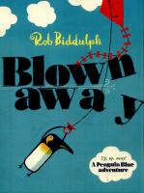
Church End Library, Saturday 6 February
2.30pm-3.30pm
Special guest, prizewinning children’s author and illustrator Rob Biddulph, will be visiting Church End library for a storytime and craft session for younger children. Spaces are limited. Pre-booking is essential.
For booking information and enquiries contact:
Church End Library, 24 Hendon Lane, Finchley N3 1TR Tel. 020 8359 3800

