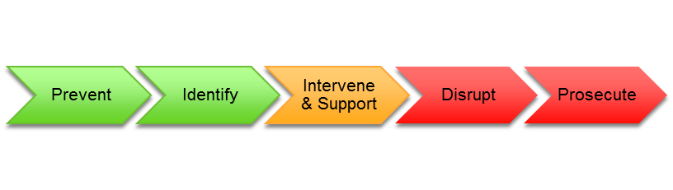
What is Child Sexual Exploitation (CSE)?

Sexual exploitation of children and young people under 18 (CSE) involves exploitative situations, contexts and relationships where the young person (or third person/s) receive “something” (e.g. food, accommodation, drugs, alcohol, cigarettes, affection, gifts, money) as a result of them performing, and/or others performing on them sexual activities.

CSE can occur through the use of technology without the child’s immediate recognition, e.g. being persuaded to post images on the internet or mobile phone without immediate payment or gain.

Violence, coercion and intimidation are common. Involvement in exploitative relationships is characterized by the child or young person’s limited availability of choice as a result of their social, economic or emotional vulnerability.

A common feature of CSE is that the child or young person does not recognize the coercive nature of the relationship and does not see themselves as a victim of exploitation, as they consider they have acted voluntarily. The reality is they have not consented and their behavior is not voluntary. As the Pan London CSE Protocol points out, a child cannot consent to his or her own abuse.

Multi-Agency Sexual Exploitation Meeting (MASE)

MASE will maintain robust oversight of all CSE cases assessed as level 1,2,3 risk in Barnet, inform prevention strategies, identify emerging trends, intervene and inform disruption strategies, secure support for victims, and work closely with the police to prosecute perpetrators. In most cases there will have already been a strategy meeting or a Multi-agency planning meeting prior to any referral being completed for MASE.

Social workers and partners can book time at CSE surgery which takes place fortnightly between Police and CSE Co-ordinator to discuss existing cases prior to MASE referral or for those cases that do not meet threshold for MASE. Contact details below.

The new stage 2 Risk assessment tool should be completed and should be attached to MASE referral
The Social Worker should complete the MASE referral form.
sxmailbox-.ppd@met.pnn.police.uk

Social workers MUST attend the first MASE meeting to present the concerns and agree an action plan.

In cases where the threshold to MASH is not met or for any other CSE related concerns, consultation and advice can be obtained by contacting the CSE Co-ordinator on 0208 359 7207.

