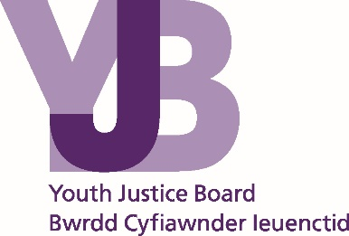
Placement Review and Transfer Guidance

Contents
Introduction 3
Legal overview 4
Reason why a transfer may be considered 5
Risk to Self 5
Risk to Others 5
Planned Placement transfer 6
Transition 6
Specialist Provisions 6
How to request a transfer 8
Placement Review Process – Instigating and Submission of a Placement Review Form process map 8
Roles and Responsibilities 11
Role of the Youth Offending Team (YOT) case manager 11
Role of the secure estate 12
Role of the YJB Placement Service 13
NOMS YOI Escalation Process 14

© Youth Justice Board for England and Wales 2016
The material featured in this document is subject to copyright protection under UK Copyright Law unless otherwise indicated. Any person or organisation wishing to use YJB materials or products for commercial purposes must apply in writing to the YJB at ipr@yjb.gsi.gov.uk for a specific licence to be granted.

Introduction
This document explains what happens if children and young people are to transfer from one custodial establishment to another during their remand period or whilst serving a sentence. It applies to the whole under-18 secure estate, which comprises young offender institutions (YOIs), secure training centres (STCs) and secure children’s homes (SCHs).
The Youth Justice Board for England and Wales (YJB) and the Secretary of State both have the statutory power to place young people who are remanded to youth detention accommodation or sentenced to custody.
A young person’s placement may need to be reviewed when their circumstances change or a particular issue or risk is identified.
A placement review should be a multidisciplinary process involving all those responsible for the care and welfare of a child or young person, including the child or young person and their family/carers where appropriate. The review aims to explore how a child or young person can be supported or managed within their existing placement from the point at which an issue is raised or a concern is identified in order to avoid, as far as possible, the need to change the placement. A transfer might be one outcome from the review.
Where it is evidenced to the YJB, via the multi-disciplinary meeting (MDM), that a placement is no longer suitable, a child or young person may be transferred to a different establishment. Transfers will only be considered where there is evidence that all that can be done to manage the young person in their current establishment has been done.
The best interests of the child or young person must be considered in any decision that is reached but also the needs and risks associated with other young people, staff and the stability of the establishment and the estate as a whole.
The YJB expects that all the establishments we place into are able to keep children safe and meet their individual needs; this is a fundamental expectation.
If a Stakeholder has any concerns or complaints about a YJB transfer decision they should formally make their complaint following the YJB complaints procedure which is available on the YJB GOV.UK website. The complaint should be made in writing to email address: enquiries@yjb.gsi.gov.uk

Legal overview
Legal position and principles
Placement reviews must be in line with the legal position as described below.
The YJB has the legal power, concurrent with the Secretary of State, to make decisions about where children remanded or sentenced to custody are placed. Only the YJB and the Secretary of State are able to make these decisions.
A decision to transfer a young person from one establishment to another is a serious matter which should have significant consideration applied to it.
Decisions regarding placements and transfers engage the rights of a child under Article 8 of the European Convention on Human Rights, which protects a child’s private and family life. A transfer may mean that a child is placed further from home, and may have an impact on the child’s ability to receive visits from family members. A transfer may also have an impact on their ability to maintain positive relationships which support their rehabilitation.
Any decision to change a child’s placement must carefully consider the extent to which the transfer affects the child’s rights under Article 8, whether the interference in those rights can be justified and is proportionate, and the steps to be taken to minimise the interference. Grounds for justifying interference are that the interference is the interests of national security or public safety, the prevention of disorder or crime, the protection of health or morals, or the protection of the rights and freedoms of others.
Any decisions made should also consider the best interests of the child, both under the UN Convention on the Rights of the Child and as a matter of domestic law, in particular the duty under the Children Act 2004 to promote the safety and welfare of the child.
International standards also have a bearing on placement reviews and placement decisions. The Havana rules for the protection of juveniles deprived of their liberty state that ‘juveniles should not be transferred from one facility to another arbitrarily’ (Rule 26).
The statutory safeguarding guidance, applicable to all those who work with children, is relevant and sets out the following principles:
  - ‘safeguarding is everyone’s responsibility: for services to be effective each professional and organisation should play their full part; and
  - a child-centred approach: for services to be effective they should be based on a clear understanding of the needs and views of children.’

Reason why a transfer may be considered
Through a multidisciplinary meeting (MDM) a particular concern may be identified with a young person’s placement. In almost every case, the grounds for a transfer are:
- Risk to self
- Risk to others; (Staff, young people and the stability of the establishment).
- Planned

A transfer should only be considered when there is evidence that an alternative placement can best meet that child or young person’s needs and, where applicable, all interventions and strategies have been exhausted in the current placement.
The best interests of the child or young person must, be a primary consideration in any placement decisions, and any decisions must be capable of being justified in relation to the child’s rights under Article 8.
Some transfers may need to take place due to urgent circumstances concerning risk to self, others or the security/stability of the establishment.
In the case of an urgent concern about a placement into a YOI the YJB Placement Service and NOMS YPE Central Team will work from a centralised position collaboratively to collate the required information from stakeholders to achieve a swift review.
The YJB Placement Service will operate in a similar manner with individual STC/SCH should urgent issues arise.
In all non-urgent cases, a request for transfer should be led by caseworkers through the MDM process.

Risk to Self
A child or young person’s placement may require a review if there is an increase in their risk of harm due to their behaviour or the behaviour of others which means that they cannot be safely managed in their current establishment. A significant change may have taken place which alters the risk associated with a child or young person.

Risk to Others
A child or young person’s placement may require a review in situations where their behaviour or conduct is such that their continued placement threatens the safety of staff, other young people or the stability of the establishment is compromised.

Planned Placement transfer
A planned transfer may be sought if the current placement cannot offer a range of interventions, treatments or other non-urgent facilities that somewhere else in the estate can offer. A placement closer to the young person’s release address and/ or family may also be a consideration. These should be identified through sentence/remand planning meetings and reviewed on a regular basis.
A planned transfer includes the following;

Transition
  - All young people who turn 18 and are remanded or sentenced, under legislation that is not a DTO, should transfer in to the young adult estate in an agreed and planned way.
  - Case managers (YOT and Secure Estate) need to ensure that a young person’s transition in to the young adult estate is considered and built in to all plans they have from their initial placement in to custody.
  - For those young people located in an SCH or STC the YJB Placement Service will pro-actively identify them as soon as possible and highlight to the relevant parties.
  - Girls will need to move directly from an SCH or STC to the adult estate.
  - In respect of the male SCH/STC populations consideration should be given by YOT Case Managers, about transfer into an under 18 year old YOI. This may be beneficial in order to plan and prepare the young person for transition into the adult estate. It may be appropriate that some young people transition directly into the adult estate.

Specialist Provisions
  - If a transfer to the Keppel unit is recommended by the MDM, then a Keppel Referral Form should be completed and submitted alongside the Placement Review Form. The “HMYOI Wetherby: Keppel Unit; Placement protocol for the complex needs unit” document sets out the criteria for the unit and the process for referring to the unit.
  - The YJB has commissioned a Mother and Baby unit (MBU) within Rainsbrook STC. Any girl who is either pregnant and/or is a mother to a baby under 18 months old can be assessed for suitability for the unit. Please call the YJB Placements Service on 0845 363 6363 to discuss a placement on to the MBU.
  - If the MDM is recommending a move on to the Long Term Unit (LTU), a national resource at HMYOI Wetherby, then the YOT case manager should clearly articulate the reasons within the Placement Review Form (Annex A).
  - If a young person who has been placed into an under-18 YOI is referred to and assessed by NOMS as requiring a Restricted Status this young person will then be managed and placed by High Security Prisons Group in liaison with NOMS YPE Central Team. Any decision to transfer a child within the YOI estate as a result of a Restricted Status assessment by NOMS will be carried out under section 12 of the Prison Act 1952.
If a young person requires a move under health grounds this will be arranged between the relevant health providers and the YJB Placement Service should be updated on any arrangements made but cannot authorise transfers into a healthcare facilities or environment. Separate arrangements are in place for mental health transfers and guidance is available. Please call the YJB Placements Service on 0845 363 6363 if further guidance is needed.

How to request a transfer

Placement Review Process – Instigating and Submission of a Placement Review Form process map
The process map below sets out the process of conducting and submitting a Placement Review to the YJB Placements Service.
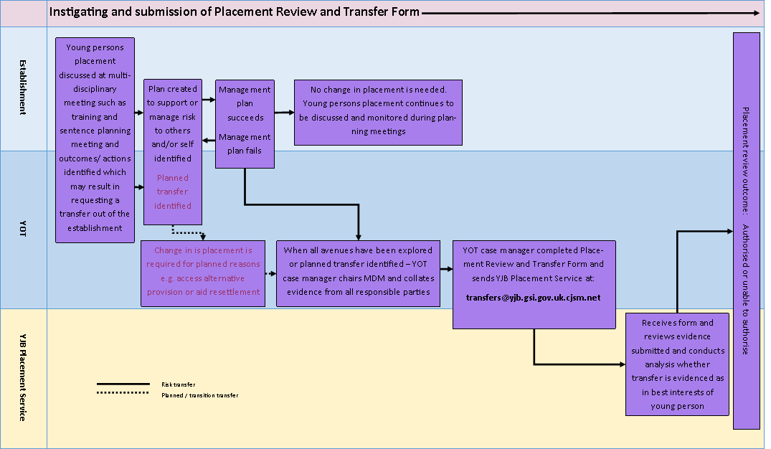

If a particular risk or concern has been identified it is suggested that the YOT Case Manager discusses the issue with a Placement Manager at the YJB, following which, if necessary, a multi-disciplinary meeting (MDM) should be convened. The purpose of this meeting should be to establish how the risk can be managed or reduced. This meeting may form part of an establishment’s existing multi-disciplinary meeting structures or the sentence planning or remand review processes. The young person’s placement should be discussed at all sentence planning or remand review meetings.
If a young person, their parent/carer or any other interested party wishes to request a review of placement they should discuss the matter with the YOT Case Manager or the secure establishment who will then make arrangements for an MDM. It is expected that an MDM will always take place in these circumstances so that concerns can be explored and solutions to problems identified: young people and their families must feel that their voices have been heard.
The MDM should be arranged and chaired by the young person’s YOT case manager or a senior manager within an establishment. The following should be invited to attend or contribute to the meeting;
- YOT Case Manager
- Establishment Operational Manager
- Establishment Case Worker
- Unit Managers
- Parents or Carers
- Advocate or legal representative for the child or young person (where requested by the child or young person)
- Local authority and social worker (if the child or young person is Looked After in England and identified under the Social Services & Wellbeing Act in Wales)
- Representative from healthcare and/or CAMHS professional
- The child or young person (for all or part of the review as appropriate to the circumstances)
- In some complex cases, it may be appropriate for a member of the YJB Placements Team to attend the MDM
- In cases where it looks likely that a transfer might take place, it may be appropriate to invite a representative from the intended receiving establishment – the YJB Placements Service can advise further on this

In the first instance, physical attendance at the MDM is preferable. If this is not achievable then input via a conference call or a written submission is required. Where a person responsible for the welfare of the child or young person has not contributed to the meeting, attempts to contact that person and/or the reasons for not contributing should be noted.
The views of the child or young person and any representative should be sought prior to any decision and the reasons for the proposed transfer explained. This consultation should take place if appropriate to the situation and risks i.e. there may be security or safeguarding reasons as to why a young person is not consulted which should be articulated on the placement review form. A young person should be made aware of the advocacy service available at their establishment and their rights in relation to this.
A transfer should only be requested when all other avenues of managing the child or young person in their current establishment have been explored. A transfer should be requested by the YOT case manager using the Placement Review Form (Annex A) which should be completed in full. The Placement Review Form should be sent to the YJB Placements Service via secure email to transfers@yjb.gsi.gov.uk.cjsm.net
In order to ensure that the YJB can reach an informed decision about the request it is essential that the Placement Review Form (Annex A) is completed as comprehensively as possible. The YOT case manager is responsible for the evidence provided within the Placement Review Form. The YOT case manager is accountable for the evidence provided.
Clear evidence that demonstrates the range of actions that have been taken to address the concerns raised, or manage the child or young person, must be presented and recorded in the form. Reasons must be given to explain why these strategies were not successful in addressing the concern and how a change of placement would do so. Clear evidence as to how any proposed alternative placement would best meet the needs of the child or young person must also be presented.
Records of involvement and consultation with the child or young person must be evident in any of the above.
The evidence contained in the Placement Review Form is crucial in establishing that the proposed transfer is the safest placement option. It will also be shared with any potential receiving establishment to enable a full assessment of any potential risk factors to be made ahead of transfer.
Should there be any disagreement within an MDM, where one or more stakeholders are not in agreement with the YOT Case Managers recommendation; details of how the YOT Case Manager has explained their recommendation to the particular stakeholder should be detailed in the Placement Review Form (Annex A). Articulation of why the Case Manager is making the recommendation despite the disagreement and any mitigating actions proposed should also be included.
Completion of the form can be undertaken by either the establishment or YOT case manager however, only the YOT case manager can authorise and sign off the contents of the Placement Review Form.
The final Placement decision will be made by the YJB (for exceptions to this, see section headed ‘NOMS YOI Escalation Process).

Roles and Responsibilities

Role of the Youth Offending Team (YOT) case manager
If you are a case manager you have responsibility for overall case management of young people on custodial orders, including a specific role in managing young people at risk of self-harm and suicide, and joint accountability with the secure estate for the sentence planning and delivery. The National Standards for Youth Justice Services and YJB Case Management guidance should be followed.
It is deemed best practice that the YOT Case Manager takes the lead in the management of the process, however there are occasions where a collaborative approach to arranging an MDM will be necessary, for example where a move needs to take place in urgent circumstances.
If the secure estate, parent, carer or any other interested party wishes to ask for a Placement review you should consider this with them and convene an MDM and complete the relevant form on their behalf. Where concerns are raised by any relevant stakeholder about a child’s placement, a MDM must be convened to explore the issues further.
If it is identified that a young person requires an alternative placement you have the responsibility to complete the Placement Review Form and send it to transfers@yjb.gsi.gov.uk.cjsm.net although the secure estate may assist you with these arrangements as part of working collaboratively with you.
In order to complete this form you are responsible for chairing a multi-disciplinary meeting (MDM) involving all the people who have responsibility for the care and welfare of the young person. Where it is not possible to complete the meeting in person you should collect all the required information through conference call or written submissions.
You should assess the urgency of the issues or risks identified and work with the secure estate to convene a MDM in a timely manner based on your assessment.
Where it has been decided at the multi-disciplinary meeting that a placement in to a specialist unit is appropriate you must complete an additional referral form. Additional referral forms are required for placements in to;
- Keppel Unit
- Mother and Baby Unit
- Long term unit (LTU)
You are accountable for all the information that is provided on the Placement Review Form. The YJB Placements Service will use this information to make a decision about moving the young person to an alternative establishment.
You are responsible (collaborating with secure estate staff, where you deem it appropriate) for the dissemination of any updates or decisions made to interested parties including the child or young person.

Role of the secure estate
If there is a concern with the child or young person’s placement you must alert the YOT case manager. If a young person’s parent, carer or any other interested party raises concerns about a placement you should discuss these with the YOT Case Manager. You should consider the need for an MDM to determine if a transfer may need to take place. Although it is best practice that the YOT Case Manager manages the process you should work collaboratively in terms of information gathering and MDM arrangements.
You will be asked by the YOT case manager to provide your views as part of a multi-disciplinary meeting. If this cannot be held in person then your views will be gathered via conference call or written submissions.
If a young person is referred to your establishment as the result of a placement review and you can provide specific information that the proposed transfer would not be suitable these must be communicated to the YJB Placement Service immediately.
If you work in a YOI and a transfer is agreed then you are responsible for organising transport in a timely manner through PMU.
Ahead of any agreed transfer, it is the responsibility of the sending establishment staff to make sure that the receiving establishment has received all relevant information about the young person to inform planning and risk assessments. This will include any management plans agreed as part of the MDM.
Though it is agreed that the YJB is the placing authority for all sentenced and remanded young people and in practice carries out this function routinely, it is also agreed that using the powers held by the Secretary of State for Justice, the Deputy Director of Custody (DDC) for NOMS Young People’s Estate is able to authorise transfers within the under-18 YOI estate, within the legal framework and best practice guidance identified within this document. Any transfers approved by the DDC which have not been agreed by the YJB will take place under his/her authority and risk, with complaints, concerns or matters arising from such decisions resting with the NOMS YPE.
Once agreed all transfers should take place at an appropriate and reasonable point in time, to allow sending and receiving establishments to put management plans in place. This will include ensuring that any educational exams or interventions are completed, or transferred, prior to the young person transferring.

Role of the YJB Placement Service
In practice the YJB Placement Service is responsible for placing all children and young people who are remanded into custody or given a custodial sentence in court.
The YJB Placement Service will provide support and advice to those requesting a transfer, and in complex cases, may be able to participate in or attend the MDM.
The YJB Placement Service is responsible for reviewing all Placement Review Forms and evidence. The YJB Placement Service allocates new placement review requests and monitor outstanding placement review requests until;
- the child or young person moves
- the YJB Placement Service decides not to move the child or young person
- the request is withdrawn
The requests will be prioritised based on level of risk and the issues presented.
The YJB Placement Service is responsible for informing the YOT case manager of the final decision they have agreed.
They will complete part 2 of the Placement Review Form which outlines their assessment and decision. They are also responsible for recording and attaching all relevant information on to the YJB case management system.
The YJB Placements Service is responsible for sharing all relevant information and evidence within or attached to the Placement Review Form (Annex A) with the receiving establishment.
Where a transfer is agreed but there are not any beds available then the YJB Placements Service is responsible for monitoring the bed availability and advising Stakeholders about potential transfer timescales so that alternative options can be considered based on the risk.
If a decision is made to move the child or young person from an STC or SCH the YJB Placements Service is responsible for arranging transport for the child or young person.
If a child or young person requires a move from an STC or SCH into a YOI the YJB will liaise with NOMS YPE Central team to assess the best placement option considering stability, operational impact on the receiving establishment and the best interests of the child or young person concerned.

NOMS YOI Escalation Process

In cases where the YJB is advised that an immediate move is required between under-18 YOIs, joint work will be undertaken with NOMS YPECT to gather sufficient information to make a risk assessment and decide upon a move.
Where the YJB deems that there is insufficient information available to make a decision about the suitability of a move, it has been agreed that the DDC for NOMS YPE can exceptionally approve a move where he/she considers that the risks and timescales involved warrant this. This will normally mean that the transfer needs to take place within 24 hours of the concern being identified. Any such moves will be undertaken under the powers conferred by section 12 of the Prison Act 1952 (which applies only to inter-YOI moves and cannot be used to facilitate moves from STCs or SCHs)
Any decision in this circumstance will be discussed with the Director of Operations within the YJB. NOMS YPE Central Team will provide the YJB with a completed Placement Review Form (PRF) signed and authorised by the DDC outlining the reasons for the decision.
Any immediate moves based on imminent risk or related to stability issues should be followed up with a strategic review of the new placement within 7 days of the transfer.
The DDC will have responsibility for any associated risk or challenge in relation to decisions made under this process.

The functions and powers of the YJB originate from the Crime and Disorder Act 1998 and the Youth Justice Board for England and Wales Order 2000, as amended by Article 2 (3) (c) of the Youth Justice Board for England and Wales (Amendment) Order 2008

