

Closure of Accounts for Schools

Financial Year 2012-13

“Success depends upon previous preparation, and without such preparation there is sure to be failure.”
Confucius; China's most famous teacher, philosopher, and political theorist, 551-479 BC

Issued by: -

Schools Accountancy Section
Building 4,
North London Business Park
Oakleigh Road South
London N11 1NP February 2013

Procedures for Closure of 2012-13 School Accounts

Contents

- Introduction

2. Revenue Financing of Capital

3. Coding of Income

4. Cash Book Reconciliation

5. March Bank Statement

6. March Bank Reconciliation and Posting Summary

7. Year-end Creditors, Debtors, Receipts and Payments in Advance
8. Capital Detail Form

9. Transfer of Information to LA

10. Period 12 Statement of School / LA Accounts

11. Final Outturn Statement

12. Consistent Financial Reporting

Appendices -

- Timetable for Closure of Accounts

- Example Cash Book Reconciliation

- Example Internal Creditor/Debtor Schedule

- Example Internal Payments/Receipts in Advance

- Example External Creditor/Debtor Schedule

- Example External Receipts/Payments in Advance

- Example Capital Detail Form

- Requirements Checklist

To the contents
[1] Introduction

Dear Colleague

I am required to close the Local Authority’s (LA) formal accounts for schools by 26th April 2013. In order to achieve this it is necessary for you to adhere to the Timetable in Appendix 1. The aim of the Closedown programme is to produce a final Statement of School/LA Accounts that will formally identify your income and expenditure during 2012-13 and disclose your capital and revenue balances carried forward into the new financial year. These instructions deal with each component part of the Closedown process and completed examples of key forms & documents are attached for illustration purposes.

Important points to note………

- You have been provided with a checklist at the end of this guidance as an aide memoire. It lists all of the requirements, their due dates and whether they are required by email or hard copy. (See appendix 8 at the end of these procedures)

- Schools should inform Schools Accountancy by email of the LBB unpresented cheques when emailing in the year end returns. (See section 6)

- If schools have any Internal Debtor items on the Internal Creditor/Debtor form please forward details of which borough department the debt is with, the value and a brief description on a separate piece of paper or written in the e-mail with the electronic version of the Internal Creditor/Debtor form.

- All schools will need to complete a Capital Expenditure Detail Form, even if the return is nil. These details are required to update the record of Capital Assets held by the Council. (See section 8)

- If your school received any capital grant from the LA except Devolved Formula Capital please note that the income must be recorded as a credit against CE02, this will negate the expenditure and effectively remove it from your local accounts. This is to avoid double accounting as the LA record’s these projects centrally.

To expedite the closedown process and ensure submission of your March and Year-end Returns before the end of term, all returns can be sent electronically using the E-Forms provided via the Working with children in Barnet website; http://www.barnet.gov.uk/WorkingWithChildrenInBarnet/info/20004/school_funding_and_finance
(although some hard copy signed originals will need to follow in the post).

What can I do to prepare for Closure of Accounts?...... Several things: -

- Ensure salary monitoring is up to date and all queries notified to your Payroll provider
- Ensure only essential orders are raised after half term to reduce the amount of creditor entries needed
- Ascertain details of all supply staff being employed in March
- Ascertain details of all additional hours (teachers, Mealtime Supervisors, Admin,
- Learning Support Assistants & Welfare Staff) and overtime (caretaker) worked in March
- Check and pay all outstanding invoices for LA traded services, in the event of any query contact the Income Section or traded service manager.
- List details of all contract commitments

To the contents

- Ensure you have reconciled your local accounts to the latest Statement of School / LA Accounts and notified any queries to the Schools Accountancy Section

If you envisage a problem in being able to meet the deadlines set out in the timetable please contact me on 020 8359 7203. Instructions on RM Finance year-end routines will be emailed to all users who have purchased support from the School Support Service. Your co-operation in meeting the Authority’s closedown deadlines is much appreciated.

Nick Adams
Schools Finance Services Manager

[2] Direct Revenue Financing of Capital

Schools using revenue resources to fund capital expenditure need to effect an accounting entry in their accounts if the capital works /acquisition (to which revenue resources have been allocated) have been completed by 31 March 2013, or have not been completed by 31 March but are imminent and the school is under contractual obligation in the new financial year i.e. a purchase order has been raised and sent to the supplier of the goods or service.

To achieve this, the school should debit revenue expenditure E30 and credit capital income code CI04 for the amount of capital spend that is to be financed by revenue resources. To avoid distorting the division of year-end balances this journal transfer must be completed by 31 March to be included on the school’s March Posting Summary.

[3] Coding of Income

Before proceeding with your school’s year end procedures please ensure that the income your school has received is in the correct CFR code. For example there is a split between;
- I01 – Funds delegated by the LA
- I02 – Funding for 6th form pupils and
- I03 – SEN funding.
If you are unsure of how your school’s funding is split then the End of Year (February 2013) funding statement, which can be found on the Working with children in Barnet web site, will be able to give you an accurate split. http://www.barnet.gov.uk/WorkingWithChildrenInBarnet/info/20004/school_funding_and_finance
You can then do a recoding of your schools income if necessary. This could also apply to your schools other delegated funding/grants;
- I04 - Funding for Minority Ethnic Pupils
- I05 - Pupil Premium
- CI01 - Capital Funding.

[4] Cash Book Reconciliation

The most up to date E copy of the Cash Book Reconciliation for your school is available on the Working with children in Barnet website; http://www.barnet.gov.uk/WorkingWithChildrenInBarnet/info/20004/school_funding_and_finance
Its purpose is to ensure that all payments and receipts to / from your local bank account have been included on your Posting Summaries. The Cash Book Reconciliation includes
data for April 2012 – January 2013. Please update it with your figures for February and March and ensure any variance is redressed by completing an adjusting Posting Summary
or revised Bank Reconciliation. An example of a completed Cash Book Reconciliation is
Shown at Appendix 2. In order to extract your school’s Cash Book Reconciliation from the

To the contents

Excel spreadsheet you will need to input your school’s Department for Education (DfE) number in the top left hand corner of the spreadsheet.

Please contact, Nicole Gibson (020 8359 7223) Faz Saeed (020 8359 7228) or Polly Baker (020 8359 7227) if you have any queries.

[5] March Bank Statement

On behalf of all schools using the Council’s contracted banker the LA will request the Co-operative Bank to produce statements for the School Budget Share and Reserve Accounts to 14th March 2012. These Statements should reach schools in sufficient time to enable the March Bank Reconciliation to be completed by Friday 22nd March. All schools must reconcile to the statement dated 14th March. Any transactions which affect the bank after this date will be treated as unpresented items to be reconciled in the New Year.
Schools using their own (external) banker need to write to their Banking Provider requesting statements dated 14th March which allows sufficient time for receipt, reconciliation and dispatch of year end returns to the LA by Friday 22nd March.

[6] March Bank Reconciliation & Posting Summary

A bank reconciliation should be completed on receipt of the statement dated 14th March.

To enable the LA to eliminate `Internal’ debtors from its balance sheet, all schools are asked to highlight any unpresented cheques that relate to payments drawn to LBB which are unpresented as at the date of the March Bank Statement. Such unpresented cheques should be highlighted on the hard copy of the printed bank reconciliation which is sent to the LA. Schools should also inform Schools Accountancy of the LBB unpresented cheques when emailing in the year end returns.

Please ensure the net VAT expenditure for March is accounted for as `Unpresented Income’ on your March Bank Reconciliation. Once the March Bank Reconciliation has been completed, the Period 12 Posting Summary should be produced.

It is imperative that your March Posting Summary and Bank Reconciliation are submitted to the Schools Accountancy Section by Friday 22nd March using the relevant E-Forms.

[7] Year-end Creditors, Debtors, Receipts & Payments in Advance

The final accounts of the LA are prepared on an accruals basis. This means that goods & services received in 2012-13 which have not been paid for by the end of March need to be recorded as a creditor so that the expenditure is charged to the correct financial year.

Schools will need to make creditor adjustments so that income or expenditure outstanding at the end of March is accounted for in the correct financial year. To do this schools need to submit data to the LA which identifies, against each CFR Heading, the level of creditors & debtors at the end of March.

Schools will need to make year-end adjustments for the following where relevant: -

Creditor – the value of any goods or service received by the school in financial year 2012-13 (irrespective of whether or not an invoice has been received) that will not be paid for until on or after 1st April 2013

To the contents

Debtor - the value of any income due to the school that relates to financial year 2012-13 that will not be received until on or after 1st April 2013 (e.g. school meals). If schools have any Internal Debtor items on the Internal Creditor/Debtor form please forward details of which borough department the debt is with, the value and a brief description on a separate piece of paper or written in the e-mail with the electronic version of the Internal Creditor/Debtor form.
Outstanding Governor donations are not debtors as there is no contractual obligation for the governors to make those donations to the school.

Receipt in Advance - the value of any income received by the school before 31 March 2013 that relates to events on or after 1 April 2013 (e.g. lettings or grant payments for an academic year)

Payments in Advance – the value of any payments made by the school before 31 March 2013 that relate to goods or services that will be received after 1 April 2013 (e.g. exam fees, equipment rentals)

Schools will be provided with a combined E-Form. For completion of Creditors / Debtors, Receipts in Advance & Payments in Advance for completion as follows: -

Internal Creditor/Debtor Schedule – on which to record all amounts owing to (and owed from) LA for goods and services provided by the Council (except timesheets for option A & C schools and option B & D schools with external payroll providers, these are to be recorded on the External Schedule).

External Creditor/Debtor Schedule – on which to record all amounts owing to (and owed from) external organisations

Internal Receipts and Payments in Advance - to record the value of any income received or payments made by the school from or to the LA before 31st March 2013 that relates to events on or after 1st April 2013. (E.g. grants that relate to an academic year, therefore the summer term would be received in advance or payments for training courses to be attended in the summer term).

External Receipts and Payments in Advance - to record the value of any income received or payments made by the school before 31 March 2013 that relate to events on or after 1st April 2013.(e.g. Grants for Summer term projects, lettings, exam fees, photocopier rental)

In completing these schedules, aggregate the net value of all creditors, debtors, RIA & PIA etc. occurring against each CFR Heading, for example: -
- If the school has a Fuel Oil Creditor of £1000 and a Gas Creditor of £900 it should record a net creditor total of £1,900 against the E16 Energy line on the External Creditor Schedule.

- If the school has four separate creditors for agency supply teachers of £300 each, it should record a creditor total of £1,200 against E26 Agency Supply Staff on the External
Creditor Schedule.

- If the school has outstanding invoices for services provided by LBB e.g. Catering, Building Maintenance Help Desk, Insurance etc. then these should be recorded against the relevant CFR Heading on the Internal Creditor Schedule

To the contents
- If the school has any money owing to it from the LA, this should be recorded on the Internal Creditor/Debtor form, though a brief description of these items are required including the borough department, value and description to match these items with the appropriate borough departments.

- If the school has received income from parents for various school journeys/trips which relate to 2013/14 these should be aggregated and entered on the External RIA/PIA form as a RIA

- If the school has paid an annual contract for photocopying for the year 01/01/13-31/12/13 the cost should be calculated for the period 01/04/13-31/12/13. This apportionment relates to the new financial year, it should be entered onto the External RIA/PIA form as a PIA

- If the school has received any funding from the LA or paid any invoices to the LA which relate to 2013/14 then these should entered onto the Internal RIA/PIA form

Amounts owing to the school should be entered as minus figures. Amounts owed by the school should be entered as positive figures on the Creditor/Debtor forms; this is the reverse on the RIA/PIA forms. Examples of completed Creditor/Debtor & RIA/PIA E-forms are shown at Appendix 3, 4, 5 & 6

Notes
Early Years Vulnerable Children Funding (Formerly CIN) – Schools that receive Early Years Vulnerable Children Funding payments will receive unpaid amounts due in the new financial year. Any school/children’s centre who usually receives Early Years Vulnerable Children Funding payments should raise a debtor for an estimated amount based on previous receipts.
Golden Hello/Handcuff - If there are any Golden Hello/Handcuff grants due to be paid to schools, schools are asked to treat these as a cash value in the next financial year. Schools will receive the income once the Golden Hello is paid to the individual teacher making the net effect nil.
Auto-payments 4th Quarter payment – schools are asked to check the Working with children in Barnet Website for the actual value of their final payment for 2012-13 (including pence) and enter this amount as unpresented income in the schools accounting system. http://www.barnet.gov.uk/WorkingWithChildrenInBarnet/info/20004/school_funding_and_finance

Depending on their Banking and Payroll arrangements, schools will need to note the following specific instructions concerning creditors relating to 2012-13

Salaries & Wages: -

Option A & C schools: -

All standard salaries & wages for March will be automatically charged to your Delegated Budget via your Salaries Account. However you will need to refer to the final submission
dates for claims regarding Supply, Additional Hours and Overtime etc.
You should raise a year-end creditor for these items on the External creditor Schedule if the claims will miss the final submission dates set by LBB Payroll for processing in the old financial year.

To the contents

Option B & D Schools: -

Schools who are invoiced from LBB Payroll – Record the value of any 2012-13 Salaries (where payment hasn’t already been drawn and included on Posting Summaries) against the relevant CFR Heading on the Internal creditor schedule.

Schools with external payroll providers: Record the value of any 2012-13 Payroll transactions (where payment hasn’t already been drawn and included on Posting Summaries) against the relevant CFR Heading on the External creditor schedule

The E-Form for Year-end Creditors, Debtors, RIA & PIA will be available on the Finance and Funding page of the Barnet Grid for Learning website from Mid March.

[8] Capital Detail Form

All schools will need to complete a Capital Expenditure Detail Form, even if the return is nil. These details are required to update the record of Capital Assets held by the Council.

The Capital Detail form needs to show all expenditure from CE01-CE04 showing the total spent on any given project and if the project is “complete” or “not complete”. If a school has started a project and will be processing a year end creditor for work to be completed in 2012-13 but not yet invoiced - this will need to be entered on the Capital Detail form with the total spent including the creditor as a “not complete” project.

If an income contribution to a capital project has come from the school’s revenue budget via Direct Revenue Financing (DRF) CFR codes E30 and CI04 or via private income or fund raising it must still be entered onto the form for the full value of the project.

Schools will also be required to record how the capital expenditure in 2012-13 was funded. This is to enable the LA to report any unspent Devolved Formula Capital grant to the DfE.

A paper copy is not needed. An authorised copy must be kept in school for audit purposes.

An example of a completed form can be found Appendix 7.

[9] Transfer of Information to LA

The March Returns, Year-end Creditor, Debtor, RIA & PIA Schedules and the Capital Expenditure Detail Form should be returned to the LA via email to schools.accountancy@barnet.gov.uk by Friday 22nd March 2013.

You are asked to return the above information electronically via email as this method ensures no time delay between submission and receipt and allows the LA to automate the processing of some of the data. However schools experiencing difficulty with email can send manual returns by: -

- Fax 020 8359 7324
- Hand Deliver to Building 4 Reception, NLBP

Hard signed copies of your Year-end Creditors, Debtors, RIA & PIA Forms and March Bank Reconciliation including a copy of the Bank Statement with un-presented cheques
To the contents

and income breakdown (cheques made payable to LBB highlighted) are required asap and should be sent to the Schools Accountancy Section by Royal Mail or the Councils Courier Service.

[ 10 ] Period 12 Statement of School / LA Accounts

A Statement of School/LA Accounts for Period 12 (March) will be available to you on the funding website by Thursday 18th April; http://www.barnet.gov.uk/WorkingWithChildrenInBarnet/info/20004/school_funding_and_finance
This will be a Provisional Outturn Report and any errors or omissions must be notified to the Schools Accountancy Section by 5pm on Wednesday 24th April to ensure correction for Final Outturn. A Statement of School/LA Accounts for Period 13 showing all corrections will be produced and published to the website by 10 May 2013.

[ 11 ] Final Outturn

Notification of Final Outturn for 2012-13 will be available on the Working with children in Barnet website by Friday 24th May; http://www.barnet.gov.uk/WorkingWithChildrenInBarnet/info/20004/school_funding_and_finance
this will be in the form of a final Statement of School / LA Accounts together with an Outturn Summary which, if applicable, will identify any cash transfer due between your Budget Share and Salaries Accounts

Schools on Banking and Funding Option A are unable to increase the amount held in their Reserve Account to reflect their 2012-13 carry forward balance until they receive this notification.

Where the underspend balance of a School on Option A has increased from that brought forward from 2011-12, a payment may be made in June to compensate for the potential loss of interest to the Reserve Account between 1 April and 31 May.

[12] Consistent Financial Reporting (CFR)

In July the LA will submit the statutory CFR Data Return to the DfE showing income and expenditure for all Barnet Schools in 2012-13 analysed against the national framework headings. However the data return requires a breakdown of balances held as at 31.03.13 and in view of this schools will be sent a simple pro-forma to complete and return to show the division of their total revenue and total capital balances as follows: -

The composition of the schools total revenue balance between,
- B01 – Committed Revenue Balance
- B02 – Uncommitted Revenue Balance
- B06 – Community Focussed School Balance

The composition of the schools total capital balance between,
- B03 – Devolved Formula Capital (DFC) Balance
- B05 - Other Capital Balances

A copy of every schools CFR pro-forma form to be completed will also be available on the Working with children in Barnet website; http://www.barnet.gov.uk/WorkingWithChildrenInBarnet/info/20004/school_funding_and_finance

B01 – Committed Revenue Balance is taken to mean items for which written and authorised purchase orders were placed in the previous financial year and for which the goods/service had not been received by 31 March 2013.

To the contents

B06 – Extended School Balance is I16 Extended school Community Focussed funding/grant + I17 Community Focussed School facilities income – E31 Community Focussed School staff – E32 Community Focussed School other costs. Plus/minus any brought forward balance from 2011-12

Please contact the Schools Accountancy Section on 020 8359 7223, 7228 or 7203 for further clarification of these notes or if you envisage any difficulty in complying with these deadlines

To the contents
Appendix 1

Timetable for Closure of Accounts
For Schools Financial Year 2012-13

Activity  No. | Date | Who? | Action
1 | By  Friday 25 February | All schools with external bankers | Write to Bank requesting statements to be prepared as at close of business on Thursday 14 March 2012  [ LA will write to Co-Operative Bank for all schools in the Corporate Banking Contract ]
2 | By Friday 15 March | Participating  Schools | Final Date for Submission of claims for Long Term Sickness and Maternity Leave to Schools Accountancy Section
3 | By Friday 22 March | All Schools | - Complete March Bank Reconciliation  - Complete March Posting Summary  - Complete Creditor, Debtor, RIA & PIA Schedules  - Complete Capital Expenditure Detail Form  Submit all to Schools Accountancy Section

School Spring Holiday: Friday 29th March – Monday 15th April

4 | By  Thursday 18 April | Schools Accountancy Section | Produce publish to the funding website Period 12 (March) Statement of School / LA Accounts. This will also act as a Provisional Outturn Report
5 | By  Wednesday 24 April | All Schools | Final date for reporting queries on Statement of School / LA Accounts to the Schools Accountancy Section
6 | By  Friday 26 April | Schools Accountancy Section | Accounts Close. Final Outturn Position compiled, Period 13 Reports Produced
7 | By  Friday  24  May | Schools Accountancy Section | Final Outturn Reports and Outturn Statement published to funding website including CFR balance forms
8 | By Friday 14 June | All Schools | Deadline for return of Information on Breakdown of CFR Balances

To the contents
Appendix 2

Example of Cashbook Reconciliation

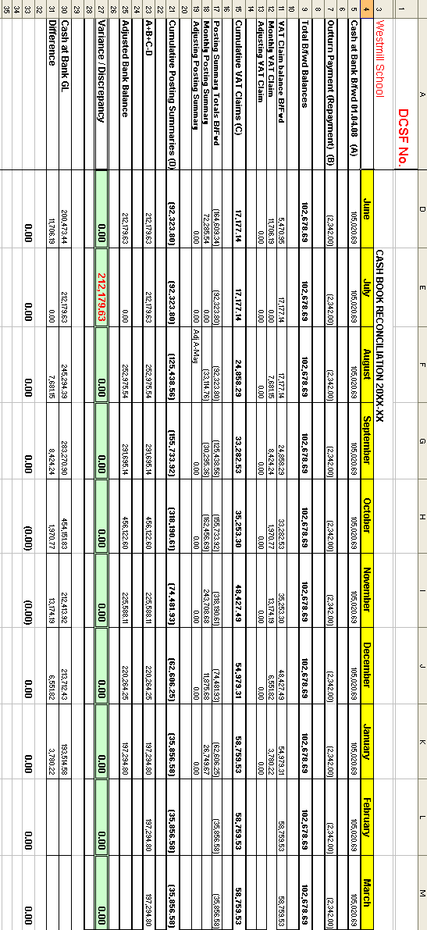

To the contents
Appendix 3
Example LBB Internal Creditors & Debtors Schedule

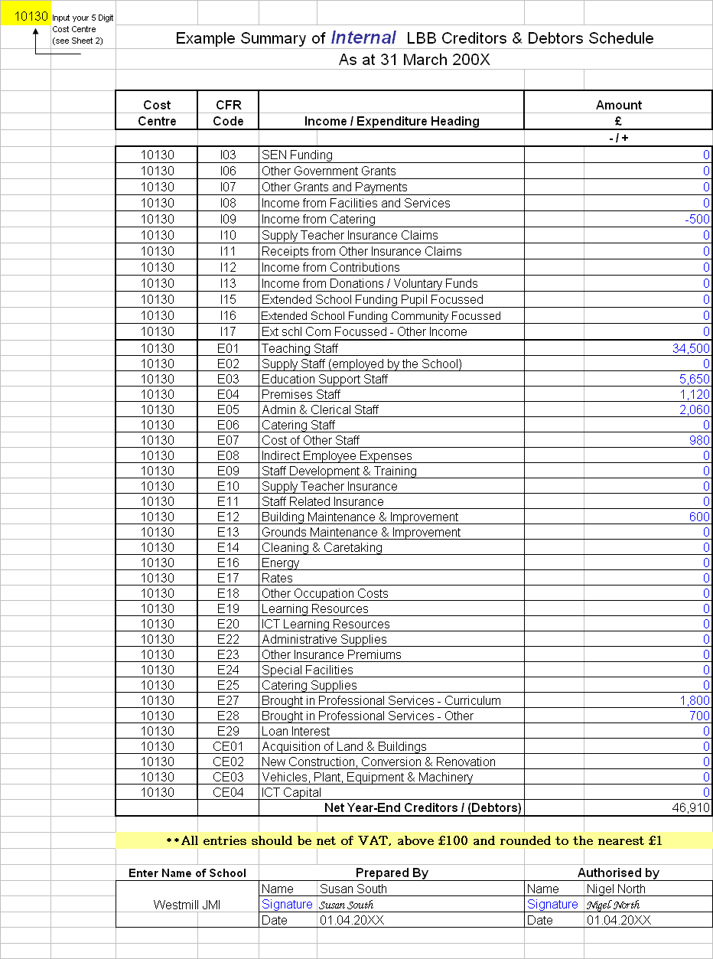

To the contents
Appendix 4
Example LBB Internal Receipts/Payments in
Advance Schedule

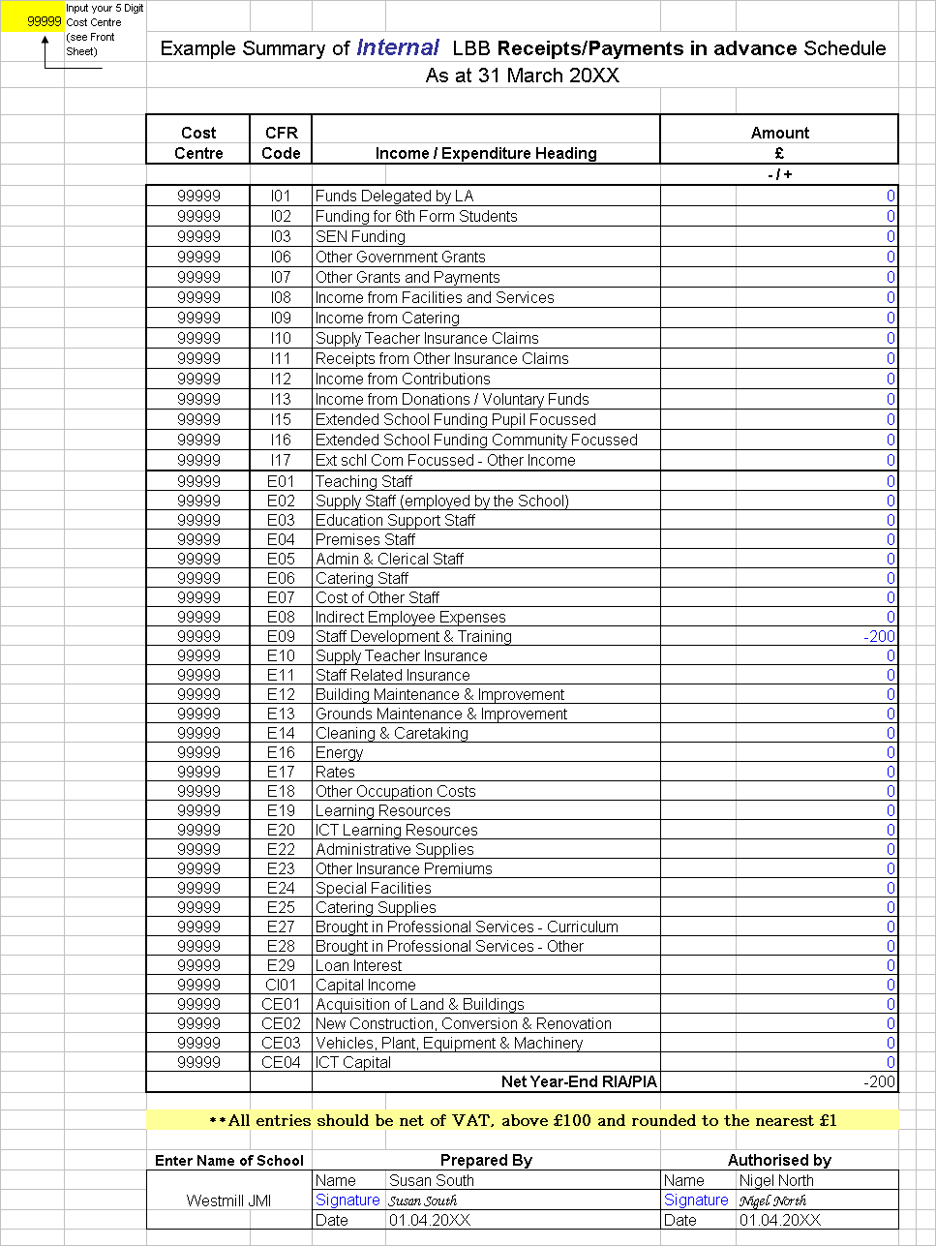

To the contents
Appendix 5
Example External Creditors & Debtors Schedule

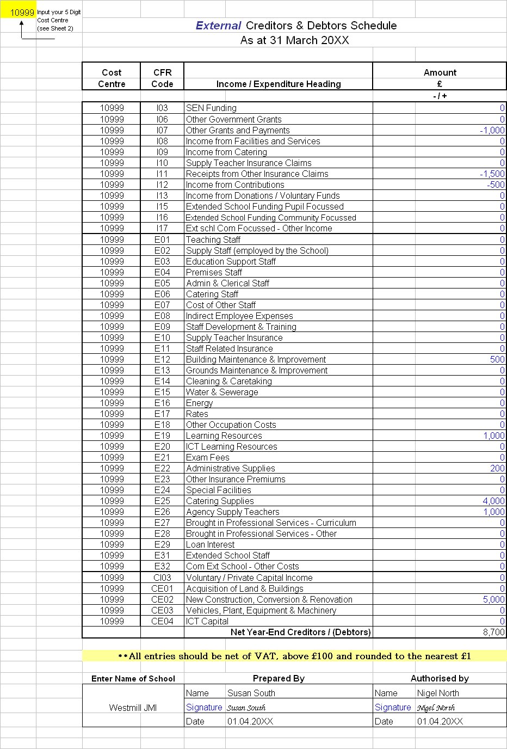

To the contents
Appendix 6
Example External Receipts/Payments in Advance Schedule

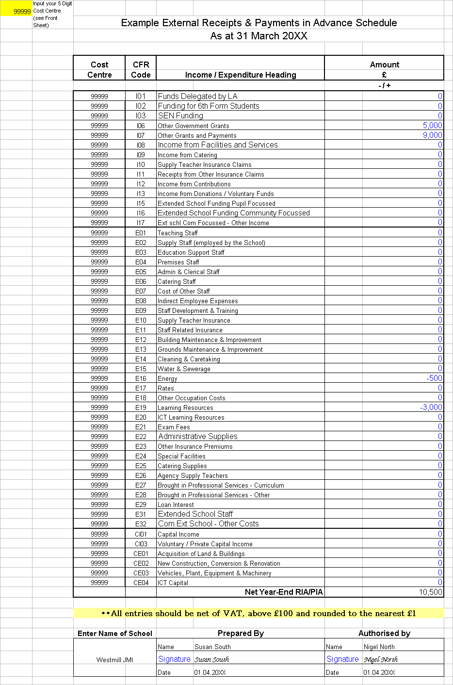

To the contents
Appendix 7
Example of Capital Detail Form
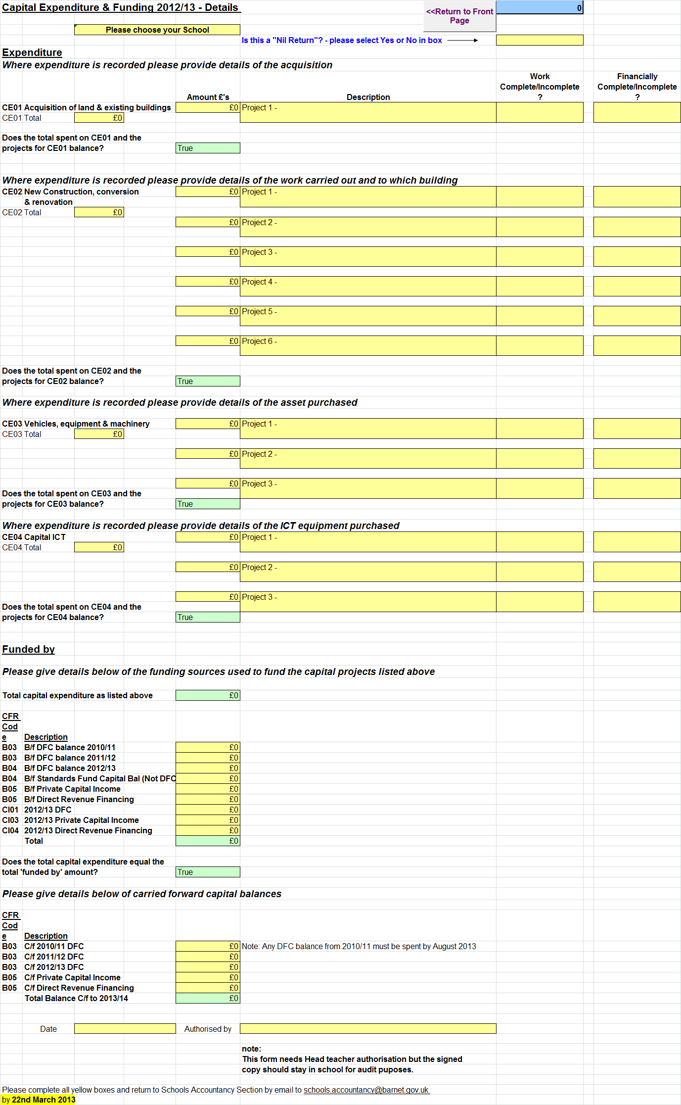

To the contents
Appendix 8
What | When | How | Where | Done
Bank Reconciliation | 22nd March | Email | Schools.accountancy@barnet.gov.uk
Unpresented Cheques/Income list –Please ensure LBB transactions are indicated | 22nd March | Email | Schools.accountancy@barnet.gov.uk  Or  Fax to 020 8359 7324
Posting Summary | 22nd March | Email | Schools.accountancy@barnet.gov.uk
Capital Detail Form | 22nd March | Email | Schools.accountancy@barnet.gov.uk
Internal Creditor/Debtor Form | 22nd March | Email | Schools.accountancy@barnet.gov.uk
External Creditor/Debtor Form | 22nd March | Email | Schools.accountancy@barnet.gov.uk
Internal RIA/PIA Form | 22nd March | Email | Schools.accountancy@barnet.gov.uk
External RIA/PIA Form | 22nd March | Email | Schools.accountancy@barnet.gov.uk
Details of all large Creditors/Debtors & RIA/PIA. Items over £8K for Nursery, Primary & Special Schools. Items over £15K for Secondary Schools. | 22nd March | Email | Schools.accountancy@barnet.gov.uk
Details of all internal Debtors | 22nd March | Email | Schools.accountancy@barnet.gov.uk
Signed Bank Reconciliation | 19th  April | Post | Schools Accountancy Section, NLBP, A15, First Floor, Building 4.
Hard Copy of Unpresented Cheques/Income | 19th  April | Post | Schools Accountancy Section, NLBP, A15, First Floor, Building 4.
Signed Creditor/Debtor & RIA/PIA schedules | 19th  April | Post | Schools Accountancy Section, NLBP, A15, First Floor, Building 4.
Copy of Bank Statements to which the final Bank Reconciliation was reconciled to. | 19th  April | Post | Schools Accountancy Section, NLBP, A15, First Floor, Building 4.
Report any errors or omissions on the Provisional Outturn Report to Schools Accountancy | 24th April | Email/Phone | Schools.accountancy@barnet.gov.uk  Or  020 8359 7223/8/5
CFR Returns – Completed & signed | 14th June | Post | Schools Accountancy Section, NLBP, A15, First Floor, Building 4.
Year End Requirements Checklist

