
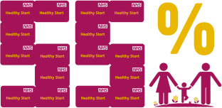
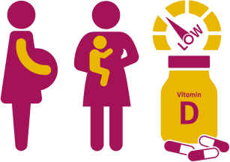
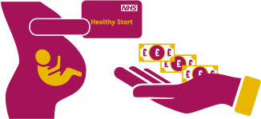
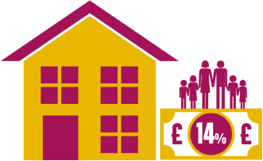
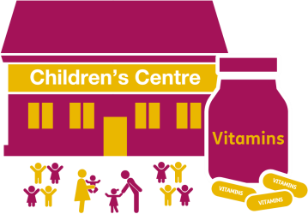
HEALTHY CHILDREN
BE FREE

FACTS AND FIGURES

Healthy Start vitamins are available for those eligible in Barnet’s children centres
It is estimated
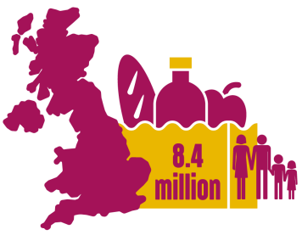
8.4 million people in the UK struggle to get
enough to eat

All pregnant and breastfeeding women and young children are at risk of vitamin D deficiency

FACTS AND FIGURES
14% of children (under 16) in Barnet live in absolute
low-income families

You qualify for ‘Healthy Start’ if you are under 18 and pregnant, even if you
don’t get other benefits or
tax credits

55% uptake of Healthy Start, for those who were eligible, in Barnet in September 2023

- If you’re more than 10 weeks pregnant or have a child under 4 years, you may be entitled to get
help to buy healthy food and milk.
- To check eligibility you need to go to the Healthy Start website on the how to apply page at: https://www.healthystart.nhs.uk/how-to-apply/
- If you’re eligible, you’ll be sent a Healthy Start card with money on it that you can use in some UK
shops, money will be added every 4 weeks
- You can use your Healthy Start card to buy the following: plain liquid cow’s milk, fresh, frozen, and tinned fruit and vegetables, fresh, dried and tinned pulses and infant formula milk based on cow’s milk
- You can also use your Healthy Start card to collect:
- Healthy Start vitamins – these support you during pregnancy and breastfeeding
- Vitamin drops for babies and young children – these are suitable from 4 weeks to 4 years old
You’ll get: £4.25 for each week of your pregnancy from the 10th week, £8.50 each week for children from birth to 1 year old. and £4.25 for children between 1 and 4 years old.

HEALTHY CHILDREN
BE FREE
LOCAL SERVICES AND ONLINE SUPPORT

Service | Type | Description | Details
Healthy Start Website | - Online | General info and FAQs on healthy start can be found here.  Link to FREE healthy start resources for professionals see below: https://media.nhsbsa.nhs.uk/resou rces/f/nhs-healthy-start-scheme | Information on eligibility and how to apply is available at: https://www.healthystart.nhs.uk/ho w-to-apply/  There is also a phoneline for queries, on 0300 330 7010.
Health Visitors | - Online  - Phone  - Face to Face | Health Visitors are able to provide general advice and support for children aged 0-5 years  Including questions around healthy eating and vitamins | Email:  hcp.4barnet@nhs.net  Phone: 020 3633 4049 / 0800 772  3110  Website: http://ww.healthychildprogramme.c o.uk
Children Centres | - Online  - Phone  - Face to Face | Healthy Start vitamins can be collected via children centres in Barnet  Providing services for children, young people and their families Children centres also have computers in which families can use to complete healthy start application forms | https://www.barnet.gov.uk/directori es/childrens-centres-in-barnet
Food banks | - Online | Food banks are available in Barnet if you are struggling to buy food. Many foodbanks in Barnet do not need a referral or can be self referral. | Website: www.barnet.gov.uk/directories/food  -banks

