




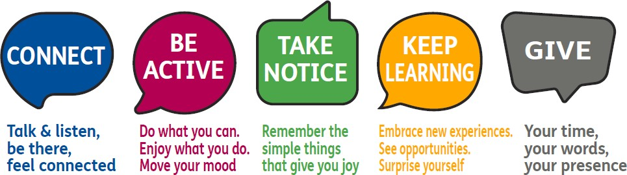

MENTAL WELLBEING

FACTS AND FIGURES
5 ways to wellbeing

1 in 4

Poor mental health impacts:
People will experience a mental health problem each year
individuals

families
income
quality of life

education

HELP AND ADVICE
- You are not alone. 1 in 4 of us experience problems with our emotional health and wellbeing at some point in our lives.
- Research carried out by the New Economics Foundation found that there are five ways to wellbeing: Connect. Be Active. Keeping learning. Give. Take notice.
- Connect with other people. Take time to be with and stay in touch with family, friends or colleagues. Make use of video-chat apps if you live far apart. You can share positive experiences, build a sense of belonging and provide emotional support to each other.
- Be physically active. Not only good for your physical health – it can also improve your mental wellbeing and positively change your mood through even the simplest activities.
- Learn new skills. This can boost self-confidence, build self esteem and help connect with others. Why not try learning to cook something new, or starting a DIY project, take up a new sport or sign up for a course.
- Give to others. This can create positive feelings and a sense of reward. You could try small acts of kindness such as offering help to someone you know or volunteering in your community.
- Take notice. Pay attention to the present moment (mindfulness), including your thoughts, feelings, your body and the world around you.
MENTAL WELLBEING
LOCAL SERVICES AND ONLINE SUPPORT
Service | Type | Description | Details
Barnet Wellbeing Service | - Face- to- face  - Phone  - Online | Based in Hendon, London, with a focus on improving your individual needs and wellbeing. The aim is to improve your mental and emotional health.  During COVID-19 pandemic, all service provision is online and via phone, including yoga classes, virtual wellbeing cafes and emotional health checks. | Phone: 03333 449088  Email: info@barnetwellbeing.org.uk  Address: Meritage Centre, Church End, Hendon, London NW4 4JT  Website: https://rb.gy/fvt20
Mind in Barnet IAPT | - Face- to-face  - Phone  - Online | Mind in Barnet IAPT (Improving Access to Psychological Therapies) are offering counselling support. | Phone: 020 8343 5703  Email:  barnetcounselling@mindeb.org.uk  Website: www.mindeb.org.uk/
Let’s Talk IAPT in Barnet | - Face- to-face  - Phone  - Online | Let’s Talk Barnet IAPT (Improving Access to Psychological Therapies) offers assessments and short-term therapy for people with mild to moderate low mood or anxiety to people aged 16 and over registered with a Barnet GP. | Phone: 020 8702 5309  Email: lets-talk-barnet@nhs.net
BEHMHT  Crisis Telephone support | - Phone | The first point of contact for people who are in mental health crisis and who live in Barnet, Enfield and Haringey. Available 24/7. | Phone: 0800 151 0023
BEHMHT  Crisis Resolution Team | - Phone | If you require crisis mental health intervention and support please contact the Barnet, Enfield and Haringey Mental Health Trust (BEHMHT) Crisis Resolution Team. | Phone: 020 8702 4040
NCL  Support After Suicide Service | - Online  - Phone | Support for people bereaved by suicide in North Central London. The service offers one-to-one support as well peer group support by a Suicide Bereavement Worker and a volunteer with lived experience of bereavement by suicide. | Website: www.rethink.org/ncl- supportaftersuicide  Phone: 07483 368 700  Email:  supportaftersuicide@rethink.org
Barnet Mental Health & wellbeing services | - Online | See the full range of mental health and wellbeing services and support available to you in Barnet. | Phone: 033 3344 9088  Website: www.barnet.gov.uk/mental- health-and-wellbeing

MENTAL WELLBEING
LOCAL SERVICES AND ONLINE SUPPORT
Service | Type | Description | Details
Good thinking | - Online | A London-wide NHS digital wellbeing service designed to support mental health needs such as sleep, anxiety, low mood and stress. It offers digital self-assessment followed by a range of personalised, clinically approved digital and local interventions based on your preferences and location. | Website: www.good-thinking.uk
Samaritans | - Phone | Samaritans is a safe place for you to talk at any time, in your own way, about whatever is getting to you. You don't have to be suicidal. | Phone: 116 123 for free  Email: jo@samaritans.org
Your Health Barnet & Better Health Every Mind Matters | - Online  - Apps | Your Health Barnet is here to help you get healthier and feel better with free tips, tools and support.  The national Better Health Every Mind Matters website has expert advice and practical tips to help you look after your mental health and wellbeing, from advice to other support helplines. | Barnet website:  https://yourhealthbarnet.org/  National website: https://www.nhs.uk/every-mind- matters/
Money and Debt Advise – Money Adviser Network | - Online | Worried about debts or have missed payments? There is free, confidential, and independent debt advice available.  Self-referral: The government sponsored MoneyHelper can direct you to a debt adviser straight away by telephone or you can get support online via: https://rb.gy/he649b  Referral by service: Barnet is also an affiliated partner with the Money Adviser Network (MAN). | Barnet website: https://www.barnet.gov.uk/benefits-grants-and-financial-advice/cost-living-support/money-and-debt  Barnet MAN referral form:  https://man.moneyhelper.org.uk  Username: barnetcouncil  New user password: 3M0y4WMi88
NHS Support and information | - Online | NHS mental health and wellbeing resource containing advice, mood self- assessments, self-help materials and treatments and other people’s stories. | Website: www.nhs.uk/mental- health
Mindfulness Apps:  - Insight timer  - Headspace  - Calm | - Apps | Practicing mindfulness can help calm anxieties should you start to feel overwhelmed. There are several freely available apps. | Websites:  Insight Timer:  https://insighttimer.com/  Headspace: https://www.headsp ace.com/  Calm: https://www.calm.com/
Jami | - Face-to- face  - Phone  - Online | Jami is the mental health service for the Jewish Community. They help navigate mental health services, provide emotional support and expert advice. Support is available for adults and young people, as well as their families and carers. | Phone: 020 8458 2223  Email: info@jamiuk.org  Website: https://jamiuk.org/

